Population Ecology

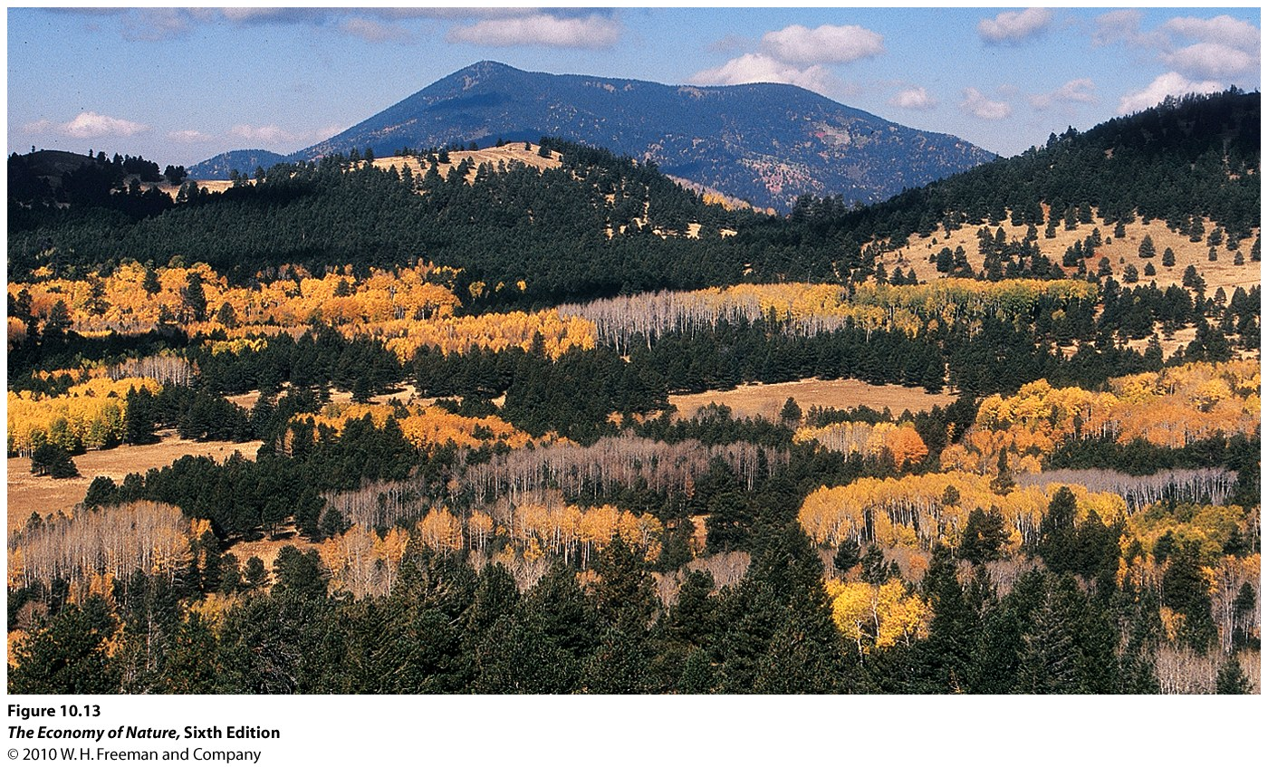
I. Attributes
II.Distribution
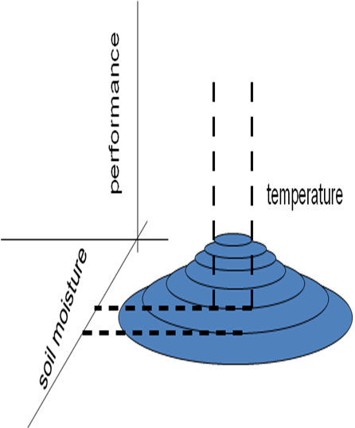
A. Determining Factors
B. Dispersion
1. Types
- Regular: variance is less than the mean, can be zero if equally dispersed. Usually caused by intraspecific competition, such as allelopathy or territoriality.
- Clumped: variance is greater than the mean, usually caused by sociality or common response to clumped resources.
- Random: variance =’s the mean. Rather unusual, just because clumped resources and competition are so common. But previously clumped or regular distributions can degrade to random over time, such as when seedlings (clumped) grow up and compete (regular) and then die of other causes…
2. Complexitie s
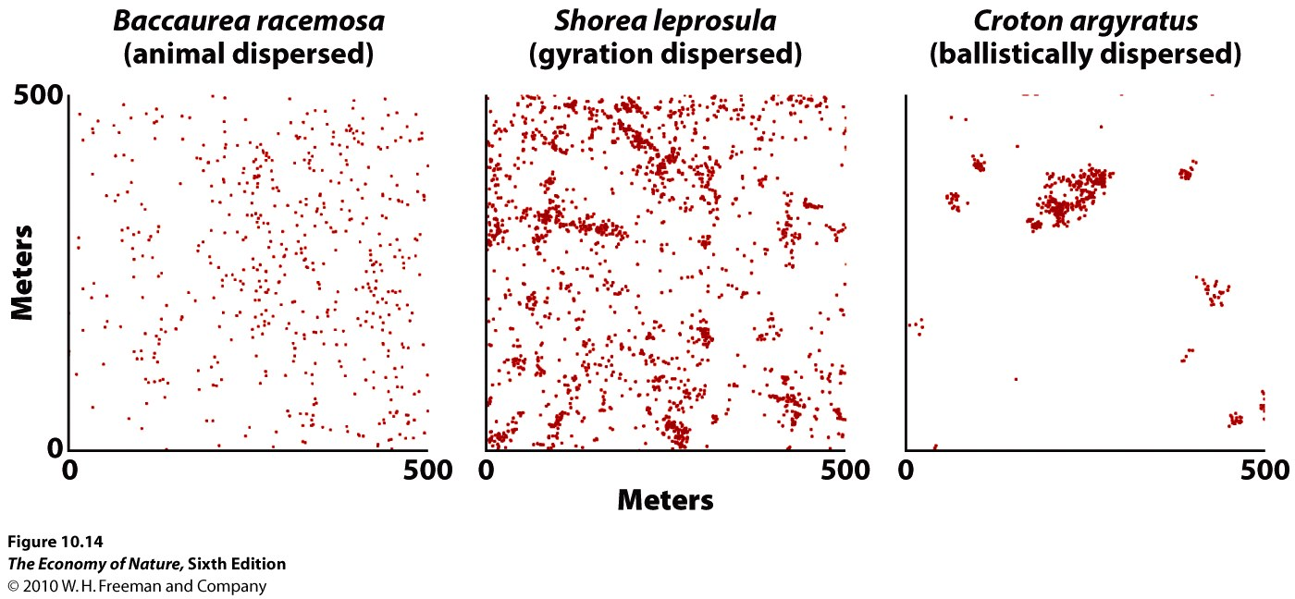
- can vary with type of dispersal
- can vary with development: as the example with tree seedlings, above
- can vary with environment and resource availability and distribution: so, we can expect organisms to move with their resources across space if they are able… creating patterns of seasonal migration
- varies with spatial scale of analysis: this is set by the experimenter. But, populations can respond at different scales to their environment and create patterns at different scales. So, at a large scale, we might find populations distributed in a clumped many over a range, localized to places where their resources are found. Then, at a smaller scale within patches, the individuals may be regularly spaced as they compete for these resources. Analyses at different scales can reveal different things that are important about the biology of the species.
C. Population Density
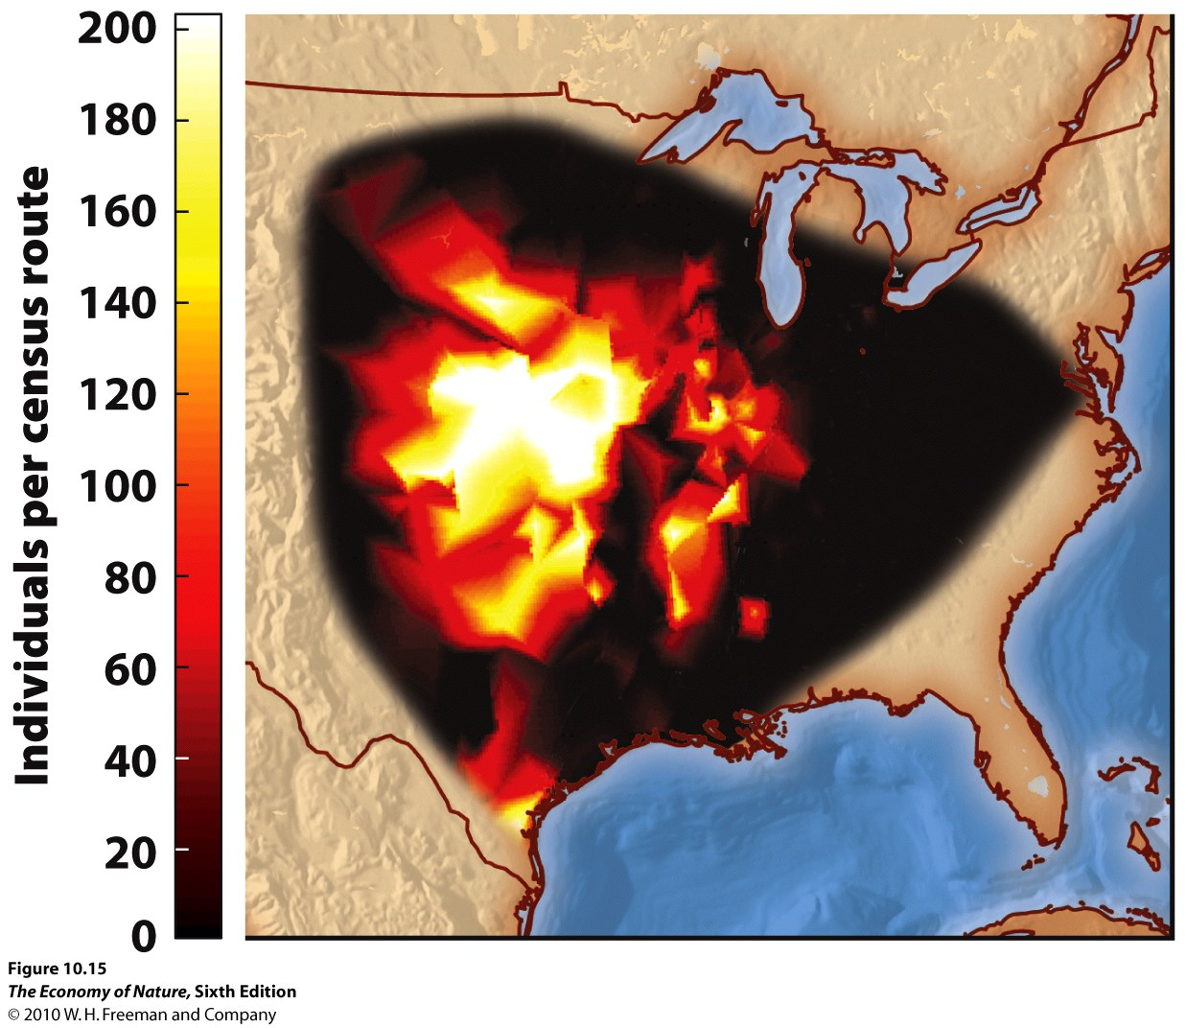
1. Correlations with Range
- This is a logical consequence of niche parameters. In the place where all environmental conditions are ideal, the population should “do the best” – meaning produce the most offspring and thrive… and thus have the highest population size. As we move from this point across space, environmental conditions will change – moving off one optima or another and lessening the populations ability to succeed under these different conditions… reducing reproduction and pop size. So, as we move away from the center in any direction, different variables become limiting and pop size decreases – for one reason or another.
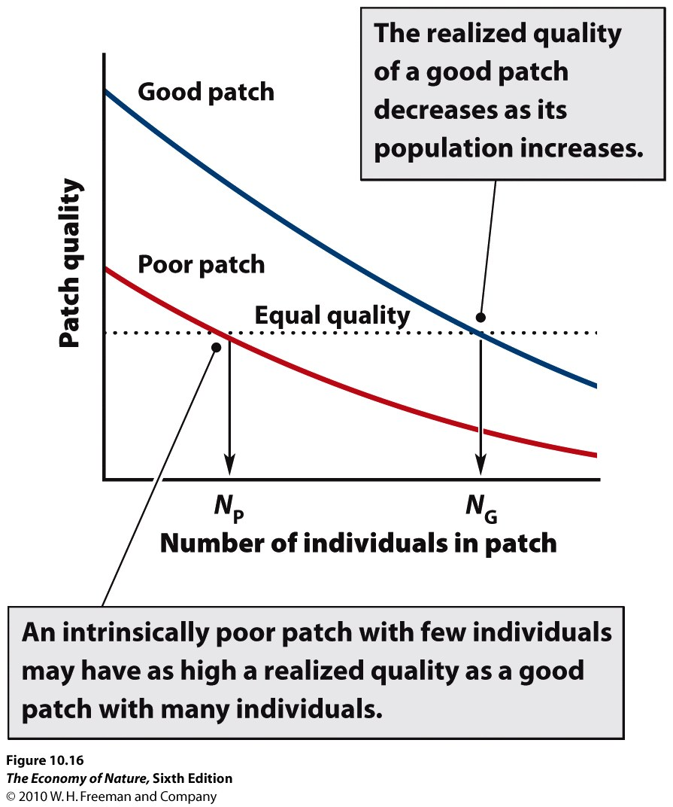
2. Habitat Selection
- If environment differ in quality, organisms should evolve to respond to this variability and GO to where conditions are BEST. (The ones that do will have greater fitness, so selection will favor this outcome). However, as population density increases in this BEST environment, the amount of resource/individual (and their fitness) declines. At some point, the fitness of an organism in this crowded habitat will be lower than the fitness the organism would have in another unoccupied habitat – even if that other habitat was of lower quality initially. At this point, selection will favor organisms that move to this habitat.
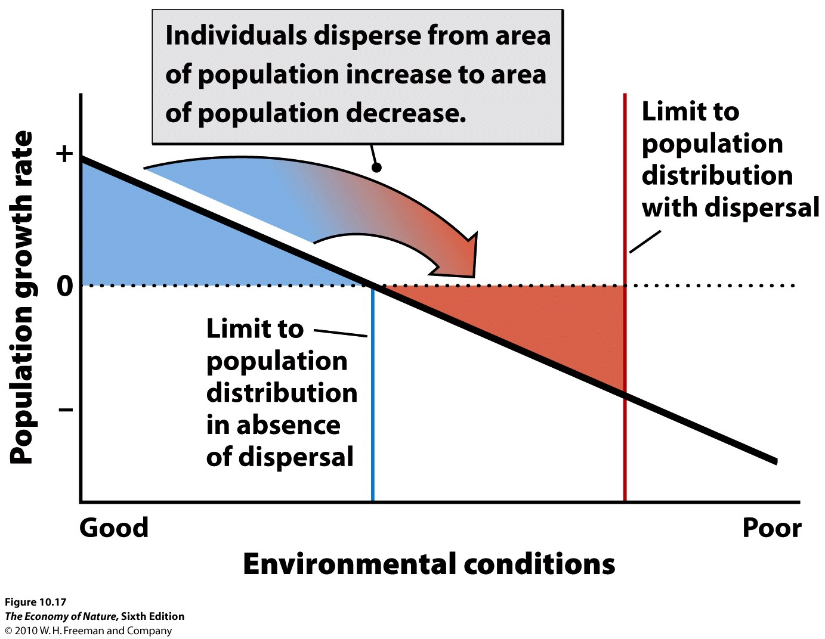
3. Maintenance of Marginal Populations
- Species may have populations in habitats that are so marginal that the population cannot sustain itself by its own reproduction. However, these populations may be maintained in these marginal habitats by migration from more heavily populated preferred habitats. One might ask, why don’t these populations adapt to the conditions in their marginal habitats, so that they can tolerate these conditions more effectively and convert resources into offspring more efficiently? Well, curiously, if the population is being maintained by migration, then genes from the populations in preferred habitats are coming in – and these genes are adapted to the preferred habitat, not this marginal one… so the effects of selection for the marginal habitat are counterbalanced by migration, bringing in genes poorly suited for this habitat.

D. Spatial Structure of Populations
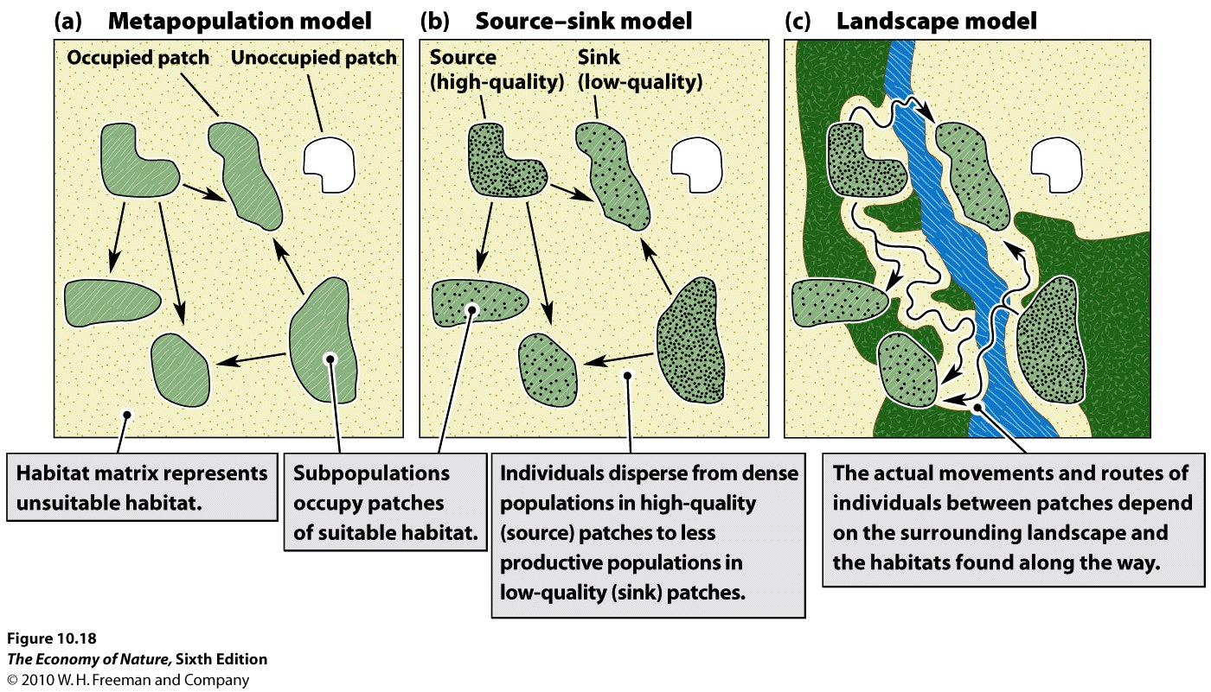
1. metapopulations = equal hab quality and adapted local pops
- This model describes the dynamics among sub-populations connected by migration. Populations inhabit equivalent habitats, and the dynamics are governed by population sizes (which determine the likelihood of extinction and the number of migrants leaving), and proximity to other habitats (which determines the probability of donating and receiving migrants).
2. Source-sink = variable quality habs and migration between
- This model adds one piece of complexity, recognizing that the quality of habits may vary. So, in accordance with the ‘habitat selection’ model, populations in high quality habitats will typically be large, and will typically be donors (“sources”) of migrants… whereas populations in marginal habitats will be smaller and will be recipients (“sinks”) of migrants. Now, migration rates not only depend on distance but also on relative habitat quality and population size.
3. Landscape = Variable quality habs, migration dependent on connectedness
- This model adds another layer of complexity, and considers the effects that variation in the matrix can have on both patch quality and migration. The matrix can influence patch quality by being a source of other species that can visit the matrix – either by providing food (like seeds blown into the patch from outside) or competitors or predators. Also, the matrix can affect migration rates between patches, because it may be a tolerable “corridor” or truly an impermeable barrier. There is a whole discipline of “landscape ecology” that looks at the effects of the distribution and connectedness of patches and habitat types on populations and communities.

III. Population Growth – changes in size through time
A. Calculating Growth Rates
1. Measuring Rate of Geometric Growth – Discrete Time (breeding seasons)
- compare population size at same point in each ‘generation’ (after breeding season).
- one generation to the next: N_{(t+1)} = N_{(t)}λ
- extrapolating from initial generation to any generation in the future: N_{(t)} = N₍₀₎λ^{t}
2. Measuring Exponential Growth – Continuous Growth
- can measure population size at any two times; it is increasing continuously: N_{(t)} = N₍₀₎e^{rt}
3. Equivalency
- they can both describe the same data and the same pattern of growth; the difference in WHEN the growth is occurring: all at once (discrete) or continuously.
- λ = e^{r}, or ln (λ) = r
4. Attributes of Growth Rate
- per capita estimate, averaged over the population
- function of per capita birth and death rates, averaged over population r = (b – d)
- more complex models include migration: r = (b + i) – (d + e)
5. Changes in Population Size
- exponential models are simpler to use, so these are generally preferred
- N_{(t)} = N₍₀₎e^{rt} ….
- We can measure the rate of instantaneous change by taking the derivative with respect to time
- dN/dt = rN so, the change in pop size depends on the intrinsic per capita rate of growth and the size of the population; larger pops will add more individuals per unit time than smaller pops with the same growth rate. it is like an interest rate, with the population size being the principal upon which interest (offspring) is generated.

B. The Effects of Age Structure
- Organisms may not be equal in their probability of reproducing ( birth rate, b, or fecundity) or of dying (d). So, to more closely approximate how a population will grow, the age specific birth and death rates must be taken into account. This is done in a “life table”
1. Life Table
- Types
- static: measure parameters over different age classes for one time period
- dynamic (“cohort”) – follow a group through their life.
- Components
- survivorship is proportion surviving to next birthday. (l_{x}) – three prototypic survivorship curves
- mortality rate is proportion dying in that age class. (q_{x})
- fecundity is number of offspring produced (on average), per capita, for that age class (b_{x})
- compute age-class specific contribution of offspring to next generation.
- Lm = average number alive during the age class interval = (n_{x} + n_{x+1})/2
- R_{o} = net rate of reproduction = Σ(l_{x}b_{x})
- Generation Time (T) = Σ(xl_{x}b_{x})/ Σ(l_{x}b_{x})
- Results
- As a population grows, it will create a ‘stable age class distribution’ in which the proportional representation of each age class equilibrates, and each age class grows at the same rate. When this happens, there is no need to compute age-specific growth rates… they are the same! So, we should be able to compute r for the whole population. This is called the “intrinsic rate of increase” and is estimated as r_{m} = ln(R_{o})/T when the population has reached a stable age class distribution.
- Doubling time = t2 = ln(2)/r = 0.69/r
2. Age Class Distributions
- after time, a stable age class distribution (ACD) is reached.
- when comparing populations of similar organisms with the same survivorship curves, the shape of the ACD can determine how fast the population may expand.
- However, the shape of the ACD is NOT an index of whether it is stable or not – a bottom-heavy ACD can be stable if there is high juvenile mortality, for instance.

Study Questions:
1) Describe the three types of dispersion patterns and list a biological reason why each would occur.
2) Why is it logical that species should have highest abundance in the center of their range? Explain in terms of niche dimensionality and zones of optima and tolerance.
3) If organisms have perfect knowledge of their environment, how should they select habitats based on initial quality and population density? In short, describe when an organism should select an initially inferior habitat.
4) The very factors that allow populations to persist in marginal habitats may hinder their ability to adapt to these habitats. Explain.
5) Why do source-sink models predict that certain populations, exploiting certain habitat patches, would more likely be donors (sources) than other patches? (This makes it more complex than simple metapopulation models).
6) Landscape models consider the effects that a heterogenous matrix might have on 1) patch quality and 2) migration rates between patches. Explain the two effects.
7) When would you use a continuous or a discrete model to describe the growth of a particular population?
8) How are r and lambda related?
9) Solve this problem for a population with discrete growth: if the population is 500 and lambda = 1.2, how long will it take to double?
10) If the human population has a current population of 7.5 billion, and an r = 0.012, how long will it take to reach 10 billion?
11) If all age classes have the same survivorship and fecundity schedules, what is the simplest equation for continuous growth that you could use to predict the change in population size over time?
12) Why does the growth rate of a population oscillate and then stabilize over time?
13) How does a cohort life table differ from a static life table?
14) Consider this cohort life table:

X | Nx | lx | dx | qx | lm | ex
0 | 150
1 | 100
2 | 50
3 | 0

Fill in the table and calculate the life expectancies for each age class (ex).

15) Now calculate the generation time and doubling time
X | Nx | lx | bx | lxbx | xlxbx
0 | 150 |  | 0
1 | 100 |  | 2
2 | 50 |  | 1
3 | 0 |  | 0

