Population Ecology
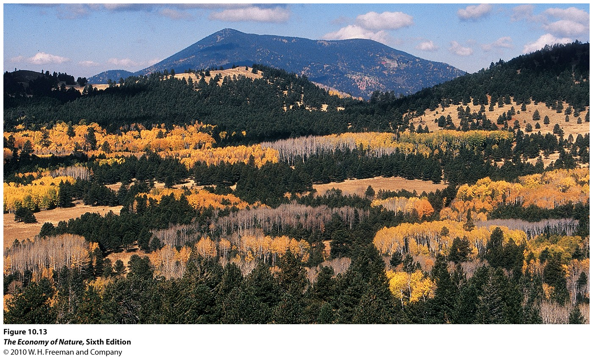
I. Attributes
II.Distribution
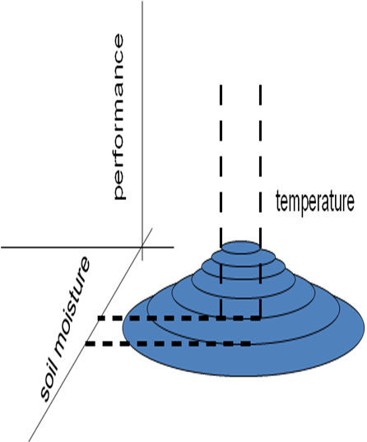
A. Determining Factors
B. Dispersion
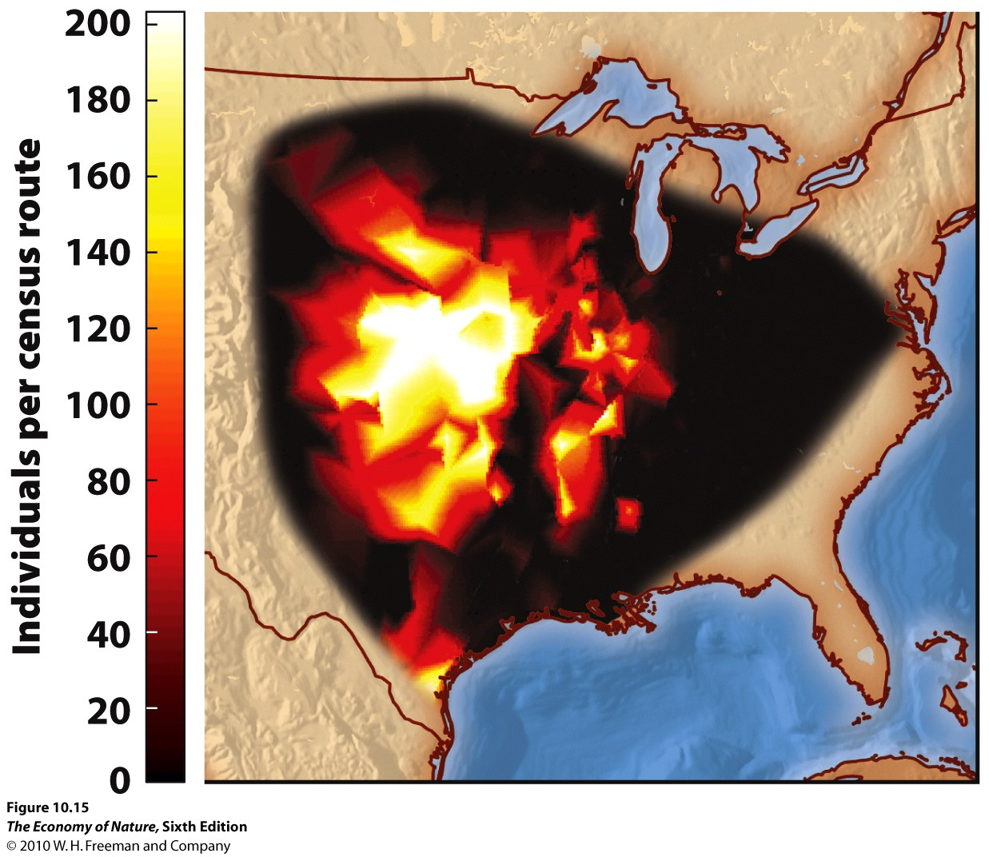
C. Population Density
D. Spatial Structure of Populations
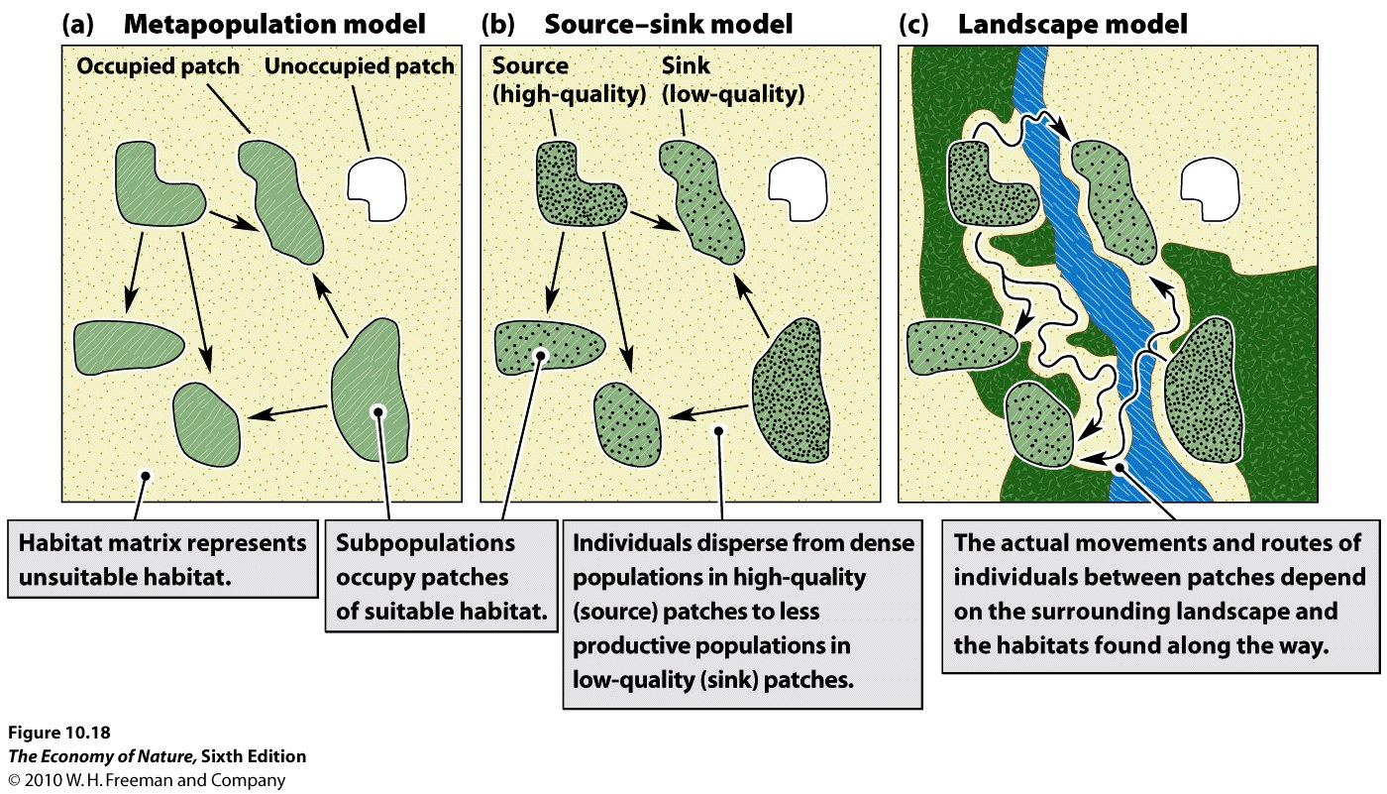
1. metapopulations = equal hab quality and adapted local pops
- This model describes the dynamics among sub-populations connected by migration. Populations inhabit equivalent habitats, and the dynamics are governed by population sizes (which determine the likelihood of extinction and the number of migrants leaving), and proximity to other habitats (which determines the probability of donating and receiving migrants).
2. Source-sink = variable quality habs and migration between
- This model adds one piece of complexity, recognizing that the quality of habits may vary. So, in accordance with the ‘habitat selection’ model, populations in high quality habitats will typically be large, and will typically be donors (“sources”) of migrants… whereas populations in marginal habitats will be smaller and will be recipients (“sinks”) of migrants. Now, migration rates not only depend on distance but also on relative habitat quality and population size.
3. Landscape = Variable quality habs, migration dependent on connectedness
- This model adds another layer of complexity, and considers the effects that variation in the matrix can have on both patch quality and migration. The matrix can influence patch quality by being a source of other species that can visit the matrix – either by providing food (like seeds blown into the patch from outside) or competitors or predators. Also, the matrix can affect migration rates between patches, because it may be a tolerable “corridor” or truly an impermeable barrier. There is a whole discipline of “landscape ecology” that looks at the effects of the distribution and connectedness of patches and habitat types on populations and communities.

E. Macroecology
- deals with large scale patterns in ecology – such as relationships between body size and species ranges. It is a fairly new subdiscipline (Brown 1984) that takes a very top-down approach – looking for important biological insights by looking at relationships across large taxonomic and geographical scales.
1. Patterns
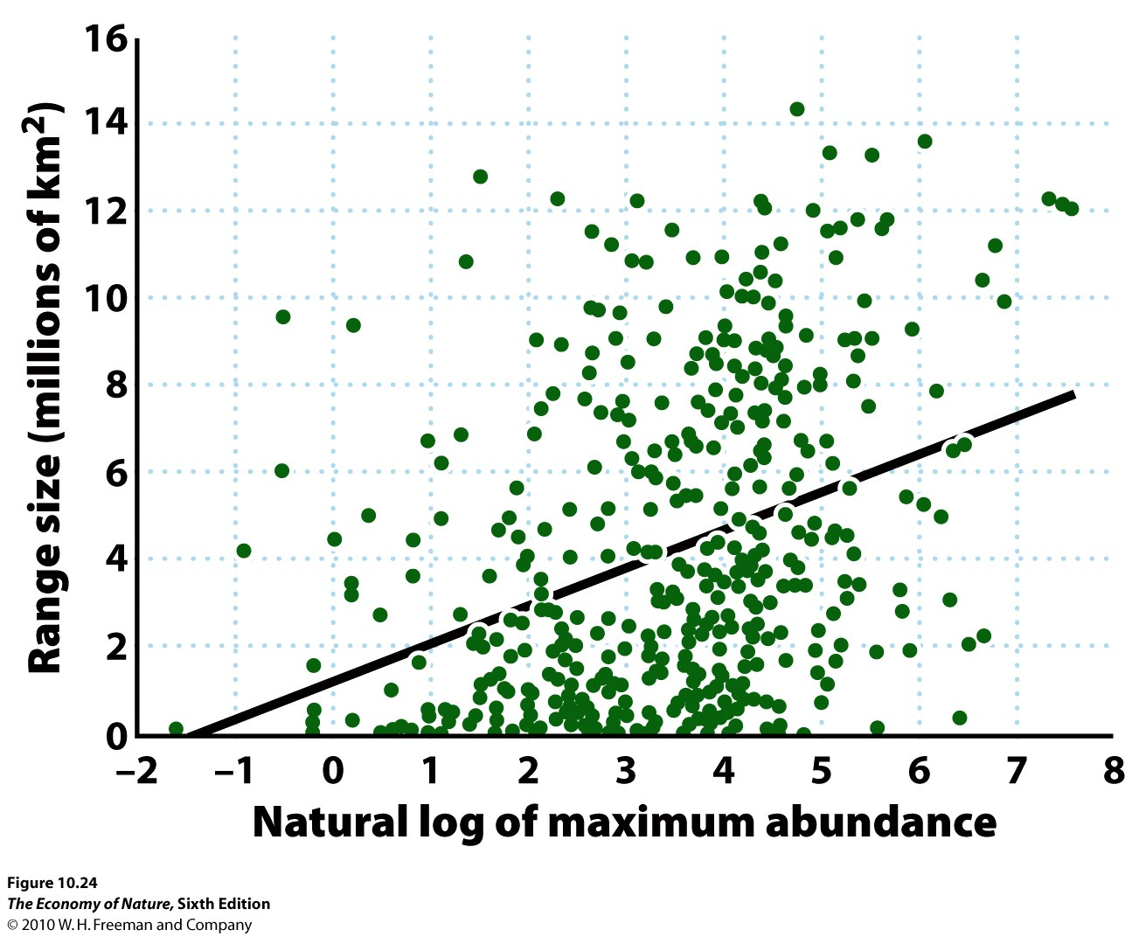
- Species with high local abundances have large ranges
- There is considerable variation in this relationship (it only explains 13% of the variance in range size) but it is still strongly significant. Brown explain it this way: generalist species that exploit a wide range of resources can reach high abundances in the middle of their range (there is more food), and should also be able to spread out over a greater range of habitats (where they can eat this or that).
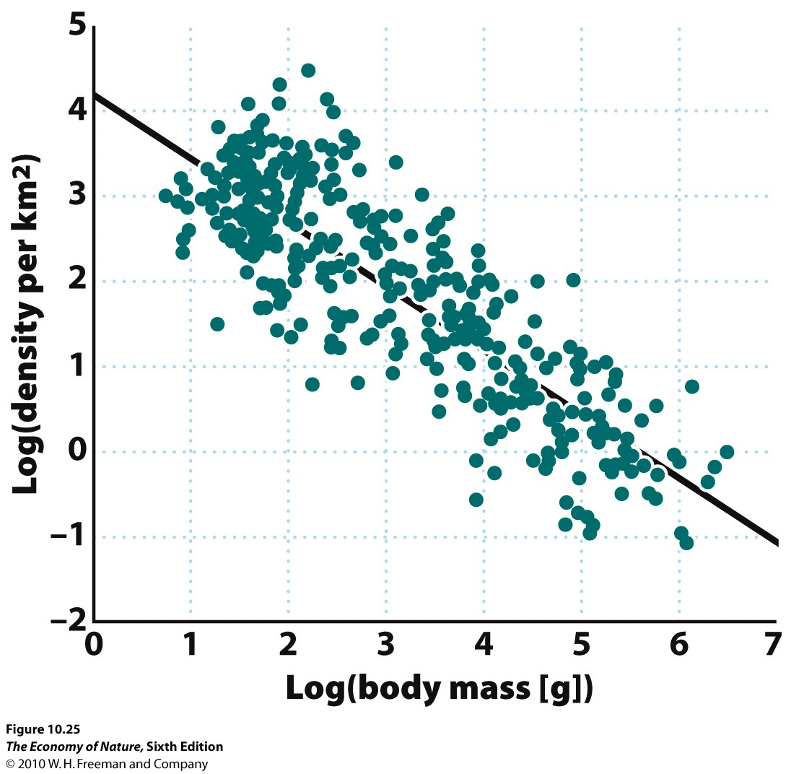
- Large organisms have lower population sizes than small organisms
- Obviously, there are energetic constraints here. However, Brown found an interesting relationship: biologically similar organisms (mammals, for instance) that differ in size show a fairly constant amount of food used/unit area – even though metabolic efficiencies increase with body size. This is the energy equivalence rule.

2. The Shapes of Ranges
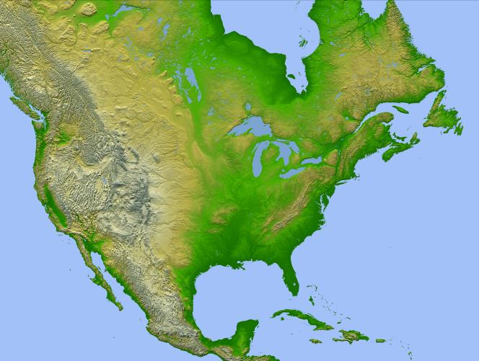
- In the U.S., abundant species have ranges running E-W; rare species have ranges running N-S.
- Brown hypothesized that species with large ranges were generalists, able to adapt to a variety of habitats. Rare species were specialists, with narrower niche spaces limited to a particular elevation, for instance.
- Brown tested this idea by looking at Europe, where the mountains run east –west. Here, rare species should have E-W distributions, corresponding to a narrow elevational range. Abundant species should have N-S ranges, corresponding to a wider range of elevations and habitats. The predictions held.

III. Population Growth – changes in size through time
A. Calculating Growth Rates
1. Measuring Rate of Geometric Growth – Discrete Time (breeding seasons)
- compare population size at same point in each ‘generation’ (after breeding season).
- one generation to the next: N_{(t+1)} = N_{(t)}λ
- extrapolating from initial generation to any generation in the future: N_{(t)} = N₍₀₎λ^{t}
2. Measuring Exponential Growth – Continuous Growth
- can measure population size at any two times; it is increasing continuously: N_{(t)} = N₍₀₎e^{rt}
3. Equivalency
- they can both describe the same data and the same pattern of growth; the difference in WHEN the growth is occurring: all at once (discrete) or continuously.
- λ = e^{r}, or ln (λ) = r
4. Attributes of Growth Rate
- per capita estimate, averaged over the population
- function of per capita birth and death rates, averaged over population r = (b – d)
- more complex models include migration: r = (b + i) – (d + e)
5. Changes in Population Size
- exponential models are simpler to use, so these are generally preferred
- N_{(t)} = N₍₀₎e^{rt} ….
- We can measure the rate of instantaneous change by taking the derivative with respect to time
- dN/dt = rN so, the change in pop size depends on the intrinsic per capita rate of growth and the size of the population; larger pops will add more individuals per unit time than smaller pops with the same growth rate. it is like an interest rate, with the population size being the principal upon which interest (offspring) is generated.

Study Questions:
1) If organisms have perfect knowledge of their environment, how should they select habitats based on initial quality and population density? In short, describe when an organism should select an initially inferior habitat.
2) The very factors that allow populations to persist in marginal habitats may hinder their ability to adapt to these habitats. Explain.
3) Why do source-sink models predict that certain populations, exploiting certain habitat patches, would more likely be donors (sources) than other patches? (This makes it more complex than simple metapopulation models).
4) Landscape models consider the effects that a heterogenous matrix might have on 1) patch quality and 2) migration rates between patches. Explain the two effects.
5) Brown found a weak but significant relationship between a species’ density at the center of its range and the size of the range. How did he explain this pattern?
6) What is the ‘energy equivalence rule’ and what affect does it have on the relationship between the densities of large and small animals per unit area?
7) In the U.S. large ranges of abundant species are oriented east-west while smaller ranges of rare species are often oriented N-S. How does this related to a species being a generalist or specialist?
8)When would you use a continuous or a discrete model to describe the growth of a particular population?
9) How are r and lambda related?
10) Solve this problem for a population with discrete growth: if the population is 500 and lambda = 1.2, how long will it take to double?
11) If the human population has a current population of 7.5 billion, and an r = 0.012, how long will it take to reach 10 billion?

