Population Ecology

I. Attributes
II.Distribution
III. Population Growth – changes in size through time
IV. Species Interactions
V. Dynamics of Consumer-Resource Interactions
VI. Competition
VII. Mutualisms

A. Overview
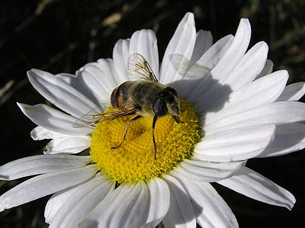
1. Dynamics
- fitness benefit to both populations
- diffuse (many partners) or species specific (one partner)
- facultative (not necessary) or obligate (necessary)
- strength of any feedback loop depends on the degree of “obligateness”

2. Historical Importance
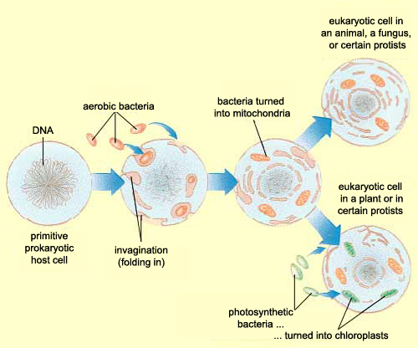
- eukaryotes evolved by endosymbiosis about 1.8 bya. Previous to that, all life was bacterial. Eukaryotic life and compartmentalization of function allowed for the evolution of sexual reproduction and the exponential production of new variation upon which evolution could act. In addition, the evolution of oxygen-releasing photosynthesis and the accumulation of oxygen in the atmosphere around 2.0 bya created a very deadly environment for most organisms that were probably anaerobic. Endosymbiosis of oxygen-using proto-mitochondria allowed cells to evolve aerotolerance, and increase their metabolic efficiency, to boot.Subsequent endosymbiosis with photosynthesizing bacteria provide the host cells with sugar – a relationship we continue to see occurring today.
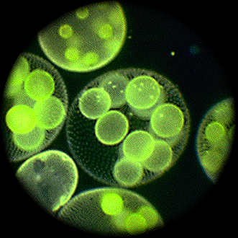
- multicellularity evolved when cells produced by division acted as mutualistic collectives, rather than completely autonomous cells. Eventually, this allowed for cell-cell communication and cell specialization – which increased efficiency of the collective.
- Most organisms are probably involved in mutualistic interactions (even beyond the cellular level). All animals, for instance, harbor gut-symbionts that aid digestion so much that they cannot live without them. And of course, they provide a suitable home for these symbionts – with a supply of food in a very stable environment. Most plants have endosymbiotic fungi that increase the absorptive surface area of their roots (increasing the supply of water and nutrients), that they feed with photosynthate.
- And of course, cooperative, mutualistic, social interactions can evolve for a number of reasons, as we discussed before (kin selection, reciprocal altruism, etc.).
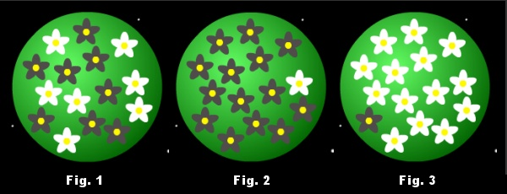
- At the community/ecosystem/planetary scales, the CYCLIC nature of energy and matter flow through different types of organisms highlights their mutual dependencies. Decomposers are dependent upon plants and animals for food, and plants and animals are dependent on decomposers for nutrients. Indeed, when these feedback loops increase, they impose a type of general stability on conditions. James Lovelock created the “Gaia Hypothesis” around this idea, suggesting that life has constructed an environment that is suitable for life – through feedbacks in the hydro- litho- and atmospheres. “Daisyworld” idea with white and black flowers equilibrating the temperature of the world, even as temperature heats up abiotically.

B. Types of Mutualism

1. Trophic Mutualisms – help one another get food
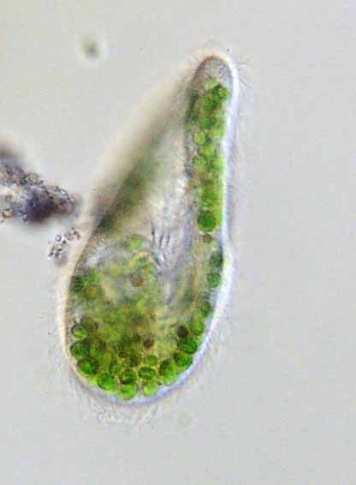
- ‘gut’ endosymbionts: gut bacteria in humans. Gut bacteria in ruminants. Gut bacteria and protists in termites to help digest their wood diet. Sulphur-bacteria in tube-worms. Sometimes the host evolves a specialized cavity for the endosymbiont, such as the “rumen” of ruminants, or the trophosome of giant tube worms. Giant tube worms don’t have a digestive tract as adults; they are colonized by these bacteria and feed off the sugars they produce. - Curiously, although one organism lives inside the other, they are not necessarily obligate (especially for the endosymbiont). In some cases, the endosymbiont can live freely – as in the zooxanthellic algae that can live in corals. The polyps are predatory and can feed without the algae, too; although both do much poorer and eventually die. Paramecium eat Chlorella (eukaryotic algae) and does not digest them, entering into an endosymbiosis. Aphids and plant hoppers suck sugary sap. They feed gut bacteria that produce some essential amino acids that the insects can’t photosynthesize. The bacteria are cultured in specialized cells called bacteriocytes in the fat bodies of the insects, and this is the only place the bacteria live.

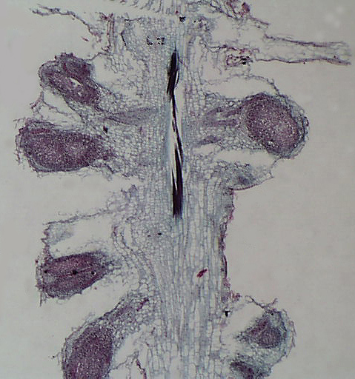
- plants and N-fixing bacteria: these are facultative relationships – each can live without the other, though not nearly as well. There are also adaptations specific to the interactions. An anaerobic soil bacterium (Rhizobium) infect roots of legumes and stimulate the production of root nodules. These nitrogen-fixing bacteria convert N2 to nitrites and nitrates that the plant can absorb – freeing it from N-limitation (which very commonly limits plant growth…which is why fertilizers stimulate growth). The plants provide sugars to the bacteria. The plants also make a heme-like chemical that binds oxygen, keeping the oxygen concentrations low for this anaerobic bacteria.

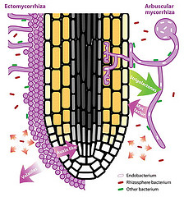
- plants and fungi: ectomycorrhizal fungi wrap their hyphae around roots but don’t penetrate the cell walls. Endomycorrhizal fungi (or vesicular-arbuscular mycorrhizal VAM fungi) have hyphae that invade the cell wall but not the membrane… but establish a more intimate relationship with the plant. Both types of fungi increase the absorptive power for water and nutrients, and they are fed photosynthate in return. Orchids have evolved obligate relationships with their fungi. The hyphae grow through the seed coat to help the seed germinate. Orchid can’t live without the fungus.

- algae and fungi: lichens. Fungi are only associated with one algal species, but an algae can have different fungal partners. These are all obligate; the fungi gets sugar and the algae gets inorganic minerals.

- mixed foraging flocks often occur when resources dwindle. Birds of several species will flock together, hunting for resources. These are very dynamic and labile interactions; the flock breaks up and can be composed of different individuals and species over time. Very diffuse and informal.

2. Defensive Mutualisms – trade protection for food
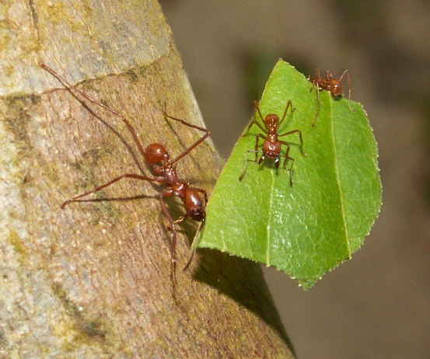
- Animals and Food Sources:
1. Leaf-cutter ants and their fungal gardens: Leaf cutters cut leaves and return them to the nest where they chew them into a mulch. They grow a single species of fungus on the mulch, and this is the only place this fungus grows. The ants farm the fungus – it is all they eat. In addition, they ‘farm’ the fungus, weeding other fungi and pathogens.
2. Ant-Acacia Interactions: Several species of ants have coevolved with acacia trees, from facultative to obligate relationships. In the facultative relationships, ants visit for pollen and nectar, and provide some defense while they are there. In the obligate relationships, the ants nest in hollow thorns, they eat nectar, pollen, and specialized fatty structures produced by the plant called Beltian bodies. So, they get protein, fats, carbos, and a place to live. They are very aggressive, and attack if the plant is disturbed – just like disturbing an ant nest in the ground. One of the most interested recent reports shows the dependency of this relationship on the environment – specifically the abundance of large herbivores. In Africa, the decline in native herbivores in certain areas changes the fitness relationships…essentially, if herbivory is reduced, then “paying” the ants “protection money” is not worth it – and plants that don’t make thorns have higher fitness than those that do.
3. Ants and Aphids: Ants farm aphids like cows… they eat the ‘honeydew’ that aphids secrete, and they herd them around to new plants and protect them from predators and parasites.
- Cleaning Mutualisms
The cleaner gets a meal, and the individual that is cleaned gets ‘protected’ from its parasites. Tick birds and their large mammal hosts are a good example. Another interesting example is ‘cleaning stations’ in marine fish communities. Certain fish will clean parasites off others. The parasite laden fish will line up, waiting for service from the cleaners at their cleaning station! There are some very interesting social interactions here, akin to the “reputation” hypothesis of altruism. Cleaners remove parasites, but they can also take bites out of their hosts! Fish watch, and go to cleaners that ‘cheat’ less. In addition, there are mimic cleaners that are different species… and they just bite.

3. Dispersive Mutualisms: trade food for transport
1. Pollination: bees, wasps, ants, butterflies, moths, flies, birds, bats, and some other small mammals visit flowers, eat nectar and pollen, and disperse pollen. These interactions can be diffuse, specific, facultative, and obligate. Syndromes such as red = hummingbird, broad and white and open at night = bat, composite flowers like daisies with broad platforms and many flowers = butterflies, create some easy patterns and some general taxonomic specificity.
2. Seed Dispersal: Animals eat the seeds, digest the fruit, and the seeds pass through the gut or are regurgitated.
VIII. Evolutionary Responses to Species Interactions

A. Overview
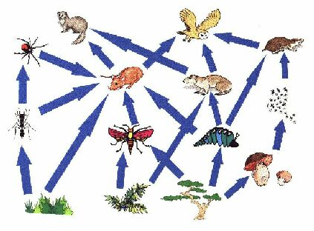
1. Why Won’t This Population Unit End?
- Will this unit on populations ever end? Good grief! Well, there is a reason why we spend so much time on populations… because they are the unit of evolutionary change. So, at a fundamental level, responses to climate, acclimation, migration, etc., are only really important over time if they affect the genetic structure of the population and are inherited. And of course, all of the interactions that we have discussed have positive or negative effects on the species – which translates into effects on growth, reproduction, and FITNESS. So, populations should respond, evolutionarily, to these interactions. Some of these responses are pretty cool, because as one species in the interaction changes, it changes the selective pressure on the other… resulting in adaptive responses of that species.

2. Coevolution
- So, the red queen hypothesis rears its head again… and when species are involved in this ‘evolutionary race/dance’ with another species, evolving in response to one another, we call that “coevolution”.

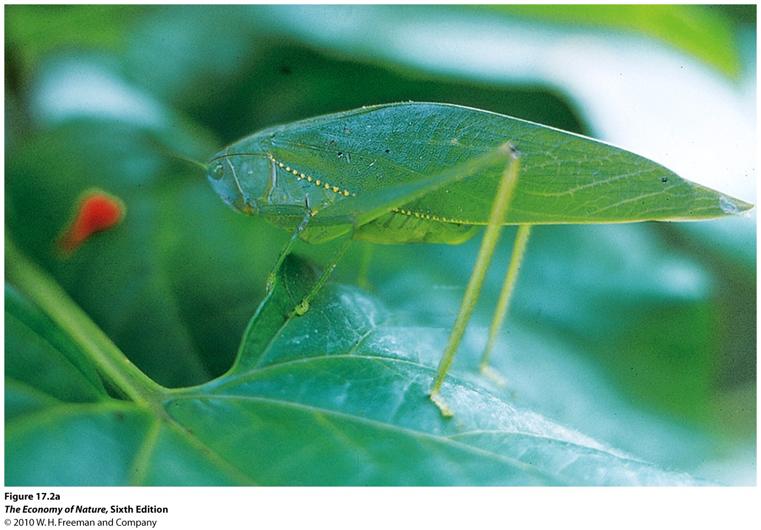
B. Coevolution in Consumer-Resource Relationships
1. Capture and evasion: crypsis, speed, schooling, pack hunting, group defense, etc.

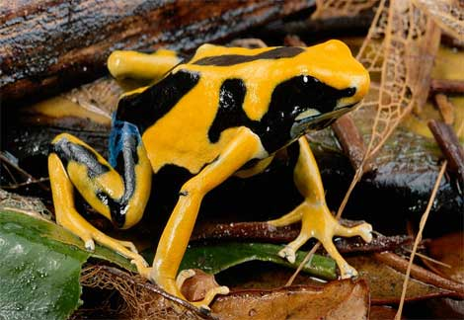
2. Chemical Defense: selection for the production or sequestration (storing of toxins harvested from the environment) of toxins by the prey, selection for detoxification mechanisms in the predators. Often we also see that unpalatable prey species advertise their unpalatability with warning coloration (aposematic coloration). Selection favors toxic species that look different from edible species, so that predators can learn to avoid just them. Classic examples are toxic butterfly species dressed in oranges, reds, yellows, and blacks, bees and wasps in black and yellow, coral snakes in black, red, and yellow, red and orange frogs, etc.

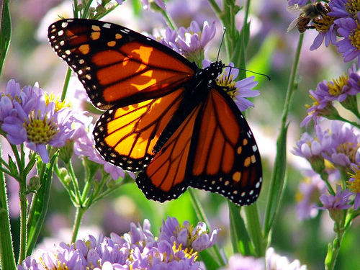
3. Mimicry: We usually use the word ‘crypsis’ to mean blending in with the habitat – matching the background. “Mimicry” means looking like another organism or specific thing. Some caterpillars mimic snakes; some mimic bird droppings (more crypsis). Many palatable butterflies mimic toxic species of butterflies. Many palatable flies mimic bees and wasps.
- Batesian Mimicry: palatable mimic mocks an unpalatable model

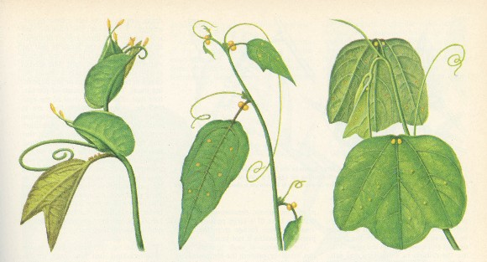
The curious case of Heliconius butterflies and Passiflora plants (Passion flower). Many butterflies and moths use a specific plant as their larval host – they have adapted to the particular chemical compounds in the plant and can detoxify them, but adapting to this plant means that they have probably lost the capacity to detoxify the compounds in other plants. Heliconius are specialists on Passiflora, only using it as the host plant. This specialization by Heliconius has selected for a couple interesting traits in Passiflora. The first is that the leaves of Passiflora are highly variable, presumably so the visual butterfly can’t hone in on leaves of one shape or size. So, the plant mimics the leaves of other plants (though none specifically – a single Passiflora will have a variety of leaf shapes). More remarkable still, some Passiflora species develop small little yellow bumps on their leaves. These look very much like the egg cases of Heliconius butterflies. Female butterflies will not lay eggs on leaves that already have egg cases, presumably as an adaptation to reduce competition with other caterpillars. By mimicking egg cases, leaves reduce the number of actual eggs that are laid on them – thus reducing caterpillar herbivory.
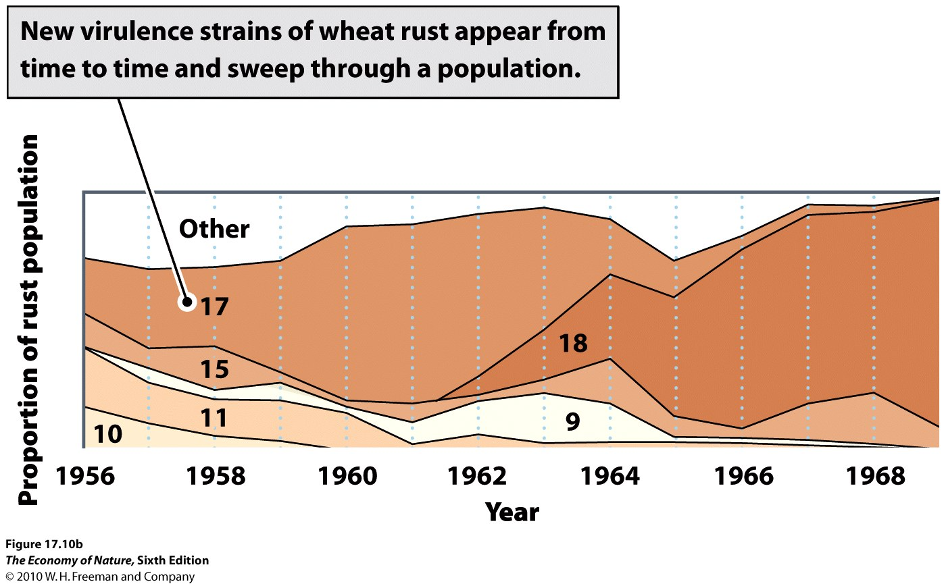
4. Pathogens: There is a dynamic relationship between a pathogen and a host, as the abundance of hosts determines how likely it is that the pathogen will be able to ‘reproduce’. So, although a pathogen may be virulent (lethal) initially, and may remain so in a very large and dense population where the probability of contagion is high even if hosts die, there is also the possibility that, as hosts die, there is selection for less virulent strains of pathogen that don’t kill the host before it has a change of being transmitted to another host. The myxomatosis example in your book is a good example. In addition, the pathogen is also affected by the evolution of resistance in the host population, which effectively reduces the suitable population of hosts, as well. In this case, the evolution of resistance wouldn’t necessarily select for decreased virulence, but would select for increased transmissibility. Finally, pathogens that can travel through the environment without direct host-host interactions are not under the same selective pressures and may remain virulent even as human host populations collapse; particularly if there is an alternate host (as with many influenza viruses that can also infect chickens and pigs – “swine flu”).

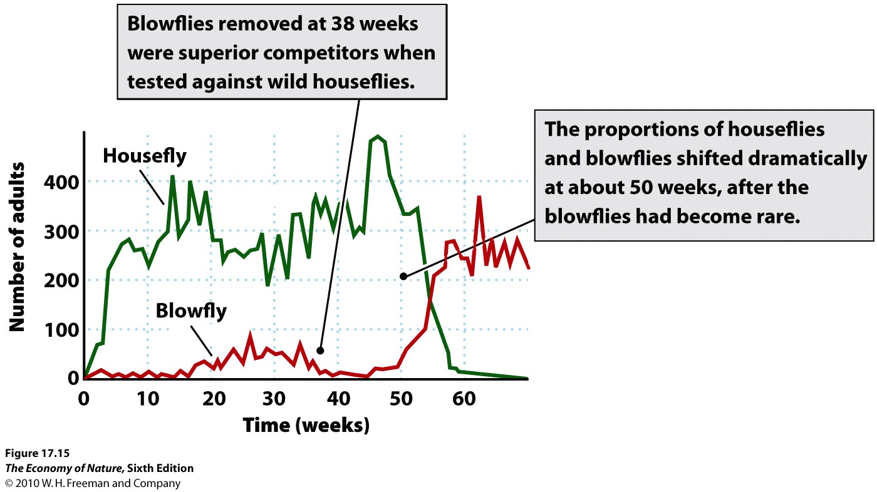
C. Evolution of Competitors
Competition can result in Changes in Physiology, Morphology, or Behavior that reduce resource overlap between species. This is called character displacement (talked about this before).
Not a positive feedback – not a coevolutionary response

D. Evolution of Mutualisms
There is a positive feedback, often selecting for more intimate relationships among partners.

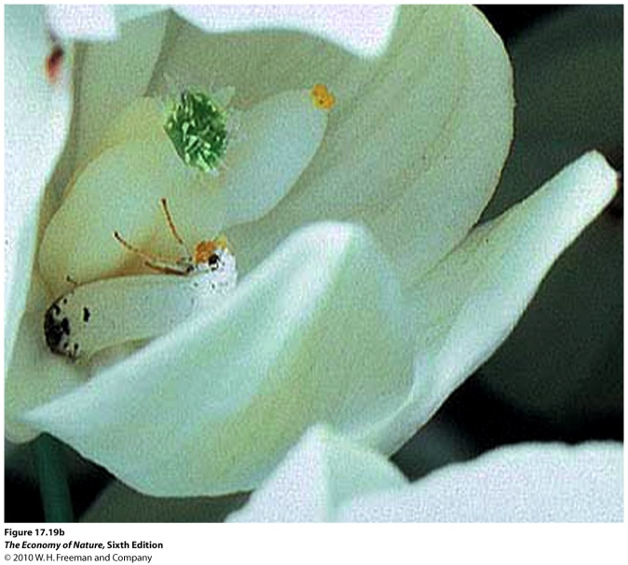
E. Relationships Change
Yucca moths lay eggs in the ovary of Yucca plant flowers. The larvae consume the seeds of the Yucca plant. So, this would seem to be a parasitic relationship (or predatory if we think of embryos as individuals). However, because Yucca moths visit flowers to lay their eggs, they also transport pollen. So, the moth is both a predator and a mutualistic of the plant. The net effect depends on the net cost/benefits of these interactions. One might presume that selection would favor an increase in egg laying by the moth – there are more seeds available that the moth larvae could consume. However, as the % of damaged seeds increases, so does the chance that the plant aborts the entire flower, thereby killing the math larvae, as well. So, selection favors moths that do not kill all the seeds in a flower. In addition, this is the only pollinator of the plant, so the plant is selected to tolerate the damage to some seeds in exchange for pollination. So, this obligate mutualism is probably a product of a complicated transformation of a parasitic relationship. Endomycorhizzal fungi may become parasitic, too, suggesting that this relationship is delicately balanced between mutualism and parasitism. Species may help one another at one life history stage, and compete at another. This is also true for predation, where adults of two species may eat the juveniles of the other species, but compete as adults.

Study Questions:
1) Describe how mutualisms are implicated in the three major evolutionary steps of life: the evolution of eukaryotes, multicellular life, and animals and plants.
2) Why do some plants form mutualistic relationships with N-fixing bacteria, how do they do it, and what group of plants do it?
3) Describe the range of relationships between ants and acacias, and describe how the intimacy of these relationships may depend on the presence of large herbivores.
4) What are the two types of mimicry, and how do they differ in terms of evolutionary dynamics?
5) List three pollination syndromes.
6) How do cleaner fish and their “clients” balance the possibility of parasitism against the benefits of mutualism?
8) Distinguish between a diffuse and an obligate mutualism, giving an example of each.
9) What is ‘coevolution’, and how does the red queen hypothesis relate?
10) Describe how aposematic coloration can be selected for, even if the organism that is bitten is killed.
11) Use the Yucca – yucca moth interaction to describe how parasites may evolve into mutualists.
12) Compare the selective pressures in competitive, predatory, and mutualistic interactions and explain why only the last too are truly coevolutionary.

