Adaptations to the Physical Environment

II. Light

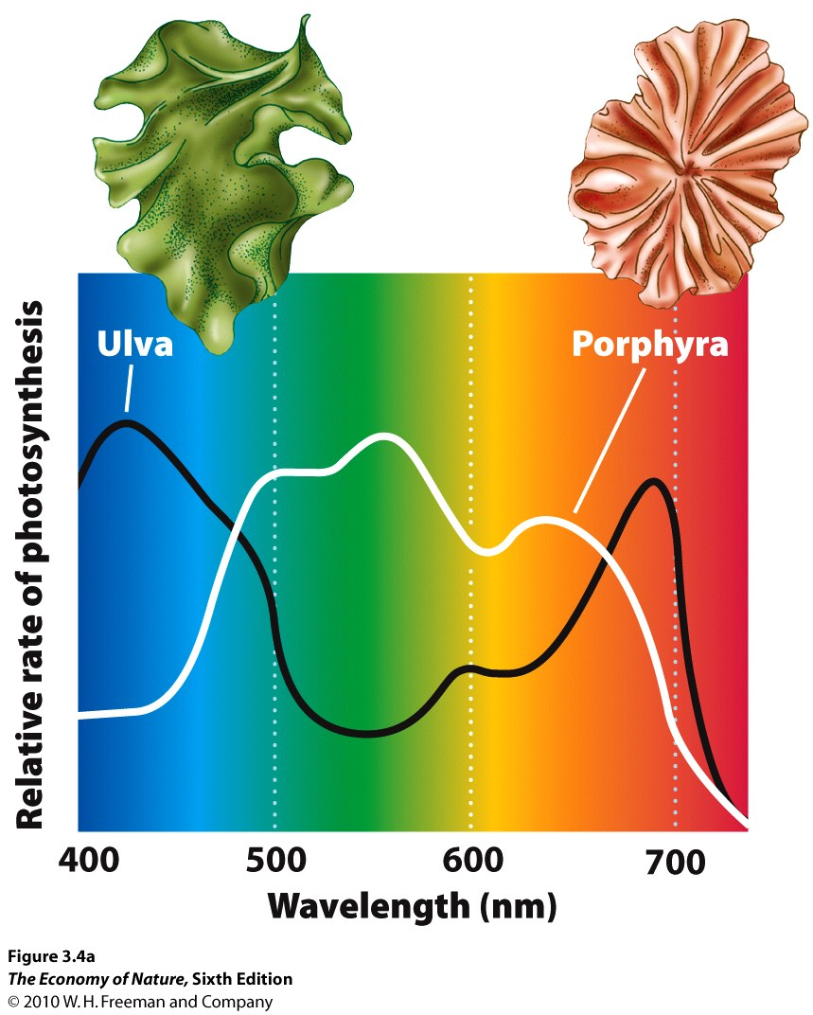
A. Properties and Adaptations
1. Pigment Absorbances
- Chlorophylls absorb in blue and red; carotenoids in blue and green.
- Algae at depth absorb in green, because red is absorbed by water quickly, and blue is scattered at surface… so the majority of light energy at depth is in green range.
2. C3 Photosynthesis
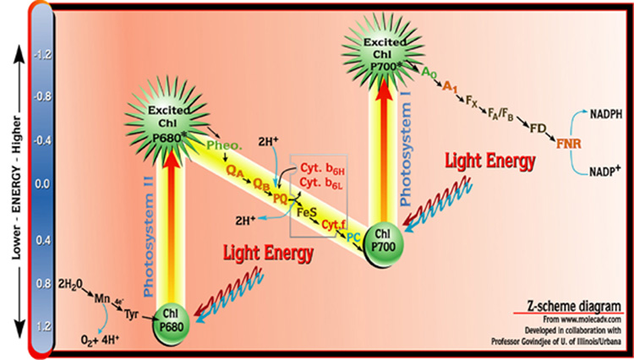
a. Light Dependent Reaction
- Photosystems irradiated; electrons excited and passed to electron transport chains
- transfer produces ATP and NADPH
- water is split to replace the electrons; oxygen is released as a waste product.
b. Light Independent Reaction
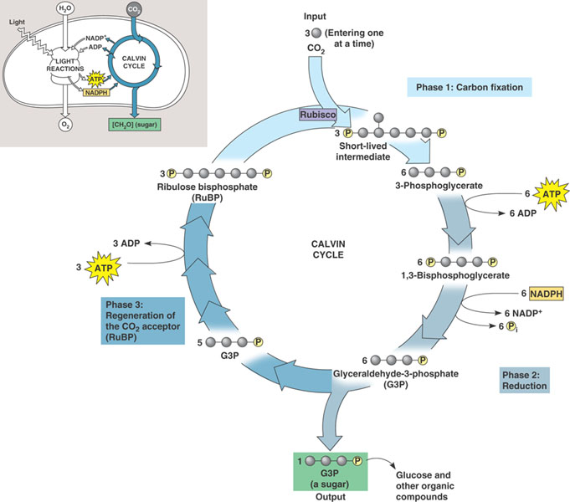
- Energy is ATP and NADPH used to reduce and bind CO₂ into glucose
- 6 CO₂ bound to 6 RUBP molecules (C₅), making 6 C₆ molecules that are unstable and split (12 C₃ molecules). Two are modified (reduced) and bound to form a C₆ molecule of glucose. The other 10 C₃ molecules are rearranged to recycle the 6 RUBP molecules. (This is a cycle… the Calvin Cycle).
- The enzyme that links RUBP to CO₂ is RUBP carboxylase-oxidase (rubisco). It is inefficient at low CO₂ concentrations, so plants overcome this shortcoming by having LOTS of it (30% dry weight of leaves!!)
c. Photorespiration
- when it is dry, plants close stomata.
- continued photosynthesis causes CO₂ concentrations to drop and O₂ concentrations to increase.
- Rubisco binds O₂, not CO₂, and reverses the reaction… at least shutting it off so no more glucose accumulates – BAD. Plants that experience dry conditions often have adapted new pathways.
3. C4 Photosynthesis
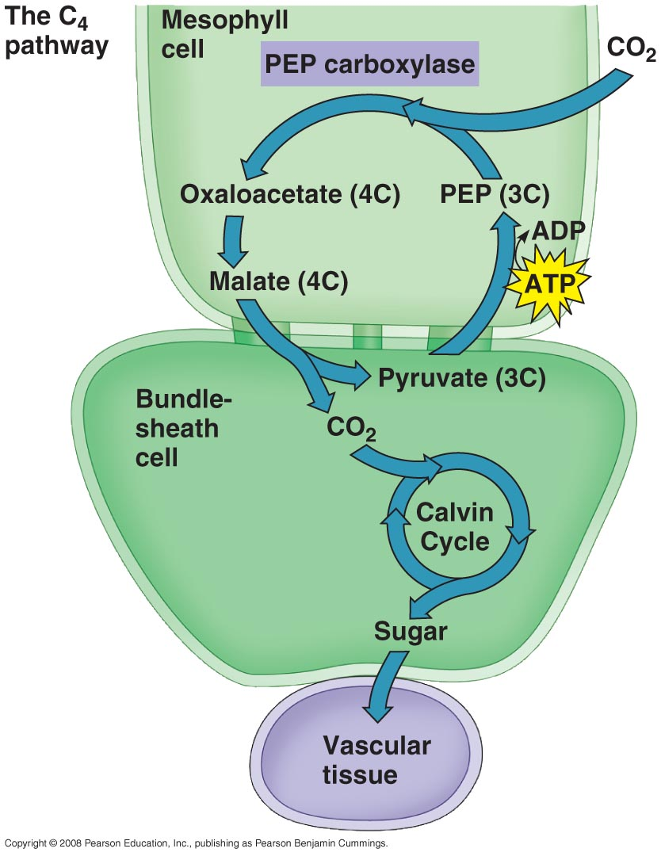
- bundle sheath cells surround xylem/phloem. Surrounded by mesophyll.
- mesophyll perform a new reaction, linking CO₂ to PEP (C₃) to form malate (C₄). PEP can fix CO₂ even at low CO₂ concentrations.
- The malate diffuses into the bundle sheath cells and is dissociated into PEP and CO₂, keeping the CO₂ concentrations high enough for rubisco to perform the Calvin Cycle correctly and photorespiration does not occur for a while. Carbon fixation and glucose production are separated spatially.
- So, these plants (many grasses) can close their stomata, save water, and still photosynthesize for a while. However, some energy is used in these extra steps, so C₃ plants have an advantage in moist environments.
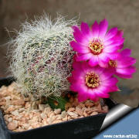
4. ‘CAM’ Plants
- Succulents (like cacti) that have adapted to desert environments where drought stress is most svere and stomata need to remain closed almost all day. So, these plants separate carbon fixation and glucose synthesis temporally; with fixation at night (when stomates can be open) and the Calvin Cycle in the day (when ATP and NADPH are available from the light reaction).
- AT NIGHT: stomates are open, CO₂ is fixed by PEP into malate (as in C4 plants) stored in vacuoles in mesophyll cells.
- IN DAY: Stomates close, malate converted to CO₂ and PEP, and CO2 used in Calvin Cycle.

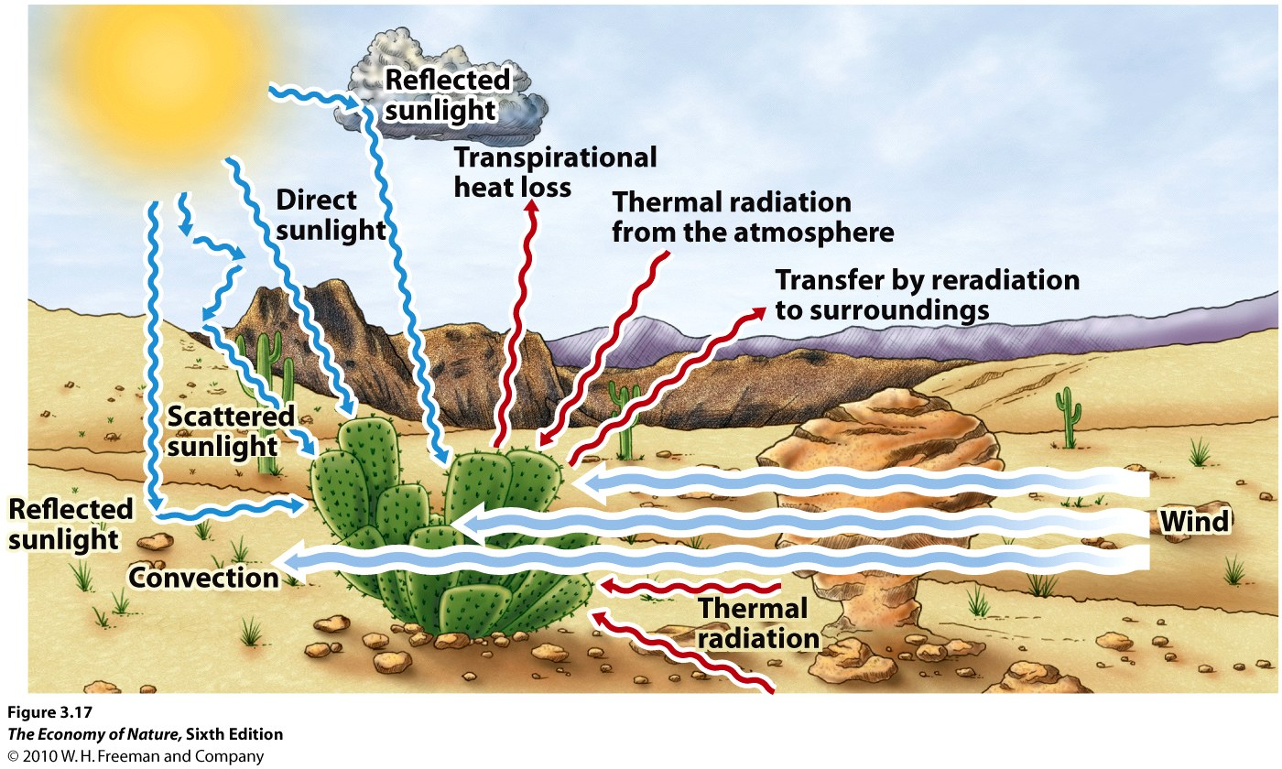
III. Heat Exchange
A. Pathways of Exchange
1. Radiation - emission of energy by a warm surface, which may be absorbed by a cooler surface. Sources are the sun, (direct solar) sky (indirect solar), earth (reflected solar and reradiated), other organisms (biogenic, reflected solar, reradiated). Rate of exchange depends on surface area and energy differential.
2. Conduction – transfer of kinetic energy between substances in contact. The denser the substance (more molecules/volume), the more rapid and efficient the energy transfer. Vacuum has no substance, so no energy transfer by conduction (thermos, vacuum windows). Water is denser than air, so transfer from a warm body to cool water is more rapid than to cool air. SA and temperature gradient affect rate, as well.
3. Convection – transfer of heat by moving liquids/gases that disrupt and remove a heated boundary layer, increasing the energy gradient between the environment and the organisms surface. “Wind chill”.
4. Evaporation – a phase change from solid to liquid to gas absorbs latent (“hidden”) energy from outside the system, cooling that system. When a droplet of water evaporates from your arm to the air, they absorb energy (needed to overcome the h-bond force linking them as a liquid) from your arm, cooling your arm.

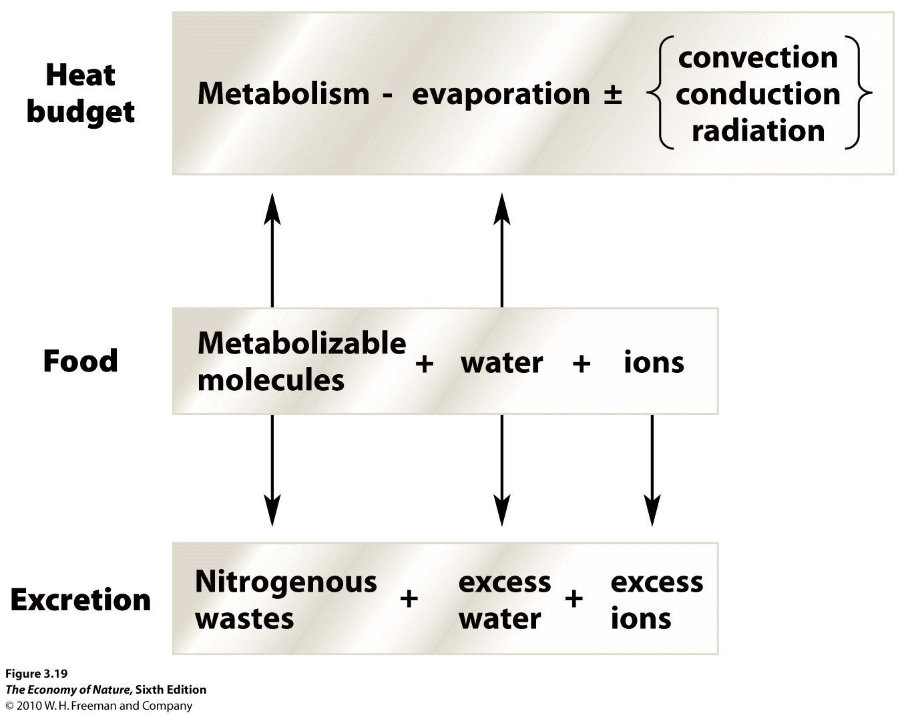
B. Effects on Organisms
1. Organismal Heat Budget
- Represents gains and losses of heat due to factors above AND heat production by metabolism.
- Because heat budget is affected by evaporation and food metabolism, the heat budget is connected to water, food, and salt budgets.
In Cold: Energy loss by radiation, conduction, convection are high. Metabolic demand for food increases. “Comfort foods” – especially those with high energy content (fats) and liquid (soups, stew).
In Heat: water loss by evap is high, heat load is high. Want to keep metabolic production of heat down (siesta), eat less, drink more, and replace salts lost by evap/urination.
2. Effects of Body Size
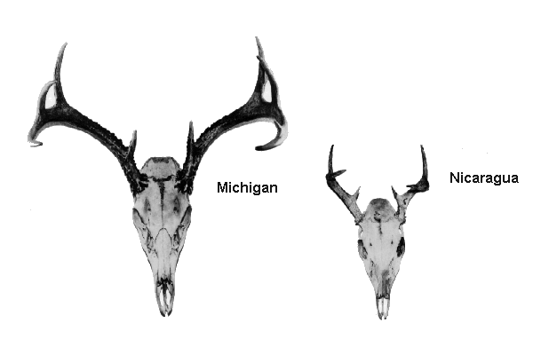
- Energy exchange occurs across the body surface, but metabolic heat is generated by the volume of the tissue in the body. As organisms get larger, the SA/V ratio decreases. So, internal heat generation and storage increase (good in cold environments), but heat dissipation declines (bad in hot environments). Bergman’s Rule: Body size in a taxon increases towards the poles.
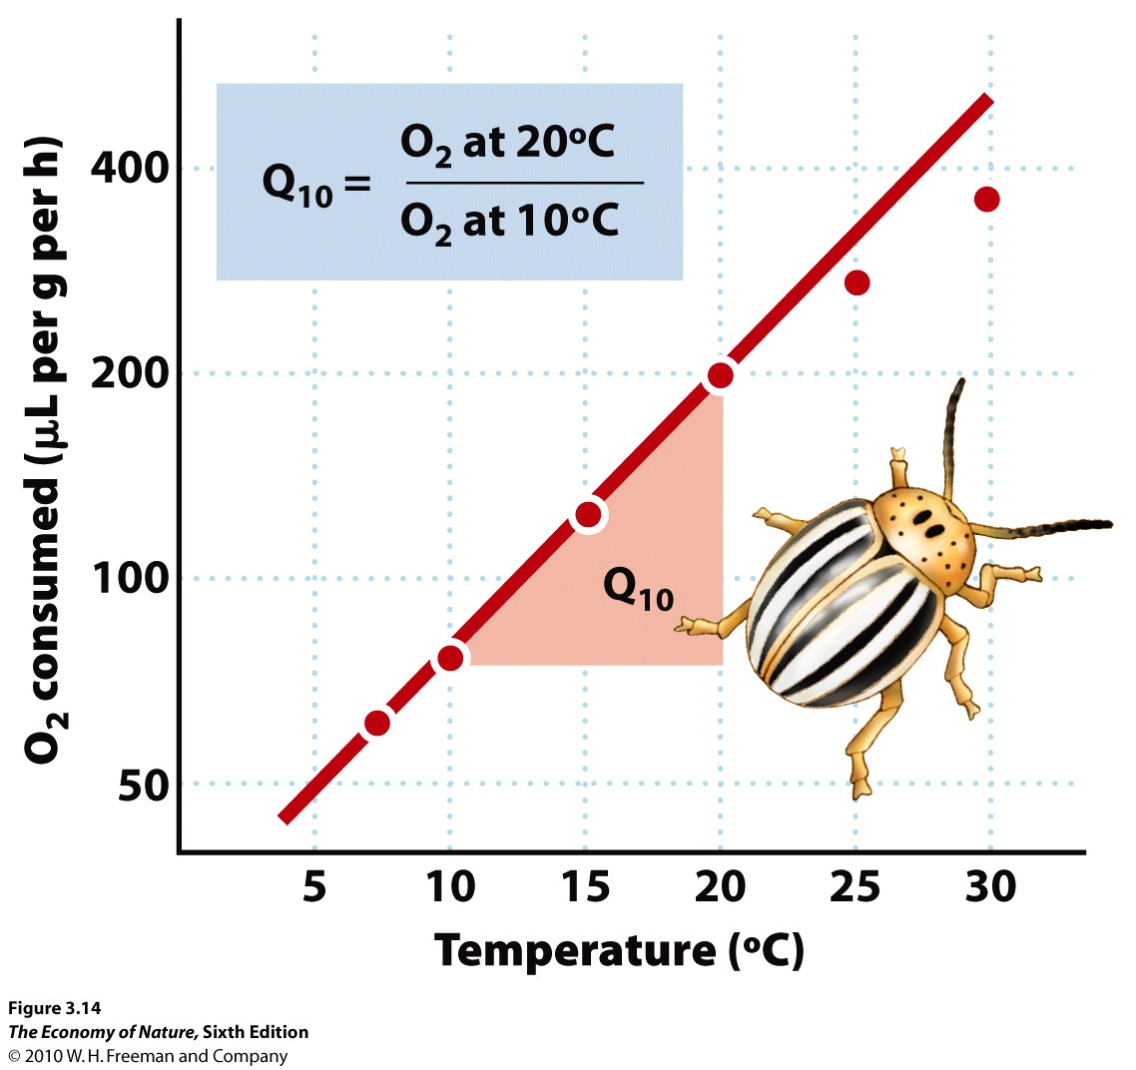
3. Effects of Temperature
- increasing temperature increases metabolic rate, increase growth rate, shorten generation time, increase reproductive rate; increase biological activity (uptake, decomposition) and biological productivity. Increase process rate 2x-4x for every 10ºC temp change. So warmer body temp is usually better
- Constant body temperature (HOMEOTHERMY) is good, too, as it allows for enzymatic adaptation (selection over generations) and acclimation (adjustment of a single organism to the environment) to maximize efficiency at that temperature.
- A constant high body temp is usually adaptive… Large or well-insulated animals can generate enough heat internally to keep body temperatures high and constant = endothermic homeotherms.
- Small organisms (insects) or those that are poorly insulated (lizards) maintain high body temperatures behaviorally by moving to warm or cool areas to keep body temps stable = ectothermic homeotherms.
- Many organisms (plants, amphibians) cannot or do not regulate their temperature and are the temp of the environment = poikilotherms.

C. Adaptations
- Concept of “flux” is a unifying idea here. The rate of exchange of E or matter is dependent on: SA/V ratio, the concentration gradient, and the characteristics of the surface
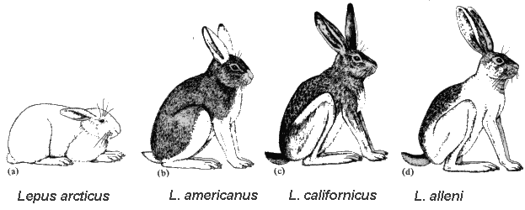
1. Structural
a. Size and SA/V Ratio
- Increase SA/V ratio to dissipate excess heat; danger is losing too much water.
- Decrease SA/V ratio to retain water, and retain metabolic heat.
- Bergman’s Rule: within a taxon, size increases with increasing latitude.
b. Hairs, Spines, Feathers
- these create a boundary layer that insulates against heat/water loss
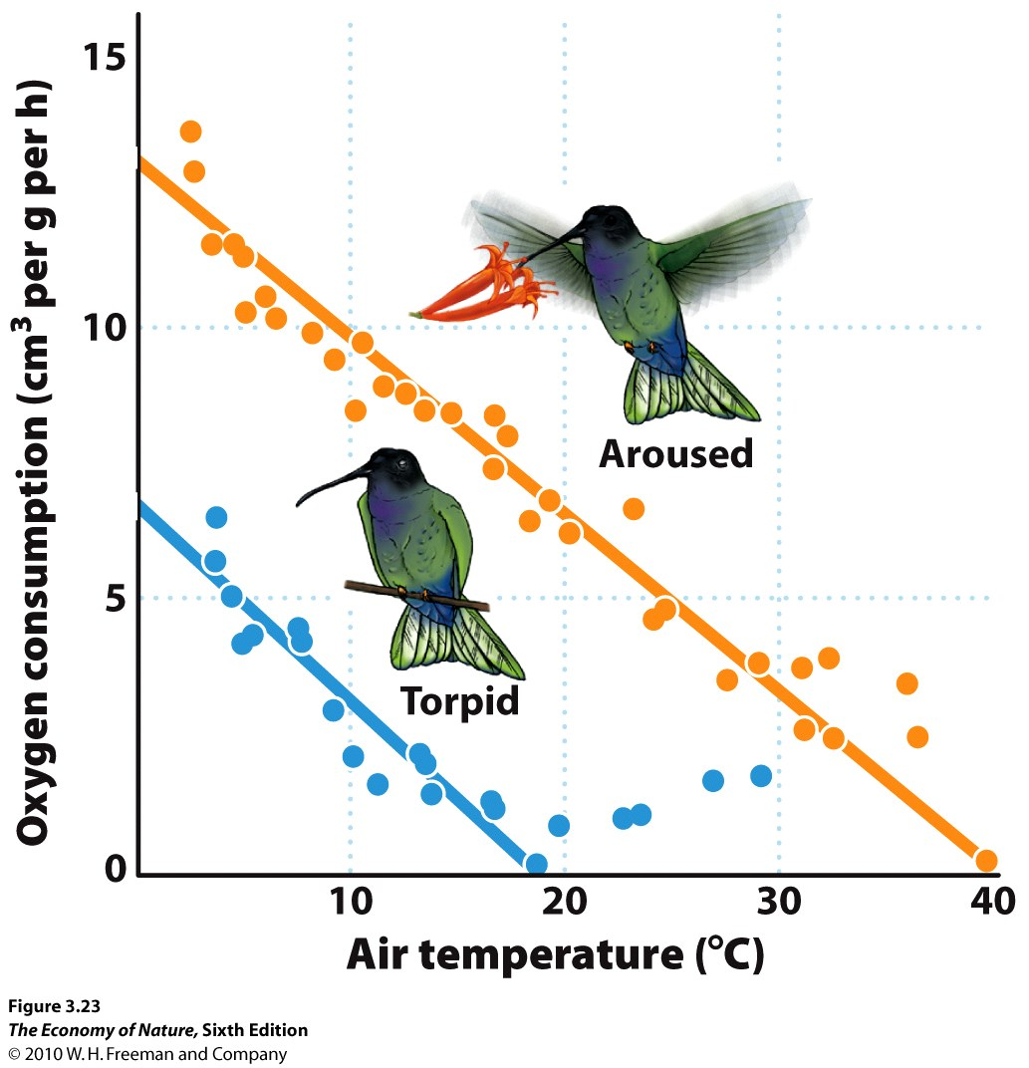
2. Physiological
- Change blood flow to dissipate or conserve heat loss.
- Maintain solute (glycerol and glycoprotein) concentrations in blood to reduce freezing point of cellular water.
- Reduce body temp/activity when food is unavailable: torpor, hibernation, aestivation
- counter-current heat exchange
3. Behavioral
- Bask or move to shade to regulate temperature
- Migrate

STUDY QUESTIONS
1) List the four mechanisms of heat exchange.
2) Why do you lose more heat to water than air of the same temp?
3) What affect does body size and the SA/V ratio have on heat production and the rate of heat loss?
4) Why are high, constant body temperatures usually adaptive?
5) Distinguish between endothermy, poikilothermy, homeothermy, and ectothermy.
6) Describe Bergmann’s and Allen’s rules, and relate them to an animals heat budget.
7) Describe two effects that hairs/spines have on an organisms heat budget, using two different mechanisms of exchange.
8) Salt water freezes at ~-2ºC. Marine vertebrates have less salty tissues and so (based on salt concentrations, alone), should freeze at higher temps (like, -1ºC). Why don’t they?
9) Explain how a counter-current exchange system in a duck’s foot conserves heat energy and minimizes heat loss to cold water.
10) An organism is confronted by many environmental variables simultaneously. Adaptations are rarely perfect solutions; rather, they are efficient compromises that weigh the relative importance of particular stresses. Consider the contradictory pressures on a plant of maximizing irradiation for photosynthesis, while maximizing water retention (and minimizing water lost by evaporation as leaf temperature increases). Considering this trade-off, explain why plants in rainforests and grasslands have different sized leaves.
11) How does the spectrum of available light energy change with water depth, and how have rooted algae responded?
12) Make a diagram of the ligh dependent reaction of photosynthesis. Why is water needed? Why os oxygen produced? What are the two useful products, and what are they used for in the light Independent reaction?
13) Diagram the light independent reaction of C3 plants.
14) What is photorespiration and why does it occur? Why is it “bad”?
15) How does C4 photosynthesis work, and under what conditions is it adaptive? When is it NOT adaptive?
16)How does CAM photosynthesis work, what plants do this, and why is it adaptive?

