Adaptation and Evolution (continued…)

III. Life History Evolution
A. Trade-Offs
1. Components of Fitness: fitness = number of reproducing offspring
- probability of survival
- number of offspring
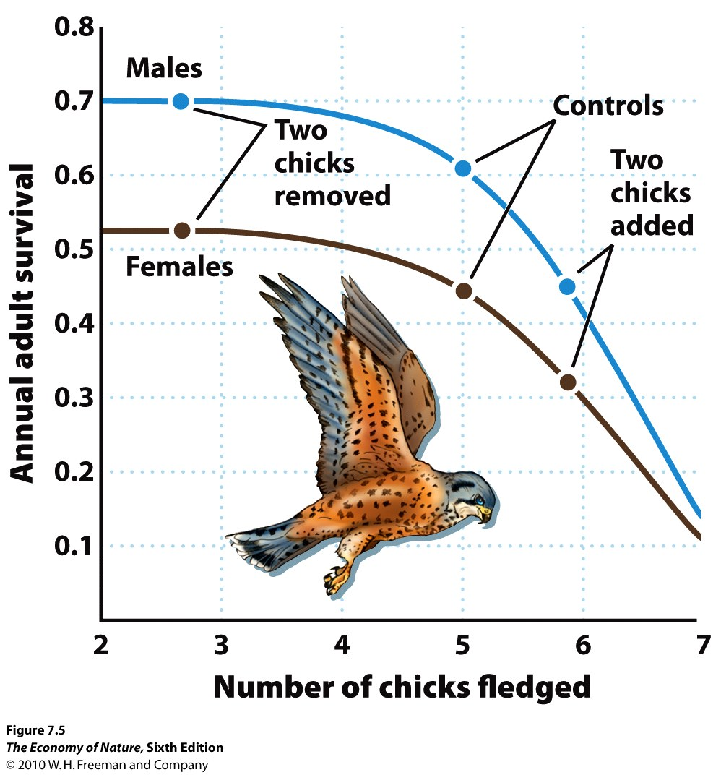
- probability of offspring survival
2. Relationships with a Finite Energy Budget
- All organisms have a finite amount of energy to spend on basal metabolism, growth, and reproduction (specific tissues, mate acquisition, parental care).
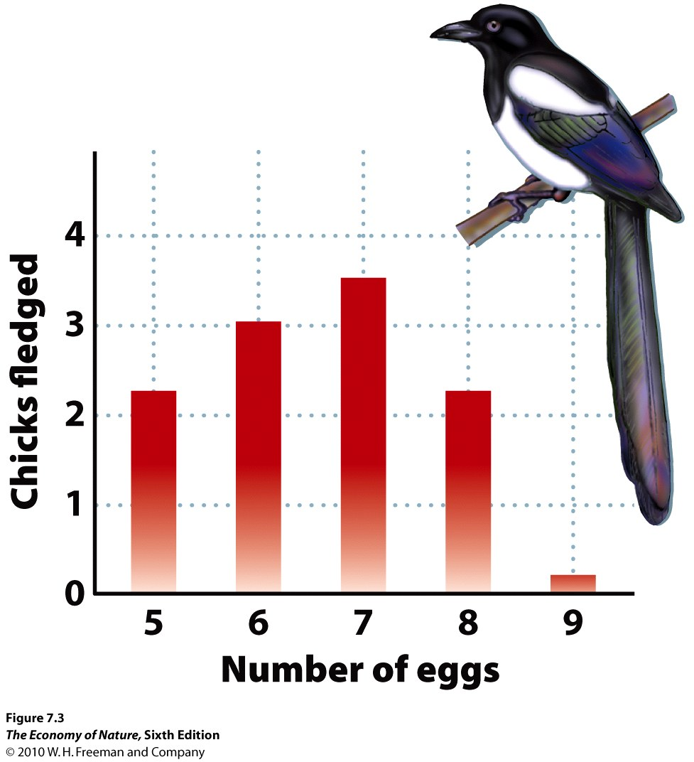
- Investing in one component means decreasing allocations to another.
3. Trade-offs between Survival and reproduction
- Investing in Metabolism (homeothermy?) and growth increase survival (and lifespan).
- Investing in reproduction decreases size and survival.
- Investing in reproduction decreases energy stores and increases mortality
4. Trade-offs between #offspring and offspring survival
- if probability of survival is low, need to maximize number
B. Timing
1. Age of first reproduction
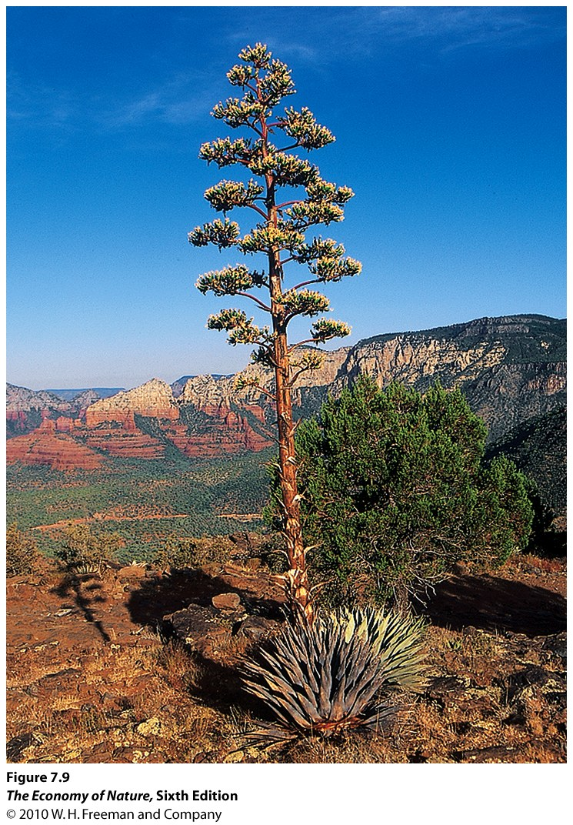
- Big selective advantage to reproducing early if all else is equal
- If you delay reproduction (to invest in growth), may payoff if you can reproduce MORE later
2. Parity: How Often
- Semelparous: reproduce once, then typically die. Adaptive if cost of reproduction are very high, or if breeding is rare and synchronous... Not the same as “annual” as annuals can breed several times in their year of life.
- Iteroparous (“iterative”) – more than one reproductive bout.
3. Senescence
- Why age?
- Accumulation of mutations
- Cost of DNA repair late in life vs. expending that energy in reproduction earlier in life.
- Why do humans have a long post-reproductive period? The selective value of grandmothers.

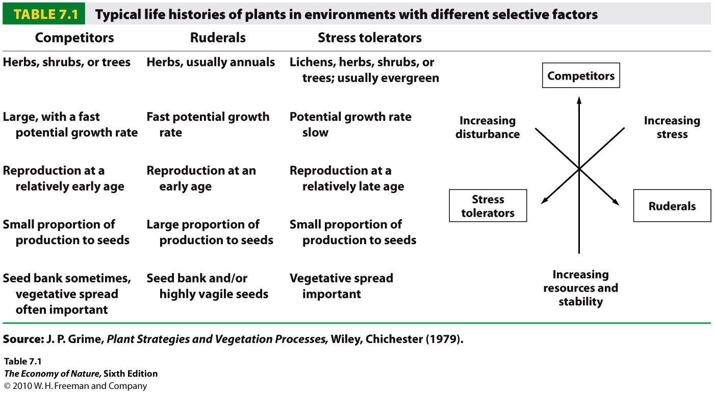
C. Life History Strategies
- these relationships between survivorship, fecundity, and fecundity schedules crate suits of traits that are often seen together as a “life history strategy”
- Ruderals (r-strategists): exploit open, disturbed habitats with lots of available resources and little competition. They exploit a “get in, get out” strategy of investing in early reproduction, typically of lots of small, vagile seeds. Investment on reproduction early results in a short life-span; often an annual life cycle.
- Competitors (K strategists): exploit closed, stable habitats where competition is often intense. Acquisition of resources is critical, selecting for growth and survival early, with some delay in reproduction. Can produce lots of little seeds or a few large ones.
- Tolerators: Exploit very stressful environments where energy acquisition limits both growth and reproduction. Usually grow slow, reproduce very late and a little.

D. Effects of Humans

- climate change: many animal and plant populations are reproducing earlier under warming conditions. Most birds in North America are breeding days earlier, and amphibians in Britain are breeding weeks earlier than 20 years ago.
- humans act as predators and change the adaptive life history characteristics of prey species. Over the last 60 years, smaller atlantic cod survive, and there is selection for earlier maturation and breeding.

STUDY QUESTIONS:
1) How does a limited energy budget impose constraints on the components of fitness?
2) What two trade-offs occur as a consequence? Provide an example for each.
3) How can these allocation patterns change under different environments? Provide an example.
4) Why is the first age of reproduction so important? If an organism delays reproduction, how can it “catch up” in tems of fitness against others that have reproduced earlier?
5) When might semelparity be adaptive? (Three reasons).
6) Provide a hypothesis why humans have a long post-reproductive senescent period.
7) Contrast ruderal, competitor, and tolerator life histories.
8) How have humans changed natural environments and selected for changes in life-history characteristics of species?

