Landscape Ecology
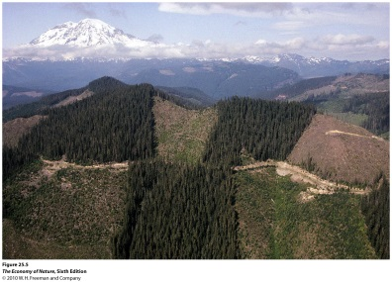
I. A Landscape Perspective
A. Integrating Communities and Ecosystems
As we move ‘upward’ from communities and consider diversity at larger spatial scales, we end up include many different habitats arranged together across a landscape. In Landscape ecology, we look at how species, community, and ecosystem level patterns and dynamics are affected by landscape characteristics. In particular we focus on how the types of habitat units, their size, and their spatial arrangement affect species dynamics, community patterns, and ecosystem processes.

B. Landscape Elements
1. Landscape: A landscape is any bounded area. It can be small (1m²) or large… up to a biome. However, for it to be an interesting level of organization to study, it must be heterogeneous
2. Matrix: the matrix is the landscape element with the greatest area, and also the greatest connectivity. It is the primary ‘cover type’ in the landscape; it is the ‘background’ in which patches and corridors exist. In Kansas, the matrix might be grassland, with patches of forest embedded. In a large forested landscape in Maine, the forest is the matrix and open fields are patches embedded in this matrix. So, it is the element with the greatest area and connectivity. It is also the element that exerts the greatest degree of control over landscape dynamics. This control comes, in part, as a consequence of the ‘permeability’ of the matrix. How easily can individuals or energy move through the matrix from one patch to another?
3. Patch: a ‘bounded area’ (that can be defined by coordinates and ‘mapped’) embedded in the matrix. Important characteristics are size, shape, origin (disturbance? Remnant?), number location; functions are habitat type, migratory stepping stones, and source/sink relationships.
4. Corridors: These are narrow ‘patches’ that differ from neighboring patches, matrix, or corridors. Corridors both divide and connect patches. They have width, length, and perhaps volume; and they may contain an internal entity (stream) that adds complexity. They have an origin, and function (habitat, conduit, barrier/filter, source/sink).

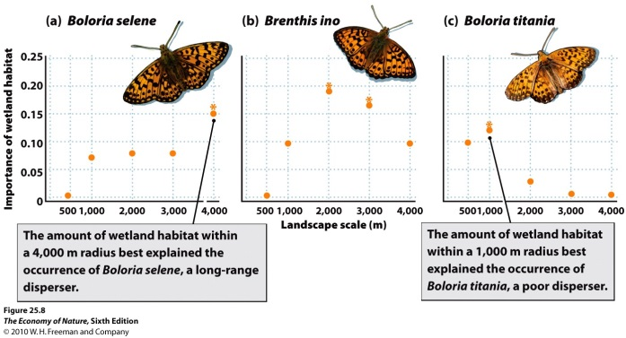
C. Scale
A landscape must be heterogenous to be interesting… in a sense, to examine landscape causality. If elements of the landscape are the independent variables, and you want to know how or if landscape elements influence species, communities, or ecosystems, then you must have variation in the landscape to study – you must have at least two elements (matrix and patch) to the independent variable to compare!
If it is uniform, it is a ‘patch’ and we need to increase the scale to see the heterogeneity implicit in the idea of a landscape. This heterogeneity can be ‘viewer defined’ or ‘user defined’. Typically, scientists are the viewers that define a landscape and identify heterogeneous elements (patches and corridors). However, the heterogeneity of a landscape is also defined by the ‘user’ – the organisms (which may also be humans) moving through that landscape. We might see a field as a homogeneous patch. However, a field mouse might see that field as a complex landscape that is very heterogeneous, with dense patches of crop connect by corridors, bisected by other corridors of game trails that fox use, and so forth. When we look at the field as homogeneous, we are using a ‘coarse grain’ … large ‘pixels’ that don’t reveal the heterogeneity well. The mouse is viewing the patch at a ‘finer grain’… which shows subtleties and complexities and elements we didn’t appreciate with our coarser perspective. It is critical to try and examine the landscape at the appropriate scale, both spatially, compositionally, and temporally.
We can analyze spatial pattern at different scales, and see at which scale we explain the greatest amount of variance in abundance.

II. Insights from Landscape Ecology

A. Patch Size Matters
1. Species-area Effects: As we know, the reduction of patch size, and the fragmentation of large patches into small isolates, causes a decrease in species diversity one ach patch.
2. Loss of Predators and Keystone Effects: As a consequence of energy pyramids, animals at the top of the pyramid, which are already at low density, are more sensitive to size reduction. These are predators. When predators are lost, competition in lower levels increases and diversity is lost.
3. Increase in particular populations and their pathogens: The animals that remain reach higher densities (not necessarily larger populations on the smaller island, but higher density. At higher densities, transmission rates of pathogens increase.

- Lyme Disease: The bacterium is carried by ticks to several mammalian hosts, including deer, white-footed mice, and humans. The infection rate of ticks, and mouse density, are inversely correlated with forest patch size. It is likely that the loss of predators on small patches led to an increase in mouse densities and an increase in the infection rate of ticks.

- West Nile Virus: Some very common birds are hosts of west nile virus, including crows and blue jays. In low diversity communities in fragmented landscapes, the abundance of these hosts is high, increasing transmission rates and infection rates of birds and humans, alike. In more diverse communities, the relative abundance of these hosts is lower, reducing transmission and infection rates in birds and humans. The abundance of hosts is ‘diluted’ in a more diverse community.

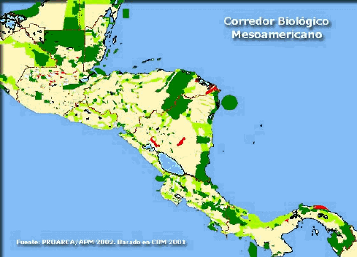
B. Patch Connectedness Matters

When patches are connected by corridors, populations can be ‘rescued’ before or shortly after they go locally extinct, thus maintaining the population in the community and maintaining diversity. Of course, corridors may facilitate the movement of predators and pathogens, too. Patch connectance may simply be a function of matrix permeability, too. There are many local, regional, national, and international attempts to link natural areas via biological corridors, or to reduce the effects of human corridors that are barriers to other organisms. Examples are underpasses in the everglades for puma and other animals, the Mountain Bridge Wilderness area and other state parks along the SC escarpment, the “wild lands” project in U.S, and the Mesoamerican Biological Corridor project.

C. Scale Matters

1. Species responses vary at different scales, so scalar analysis can reveal the scale of importance.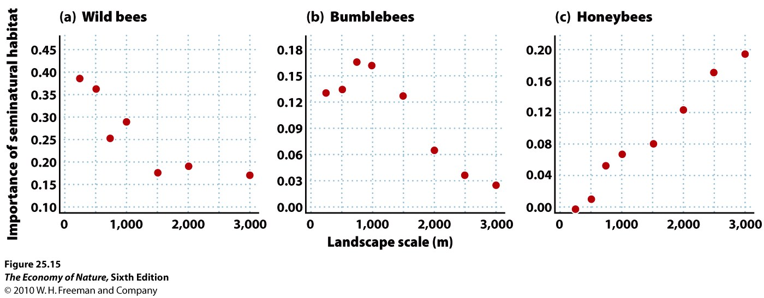

B. Measuring Diversity at a Landscape Scale
α – alpha diversity: this is the diversity within a habitat unit, or the mean diversity among units of the same habitat type.
β-beta diversity: typically, this refers to the ‘diversity’, or difference, among communities using different habitat types. So, consider two habitat types: field and forest. Suppose that 6 species are found in each habitat (α = 6 for forest, α = 6 for field). We can calculate the Beta diversity as:
(S₁ – c) + (S₂ – c), where S₁ = the number of species in the first habitat, S₂ = number of species in the second habitat, and c = the number of species the habitats have in common. In our example, if the field and forest have 2 species in common, then the beta diversity = (6-2) + (6-2) = 8. If there are no species in common, the Beta = 12. So, a larger number suggests greater difference between the species membership in the habitat types. There are slightly more complicated formulae for comparing the relative abundance patterns in two communities called (dis)similarity indices.
γ-gamma diversity: This is the total diversity across the entire landscape, regardless of habitat. So, if the forest and field have no species in common, then gamma diversity = 12. If the forest and field share 2 species, then gamma = 10 (6 in the forest, and four additional NEW species in the field).

Study Questions:
1. List the four elements of landscape analyses.
2. What is meant by a ‘coarse grained’ and ‘fine grained’ approach to a landscape?
3. What is the dilution effect and how can it influence the spread of disease from non-human hosts to humans? Use a real example.
4. Provide an example of a regional, national, or international example of exploiting corridors to maintain diversity.
5. Describe the three types of diversity in a landscape.

