Adaptation and Evolution

I. The Modern Synthetic Theory of Evolution
A. Initial Structure – 1940
1. Definition: Evolution is a change in the genetic structure of a population. This is often (but not always) reflected in the physiology, structure, and behavior of organisms in the population. However, some genetic change is silent, or is expressed only under particular environmental conditions.
2. Sources of Variation:
- mutation: source of new genes
- recombination: crossing over and independent assortment create new combinations of genes in genotypes
3. Agents of Change:
- Natural Selection (Darwin)
- Chance/Genetic Drift (Sewall Wright)
- Migration
- Mutation
- Non-random Mating

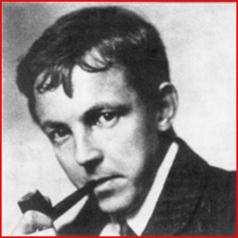
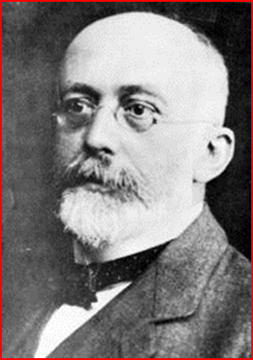
B. Measuring Evolution: Population Genetics
(see computations in ppts)
1. Hardy-Weinberg Equilibrium
- The genetic structure of an infinitely large population (no drift), with no selection, migration, or mutation, will equilibrate after one generation of random mating.
- Real populations that are NOT in HWE must be violating one of these assumptions… in other words, the population must be evolving (not in static equilibrium).
2. Effects of Different Agents:
- MUTATION is important as a source of new genes, but rates of mutation are so low that they have little effect on allele frequencies. P₁ = p₀ +qm where m = mutation rate.
- MIGRATION is important as a source of new genotypes in a population, also, but effects are small unless the ratio of migrants to residents is high. P₁ = (1-m)p_{r} + p_{m}m where m = prop. of migrants.
- NON-RANDOM MATING: Effects can be strong. Positive assortative mating causes a decrease in heterozygosity and an increase in homozygosity at that locus for which the population is assorting. Inbreeding is mating with a relative, and this causes a decrease in het across the whole genome… the increase in homozygosity across the whole genome can reveal rare deleterious recessives that reduce survivorship or reproduction – called inbreeding depression.
- DRIFT: Sampling error; only a random fraction of a population will mate in the next generation. The genetic structure of the population will change, simply because, as the sample of reproductives get smaller, it is more likely to deviate (not exactly represent) the genetic structure of the last generation. Effects correlate with decreasing population size, and can be dramatic in very small populations. Small populations are more different from the original population that large populations, and are more different from other small populations than replicate large populations would be.
Founder Effects and Genetic Bottlenecks are examples where population size is small and genetic variation is reduced. Also, inbreeding is increased. Mutation and migration can introduce new variation and balance the loss of variation due to drift.
- SELECTION: Selection is the only mechanism of evolutionary change that produces ADAPTATIONS. It is best defined as ‘Differential reproductive success among genotypes’, not as survival of the fittest, because survival is really only important as a precondition for reproduction. It is differential reproductive success that causes a change in the frequency of traits in a population over time (evolution). Reproductive success (“fitness”) is a function of :
- probability of surviving to reproductive age
- number of offspring produced
- probability that offspring survive to reproductive age
With limited energy, an organism can’t maximize all three components of fitness. This results in necessary ‘trade-offs’, such as maximizing the number of offspring by producing many SMALL offspring. Particular, common trade-offs create “life history strategies”.
We will look at selection in more detail because ecologists are particularly interested in how organisms adapt to their environment.

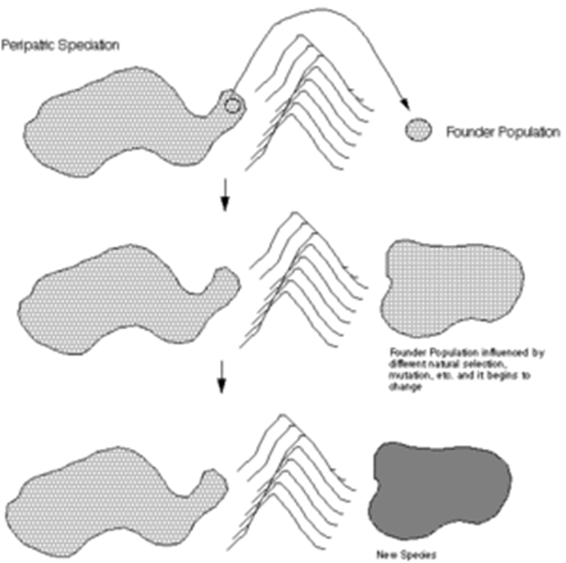
C. Subsequent Modifications
1. The Importance of Peripatric Speciation
- Ernst Mayr suggested that speciation would result from accumulated genetic differences among populations.
- If selection and drift cause the greatest amount of genetic change, then the most change, resulting in the formation of new species, should occur when these processes were occurring together: when small populations “bud-off” an existing species- range and colonize a new habitat. Drift (small pop) and selection (new habitat) should be strong, so response and speciation should be rapid.
2. Punctuated Equilibrium
- Gould and Eldridge suggested that, if Mayr was right, then the geologic record should show a pattern of species stasis, periodically ‘punctuated’ by period of rapid change when small populations were adapting rapidly to new environments. And these intermediates would be unlikely to leave a fossil, so the fossil record should be discontinuous. We shouldn’t expect to see long sequences of transitional fossils, because change will be concentrated in rapid speciation evelnts occur in isolated, small populations unlikely to leave a fossil.
3. Evo-Devo
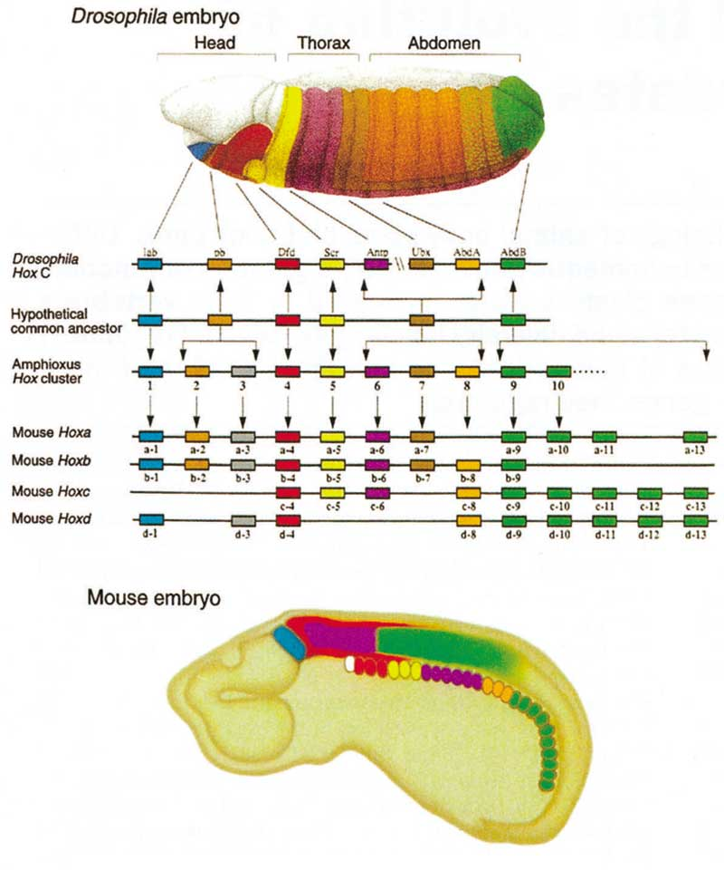
- Dramatic evolutionary change to body plans or morphology are probably due to changes in genetic regulation of development, rather than in the production of new structural genes. The presence of the same homeobox genes in all bilaterally symmetrical species suggest basic developmental pathways are just modified in different ways to produce the body plans of different phyla. So, small changes in regulatory genes that code for transcription factors can have big morphological effects.

STUDY QUESTIONS:
1) Diagram the structure of the Modern Synthetic Theory of Evolution as “sources of variation” and “agents of change”.
2) Consider a population with AA = .4, Aa = .2, and aa = .5. What are the gen frequencies? Is the population in HWE? What could cause the decline in heterozygosity at this locus (3 things).
3) Consider this population:

AA Aa aa
Zygotes 0.4 0.4 0.2
Survival 0.2 0.4 0.8

What will the genetic structure of the population be in the next generation of zygotes?

4) What two effects does drift have on genetic variation among populations of different size?
5) Why are complete sequences of intermediates in the fossil record rare, according to the theory of punctuated equilibrium?
6) How can dramatic morphological change occur with only a small amount of genetic change?
7) Describe and provide an example for directional, stabilizing, and disruptive selection.
8) What is a ‘reaction norm’ and how does it complicate questions of whether a phenotype is adaptive?
9) How can reciprocal transplant experiments resolve the contribution of genetic and environmental effects? How would adaptive response to different environments be expressed in this method?
10) How are genetic variations resolved using a “common garden” experiment?
11) Can the ability to acclimate, itself, be adaptive? What environments should select for this ability? How might this be genetically encoded?

