Climate and Biomes

II. Determinants of Local Climates
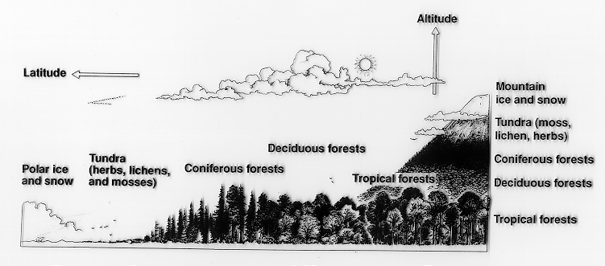
A. Topography
1. Mountains
a. Effect on Temperature
- decrease in temperature with elevation
- 110m in elevation = 1 degree latitude

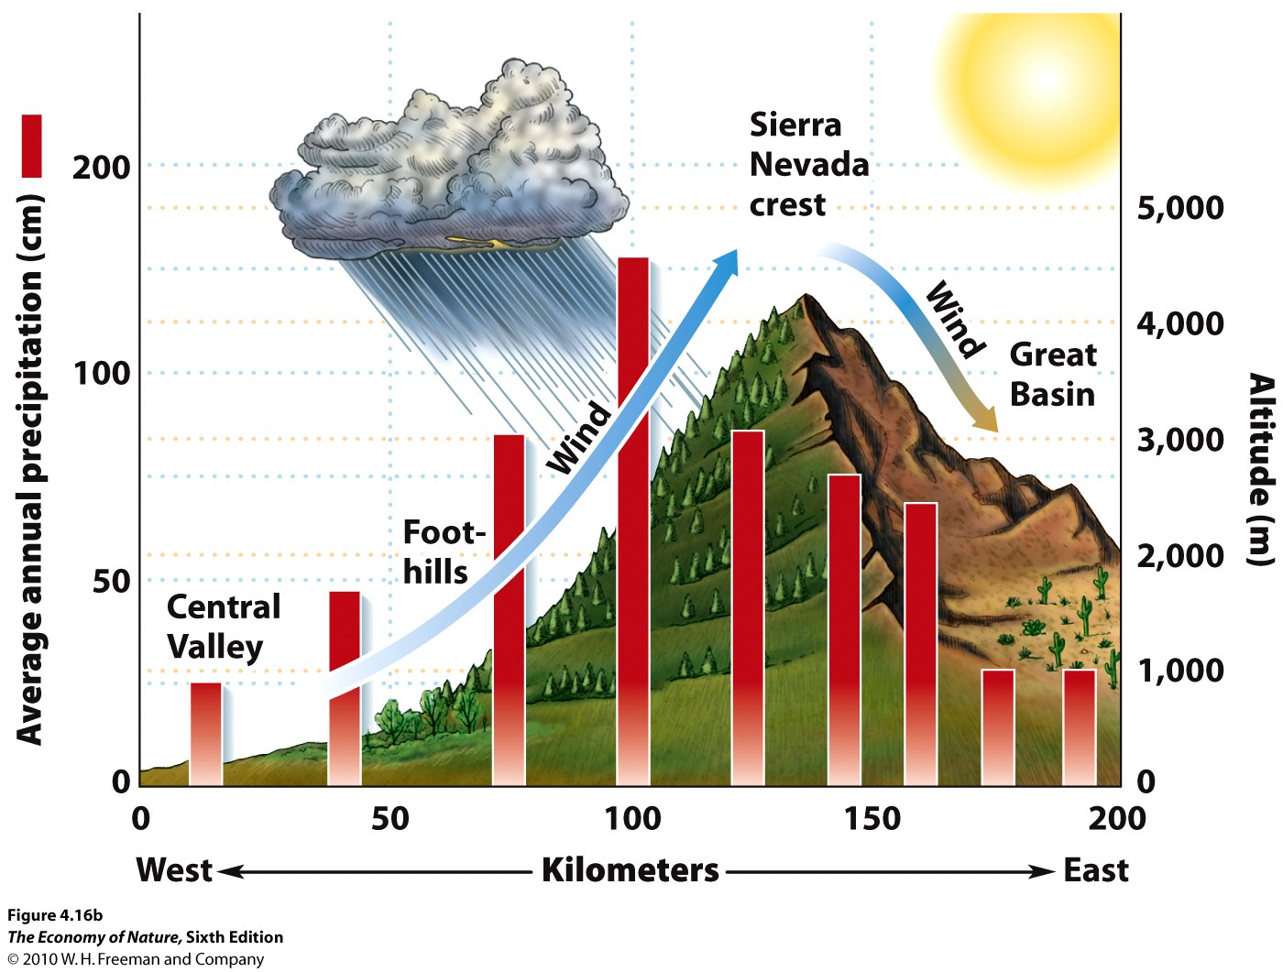
b. Effect on Rainfall
- surface winds hit the windward side of a range
- air mass is deflected to higher altitude; cools adiabatically
- precipitation on windward side
- in leeward “shadow”, cool dry air drops – drier climate
- magnitude of effect correlates with height of range

2. Valleys
- Parabolic warming during day (Death Valley – 134F!)
- cold air trap at night – extreme temperatures (DV, -9F)
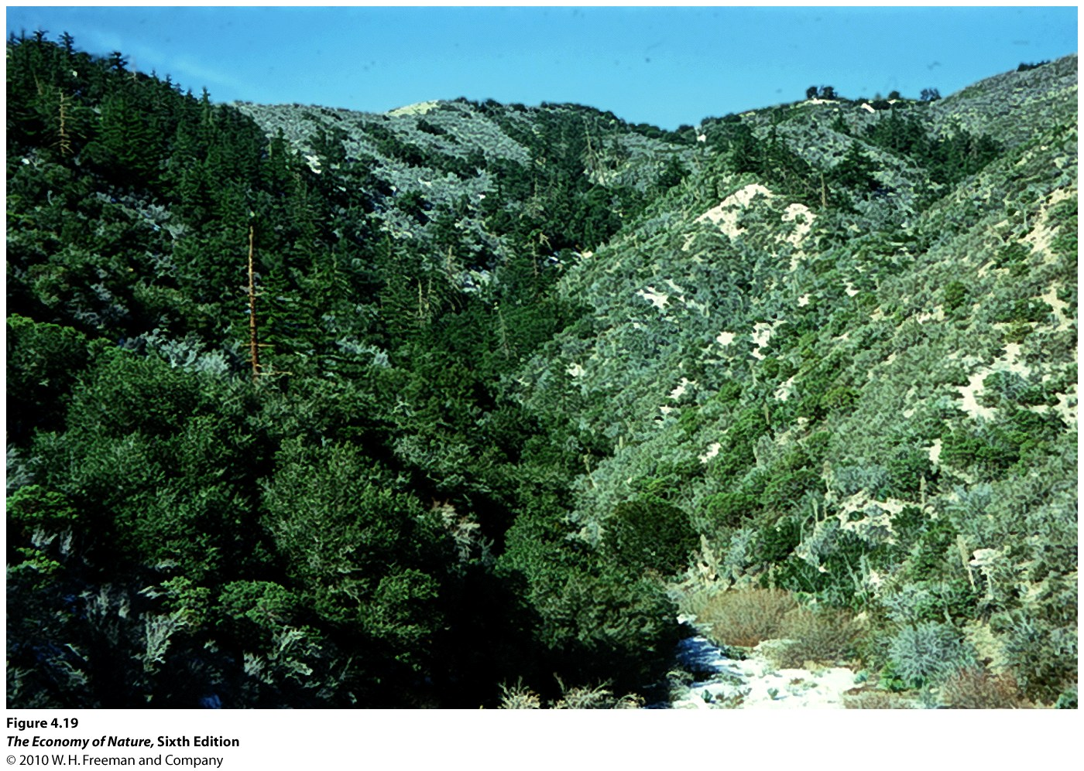
3. Slope Face
- in northern hemisphere, south-facing slopes are warmer and drier
- north facing slopes are cooler and wetter

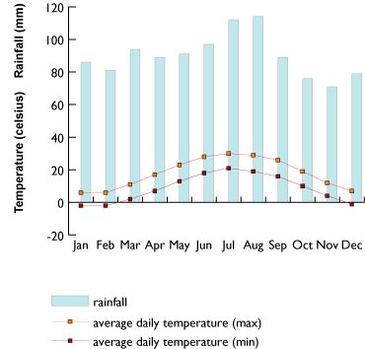
B. Water Bodies
1. Effects on temperature
- act as heat sink in summer, heat source in winter
- buffers temperature variation
- continental vs. maritime climates
2. Effects on moisture
- large water bodies can be a source of moisture
- “lake effect” snow
- dependent on onshore/offshore wind/current patterns

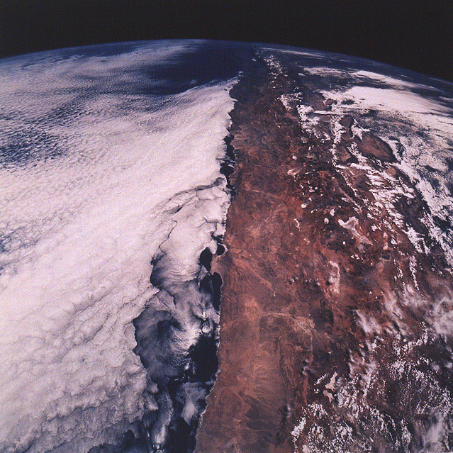
C. Additive Effects
- The Atacama Desert in northern Chile is the driest place on the planet. It is behind a tall mtn range, it is at 30S latitude, and there are offshore currents. No source of moisture, and some weather stations with no recorded rainfall in 100 years.
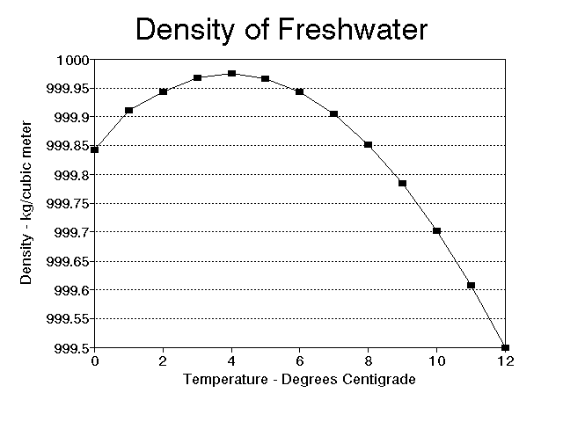
D. Seasonality in Temperate Lakes
1. Water density changes with water temperature
- most dense at 4C
- less dense as it cools to 0C and freezes, so ice floats
- less dense as it warms above 4C – thermocline with warm water on top

2. Seasonal change and turnover
a. Winter:
- ice on top, then water 0-3 degrees, then 4 degrees to bottom.

b. Spring:
- ice melts and surface water warms to 4C – isothermal
- surface winds stimulate mixing – “turnover”; brings nutrients to surface – algal bloom
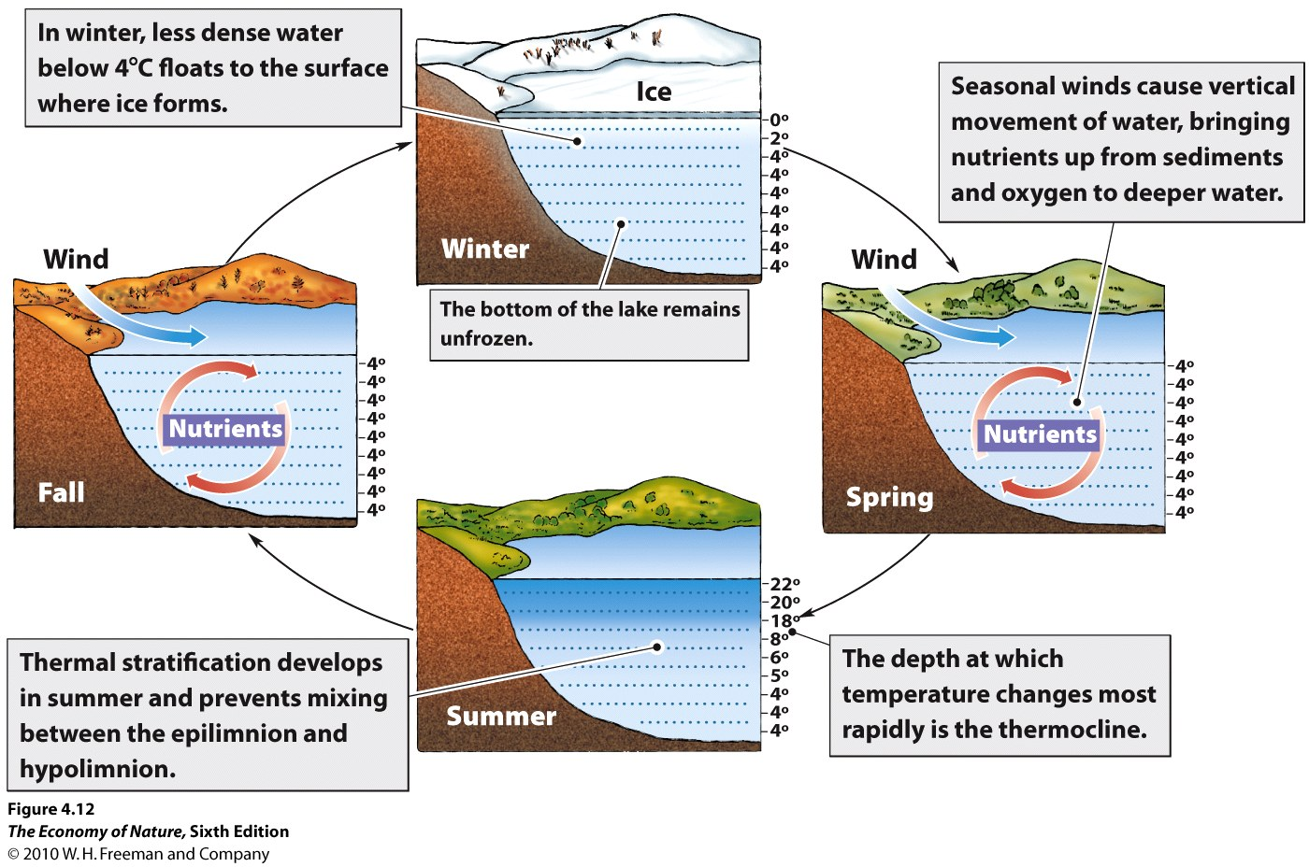
c. Summer:
- surface waters continue to warm, stay on top
- establish a dramatic temperature gradient = thermocline
- thermocline retards mixing of deep and surface water

d. Fall
- surface water cools and drops, warm water rises and gives up heat and drops
- eventually 4C throughout – another turnover.
- further cooling of surface waters keeps cold water at surface until it freezes.

III. Climate and Soil

A. Soil
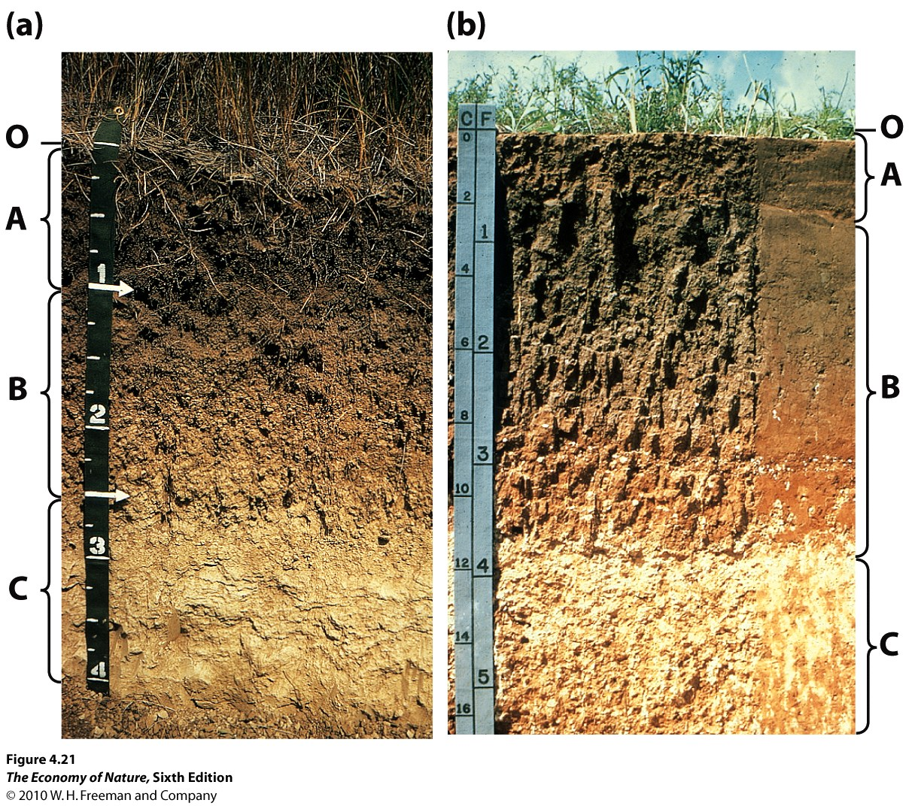
1. Definition
- ‘soil’ is the chemically and biologically altered material that overlies unaltered material (rock, sand)
2. Horizons
- O = “organic” – undecomposed dead organic ‘litter’
- A = decomposed organics (‘humus’) and some inorganic minerals
- E = where minerals ‘leach’ – are dissolved – and so rich in roots (sometimes part of A)
- B = mostly weathered inorganics, with layers of iron/aluminum deposition
- C = more like parent material, with deposition of calcium and magnesium carbonates
- R = parent material (bedrock)
3. Inputs
- weathering of parent rock by water dissolves minerals into the soil
- decomposition by bacteria and fungi add organics
- both these processes increase under warm, wet conditions.

4. Outputs
- leaching of soluble minerals and nutrients is increased under wet conditions; this typically
transports materials down through the soil horizons and ultimately to the water table.
- in very dry conditions, small amount of water can draw salts to the surface by capillary action,
creating salt licks.
- Plants and detritivores take nutrients and water out of soil and transport it to the living biomass in
a system.
Leaching and biouptake are increased by warm, wet conditions.

5. Weathering
- Hydrogen ions displace the Fe, K. Mg, Al from aluminosilicates in granitic rock, freeing these materials for uptake by plants. This is called cation displacement, and it correlates with the fertility of the soil.

STUDY QUESTIONS:

1) Describe a rain shadow effect.

2) How can slopeface affect local climatic conditions?

3) How do continental and maritime climates differ, and why?

4) Why is the Atacama Desert the driest place on the planet? Consider three variables.

5) Why are there two rainy seasons at the equator but one at the tropic of Cancer/Capricorn?

6) Why are there algal blooms in deep temperate lakes in the spring and fall?

7) List the layers in a soil profile and say what each generally contains.

8) Describe the inputs and outputs to a tropical soil with lots of rainfall.

9) Explain how plants mobilize soil nutrients through cation displacement.

