Climate and Biomes
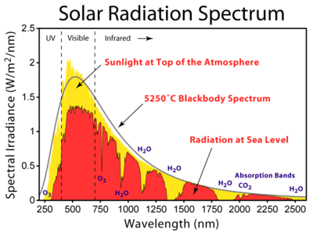
I. Determinants of Global Climate
A. Solar Radiation
1. Solar constant: 2 cal/cm²/min
- 50% is reflected, absorbed, or reradiated by the atmosphere; mostly UV radiation (by ozone), and other wavelengths by water and CO2.
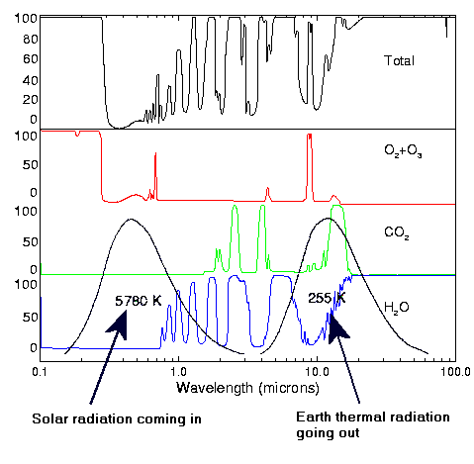
- the radiation that hits the earth and is absorbed is reradiated as infrared radiation.
- most of this is absorbed by water vapor, but there is an important ‘window’ in water vapor’s spectrum.
- part of this window is filled by CO2 absorption.
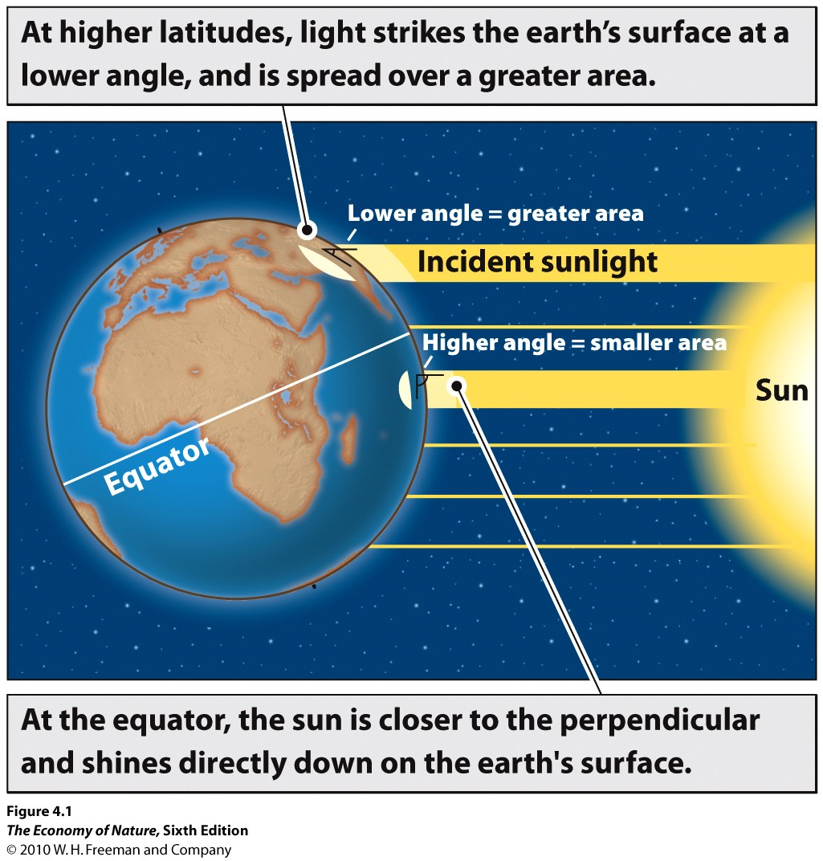
2. Local Radiation Budget – Angle of incidence
- changes with latitude
- changes with season – concept of solar equator
- as angle declines from 90 to 0:
- less energy/unit area
- more absorbed by atmosphere
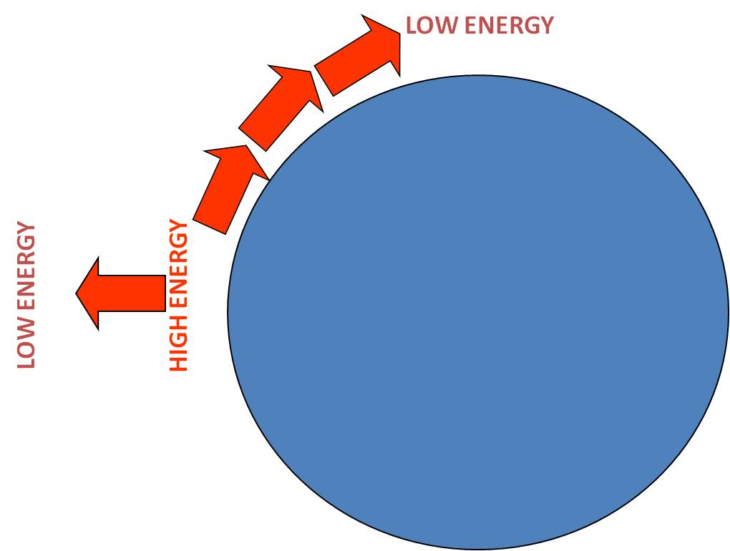
- more reflected off surface

3. Global Consequences
- tropics are warmer than poles
- warmer at sea level than at altitude
- energy is transferred from high to low by mass movement
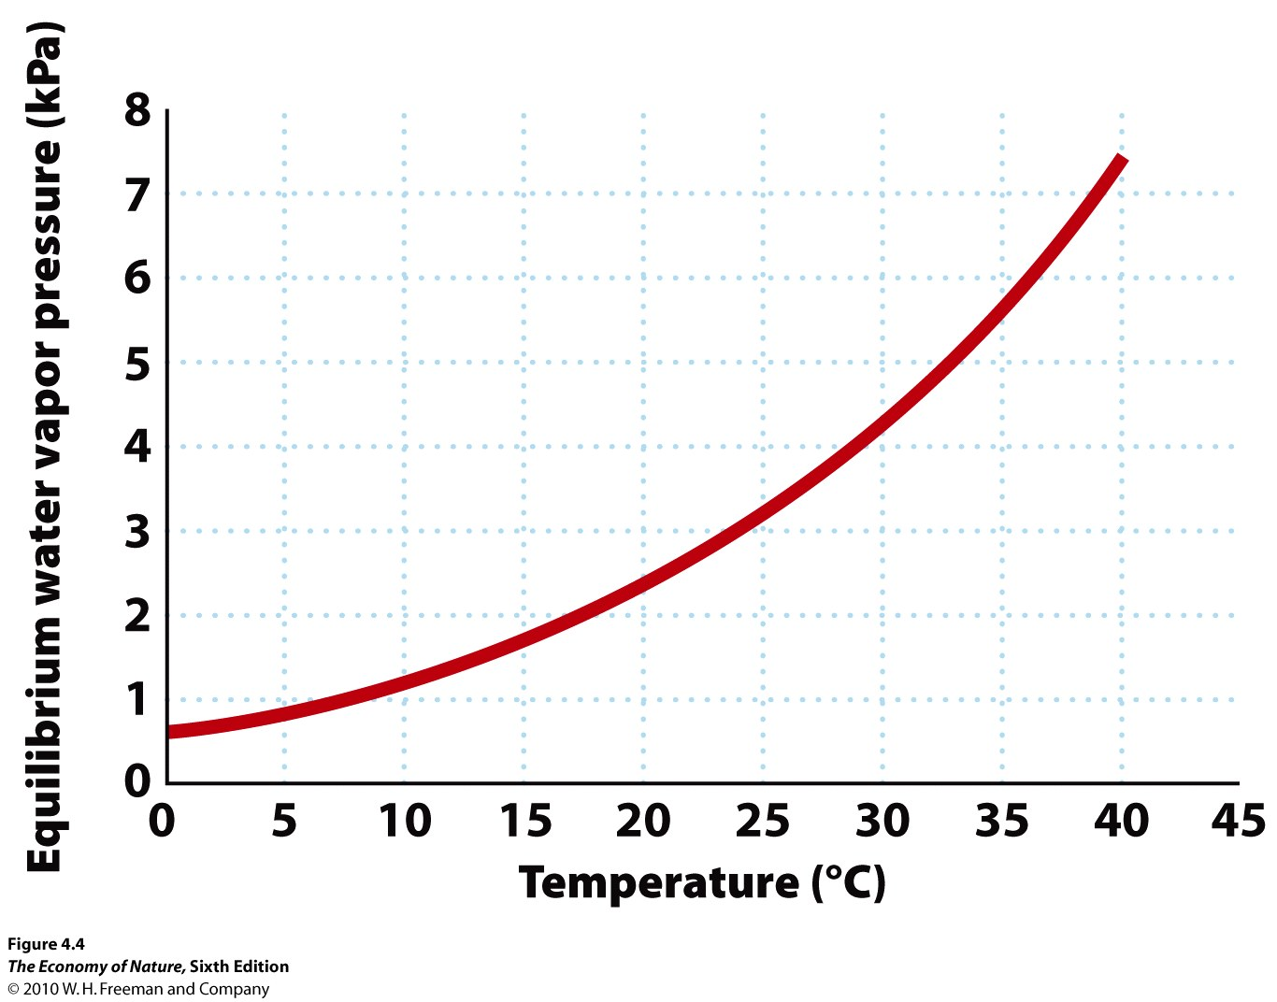
- creates atmospheric and oceanic circulation patterns

B. Effects on Atmospheric Circulation
1. Hadley Cell
- At solar equator, E/area is greatest; surface air warmed by earth
- At high temps, equil vapor pressure is high; water evaporates to air
- Warm, humid air mass rises… less pressure, gas expands and cools
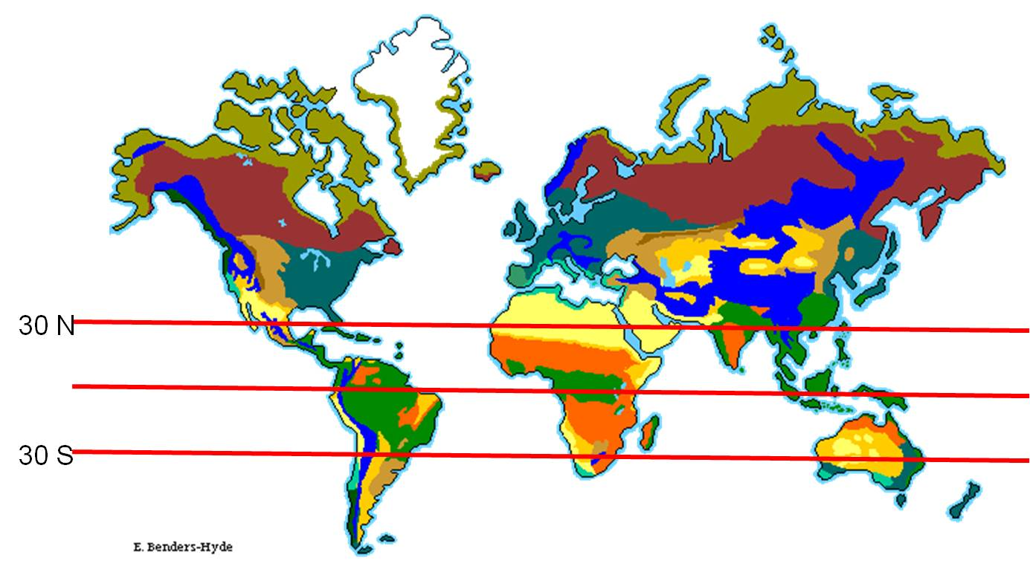
- At cooler temp, vapor pressure lower, vapor condenses …
tropical rain
- This is called adiabatic cooling
- Cold dry air drops towards surface of Earth at about 30 N/S
- as it drops, greater pressure, smaller volume, temp increases
- Vapor pressures rises – the hot dry air sucks water off surface –
deserts
- So, rainforests are equatorial whereas deserts are often near 30 N/S
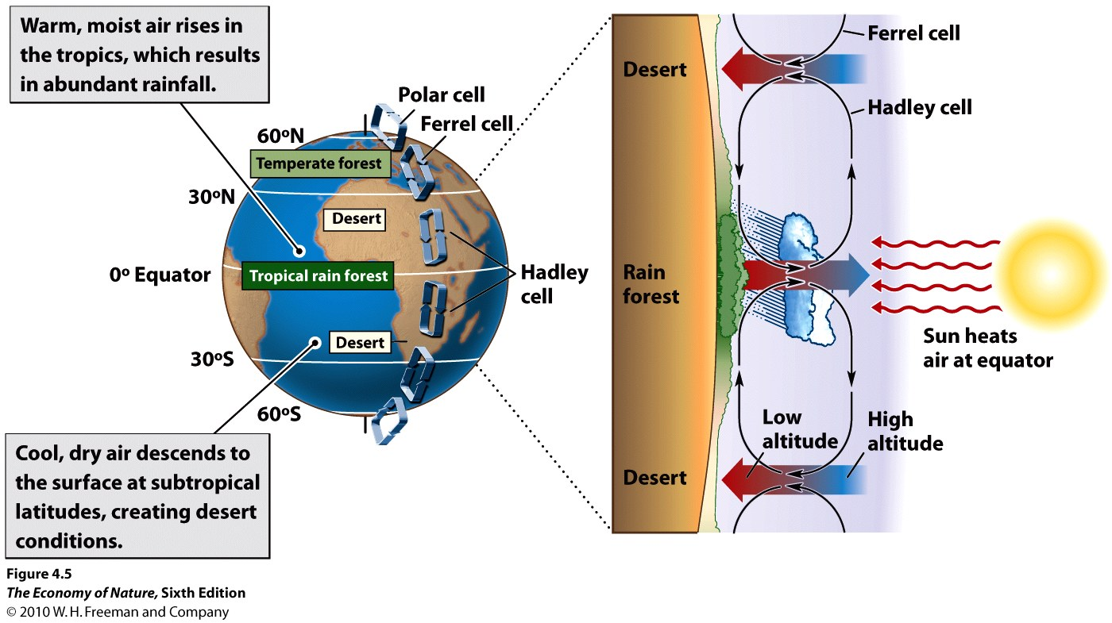
3. Ferrell and Polar Cells
- Air moves off the surface at 60 N/S also, though less
predictably… and drops at poles… forming two other ‘cells’
- Jet streams form where air in neighboring cells converge; at
altitude for Hadley/Ferrell, at surface for Ferrell/Polar
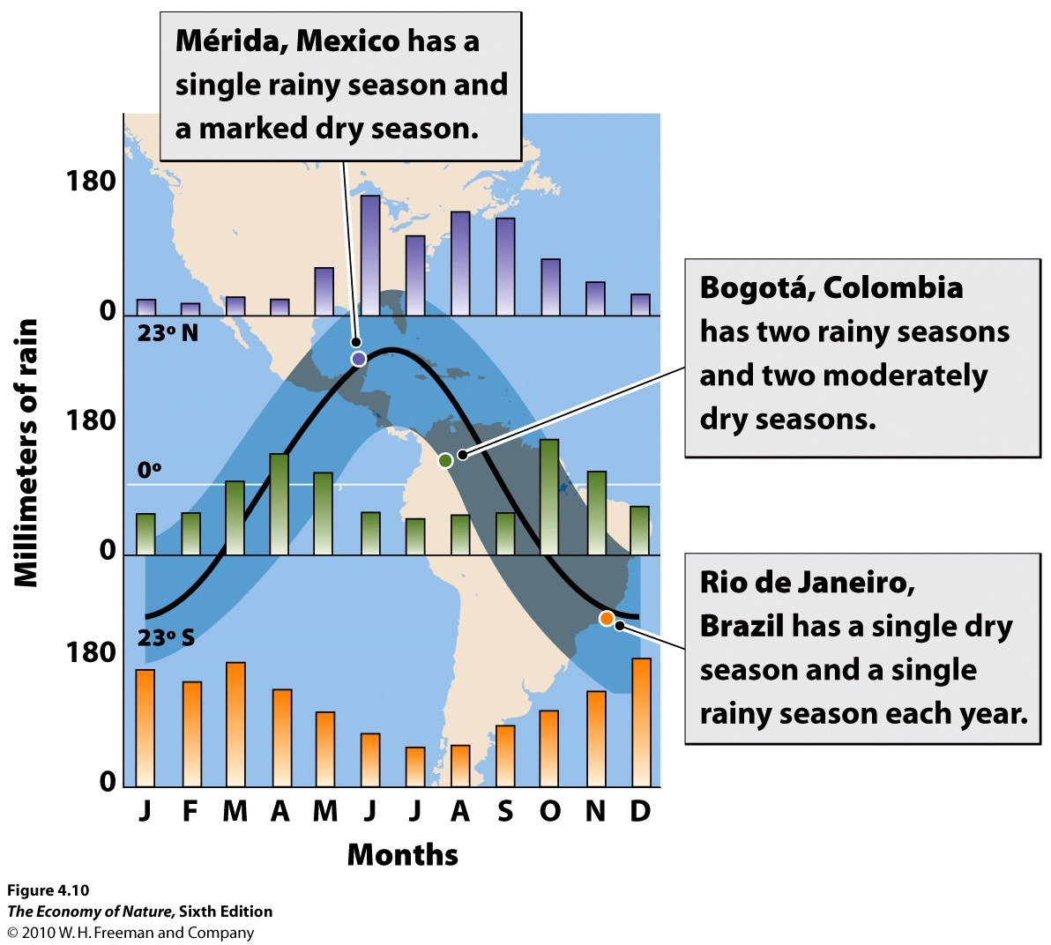
3. Effects on ‘Rainy Seasons’
- The adiabatic rainfall will be most intense where the sun’s rays are most concentrated (at the solar equator).
- The solar equator is at the geographical equator twice a year (at the spring and autumn equinox), but only at a tropical margins once a year (summer solstice in each hemisphere). So, places on the quator should have two rainy seasons a year, while places at higher tropical latitudes will grade into a single rainy season/year.

C. The Coriolis Effect
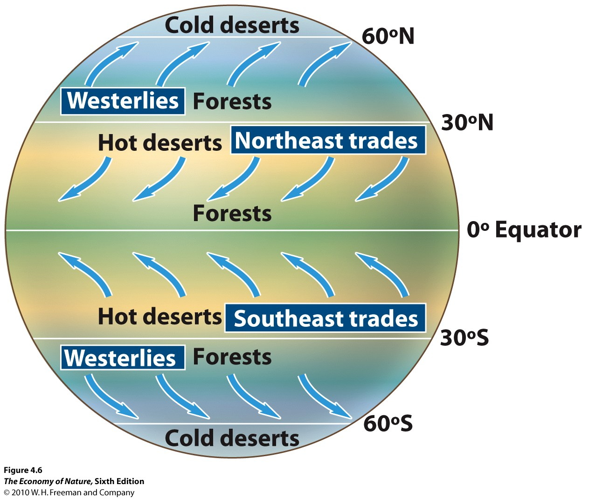
1. The cause
- as a sphere, the distance traveled/day at a given latitude decreases from the equator (where the earth is fat) to the poles (where the earth is skinny). Standing on the north pole, the earth would simply rotate beneath you and you would travel no linear distance in space in one day, and would have a speed of 0 mph. On the equator, you would circumscribe the entire circumference of the earth – roughly 24,000 miles… and thus be travelling through space at 1000 mph.
2. The Effect
- air dropping from altitude at 30 N and S is dragged to the east by the earth – at the speed the earth is moving at that latitude. This air mass is now moving to the east at that given speed. As THAT AIR MASS IS DEFLECTED POLEWARD (as part of the Ferrell Cells), it conserves it easterly momentum. Underneath it, the earth is slowing down. So, relative to the earth, this air mass is moving progressively faster, to the east, than the earth. So, as this air mass moves poleward from 30N and 30S, it “outraces” the earth to the east (eastward deflection).
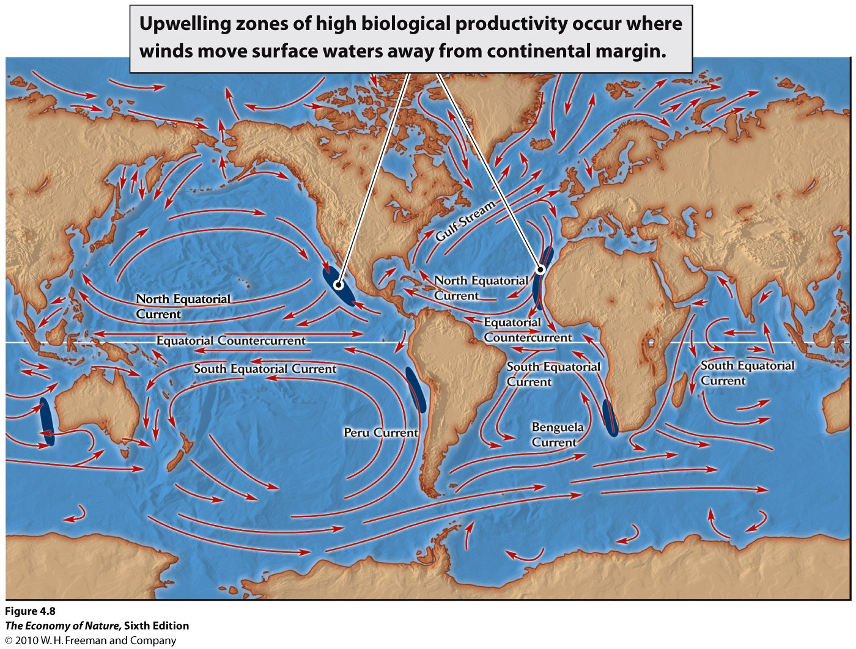
- Likewise, as the air at 30 N/S moves towards the equator (as part of their respective Hadley Cells), it experiences an earth that is moving progressively faster, to the east. So, the air mass “loses ground to the east” relative to the earth.. ie, it is deflected west.

D. Ocean Currents
1. Surface Currents
- affected by wind currents pulling surface water along
- coupled with shape of the basin
- create circular patterns in the basins called “gyres” – circulating clockwise in the N and counterclockwise in the S.
2. Upwellings
- where surface current move off shore, deep water rises to take its place
- this is called an upwelling, and it brings nutrients from depth
- creating areas of high marine productivity – major fisheries.
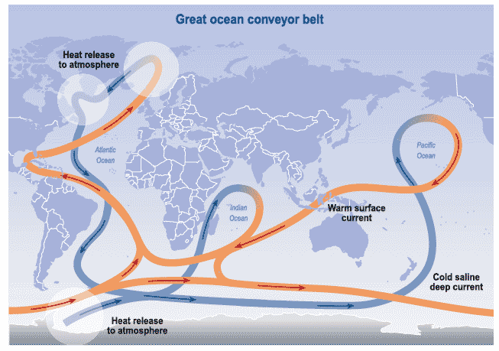
3. Deepwater Currents
- As tropical water cools to 4C, it increases in density. As the water cools to freezing, the water freezes but the liquid water becomes more saline and even more dense… so this water sinks in the north Atlantic and moves south over the abyssal plain to surface elsewhere.

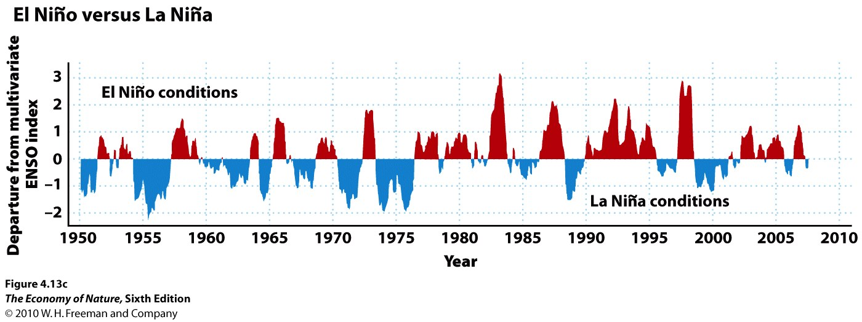
E. Long Term Patterns
1. ENSO (El Nino Southern Oscillation)
- Typically, cold water rising of western South
America moves west across pacific
- During an ENSO event, warm pacific water from the west moves east, shutting off the upwelling and warming the eastern pacific. Fisheries productivity collapses, the eatern tropics are more moist, with stronger Hadley Cells.
- changes global weather patterns.
- Historically, it happened about every 7 years…. Now, far more frequent and maybe even typical.
2. Younger Dryas
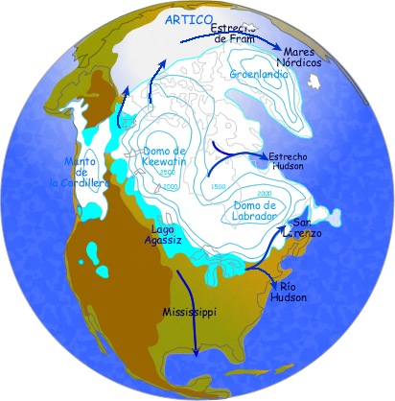
- Dramtic cooling of northern europe 11,000-13,000 years ago, correlating
with the melting of the Laurentian Ice Sheet in North America.
- Fresh water formed a lens on surface; deflecting Gulf Stream to the east at a much lower latitude, starving Europe of the heat transferred by the
Gulf Stream.

F. Difficulties in Modelling Global Climate Change
1. Positive Feedback Loops
a. Water and Ice
- Water absorbs more energy than ice, which reflects more energy. -
- Absorbed energy warms the water, melting more ice, increasing energy absorbed.
- the decrease in ice causes a further warming of polar climates.
- as CO2 increases and the temperature increases, more ice will melt, the ocean will warm, and more ice will
melt.
b. Permafrost
- 14% of the Earths organic carbon is frozen in permafrost – not available for biological decomposition
- if it melts, then bacteria will decompose it and release CO2 and methane.
- which will warm the climate and melt more permafrost
- and this is a non-linear response… no change til temp goes from -1C to +1C… then bang.
2. Negative Feedback Loops
- Increase temperature of water – increase evaporation
- increase evaporation, increase cloud cover
- increase cloud cover, decrease temperature of water.
II. Determinants of Local Climates
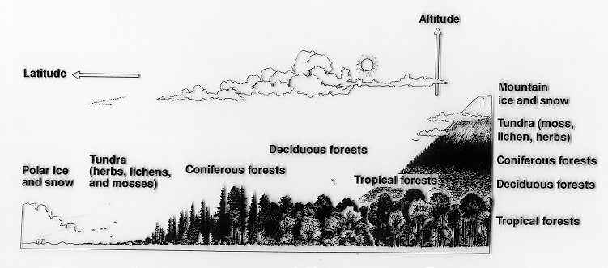
A. Topography
1. Mountains
a. Effect on Temperature
- decrease in temperature with elevation
- 110m in elevation = 1 degree latitude

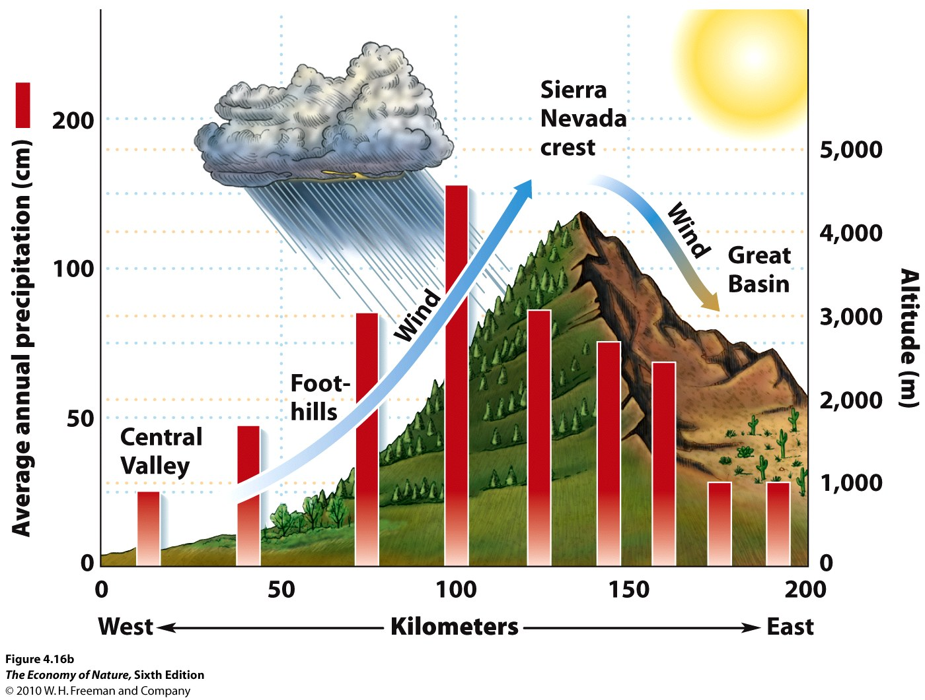
b. Effect on Rainfall
- surface winds hit the windward side of a range
- air mass is deflected to higher altitude; cools adiabatically
- precipitation on windward side
- in leeward “shadow”, cool dry air drops – drier climate
- magnitude of effect correlates with height of range

2. Valleys
- Parabolic warming during day (Death Valley – 134F!)
- cold air trap at night – extreme temperatures (DV, -9F)
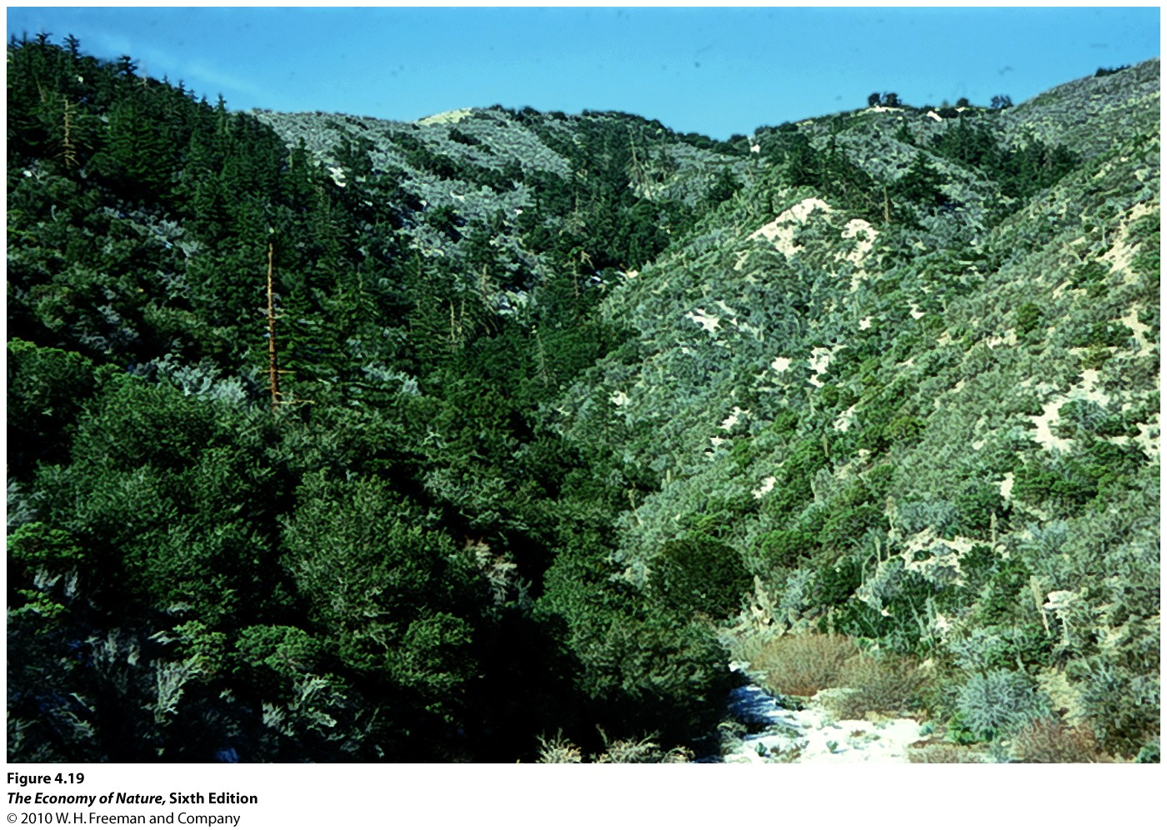
3. Slope Face
- in northern hemisphere, south-facing slopes are warmer and drier
- north facing slopes are cooler and wetter

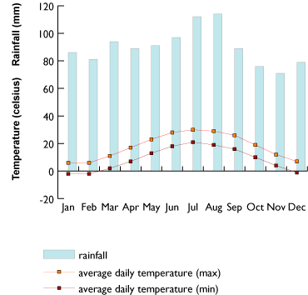
B. Water Bodies
1. Effects on temperature
- act as heat sink in summer, heat source in winter
- buffers temperature variation
- continental vs. maritime climates
2. Effects on moisture
- large water bodies can be a source of moisture
- “lake effect” snow
- dependent on onshore/offshore wind/current patterns

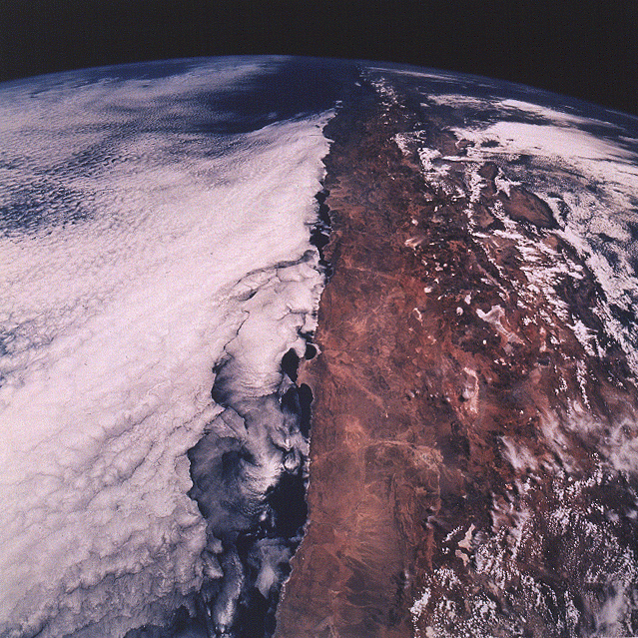
C. Additive Effects
- The Atacama Desert in northern Chile is the driest place on the planet. It is behind a tall mtn range, it is at 30S latitude, and there are offshore currents. No source of moisture, and some weather stations with no recorded rainfall in 100 years.
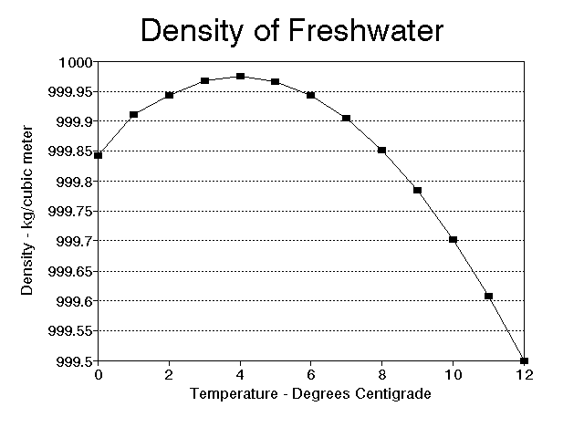
D. Seasonality in Temperate Lakes
1. Water density changes with water temperature
- most dense at 4C
- less dense as it cools to 0C and freezes, so ice floats
- less dense as it warms above 4C – thermocline with warm water on top

2. Seasonal change and turnover
a. Winter:
- ice on top, then water 0-3 degrees, then 4 degrees to bottom.

b. Spring:
- ice melts and surface water warms to 4C – isothermal
- surface winds stimulate mixing – “turnover”; brings nutrients to surface – algal bloom
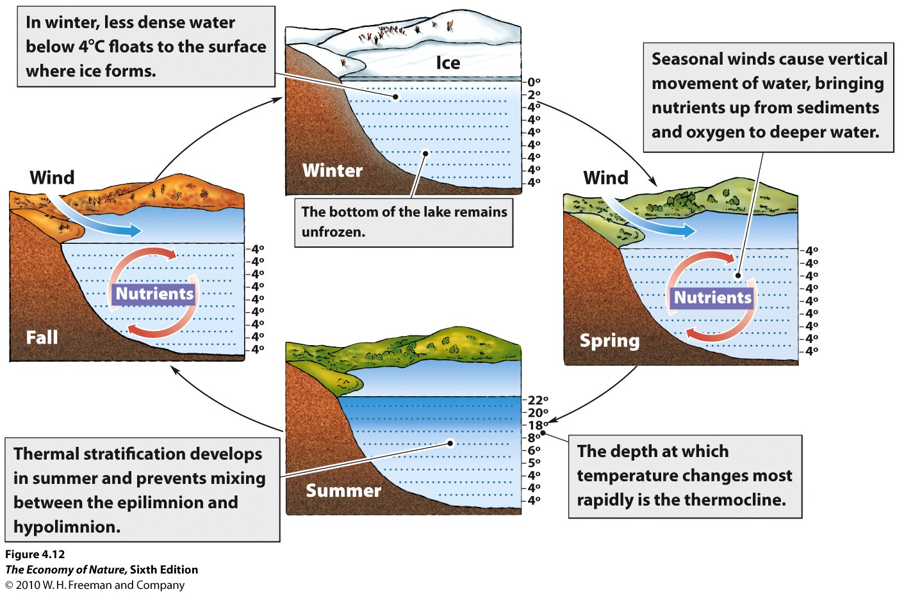
c. Summer:
- surface waters continue to warm, stay on top
- establish a dramatic temperature gradient = thermocline
- thermocline retards mixing of deep and surface water

d. Fall
- surface water cools and drops, warm water rises and gives up heat and drops
- eventually 4C throughout – another turnover.
- further cooling of surface waters keeps cold water at surface until it freezes.

III. Climate and Soil

A. Soil
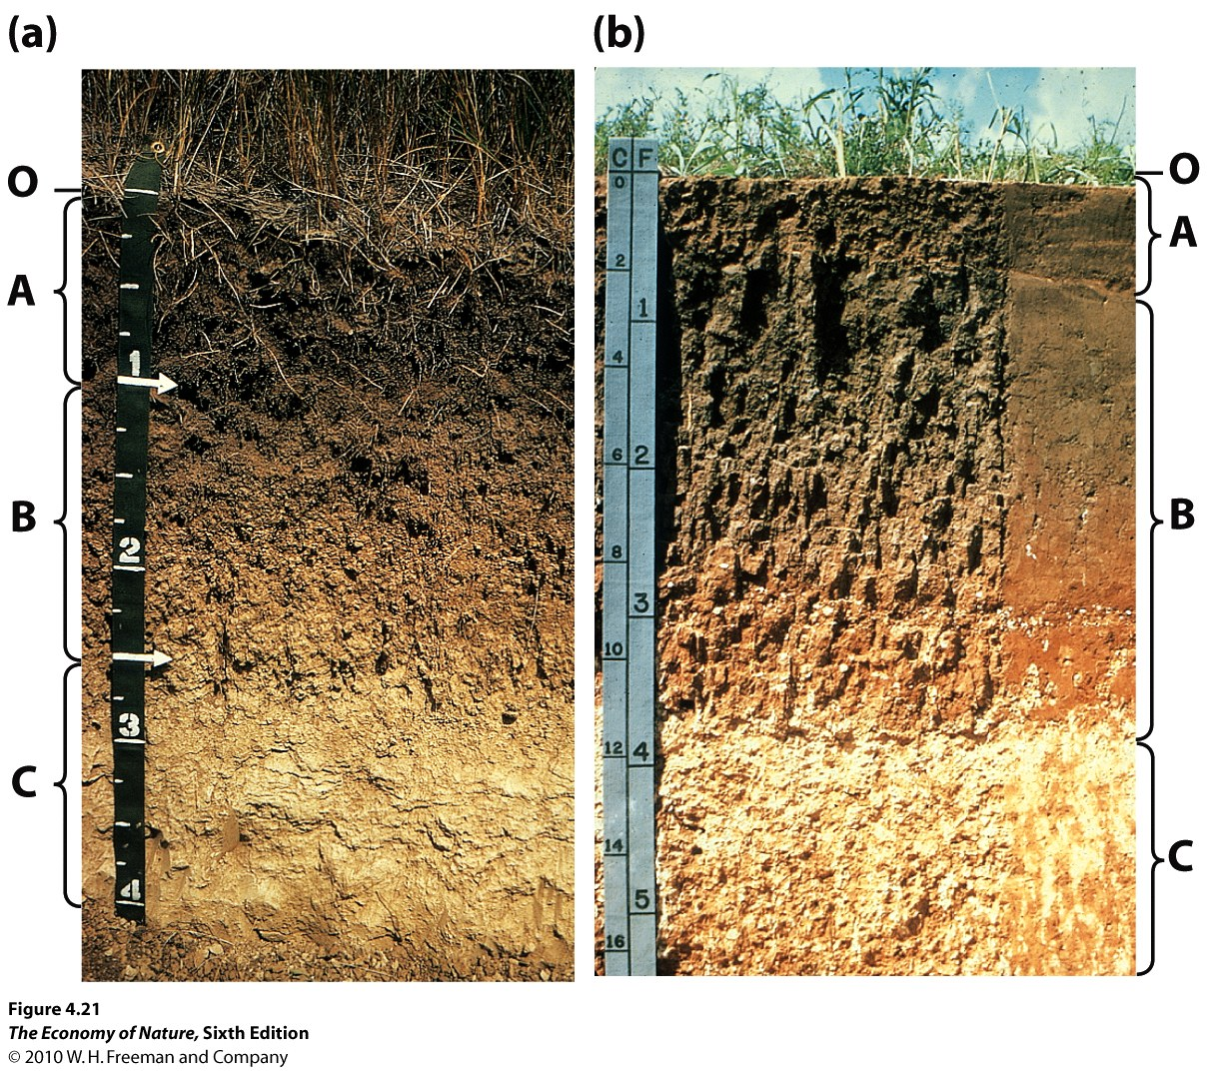
1. Definition
- ‘soil’ is the chemically and biologically altered material that overlies unaltered material (rock, sand)
2. Horizons
- O = “organic” – undecomposed dead organic ‘litter’
- A = decomposed organics (‘humus’) and some inorganic minerals
- E = where minerals ‘leach’ – are dissolved – and so rich in roots (sometimes part of A)
- B = mostly weathered inorganics, with layers of iron/aluminum deposition
- C = more like parent material, with deposition of calcium and magnesium carbonates
- R = parent material (bedrock)
3. Inputs
- weathering of parent rock by water dissolves minerals into the soil
- decomposition by bacteria and fungi add organics
- both these processes increase under warm, wet conditions.

4. Outputs
- leaching of soluble minerals and nutrients is increased under wet conditions; this typically
transports materials down through the soil horizons and ultimately to the water table.
- in very dry conditions, small amount of water can draw salts to the surface by capillary action,
creating salt licks.
- Plants and detritivores take nutrients and water out of soil and transport it to the living biomass in
a system.
Leaching and biouptake are increased by warm, wet conditions.

5. Weathering
- Hydrogen ions displace the Fe, K. Mg, Al from aluminosilicates in granitic rock, freeing these materials for uptake by plants. This is called cation displacement, and it correlates with the fertility of the soil.

So, modeling the combined effects of positive and negative feedback loops, and the production and extent of cloud cover, is very difficult.
STUDY QUESTIONS:

1) How do energy levels vary from tropics to poles and from the surface of the Earth to the upper atmosphere, and what relationship do these energy gradients have for wind and ocean circulation patterns?

2) Describe the greenhouse effect, whereby the atmosphere is warmed more by the Earth than the sun, in terms of absorption spectra of atmospheric gases.

3) How are tropical rains produced at the solar equator? Why is this effect most dramatic at the solar equator than elsewhere? Include the changes in pressure, temperature, and volume. Why does the number of rainy seasons vary in the tropics?

4) Why are deserts at 30degrees latitude? Include the effects of pressure, volume, and temperature.

5) Explain the Coriolis effect, as a consequence of the conservation of momentum, using air moving from 30-60 degrees latitude as an example.

6) The patterns in the temperate zone are less stable, associated with fronts of High and Low pressure systems. Explain why rain is associated with low pressure and clear skies with high pressure.

7) What happens in an El Nino event?

8) What happened during the Younger Dryas event?

9) Why is climatic modeling so difficult? Make reference to at least one positive and one negative feedback loop.

10) Describe a rain shadow effect.

11) How can slopeface affect local climatic conditions?

12) How do continental and maritime climates differ, and why?

13) Why is the Atacama desert the driest place on the planet? Consider three variables.

14) Why are there two rainy seasons at the equator but one at the tropic of cancer/capricorn?

15) Why are there algal blooms in deep temperate lakes in the spring and fall?

16) List the layers in a soil profile and say what each generally contains.

17) Describe the inputs and outputs to a tropical soil with lots of rainfall.

