Climate and Biomes

III. Biomes
C. The Temperate Zone (avg. annual temp between 5ºC and 20ºC)
1. The Environment
- quite variable in rainfall and temperature; both can be limiting
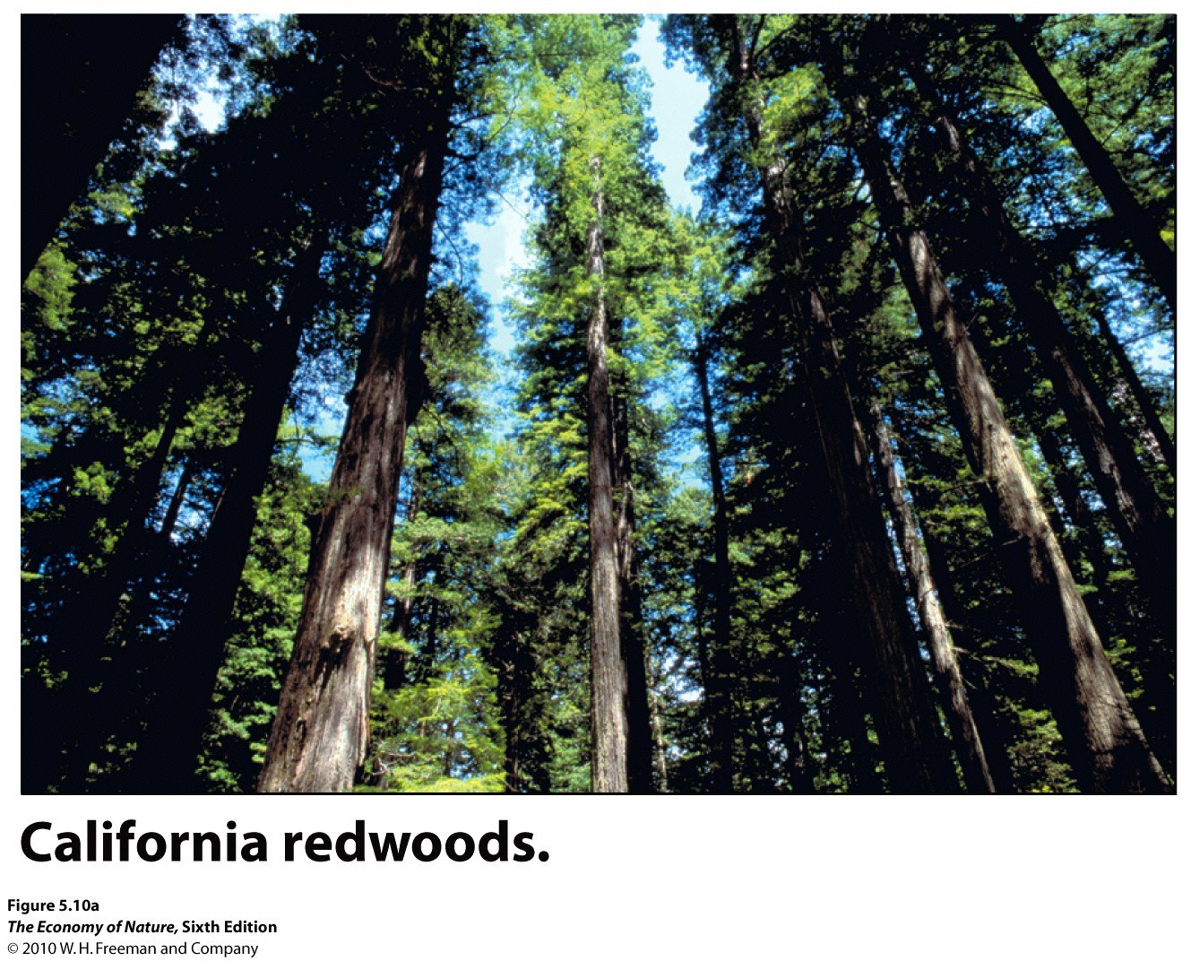
2. Temperate Rain Forest
- TEMP: seasonal but not extreme - moderated by coastal currents. Cool - 10C mean.
- RAINFALL: High but seasonal - dry summer moderated by fogs
- EVAPOTRANSPIRATIONAL STRESS: low due to fog
- LIGHT: Seasonally limiting in winter and under closed canopies.
- SOILS: deep, rich humus layer, rich A horizon. Slow decomposition and shallower bedrock keep nutrients at surface
- DISTURBANCE: winter, treefalls, storms
- NUTRIENTS and CYCLING: stalled by winter and dry summer, but otherwise wet .
- BIOTA: Low diversity, but tallest trees on the planet, in NA, hemlock and spruce in north give way to redwoods and sequoia in south. Structurally simple; dark understory retards growth of understory except mosses... heavy epiphyte load.
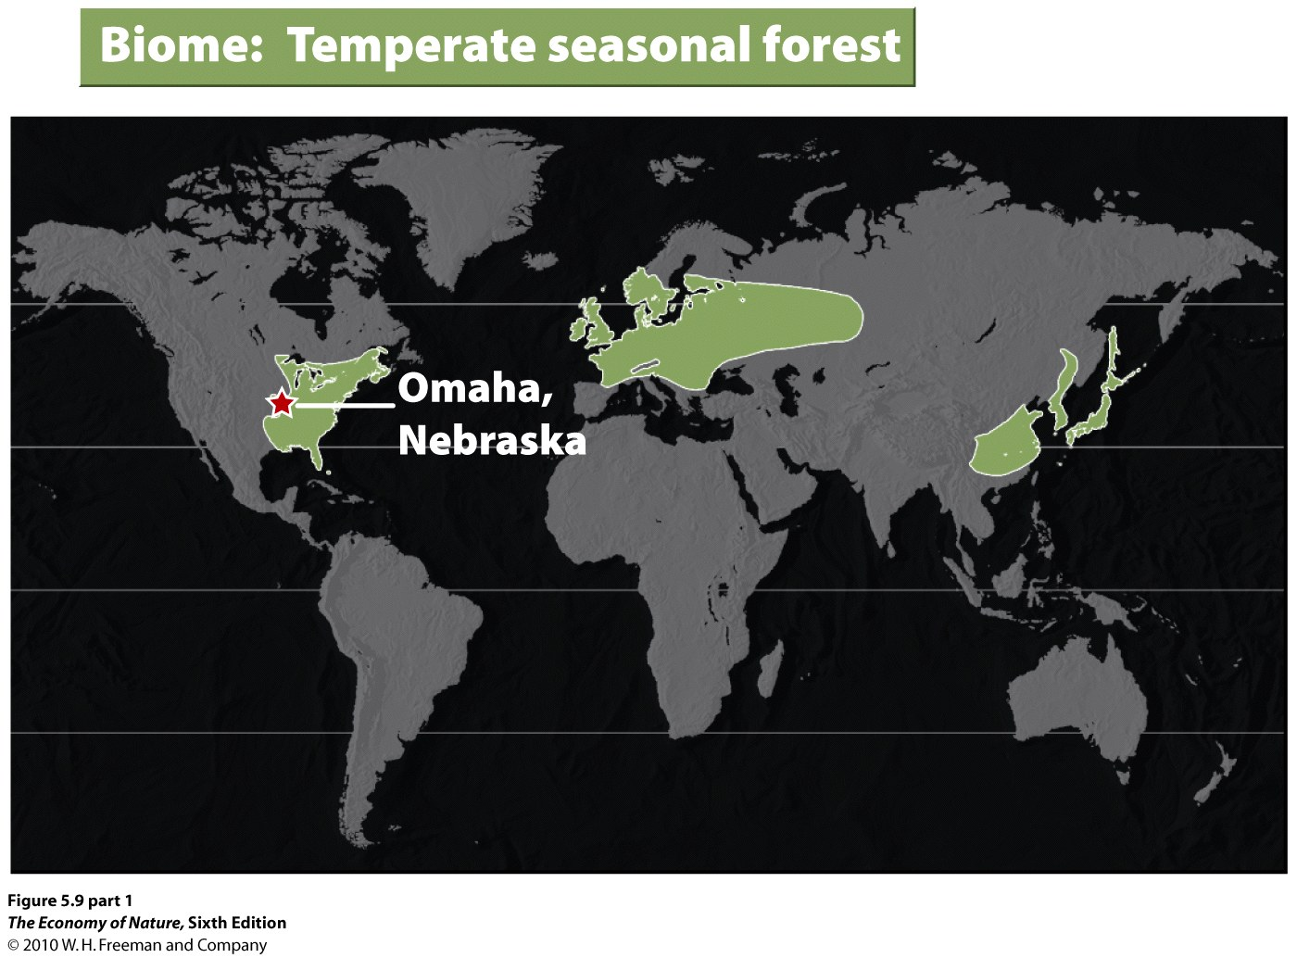
3. Temperate Deciduous (Seasonal) Forest
- TEMP: Seasonality is extreme, with more severely cold winters but moist spring and summer.
- RAINFALL: Plentiful in growing season; less in winter.
- EVAPOTRANSPIRATIONAL STRESS: low in growing season; high in wnter
- LIGHT: Seasonally limiting in winter and under closed canopies.
- SOILS: Soils are rich in nutrients and fairly deep
- DISTURBANCE: winter, storms, fires on dry substrates
- NUTRIENTS and CYCLING: Slow but efficient; deep litter layer.
- BIOTA: Deciduous trees dominate on good soils; pines dominate on sandy soils, dry slopes, early in succession, and nutrient poor soils. Simple four-layer structure to forest. Herbs flower in spring when light abundant; also when wind-dispersed canopy trees pollinate Biota varies dramatically with climate, from northern hardwoods of Beech and Maple to Southern Poplar-Oak (moist) and Oak-Hickory (dry).
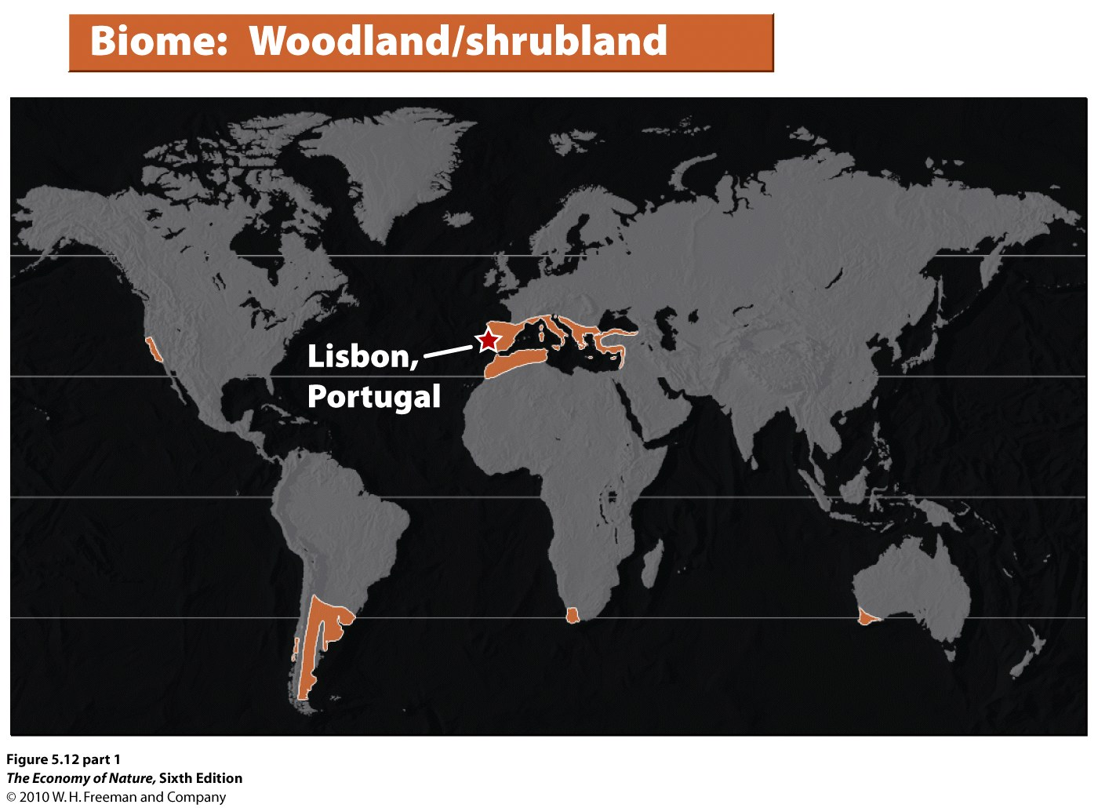
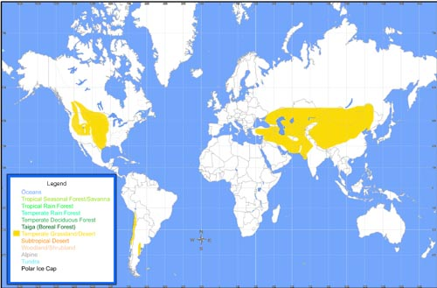
5. Temperate Grasslands: Prairie and Steppe
- TEMP: seasonal extremes - continental climate limits growing season depending on latitude and temperature extremes.
- RAINFALL: Low summer rainfall is predictably seasonal. Rainfall is too low to leach cations from soil but can be high enough for grasses.
- EVAPOTRANSPIRATIONAL STRESS: high, especially in dry season; selects for C4 grasses but C3 grasses still plentiful
- LIGHT: seasonally limiting
- SOILS: deep and rich
- DISTURBANCE: fire - selects for grasses
- NUTRIENTS and CYCLING: moist grasslands are richest soils on Earth, rich in nutrients and organics because leaching is low.
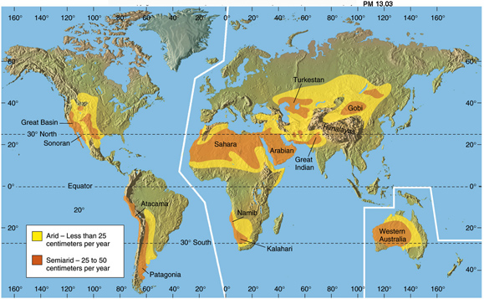
- -BIOTA: The height and density of grasses correlates with rainfall, which changes the soil conditions. Perennial C4 grasses dominate. Again, large grazers and predators dominate the food webs.
6. Deserts: Quite variable, from cold (temperate) to hot (subtropical)
- TEMP: Temperatures vary from hot to freezing, dramatically, depending on time of day, time of year, and latitude.
- RAINFALL: <25cm. Limits growth.
- EVAPOTRANSPIRATIONAL STRESS: very high; evaporation exceeds rainfall. In Phoenix, AZ, potential evapotranspiration is 130 cm a year, but rainfall is only 18 cm/year.
- LIGHT: not limiting during growing season
- SOILS: mineral with little organic input. Salts rise to form hardpan called caliche, exacerbating desiccation.
- DISTURBANCE: desiccation, drought, temperature extremes
- NUTRIENTS and CYCLING: very poor.
- -BIOTA: Xerophyllic plants adapted to extreme drought stress dominate (CAM plants) strong diurnal patterns in animal and plant activity (CAM) Plant density tightly linked to water availability.

D. Boreal and Polar Zones (avg. annual temp below 5ºC)
1. The Environment:
- low temperature and daylength are limiting.
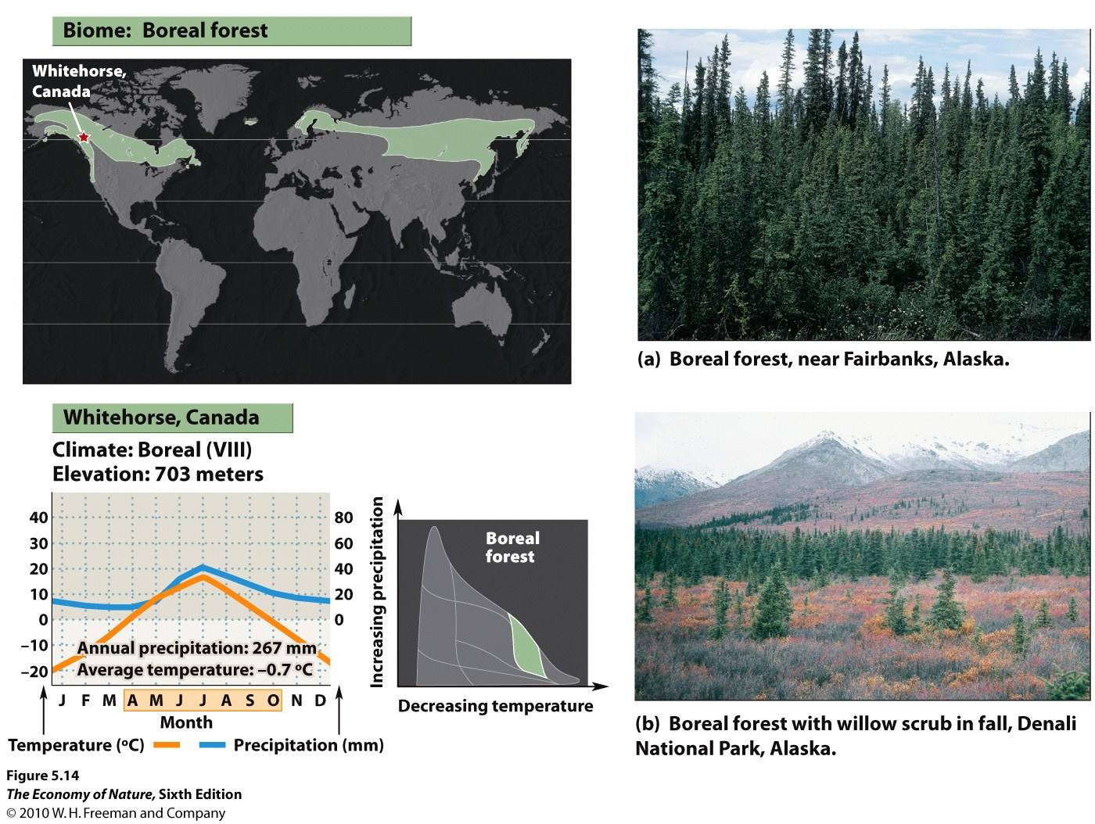
2. Boreal Forest – Taiga
- TEMP: Cold; short growing season
- RAINFALL: Precip. is low (40-100 cm/year) and mostly snow
- EVAPOTRANSPIRATIONAL STRESS: Severe in long winter due to low water availability; low in growing season because soil is often saturated (low evaporation).
- LIGHT: Seasonally limiting in winter and under closed canopies.
- SOILS: Soils are shallow due to recent glaciation; nutrient poor due to slow decomposition, and often saturated due to shallow depth of bedrock and rapid spring/summer melt. Deep acidic humus layer. Bogs develop in depressions
- DISTURBANCE: winter, storms
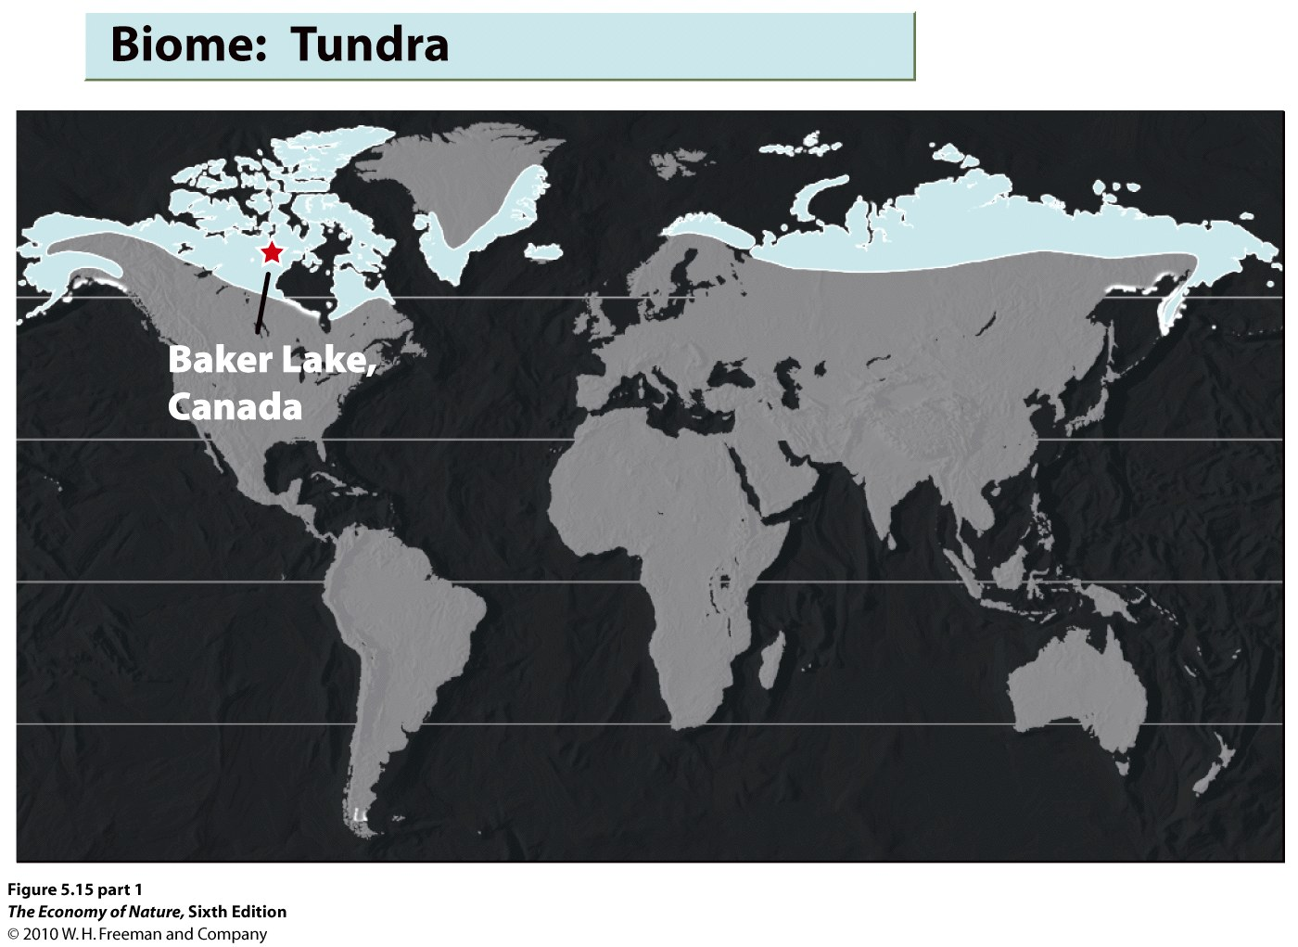
- BIOTA: Slow growing, evergreen conifers dominate; spruce, fir, pine. Birch and Aspen are only deciduous trees to make it. Dense brush in gaps; otherwise no shrub layer . Dramatic seasonality to many animal populations, too: migrate or hibernate. Diversity is very low.
3. Arctic Tundra
- TEMP: Cold most of the year, with a growing season of 50-60 days. The summer does have long days, but light intensities are still low due to oblique angle.
- RAINFALL: Precipitation is very low, less than 25cm/year.
- EVAPOTRANSPIRATIONAL STRESS: low during growing season; melt water accumulates.
- LIGHT: Limiting most of year; growing season very short
- SOILS: shallow; just above permafrost; boggy in summer; very slow decomposition - mats of peat that transfer little nitrogen to soil
- DISTURBANCE: winter, freez-thaw cycles, storms, exposure
- NUTRIENTS and CYCLING: soils nutrient poor and shallow
- BIOTA: treeless plain; a flush of herbaceous plants in growing season; over 400 species of plants.
4. Alpine Tundra – above the treeline
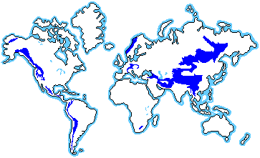
- Elevational treelines vary with latitude, being 900m at 65N, 2100m at 49N, 3300m at 40N, and 4200m at 19N. The presence of cold-hardy trees is also critical. In Brazil near 22S, the treeline is below 2000m because there are no cold-tolerant trees in the region. Short growing season and a long cold winter, but lots of precipitation, lower oxygen, high UV radiation, and unpredictable storms makes this a very different environment from arctic tundra. Soils lack permafrost but are thin and "new". Well drained (water runs downslope and does not pool) and summer droughts can occur.

D. Anthromes

Human have transformed ½ the terrestrial biosphere to “human dominated systems”, and now 40-50% of the terrestrial NPP (net primary productivity… ie. “photosynthetically produced biomass”) is produced in human dominated systems. So, understanding what these systems are, and what their impacts and interactions are with remaining natural systems, becomes important to the long-term sustainability of both.

- Anthromes are determined by I = PAT
Impact = (population size) x (affluence) x (technology)
Urban, villages, cropland, rangeland, semi-natural (forested), wildlands.
In this rubric, undeveloped forests are in the same category, regardless of whether they are tropical rainforest or boreal forest. The emphasis is on the level and type of land transformation, not the type of habitat, really, that was transformed.

STUDY QUESTIONS

1) Why are temperate rain forest coastal? Two reasons.

2) Why do deciduous trees dominate in the deciduous forest, but evergreens dominate in the boreal forest?

3) How do temperate grasslands and scrublands differ climatically, and why does this lead to differences in vegetation?

4) Describe the organic and inorganic content of a desert soil.

5) How do arctic and alpine tundra differ in water availability, and why?

6) What are anthromes and why is this classification ‘legitimate’ in understanding global processes?

7) How is this anthrome perspective important to understanding the dynamicis in an embedded natural system?

8) Likewise, how is the “biomic” perspective important for understanding the limitations, constraints, and potentialities of human systems?

