Climate and Biomes

III. Biomes
A. Overview
1. Definition
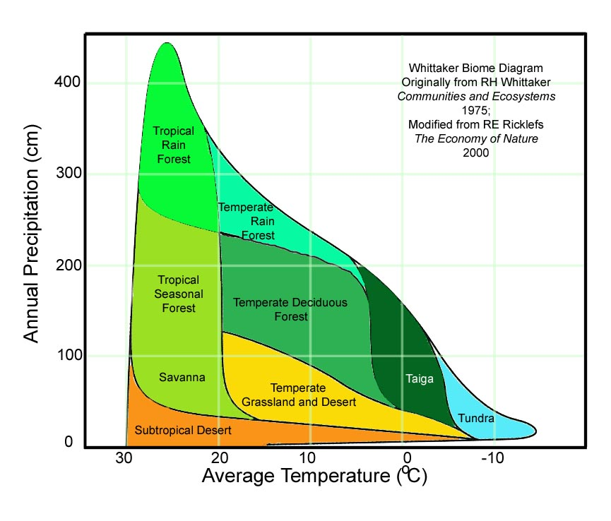
- A classification of communities and ecosystems based primarily on climate and dominant plant growth forms (Ricklefs).
2. Climatic Determinants
- Temperature: in terms of means, extremes, and seasonality
- Moisture: in terms of means, extremes, and seasonality
- These combine to a derived variable: evapotranspirational stress
3. Evapotranspirational Stress
- represents the potential water deficit between the tendency of water to be lost by evapotranspiration to the atmosphere compared to the availability of water in the soil.
- As temperature increases, evapotranspiration will increase (both because of increasing evaporation and increasing metabolic rate).
- In order for the plant NOT to experience an increase in et stress, water availability must increase also, to offset the increase in water lost to evaporation. So, hot habitats will change from forest to grassland than cool areas, with a smaller decrease in water.

B. The Tropics (avg. annual temp >20ºC)
1. Environment
- always warm
- vegetation type (biome) determined primarily by rainfall – amount and seasonality.
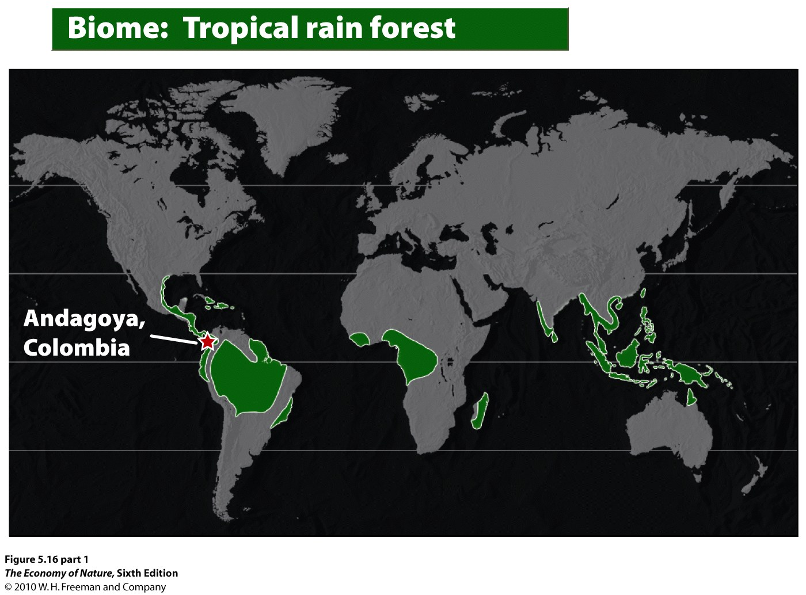
2. Tropical Rain Forests - Equatorial
- TEMP: Uniformly warm
- RAINFALL: High (200-450cm); no month with less than 10cm
- LIGHT: limiting below the canopy
- EVAPOTRANS. STRESS: low
- NUTRIENT CYCLING: Most nutrients bound in biomass; rapid decomposition and rapid absorption. Little litter accumulation.
- BIOTA: Broad-leaved evergreen trees; multi-layered with emergents, lianas, and epiphytes. Most diverse terrestrial biome; as many tree species in 1 ha (300) as in all U.S.

3. Tropical Dry Forest– beyond 10º latitude
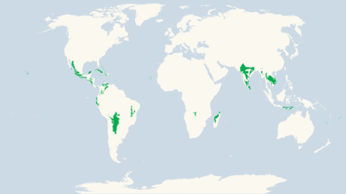
- TEMP: Uniformly warm; annual temp > 20C little annual variation
- RAINFALL: 50-200cm, extreme seasonality, with a pronounced dry season of several months.
- EVAPOTRANSPIRATIONAL STRESS: high in dry season; water limiting – DROP LEAVES
- LIGHT: Never limiting, neither seasonally nor beneath a canopy.
- NUTRIENTS and CYCLING: Cycling is seasonal. Litter accumulates until rainy - then nutrients recycled.
- BIOTA: Open, four-layered forest with density dependent on rainfall – grading into scrub forest. No epiphytes but lianas still common. Many animals (insects and amphibians) strongly seasonal.
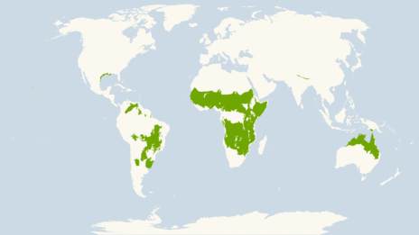
4. Savannah
- TEMP: Uniformly warm; annual temp > 20C little annual variation
- RAINFALL: <50cm, limited to wet season; rain determines ‘tree line’.
- EVAPOTRANSPIRATIONAL STRESS: high dry season; water limiting – grasses dominate
- LIGHT: Never limiting
- NUTRIENTS and CYCLING: Cycling is seasonal. Litter accumulates until rainy - then nutrients recycled. But lower organic input – just grasses.
C. The Temperate Zone (avg. annual temp between 5ºC and 20ºC)
1. The Environment
- quite variable in rainfall and temperature; both can be limiting
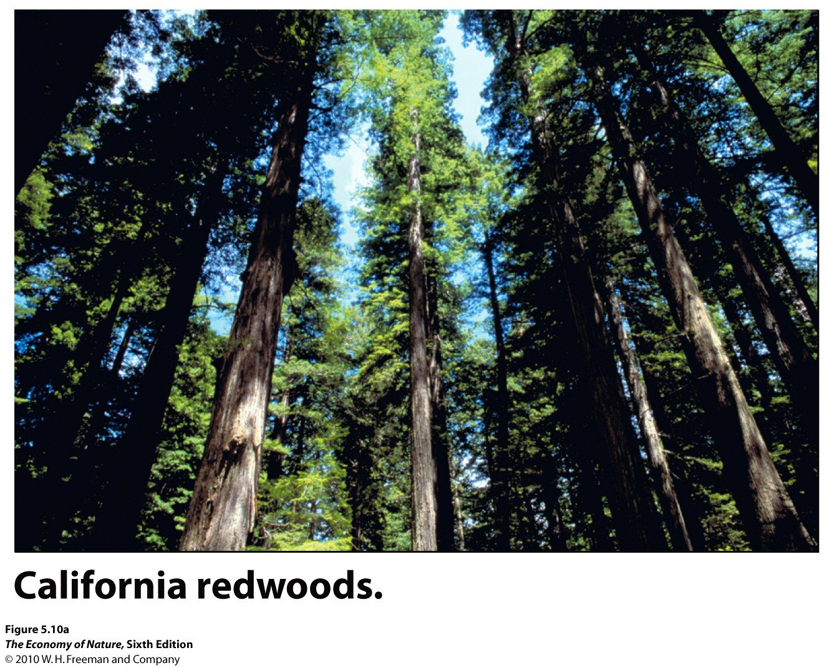
2. Temperate Rain Forest
- TEMP: seasonal but not extreme - moderated by coastal currents. Cool - 10C mean.
- RAINFALL: High but seasonal - dry summer moderated by fogs
- EVAPOTRANSPIRATIONAL STRESS: low due to fog
- LIGHT: Seasonally limiting in winter and under closed canopies.
- BIOTA: Low diversity, but tallest trees on the planet, in NA, hemlock and spruce in north give way to redwoods and sequoia in south. Structurally simple; dark understory retards growth of understory except mosses... heavy epiphyte load.
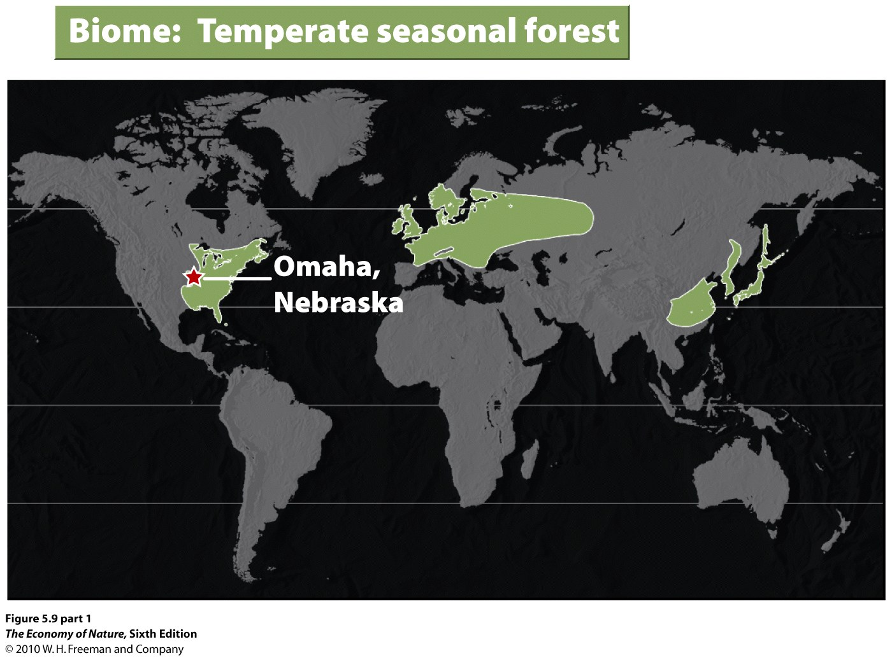
3. Temperate Deciduous (Seasonal) Forest
- TEMP: Seasonality is extreme, with more severely cold winters but moist spring and summer.
- RAINFALL: Plentiful in growing season; less in winter.
- EVAPOTRANSPIRATIONAL STRESS: low in growing season; high in wnter
- LIGHT: Seasonally limiting in winter and under closed canopies.
- BIOTA: Deciduous trees dominate on good soils; pines dominate on sandy soils, dry slopes, early in succession, and nutrient poor soils. Simple four-layer structure to forest. Herbs flower in spring when light abundant; also when wind-dispersed canopy trees pollinate Biota varies dramatically with climate, from northern hardwoods of Beech and Maple to Southern Poplar-Oak (moist) and Oak-Hickory (dry).
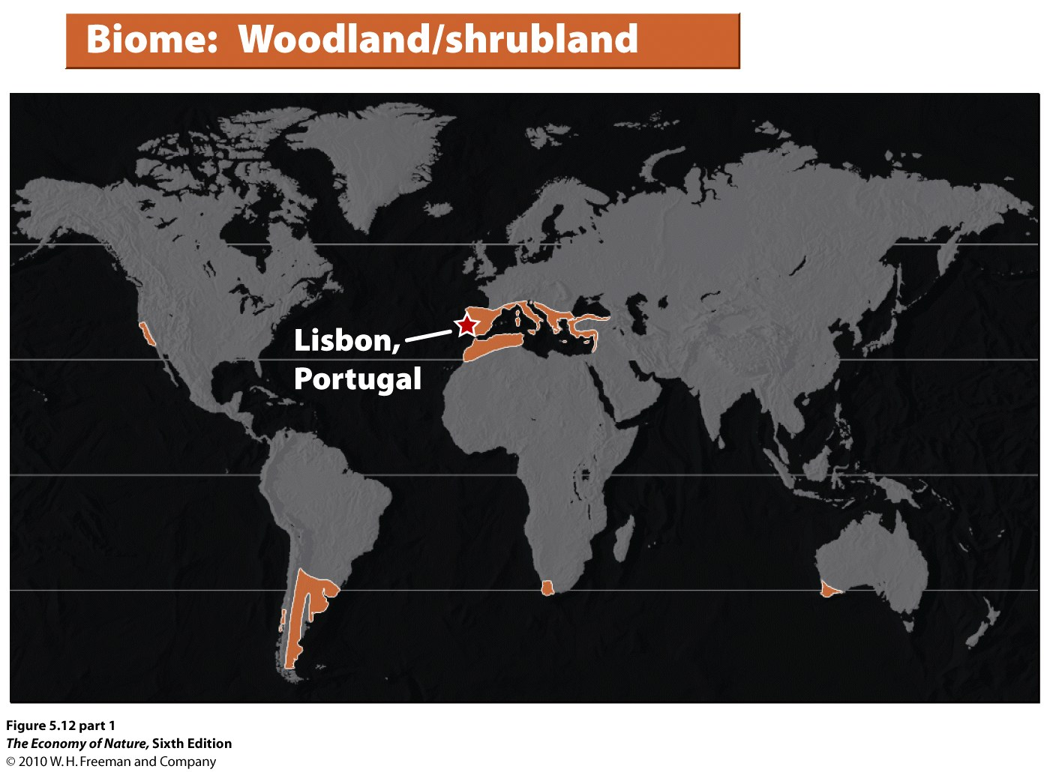
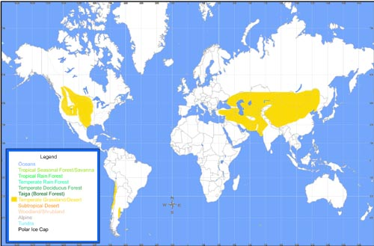
5. Temperate Grasslands: Prairie and Steppe
- TEMP: seasonal extremes - continental climate limits growing season depending on latitude and temperature extremes.
- RAINFALL: Low summer rainfall is predictably seasonal. Rainfall is too low to leach cations from soil but can be high enough for grasses.
- EVAPOTRANSPIRATIONAL STRESS: high, especially in dry season; selects for C4 grasses but C3 grasses still plentiful
- LIGHT: seasonally limiting
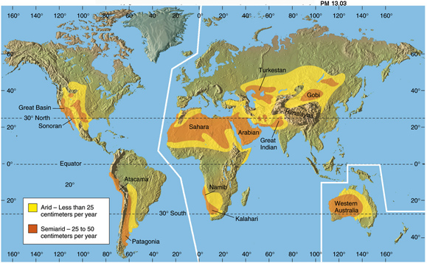
- -BIOTA: The height and density of grasses correlates with rainfall, which changes the soil conditions. Perennial C4 grasses dominate. Again, large grazers and predators dominate the food webs.
6. Deserts: Quite variable, from cold (temperate) to hot (subtropical)
- TEMP: Temperatures vary from hot to freezing, dramatically, depending on time of day, time of year, and latitude.
- RAINFALL: <25cm. Limits growth.
- EVAPOTRANSPIRATIONAL STRESS: very high; evaporation exceeds rainfall. In Phoenix, AZ, potential evapotranspiration is 130 cm a year, but rainfall is only 18 cm/year.
- LIGHT: not limiting during growing season
- -BIOTA: Xerophyllic plants adapted to extreme drought stress dominate (CAM plants) strong diurnal patterns in animal and plant activity (CAM) Plant density tightly linked to water availability.

D. Boreal and Polar Zones (avg. annual temp below 5ºC)
1. The Environment:
- low temperature and daylength are limiting.
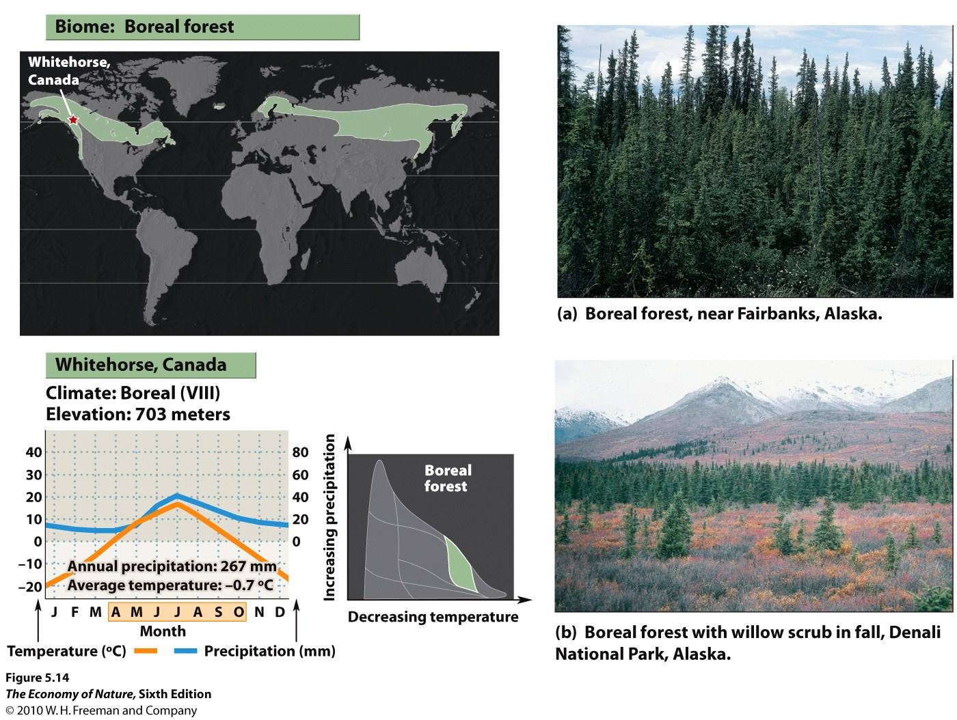
2. Boreal Forest – Taiga
- TEMP: Cold; short growing season
- RAINFALL: Precip. is low (40-100 cm/year) and mostly snow
- EVAPOTRANSPIRATIONAL STRESS: Severe in long winter due to low water availability; low in growing season because soil is often saturated (low evaporation).
- LIGHT: Seasonally limiting in winter and under closed canopies.
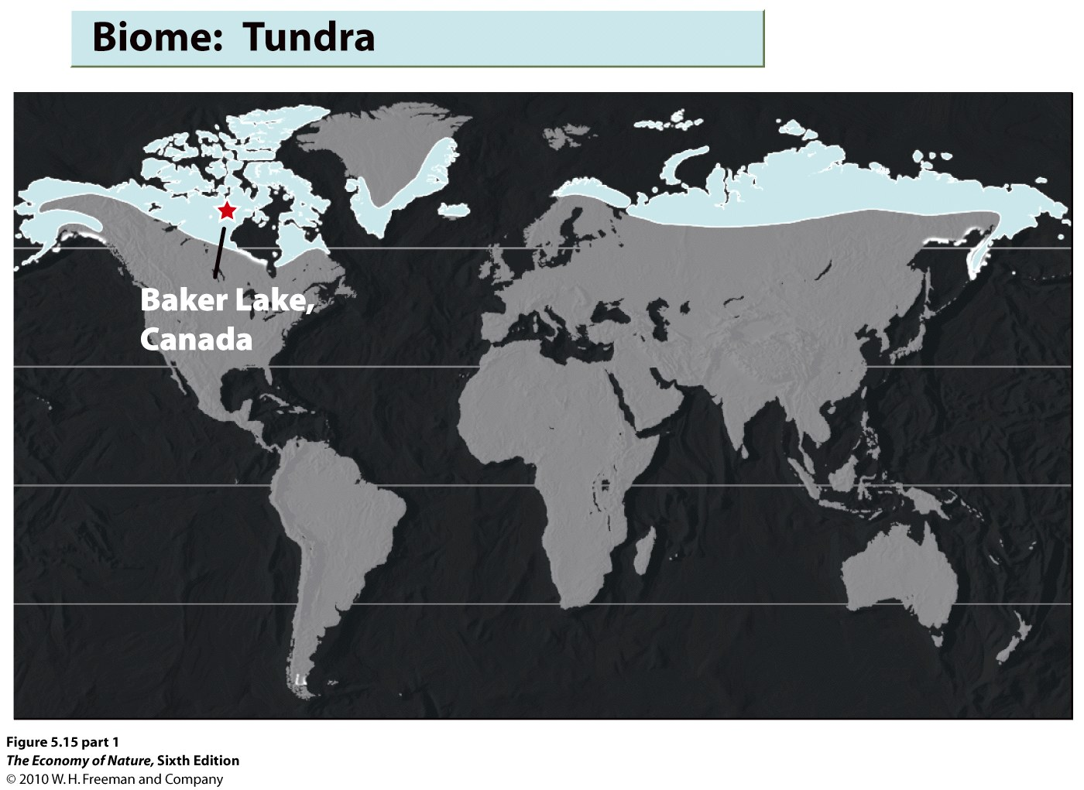
- BIOTA: Slow growing, evergreen conifers dominate; spruce, fir, pine. Birch and Aspen are only deciduous trees to make it. Dense brush in gaps; otherwise no shrub layer . Dramatic seasonality to many animal populations, too: migrate or hibernate. Diversity is very low.
3. Arctic Tundra
- TEMP: Cold most of the year, with a growing season of 50-60 days. The summer does have long days, but light intensities are still low due to oblique angle.
- RAINFALL: Precipitation is very low, less than 25cm/year.
- EVAPOTRANSPIRATIONAL STRESS: low during growing season; melt water accumulates.
- LIGHT: Limiting most of year; growing season very short
- SOILS: shallow; just above permafrost; boggy in summer; very slow decomposition - mats of peat that transfer little nitrogen to soil
- BIOTA: treeless plain; a flush of herbaceous plants in growing season; over 400 species of plants.
4. Alpine Tundra – above the treeline
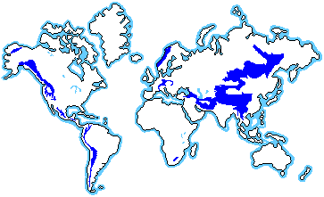
- Elevational treelines vary with latitude, being 900m at 65N, 2100m at 49N, 3300m at 40N, and 4200m at 19N. The presence of cold-hardy trees is also critical. In Brazil near 22S, the treeline is below 2000m because there are no cold-tolerant trees in the region. Short growing season and a long cold winter, but lots of precipitation, lower oxygen, high UV radiation, and unpredictable storms makes this a very different environment from arctic tundra. Soils lack permafrost but are thin and "new". Well drained (water runs downslope and does not pool) and summer droughts can occur.
D. Anthromes

Human have transformed ½ the terrestrial biosphere to “human dominated systems”, and now 40-50% of the terrestrial NPP (net primary productivity… ie. “photosynthetically produced biomass”) is produced in human dominated systems. So, understanding what these systems are, and what their impacts and interactions are with remaining natural systems, becomes important to the long-term sustainability of both.

- Anthromes are determined by I = PAT
Impact = (population size) x (affluence) x (technology)
Urban, villages, cropland, rangeland, semi-natural (forested), wildlands.
In this rubric, undeveloped forests are in the same category, regardless of whether they are tropical rainforest or boreal forest. The emphasis is on the level and type of land transformation, not the type of habitat, really, that was transformed.

STUDY QUESTIONS

1) Tropical rainforest soils are nutrient rich, but nutrient transport is rapid. Describe the inputs and outputs to the soil, and describe how these change when the vegetation is cleared.

2) Explain why trees drop their leaves in tropical dry forest.

3) Describe how evapotranspirational stress changes with temperature and water availability.

4) Why are tropical rainforests equatorial, while dry forests and grasslands are at higher latitudes?

5) Why are temperate rain forest coastal? Two reasons.

6) Why do deciduous trees dominate in the deciduous forest, but evergreens dominate in the boreal forest?

7) How do temperate grasslands and scrublands differ climatically, and why does this lead to differences in vegetation?

8) What are anthromes?

