Adaptations to the Physical Environment

I. Water

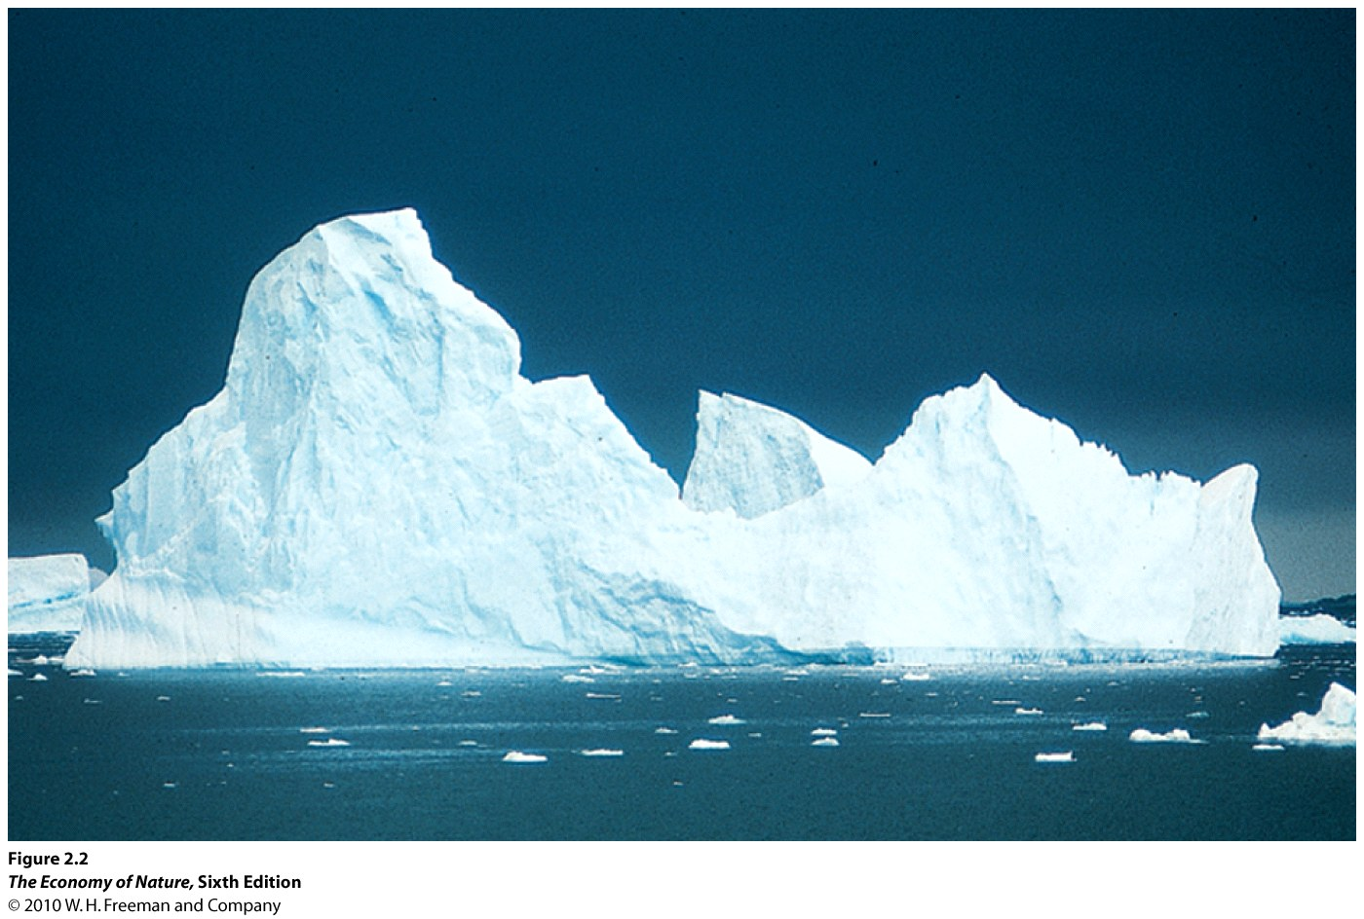
A. Properties and Adaptations
1. High Specific Heat
- It takes a large change in energy content to change the temperature of water
- it takes a MUCH larger change in energy content to change its state
- So, over most earthly temperatures, water is a liquid and stays a liquid – and is a thermally stable liquid.
- So, water is an excellent internal and external environment for life, because it is thermally stable, and it is a liquid in which other things can dissolve and interact.
- Also, the evaporation of water from a surface transfers latent heat energy from surface (earth or organism) to the atmosphere, cooling that surface. Evaporative cooling is a great way to lose heat, but you lose water, too.
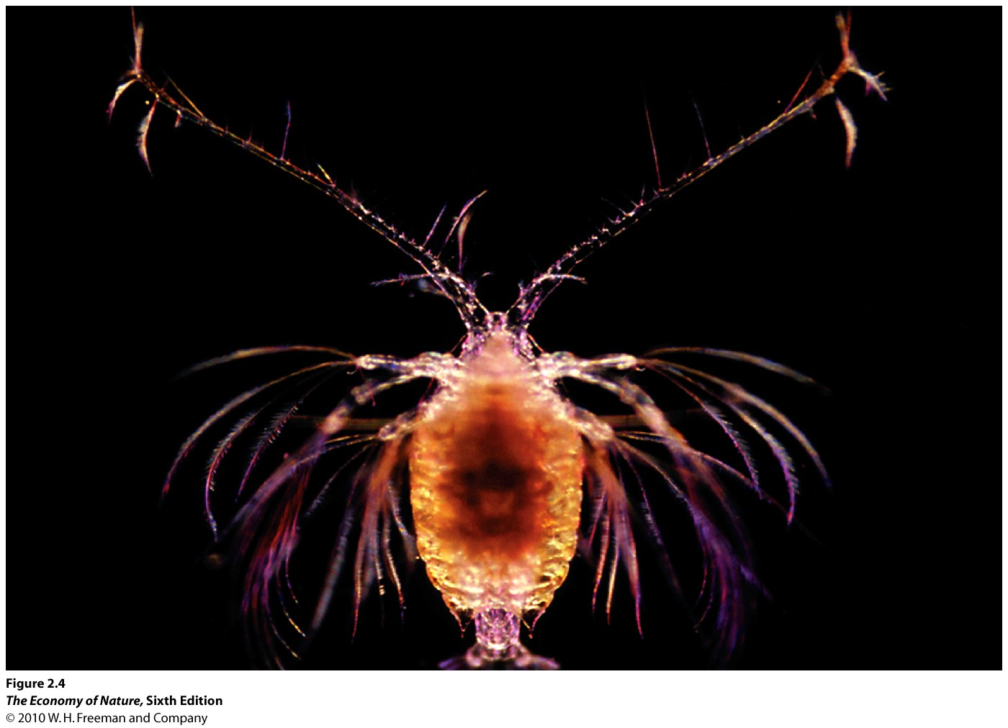
2. Density and Viscosity
- water is dense and viscous, providing bouyancy but also drag.
- salt water is more dense than cellular fluid, so many marine organism float
- those with dense tissues (cellulose, cartilage) have flotation devices (oil droplets, gas bladders, or filamentous appendages that increase SA/V and drag to prevent sinking, and they swim).
- Hydrodynamic shapes are selected for to reduce drag… sphere has lowest sa/v ratio for a given volume.
3. Universal Solvent
- polar molecules, gases, and ions dissolve in water, up to their maximum solubility (saturation value).
- Plants absorb inorganic nutrients dissolved in soil water (NH₄⁺, NO₃⁻,PO₄³⁻)
- H₂O + CO₂ → H₂CO₃ (carbonic acid) → H⁺ + HCO₃⁻ (bicarbonate) → 2H⁺ + CO₃²⁻ (carbonate)
SO: CO₂ dissolves in water, forming an acid. 50% of all the anthropogenic CO₂ has dissolved in water, actually lowering the pH of the OCEANS by 0.1 pH (remember, pH is a log scale!!).
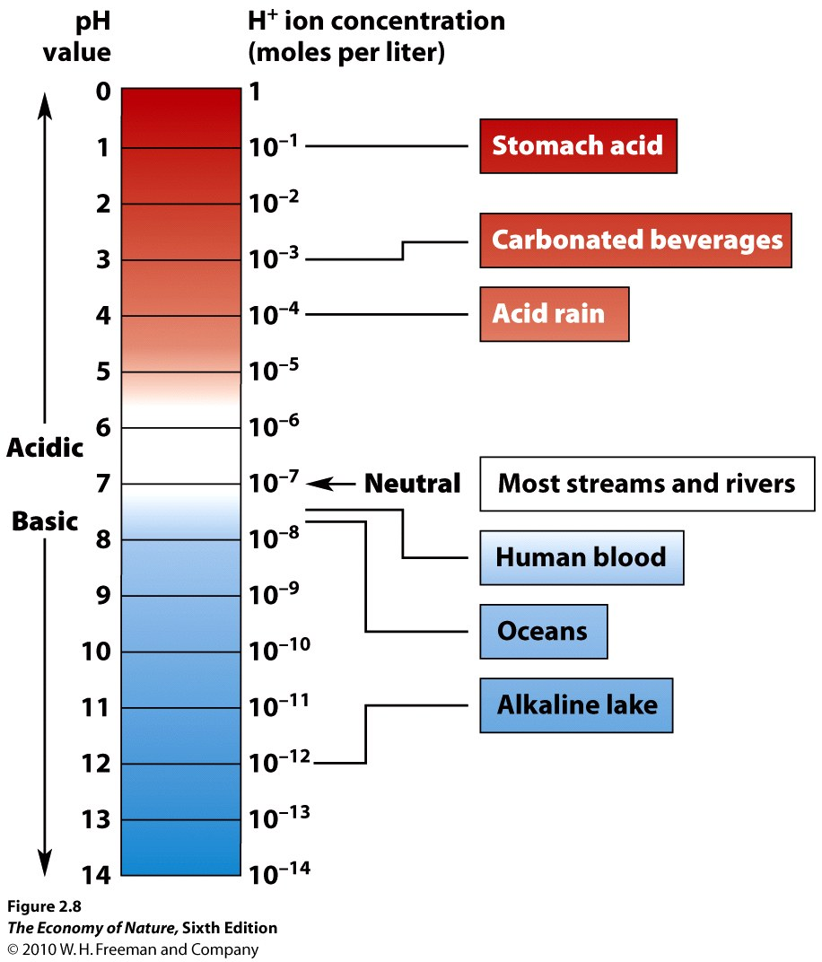
Carbonate ions react with Ca²⁺, forming calcium carbonate (CaCO₃) which is not very soluble in water (the oceans are already saturated with it) so it precipitates out as limestone deposits. Thus, the lithosphere, via the hydrosphere, is a major carbon sink; making the composition of the Earth’s atmosphere much different than that of Mars or Venus.
4. Water Dissociates
- Water dissociates, releasing H⁺ that are very reactive. Also, CO₂ dissolves in water, making carbonic acid which dissociates (above), releasing H+ ions. H+ ions can displace other cations from minerals, in a process called “cation displacement”, freeing soluble Na⁺, Ca⁺, K⁺ nutrients for biological uptake. However, it also frees heavy metals like Fe⁺, Al⁺, As⁺, Cd⁺, Hg⁺ that can be toxic.
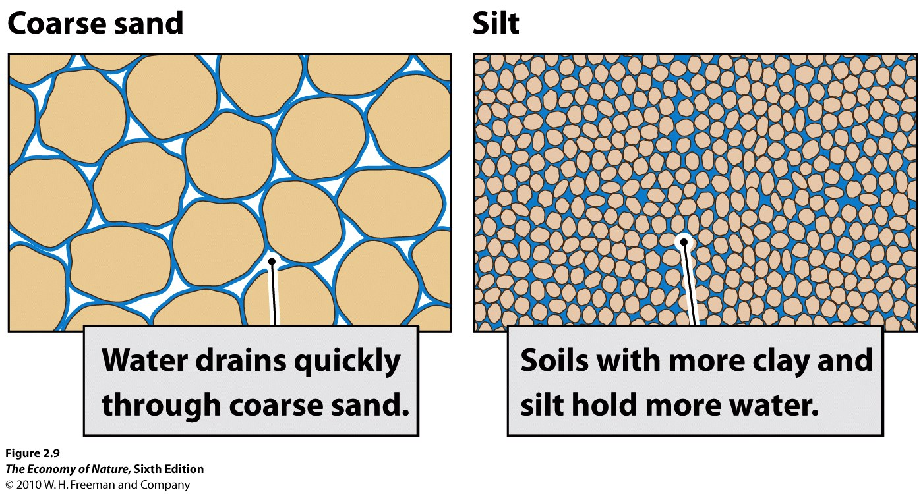
5. Water is Adhesive and Cohesive
- Water sticks to charged surfaces, like soil particles of clays (smallest), silts (medium), and sand (large). A given volume of clay particles has more total surface area, and so will bind more water, than the same volume of sand (with lots of spaces between). The amount of water held by the soil, after gravity has drained excess water out of the interstices, is called the field capacity (50% by volume for clay, 10% soil volume for sand).
6. Water Potential (Ψ)
- Water moves from areas of high water potential to low water potential.
- Pure water at sea level is standardized as having a water potential = 0.
- Water Potential is a function of:
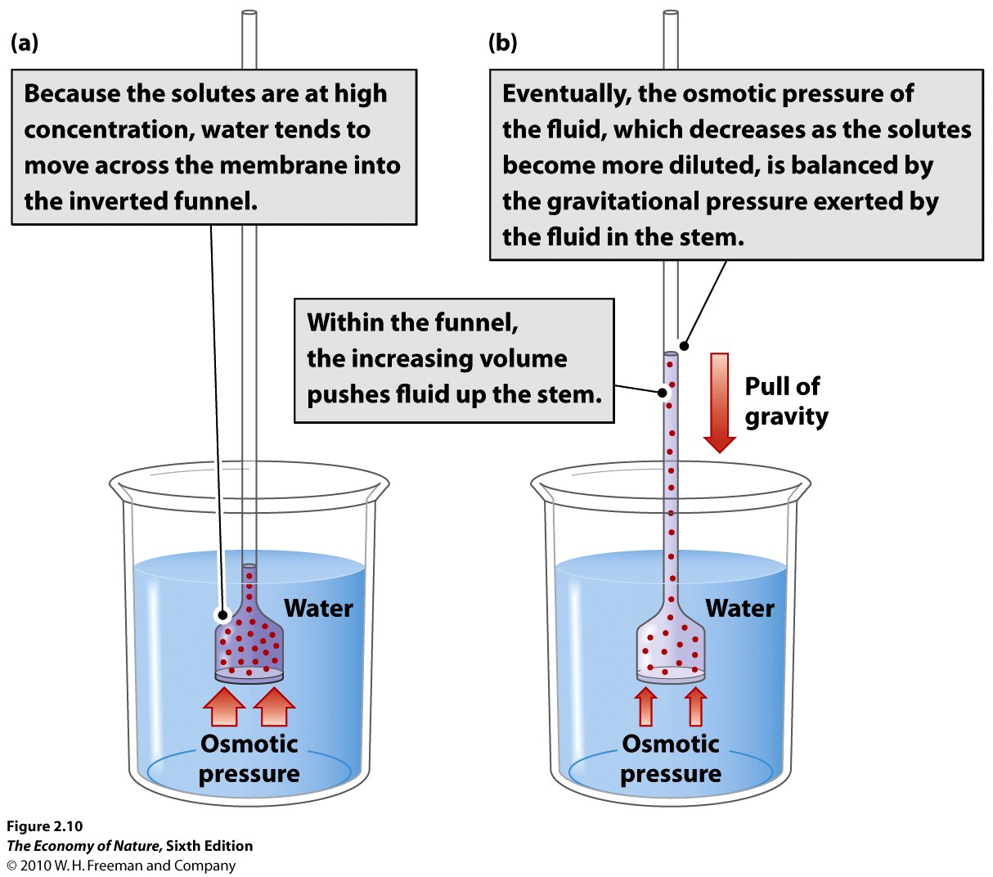
- mechanical pressure: water, pushing out against a cell wall of a plant, can make the cell wall more rigid (TURGOR ) and equalize the force of gravity. When pressure drops, leaves and stems wilt and fall.
- solute pressure: has a negative effect on water potential. So, as solute concentration increases, water pressure declines. So, water will move from a more dilute solution (with higher water potential) to a more saline solution (lower water potential).
- gravimetric pressure: the force of gravity acting on the mass of the water
- potential due to humidity (to explain flow from liquid water to the atmosphere; drier air is more negative)
- matrix effects (surface tension and cohesion, as in a soil – also negative).
- Because soil ABSORBS/ATTRACTS/SUCKS UP pure water (capillary action), soil has a negative water potential. The more negative the water potential, the more water the soil will hold against the pressure of gravity (-0.01 MegaPascals). A saturated clay soil may be 50% water by volume; a saturated sandy soil may be only 10% water by volume. A very dry, salty soil will have a very negative water potential, even as low as -10 MPa. Water will be absorbed by the soil until water potential of the soil rises to -0.01MPa, at which point it will begin to drain from the soil (by gravity) to the water table.
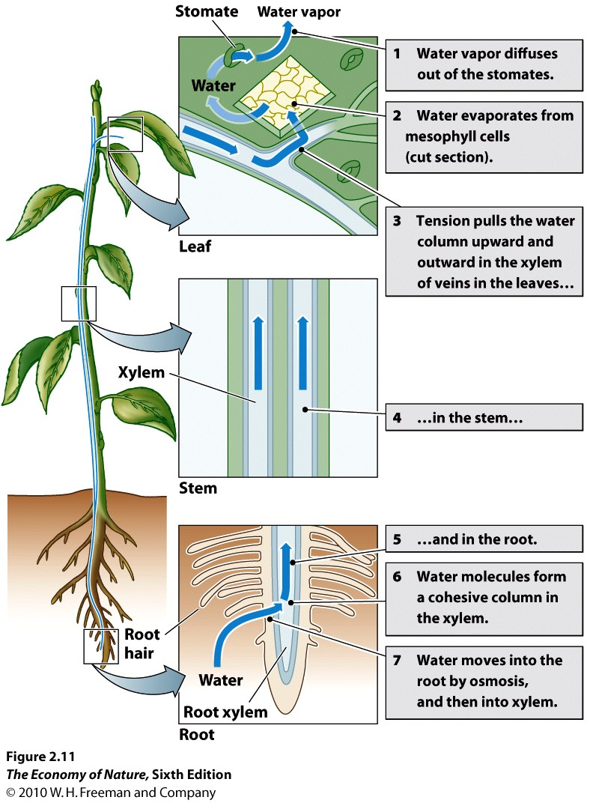
7. Water Absorption, Transport, and Regulation in Plants
- Plants must lower the water potential in their roots below that in soil to absorb water
- They lower water potential by increasing the concentration of dissolved solutes (amino acids, sugars, ions).
- large molecules stay in the cell, but ions leak out and their concentration gradient must be maintained by active transport, which can be energetically expensive in dry salty soils.
- Transport occurs in xylem – dead, hollow cells which, end to end, form long hollow tubes.
- The osmotic pressure of water (“root pressure”) entering the roots pushes water up the xylem (6m max)
- in the stem, water clings and crawls up xylem walls by adhesion and cohesion (“capillary action”), with dreiction encouraged by root pressure and, more significantly, by evapotranspirational loss of water from leaves…pulling water up tree.
- In leaves, water evaporating out of leaves to air (-133 MPa!!!) lowers the water potential in the leaves. Difference of -2 to -5 between roots and leaves causes the continuous column of water flows up the tree as long as the pressure offsets the gravitational pull on this long column of water in the xylem (cohesion-tension theory).
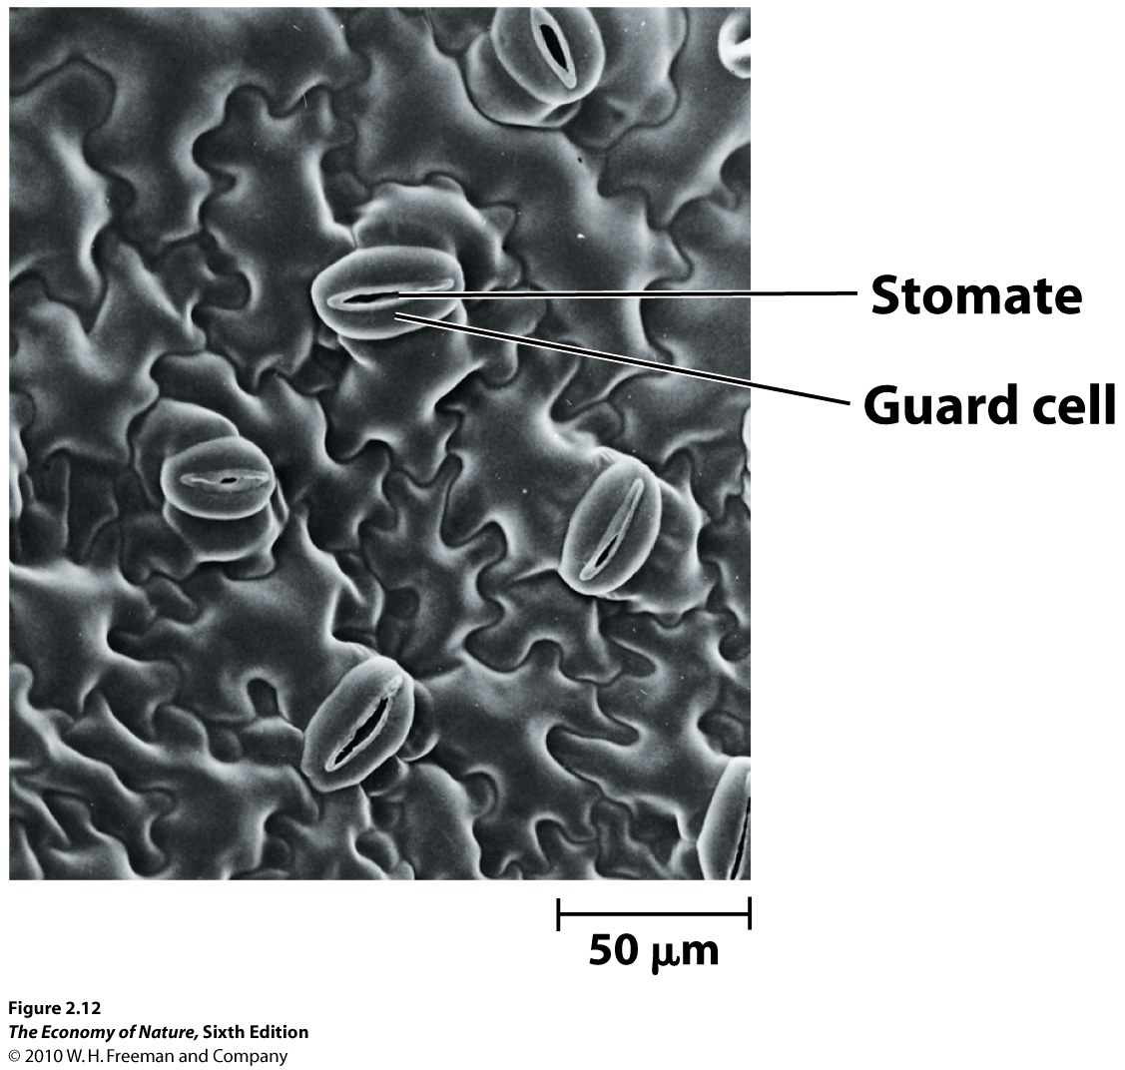
- When soil reaches wilting point (lower potential than roots), water doesn’t enter root or flow up
- Leaves dry, and stomates close, stopping water loss due to evapotranspiration, water movement, and energy expended on active transport of salts into roots. But closing stomates also stops gas exchange and eventually stops photosynthesis and energy harvest.
- In salty environments, plants pump salts out, but maintain a low water potential by maintaining high concentrations of amino acids and sugars in roots.
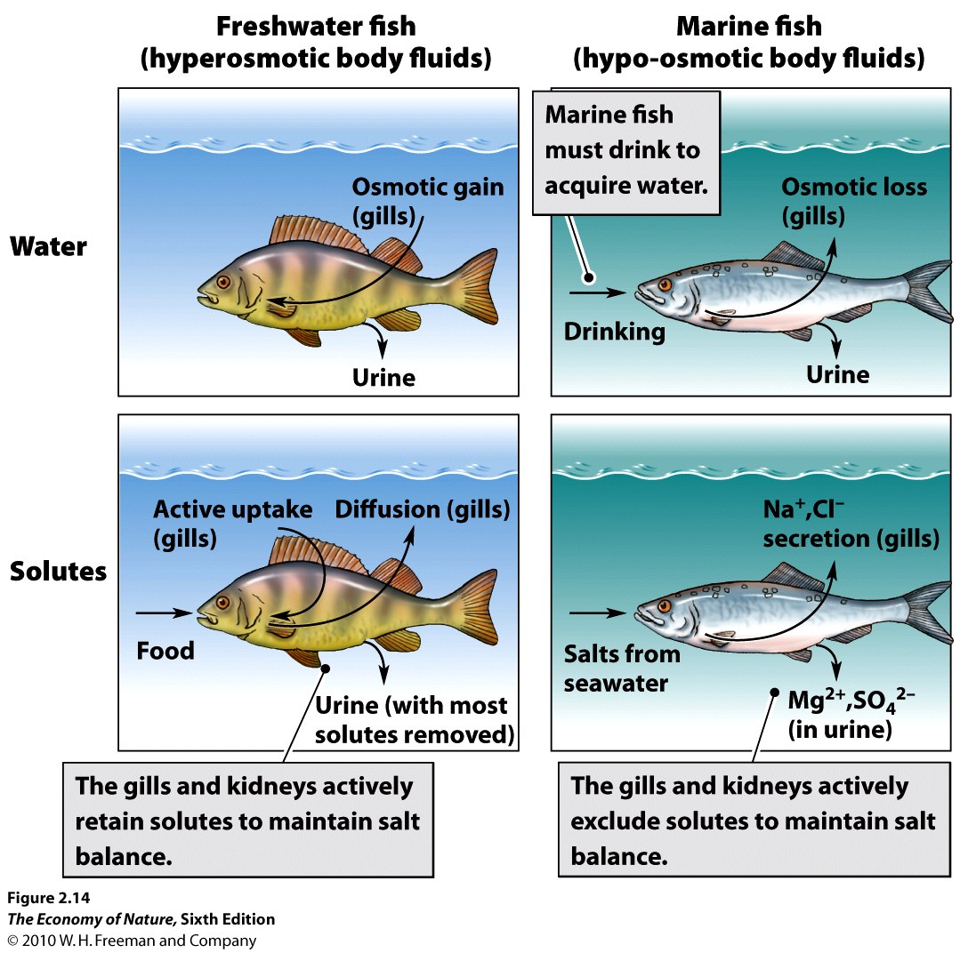
8. Osmoregulation in Animals
- Freshwater organisms have saltier tissue than the environment and absorb excess water. This is excreted in a dilute urine, and salts are retained by the kidney and actively transported into animal across gills.
- Marine organisms either passively react (and increase salt concentrations to match ocean), or retain other molecules in tissues to lower water potential to that of sea water (-1.2MPa). Marine sharks and rays retain urea; copepods synthesize amino acids when the environment gets salty.
- Osmoregulation is tied to excretion of nitrogenous waste. Freshwater animals excrete NH₃ in dilute urine. Mammals convert ammonium to urea, which still requires water to dilute and excrete the waste. Birds and reptiles convert it to uric acid which crystallizes out of solution into a paste.
- Metabolism to urea and uric acid costs animal organic carbon.

STUDY QUESTIONS
1) How does water’s high specific heat affect it as an internal and external environment?
2) Water is dense and viscous, providing buoyancy and drag. What physical adaptations maximize buoyancy? Minimize drag?
3) Liquid water has changed the Earth’s atmospheric composition in a very important way, dramatically reducing the CO2. How? What two sinks now store the Earth’s carbon, and how did it get there?
4) Water dissociates into what? What affect do the products of dissociation have on weathering rock and mobilizing soil nutrients? What negative effect of “cation displacement” can occur?
5) Water is adhesive, binding to charged surfaces like soil particles. Explain why clay holds more water per unit soil volume than sand.
6) List the five components of water potential.
7) Water moves from areas of high water potential to low water potential. What is the primary method that roots use to lower their water potential and “entice” water to move into them?
8) As water moves into roots, it is pushed up by the force of the water moving in behind it… this is root pressure and it is eventually balanced by gravity far below the height of most tall trees. So, what other force (or “negative force”) helps explain how water moves up trees?
9) Where does the nitrogen in animal’s nitrogenous waste come from? What does it turn into in the aqueous solution of the blood? How do freshwater organisms get rid of it? How do saltwater organisms and terrestrial organisms get rid of it? How do saltwater organisms retain water in their tissues against the tendency of water to be lost from their tissues to the saltier environment?

