Adaptations to the Environment

III. Life History Evolution
A. Trade-Offs
1. Components of Fitness: fitness = number of reproducing offspring
- probability of survival
- number of offspring
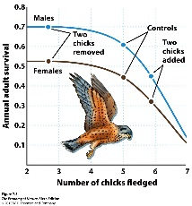
- probability of offspring survival
2. Relationships with a Finite Energy Budget
- All organisms have a finite amount of energy to spend on basal metabolism, growth, and reproduction (specific tissues, mate acquisition, parental care).
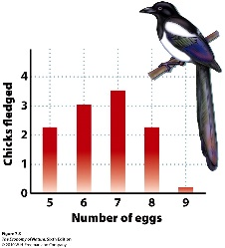
- Investing in one component means decreasing allocations to another.
3. Trade-offs between Survival and reproduction
- Investing in Metabolism (homeothermy?) and growth increase survival (and lifespan).
- Investing in reproduction decreases size and survival.
- Investing in reproduction decreases energy stores and increases mortality
4. Trade-offs between #offspring and offspring survival
- if probability of survival is low, need to maximize number of offspring

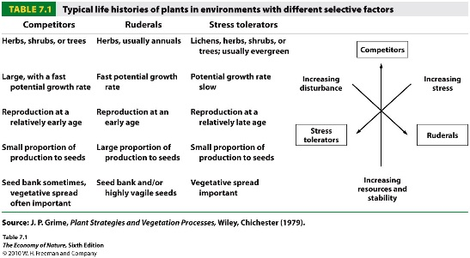
C. Life History Strategies
- these relationships between survivorship, fecundity, and fecundity schedules crate suits of traits that are often seen together as a “life history strategy”
- Ruderals (r-strategists): exploit open, disturbed habitats with lots of available resources and little competition. They exploit a “get in, get out” strategy of investing in early reproduction, typically of lots of small, vagile seeds. Investment on reproduction early results in a short life-span; often an annual life cycle.
- Competitors (K strategists): exploit closed, stable habitats where competition is often intense. Acquisition of resources is critical, selecting for growth and survival early, with some delay in reproduction. Can produce lots of little seeds or a few large ones.
- Tolerators: Exploit very stressful environments where energy acquisition limits both growth and reproduction. Usually grow slow, reproduce very late and a little.

Population Ecology
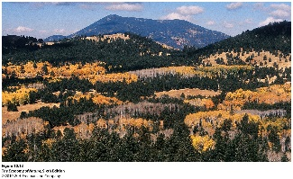
I. Attributes
- Population: A group of potentially interbreeding organisms at the same time and place, that share a common gene pool.
- Population size: number of individuals
- Population Growth Rate: change in number over time, as a function of (birth +immigration)- (death + emigration)

II.Distribution
A. Environmental Tolerance: The Niche Concept
- organisms will only live in ecologically suitable habitats.
- “fundamental niche” – describes the abiotic conditions they can tolerate
- “realized niche” – includes biotic effects, like distribution of food, competitors, and predators
- For each variable, there is an ‘optimal zone’ where conditions are ideal for the organism. Then, there are zones of tolerance where the organism can survive, and zones of intolerance beyond the conditions in which the organism can survive.
- Reproductive fitness will be highest within the fundamental niche where the optimal zones for all variables overlap. As the population experiences any departure from these optimal conditions, departing from the optimum along any of the ‘N-dimensional” axes, performance will necessarily decline.
- The variable restricting survival is called the ‘limiting variable’ because it limits the population’s distribution. It may be an abiotic or biotic variable, and may relate to the fundamental or realized niche

B. Changes in Distributions Thru Time: Climate Change
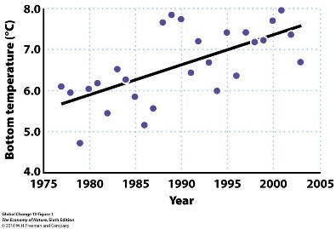
- As environments change, the geographical area that contains the fundamental niche requirements may move, expand, or contract… necessitating a behavioral (migratory) or evolutionary (adapting to new local environment) response.
- Marine fishes are moving north into the north Sea as water temps increase.
- Alpine mammals, birds, and plants are increasing their elevation (and decreasing the size of their habitat and population).
- Some scientists estimate that 35% of species may go extinct in the next 50 years because of climate change and these types of range shifts.

C. Spatial Structure of Populations
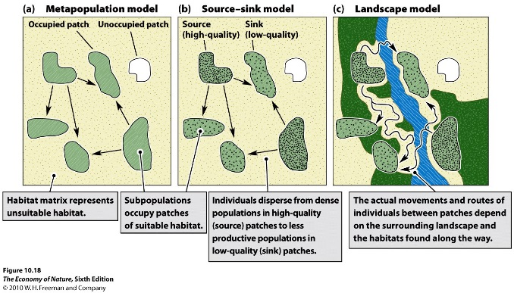
1. metapopulations = equal hab quality and adapted local pops
- This model describes the dynamics among sub-populations connected by migration. Populations inhabit equivalent habitats, and the dynamics are governed by population sizes (which determine the likelihood of extinction and the number of migrants leaving), and proximity to other habitats (which determines the probability of donating and receiving migrants).
2. Source-sink = variable quality habs and migration between
- This model adds one piece of complexity, recognizing that the quality of habits may vary. So, in accordance with the ‘habitat selection’ model, populations in high quality habitats will typically be large, and will typically be donors (“sources”) of migrants… whereas populations in marginal habitats will be smaller and will be recipients (“sinks”) of migrants. Now, migration rates not only depend on distance but also on relative habitat quality and population size.
3. Landscape = Variable quality habs, migration dependent on connectedness
- This model adds another layer of complexity, and considers the effects that variation in the matrix can have on both patch quality and migration. The matrix can influence patch quality by being a source of other species that can visit the matrix – either by providing food (like seeds blown into the patch from outside) or competitors or predators. Also, the matrix can affect migration rates between patches, because it may be a tolerable “corridor” or truly an impermeable barrier. There is a whole discipline of “landscape ecology” that looks at the effects of the distribution and connectedness of patches and habitat types on populations and communities.

D. Population Growth
1. Exponential Growth dN/dt = rN
2. Life History Redux:
There are tradeoffs – early reproduction leads to the fastest population growth rate, and should be selected for… unless, by delaying reproduction and growing larger, you can reproduce disproportionally later.
3. Density Dependent Growth
1. Malthus
P1: All populations have the capacity to increase exponentially
P2: But eventually, as the population increases, a necessary resource will become limiting
C1: At this point, there will be a struggle for existence and the population will stop growing
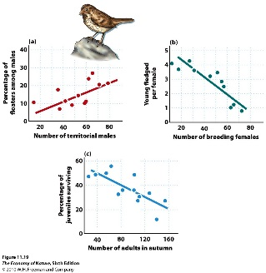
2. Effects of density on the intrinsic rate of increase r = (b-d)
- as the population increase is size, competition may cause an increase in mortality rate (d), a decrease in birth rate (b), or both.
- This occurs in animals (song sparrow) and plants
- competitive effects in plants also produce the “-3/2 self-thinning pattern”, in which the slope of the line describing the relationship between plant size and plant density has a slope of -3/2.
- Result
– produce an equilibrial density where b= d. This is called the “carrying capacity” and it is a function of a particular population in a specific environment; it is not a characteristic of one (population) or the other. In a different environment with more resources, for instance, the population may equilibrate at a higher density.
- The Model: Logistic Growth Curve
dN/dt = rN((K-N)/K)
- when the population is very small, (K-N)/K goes to one and the growth rate approximates the exponential maximum of rN.
- When the population is large and almost as large as K. then (K-N)/K becomes a very small fraction, and the growth rate of the population slows.
- When the population is at the carrying capacity, N=K, (K-N)K goes to zero, and the population does not grow… it has reached equilibrium where b = d.
- When the population is larger than the carrying capacity, then (K-N)/K becomes negative and the population declines in size.
The first bullet point here seems unrealistic. Can we believe that the smaller a population gets, the faster its rate of growth? Wouldn’t it be more difficult to find a sexual partner? Might there not be a minimum size that a population can reach and still maintain itself in the community without necessarily going extinct? Yes = Minimum Population Size, and it is modeled by Dn/dt = rN[(K-n)/K] [(N-m)/N].
4. Metapopulation Dynamics
In order for a population to persist through time, the probability of extinction in a habitat must be balanced by the probability that new colonists can ‘rescue’ the lost population and re-establish. Population size, and habitat area that affects population size, are the primary determinants of extinction probability. Small populations are more likely to go extinct. Populations exploiting a smaller patch are more likely to be small (limiting resources).
“Connectivity” of patches increases colonization probability. But habitat isolation degrease colonization probability. So, a population subdivided on small. Isolated patches has a high probability of going extinct, as each subpopulation winks out and is not replaced by colonization. This is imporatn because one of the primary affects that humans have had on natural habitats is to chop them up into smaller pieces, isolated by our development.

Community Ecology

I. Introduction

A. Definitions of Community
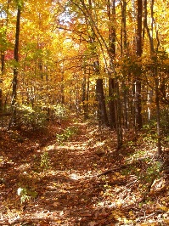
1. Broad:
- most ecologists define a community as an assemblage of populations interacting in the same place at the same time. In this context, they often identify the community by the ‘dominant’ species in the community, such as an “oak-hickory” community.
2. Narrow:
We can also define communities more narrowly – either functionally or taxonomically. So, we might refer to the “small-mammal community” of the southeastern U. S., which would include predatory mice like the grasshopper mouse, as well as seed-eating mice. Or, we might refer to a “guild” – which is a functional subgroup of populations in an area that use a common set of resources in similar ways. So, much as we might think of a guild of medieval craftsmen (‘clockmaker’s guild’) that all do similar things, we can use this in an ecological context, too. So, large carnivores are a guild on the plains of Africa.
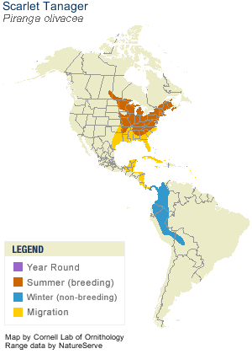
3. Complex:
- Finally, there might be energetic relationships between communities separated in space. Species might migrate between them, linking these communities into a ‘complex’. In this case, the dynamics of a population must be understood in both communities. For example, songbirds in the Eastern U.S. have been declining for the last 50 years, even though the forested habitat of the southeast has been increasing. How can this be? Well, these songbirds migrate to the tropical forests of central and South America, which have been shrinking over the last 50 years. So, the populations have been constrained by the loss of habitat in their wintering grounds, and their reproductive rate in the summer breeding grounds has not been enough to offset these loses.
- Likewise, we often think of terrestrial and aquatic communities as separate from one another… how can trees affect the amount of fish in a stream? But the trees transfer lots of energy to the stream system through their dropped leaves – energy that feeds the aquatic communities.
- Another example is the effect fish have on the reproduction of surrounding plants. Ponds without fish have lots of dragonfly larvae, which develop into dragonflies that eat pollinators and reduce plant reproduction. Fish eat dragonfly larvae, and thereby keep pollinator densities and plant reproduction rates high.

B. Key Descriptors
1. Species Richness
- this is simply the number of species in the community
2. Species Diversity
- species diversity includes some reference to the relative abundance of the species in the community. If all species are equally abundant, the community is very diverse. If there are species that are very abundant and others that are very very rare, then we would experience a less diverse community. Several indices measure diversity and are affected by changes in both richness and relative abundance (evenness).
3. Membership
- this is perhaps the most fundamental descriptor, but it is often overlooked because it is not quantitative. This refers to WHICH species are present – not the number of species or their relative abundance. Two communities could have the same richness and diversity, but contain completely different species.
4. Trophic Relationships
- This describes who eats who, and so describes the community in a FUNCTIONAL context. First, one must define the “nodes” or “interactors”. Typically, these are species. However, it may be that a group of species are ecologically similar and can be ‘lumped’ into one ‘trophic species’. Or, life history stages may be so different (like aquatic dragonfly larvae and adult flying dragonflies that prey upon and eat very different things) that one taxonomic species is divided into two or more trophic species.

D. Conceptual Models of Trophic Relationships

1. Elton – Trophic Pyramids
- In the 1920’s Charles Elton appreciated that organisms are involved in trophic relationships, forming “food chains” of producers, herbivores, and carnivores. He recognized that there were often rather consistent quantitative relationships among these levels, both ‘numerical’ (more plants than herbivores than carnivores), and in terms of biomass. He appreciated that there could be inversions in these relationships (lots of insects on one tree, or a small amount of insect biomass feeding lots of birds if the insects reproduced fast enough), but that PRODUCTIVITY… NEW BIOMASS PRODUCED / AREA / TIME COULD NOT BE INVERTED.

2. Lindeman – The Energetic Perspective
Ray Lindeman, working in the 40’s, explained these consistencies energetically, in terms of energy flowing from one level to another through trophic relationships. Critical to his understanding was an appreciation for the metabolic efficiency of the animals in the web and how that would influence the structure of the pyramid and food web. A community dominated by endotherms, like mammals, would necessarily be short (usually 3-4 links in a ‘chain’); endotherms are very inefficient metabolically, converting only about 10% of the energy they consume into biomass. This is CRITICAL, because it is ONLY the energy converted into biomass that is available to higher trophic levels. If a lion eats me, he only gets the energy stored as chemical bond energy in my molecules; he doesn’t get the energy I spend to keep my body temperature high, or the energy I spent running away from him. Food webs dominated by ectotherms – like marine food chains – can be much longer (7 links in a chain) because they are 50% efficient, transferring more of they energy they consume into biomass, meaning that more levels can be supported before there is too little energy at the top to support another level.
- The implication here is that the amount of herbivore biomass is influenced by the amount of food available; increase the amount of primary production and there will be an increase in herbivores and then an increase in carnivores. This describes “bottom-up” regulation of community structure.

3. Hairston, Slobodkin, and Smith (HSS) – “The World is Green”
In the 1960’s, these three ecologists developed a different conceptual model, based on the observation that there was a super-abundant supply of plant matter in the environment. Shouldn’t the herbivores be increasing as they consume these resources? Why weren’t they? HSS reasoned that the herbivores must NOT be limited by food… they must be limited by carnivores. So, carnivores increase and become limited by their food supply. As such, they are limited by COMPETITION for limiting resources. Because they are gobbling up herbivores, herbivore populations do not grow to their carrying capacity; they are limited by PREDATION and are kept at low densities. As a consequence of low herbivore biomass, plants are released from predation and grow until they are limited by COMPETITION for nutrients. So, competition and predation alternate as the primary determinants as you move down a food pyramid. In this model, the community is regulated from the “top-down”, and effects ‘cascade’ down the trophic pyramid, with competition and predations alternating as we go.

4. Leibold et al. (1997)
- They looked at the biomass of producers (phytoplankton) and herbivores (zooplankton) across more than 50 lakes. As phytoplankton biomass rose, zooplankton biomass rose, demonstrating bottom-up effects. Many of those lakes were later stocked with fish. This caused a reduction in zooplankton, and an INCREASE in phytoplankton released from herbivory – a top-down effect.

II. Multi-species Interactions within a Trophic Level

A. Additive Effects
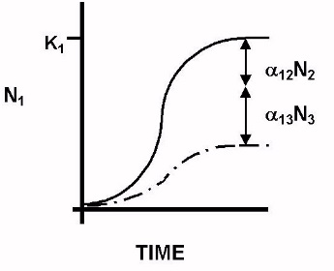
- the effects of competitors can be modeled very easily by Lotka-Volterra models; you would simply add a new term, describing the addition effects of multiple competitors. Some research has demonstrated that additive effects do, indeed, occur, such as the protist experiments by Vandermeer. He grew protists in pairwise combinations, and then predicted the outcomes in 3 and 4 species assemblages. The predictions were met reasonable well.

B. Non-Additive Effects
- non-additive effects can occur if the presence of a third species affects the impact of the second on the first, which is aN2. So, there are two ways a non-additive effect can occur – the addition of a third species can change the abundance of the second (N2), and thus the competitive impact, or it can change the nature of the interaction, itself (a).
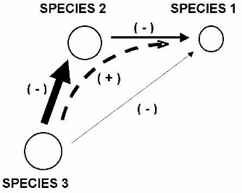
1. Indirect Effects: are mediated by changes in abundance. So, in the fly example, D. putrida was affected negatively by two other species. However, when all three species were present, D. putrida did better than when it was competing with D. tripunctata, alone. So, D. falleni had a direct negative effect on D. putrida (pairwise competition). But, it also had a direct negative effect on D. tripunctata – reducing the effect of D. tripunctata on D. putrida. “The enemy of my enemy is my friend”. Well, only when that common enemy is present. Once things revert to a two-species system, you are enemies again. Sort of like al-quaeda. When they were fighting Russia in Afghanistan, we perceived them as our friend fighting a common foe and we gave them lots of money and arms. Once the threat from Russia was over, the negative interaction between us and al-quaeda resumed. “The enemy of my enemy is my friend” is a very dangerous and fragile relationship, because it does not define the direct effect in the absence of the common enemy.
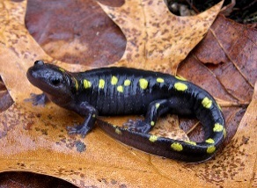
2. Higher-Order Interactions: are mediated by changes in the per capita competitive effect (a). These changes can be seen when abundances are kept constant and the effects are non-additive. In Wilbur’s (1972) experiment with salamanders, A. laterale was larger in the presence of two competitors than in the presence of either, alone. As density is not affected, the change must come in the per capita effect – which might be explained by the decrease in size.

C. Results
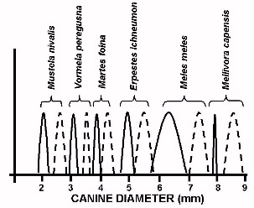
1. Species Packing: this is resource partitioning and character displacement at the community level. What we might expect to see is a non-random ordering of species along a resource or morphology axis. Dragonflies at Congaree National Park perch at heights that are evenly distributed. Weasel species in the middle east provide a nice example of morphological character displacement at the community level – the species are ordered with equal distances between them in canine width, correlating with differences in prey. The sexes also reduce intraspecific competition by shifting morphologically.
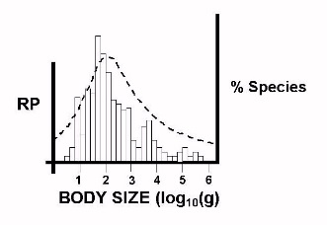
2. Optimal Body Size: For most species in a biologically similar group, there is a right skew to the distribution of body sizes… but a size that is most common. Brown (in another macroecological idea) suggested this might represent the ‘optimal’ body size for a group, based on two basic biological principles. First, the conversion rate of energy to offspring declines with body size; large organisms are not very efficient at converting energy to offspring – they harvest a lot of energy, but metabolic rates are slow and most energy is used for growth (not reproduction). However, energy intake increases with body size; larger animals have larger ranges and dissipate less energy to the environment as heat (smaller sa/v ratio). So, as a function of these two opposing relationships, and for a given group of biologically similar organisms, there should be an optimal body size. Now, we can think of body size as a niche, in a sense. There is a benefit to being at the optimal size (uh, that’s what optimal means). But, as the number of optimally-sized species in an area increases, they will compete with one another and the benefit of being that size will decline – just like the quality of a habitat niche as density increases. At some point, selection will favor species that are different from this optimal size… creating a skewed distribution.

III. Multi-species interactions across Trophic Levels
A. Keystone Predator Effects
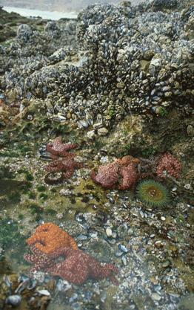
1. Paine (1966) – Rocky Intertidal
Seastars prey on a wide variety of sessile organisms, from mussels to barnacles to chitons. However, they prefer mussels, which are also the competitive dominant for space in the intertidal. Paine allowed and excluded seastars from areas and compared the responses of other species. Seastars exert a direct negative predatory effect on barnacles and other species, but they exert a stronger, positive, indirect effect by reducing the abundance of the competitively dominant mussels and releasing these species from competitive exclusion. At the community level, plots that had seastars excluded eventually became low diversity ‘monocultures’ of mussels, whereas plots where seastars had access were maintained as high diversity systems with open areas for the colonization and settlement of new species. He coined the term “keystone predator” – the “keystone” of community structure that supports the diversity of the system.
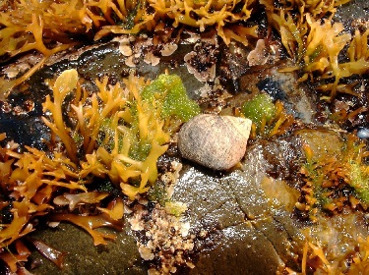
2. Lubchenco (1978)
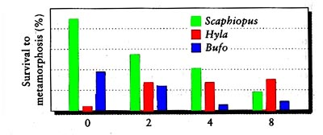
Looked at how keystone effects change in different environments and at different levels of predation, using the periwinkle Littorina littorea and its grazing effects on algal diversity. The green algae Enteromorpha is the competitive dominant in tide pools over the red algae Chondrus, but competitive abilities are reversed on emergent rocks in the intertidal. Snails prefer Enteromorpha everywhere. So, in tide pools, you get a classic keystone effect from low to intermediate snail densities, as the predator preys on the competitive dominant, reducing its abundance and releasing competitively subordinate species from competition. As snail densities increase, however, they eventually eat everything in the tide pool and reduce diversity. On emergent rocks the effects were different, as Enteromorpha and palatable algae got hammered by BOTH competition and predation – so diversity decreased monotonically as snail density increased. This highlights that the impact of predation depends on the foragin preferences of the predator, the competitive abilities of the prey, and density effects of predation.
3. Morin (1983) Looked at the effect of predation by red-spotted newts on diversity in anuran communities. In the absence of predators, Scaphiopus (spade-footed toads) and Bufo (American toads) tadpoles competitively excluded Hyla (treefrog) tadpoles. Newts preferentially feed on large tadpoles (Scaphiopus and Bufo), and so as predator abundance increases, their densities declined and the abundance of Hyla increased – increasing species diversity in the community. This was the first demonstration of a keystone effect in a vertebrate system.
4. Worthen (1989)
In three species of drosophilids, D. tripunctata competitively dominates over D. putrida and D. falleni. Add a predaceous rove beetle that eats larvae of all three species, and the competitive intensities are reduced and the competitively subordinate species do better; even though all species are eaten.
B. Apparent Competition
- We tend to perceive competition as occurring when an increase in one species causes a decline in another species at the same trophic level. However, indirect effects can cause these same patterns without competition occurring. Consider two species eaten by the same predator. Suppose one increases for some reason (immigration)… this provides more food for the predator, and their population increases. This causes a decline in the second species of prey. So, we might observe an increase in one prey species (by immigration) and a decline in another prey species – looking like a competitive effect but mediated through a shared predator.

So, the take home message is this: most natural communities contain lots of species that are interacting in complex ways, having both direct and indirect effects on one another. Although we might discern some large scale patterns like keystone effects on diversity, our ability to predict the effects of losing a species by extinction or gaining a species by introduction of non-natives is very very low. We have no real idea of how the loss or gain of particular species will affect the diversity of the system… yet we unwittingly change these things all the time – threatening the collapse of the system. There ARE keystone species. Because of these networks of interactions, we might remove one species purposefully, only to have a negative impact on a keystone species whose loss causes the system to collapse.

STUDY QUESTIONS
1) An organism is confronted by many environmental variables simultaneously. Adaptations are rarely perfect solutions; rather, they are efficient compromises that weigh the relative importance of particular stresses. Consider the contradictory pressures on a plant of maximizing irradiation for photosynthesis, while maximizing water retention (and minimizing water lost by evaporation as leaf temperature increases). Considering this trade-off, explain why plants in rainforests and grasslands have different sized leaves.
2) How does a limited energy budget impose constraints on the components of fitness?
3) What two trade-offs arise as a consequence? Provide an example for each.
4) How can these allocation patterns change under different environments? Provide an example.
5) Contrast r and K life histories life histories.
6) Define populations.
7) Distinguish between the ‘fundamental’ and ‘realized’ niches.
8) What is a ‘limiting variable’?
9) How can elevational shifts occurring with climate change cause a reduction in habitat size and a decrease in the size of montane populations?
10) Why do source-sink models predict that certain populations, exploiting certain habitat patches, would more likely be donors (sources) than other patches? (This makes it more complex than simple metapopulation models).
11) Landscape models consider the effects that a heterogenous matrix might have on 1) patch quality and 2) migration rates between patches. Explain the two effects. Why does this become important for people trying to conserve rare species?
12)What is the equation for exponential population growth? Define the terms and show how it works, graphically.
13) In terms of life history adaptations and maximizing reproductive success, when will delaying reproduction be favored? Why is early reproduction such a boon to long-term genetic domination in a population?
14) How can changes in the birth rate or death rate with increasing population size result in the population stabilizing at an equilibrium, rather than continuing to increase exponentially?
15) Outline Malthus’s argument for the importance of density dependence.
16) Write the logistic equation and explain how the new term (K-N)/K works to damp growth at high N.
17) How does species richness differ from a diversity index?
18) Why are food webs with endotherms shorter (fewer levels) than those with ectotherms?
19) How should increasing primary productivity affect biomass in higher levels if bottom-up forces dominate? How about in a three-level community where top-down forces dominate?
20) What is meant by the term “non-additive effects”? Give an example.
21) There is an interesting, common pattern in body sizes in biologically similar groups. What’s the pattern, and how does Brown explain it?
22) Describe the experiments of Paine and Lubchenco, and state their major conclusions.
23) A food chain is a linkage describing the direct effects between a plant, herbivore and carnivore. What is different about a food web, especially in terms of the types of interactions that are possible? What does this do to our ability to predict the effect of gaining or losing a species?
24) What is a minimum viable population, why (biologically) might it occur? So, can we maintain all natural populations on small pieces of natural habitat?

