Lecture 5: Reproduction and Heredity
Overview:
So far, we have described how special the Earth is, and how water and life have made it (and KEEP IT) so different from any other place we know about in the universe. Then, we began a consideration of how life works – how the molecules it is made of allow cells to take in matter (diffusion, facilitated diffusion, and active transport, right?), harvest energy (with protein catalysts known as enzymes), and use a molecular program (DNA and RNA) to store and access the recipes for proteins… which really do all the work of the cell and of living things composed of cells. So, we have described the planet and how life works. That’s pretty impressive progress for one week!
This week we will discuss another important aspects of living systems… that they can evolve and change. This has always been critically important characteristic of life, because the environment has not always been the same on Earth, as we know. Living things that could adapt to changing conditions have persisted, while those that cannot have perished. As such, “adaptability” is now a characteristic of life. The idea that living things change is one of the greatest contributions to knowledge, so we will look at that how we can to know this fact, as well.
When we say a population “evolves”, we mean that it changes somehow over time, from one generation to the next. The organisms in the population are different from their ancestors, either physiologically (they make new proteins and can eat new things), structurally (they are bigger or now have feet instead of fins), or behaviorally (they act different). Because genes influence these attributes, and because genes are all that is passed down through generations, the combination of genes that have been inherited must have changed, in order for these biological attributes to change. So, to understand evolution, you must understand what genes are and what they do (you know this – they are regions of DNA that code for a protein), and you must understand how they are passed from one generation to the next. These are the topics we discuss today: reproduction (of DNA and cells) and the patterns of genetic relatedness that reproduction through time produces (heredity).
I. Reproduction

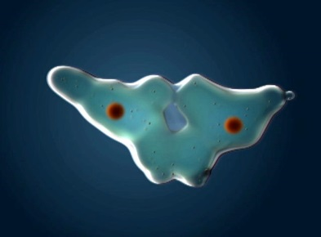
A. Overview: Why Reproduce?

Living systems reproduce. In many ways, reproduction seems like the most purposeful thing that living systems do. Indeed, most nature shows describe this attribute as a "desire", "goal" or "urge", often described in these same shows as a process performed "in order to perpetuate the species". Well, it is currently impossible for us to ascertain the "desires", "goals" or "urges" of an ameoba or an oak tree; or whether the amoeba or oak tree is 'thinking' about the survival of its species as it reproduces. Thankfully, Darwin's theory of natural selection absolves us from having to understand "desires" - it explains the existence of complex physiology, morphology, and behavior as a function of the relative benefit of that trait to relative reproductive success.
In this context, the adaptive value of reproduction is as obvious as the difference between "1" and "0". Think about it this way: the natural world is a dangerous place. It is exciting and fun for a while, but all living things will eventually die as a consequence of encountering an environment in which they cannot survive (flood, fire, heat, or cold), or being eaten by a predator, or infected by a pathogen, or simply by accident. So, the only life forms that will persist through time are those that copy themselves at a faster rate than they are dying. This works from the cell level through the populational level, and even at the phylogenetic level with respect to the persistence of particular lineages through geologic time. So, for any population of cells or individuals, if the birth rate remains lower than the death rate then population will eventually go extinct. In a multicellular organism, if the rate of cell production is lower than the rate of cell death, the organism will waste away, losing tissue mass. At a geologic scale, lineages that produce species faster than the extinction rate will persist longer through time that lineages where the rate of speciation is lower than the rate of extinction. So today, when we look at the entire diversity of the living world, we only see descendants of those life forms that reproduce effectively, and have inherited this capacity to reproduce, as well.
For prokaryotes, cell reproduction occurs by binary fission. For eukaryotic cells, cell reproduction occurs by mitosis and has specific stages. In single-celled protists, mitosis produces two new organisms. In multicellular organisms, mitosis produces new cells that can replace dead cells or increase the number of cells in the organism. As the number of cells increases, the multicellular organism grows. Growth is usually a good thing. First, the bigger you are, the fewer things can eat you. Second, becoming larger through multicellularity allows for the increased efficiency and functional diversity of cell specialization.
B. Mitosis: Cell Division (Reproduction)
1. Why is cellular division beneficial?
- First, only cells that divide (or organisms that reproduce) will persisit through time, as we described, above. But there are two other reasons.
-Second, as cells grow, they become less efficient, energetically. Consider a cube-shaped cell, 1 mm on a side. Each side is 1 x 1 = 1 mm². Our cube-shaped cell has six sides, so the total surface area of the cell is 6 mm². This surface area is the MEMBRANE, and this quantity determines the rate at which needed materials can be absorbed across the membrane by the cell. You can think of surface area (SA) as limiting the “supply” of nutrients. What determines the “demand”? Well, that is the volume of the cell, where the enzymes are and where reactions are occurring that, say, harvest energy from the material that is absorbed. Volume is a cubic dimension, so a cell 1mm on an edge has a volume (V) = 1 x 1 x 1 = 1mm³. So, for our cell, the “supply” rate can easily satisfy the “demand”: the ration of SA/V = 6/1. But what happens as the cell grows, as a consequence of efficiently metabolizing these nutrients and changing them into proteins, phospholipids, and carbs? Suppose it doubles in linear length to 2 mm on an edge. Each side = 2 x 2 = 4 mm², and the total surface area is 6 x 4 = 24 mm². WOW! That’s great! The cell doubled in length, but the surface area increased 4-fold! This is because the SA increased as the square of the change in length, so length increased 2-fold but SA increases 2² = 4-fold. Hmmmm… see the problem that’s coming? The volume will increase by the cube of the length; for a cube-shaped cell that is 2mm on an edge, the volume is 2 x 2 x 2 = 8 mm³. Volume increases at a higher rate than SA, so the ratio of SA/V decreases… from 6/1 to 24/8 = 3/1. As a cell increases in size, the SA quickly becomes unable to “feed” the volume efficiently, and metabolic rate slows to the rate limited by the SA.
This is why there are no huge blob-like monsters composed of a single cell. They are way to inefficient, metabolically, and can’t replace the materials that are used or damaged inside the cell fast enough.
To maintain energetic efficiency, it is better to divide into two smaller cells.
-Third, cell division means that there are now two cells, in close proximity, that are genetically identical. They can do all the same things. If they were to divide and divide, there would be thousands of cells that could all do the same things. At this point, this group of cells can increase their collective energetic efficiency through a process known as “the division of labor”. Instead of each cell making everything it needs, cells in the group can specialize, efficiently making only a few things. Collectively, everything gets made, but now even more efficiently. This requires that the cells communicate and act together. It is possible that bacteria in stromatolites acted in this manner – bacteria that form mats in biofilms often show some degree of cell specialization. Of course, cell specialization is the hallmark of multicellular eukaryotes: plants fungi and animals that have radiated so dramatically in the last 500 million years, in part because of their ability to evolve new specialized cells that can perform new functions and form new structures.
2. How do cells divide?
Cell division is the process of producing two functional 'daughter' cells from one ancestral 'parental' cell. In order for both of the daughter cells to have the full functional repertoire of the original parental cell, they must be able to make the full complement of proteins that the parent cell makes. In order for this to happen, they must both receive the full complement of genetic information (DNA) in the parental cell. Hmmm.... how can they BOTH get the FULL COMPLEMENT of genetic information in the parental cell? Well, in order for this to happen, the parental cell must duplicate its DNA prior to cell division. This process of DNA replication produces two full complements of genetic information. Then, this genetic information must be divided evenly, in an organized manner, to insure that both daughter cells get the complete complement of information (and not a duplication of some information or an omission of other information). Cells that receive an incomplete complement of genetic information will not be able to make all the proteins the parental cell made, and may not be able to survive. So, again, DNA replication and the process of mitosis are of great selective, adaptive value. Only cells that replicate and divide their genetic information evenly, with only minor errors or inconsistencies, will be likely to survive. These survivors will pass on the tendancy to replicate and divide their genetic information evenly, as well.
These processes of DNA replication and mitosis are only two stages in the life of a cell. To place them in context, it's useful to consider the full life of a cell, from it's production by the division of its parental cell through to its own division.

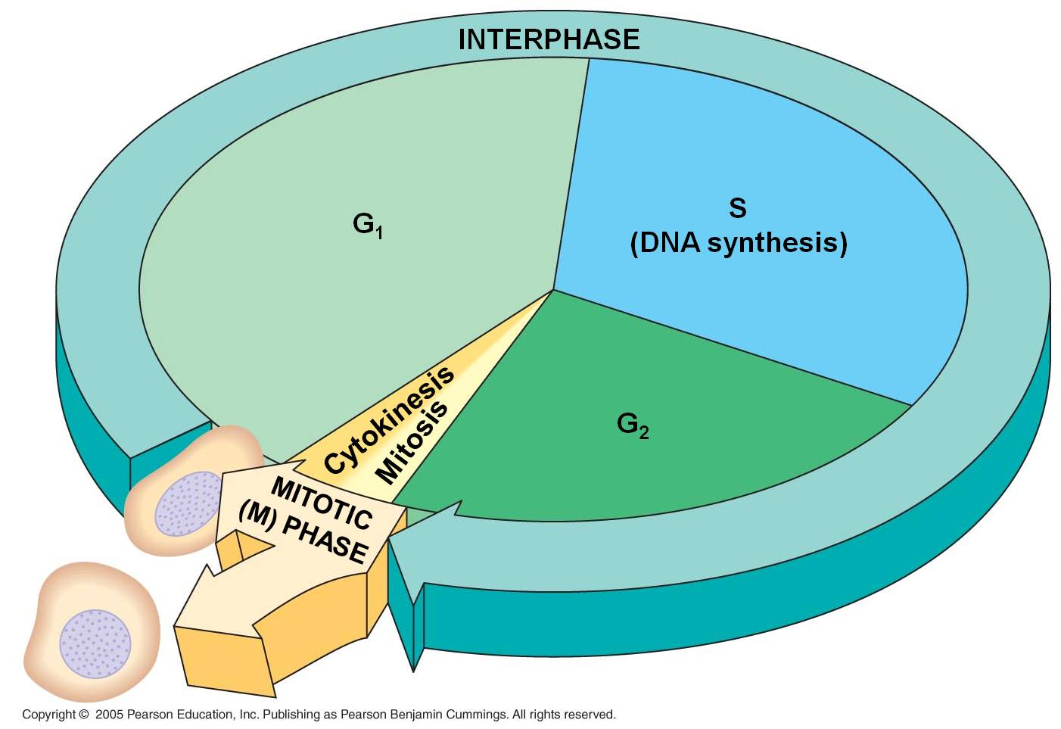
a. The Cell Cycle
1. Interphase - the 'interval' between divisions
a. G1
Our cell's life begins. That's sort of a funny way to put it, because it seems to suggest that it is something new; yet all of its constituents were part of the original parental cell. It is more truly "1/2 an old cell with a full complement of DNA". Nevertheless, it is an independent entity. In most protists, binary fission of the mitochondria and chloroplasts occurs concurrently with the division of the nucleus during mitosis, so the daughter cells have 'new' organelles, too. But in most multicellular organisms, the allocation of organelles is largely a random process based on how they are distributed in the cytoplasm during division. Then, the organelles divide and 'repopulate' each daughter cell in G1.
The cell is roughly 1/2 the size of the original parental cell. To grow to its appropriate size, it must synthesize new biological molecules - and that means making the enzymes that will catalyze those reactions. So, the DNA unwinds to the 'beads on a string' level, and the genes between histones are available for transcription. When the DNA is unwound ('diffuse'), separate chromosomes cannot be seen with a light microscope. Rather, the nucleus stains a uniform color except for one or several dark regions called 'nucleoli' (singular = nucleolus). These are areas were large amounts of r-RNA are being synthesized and complexed with ribosomal proteins into functional ribosomes. The ribosomes are exported from the nucleus to the cytoplasm, where they will anchor to endoplasmic reticulum or the cytoskeleton.
Indeed, the G1 phase of a cell's life is the most metabolically active period of it's life. It is growing in size, and producing the proteins appropriate for its tissue type. Most cells in multicellular organisms specialize during this period. Cells with very specific structural adaptations to their specialized tissue type - like neurons with long axons and muscle cells crammed with linear microfilaments - often remain stalled in this stage after they become specialized; they do not divide again. In this case, this stalled 'permanent' G1 phase is referred to a G0 ("G-nought').
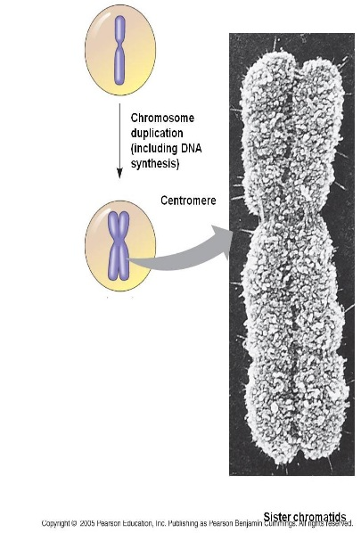
b. S
The S phase of the cell cycle is when DNA replication occurs. The chromosomes are diffuse during this stage, as well, so the enzymes (DNA polymerases) that replicate the DNA can access the helices. Each double helix is separated, and the single strands are used as templates for the formation of new helices on each template - changing one double helix into two. Terminology becomes a bit ambiguous here. A DNA double helix is equivalent to a "chromatid". A chromosome may have one chromatid (in its unreplicated form) or two chromatids (in its replicated form). DNA replication is a rather complicated process described in more detail below. The transition from the G1 to the S phase is a very critical stage in a cell's life cycle, signalling the cell's progression towards division. In eukaryotes it is called a 'restriction point'. Once the S phase begins, the cell will proceed through to mitosis. This transition is orchestrated by a complex interplay of transcription factors that regulate the activity of "cell division cycle genes". These genes produce cyclin proteins that vary in concentration through the cell cycle. They bind with 'cyclin-dependent kinases' and these cdk-cyclin complexes activate transcription factors that initiate the next phase of the cell cycle.
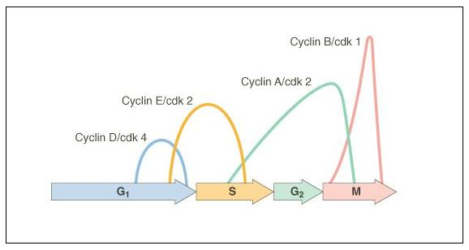
The timing of the G1/S transition is very important. During the G1 phase, the DNA is 'checked' by repair enzymes... mismatched bases and other mutations are corrected. It is important that the G1 lasts long enough for DNA repair to take place; otherwise any errors will be copied during DNA replication and mutations will be passed to the next generation of cells. There are several proteins that inhibit the progression of the cell cycle - the most notable is called p53. This protein is a cell cycle inhibitor, indirectly causing the inactivation of cdk-cyclin complexes that would stimulate the onset of the S phase. Mutations in this gene can make the protein non-functional; so cdk-cyclins are not inhibited, and the onset of S happens quickly and prematurely - before DNA repair is completed. This mutation is passed to the daughter cells, too, along with all the other uncorrected mutations. These mutations accumulate with each generation of cell division, affecting other genes that influence cell function and specialization. This unregulated division of undifferentiated cells creates a cancerous tumour. There are several other 'tumor suppressor' genes, but mutations in p53 occur in 70% of small cell lung cancers, 80% of non-melanoma skin cancers, and 60% of colon cancers. Obviously, correct regulation of the cell cycle is critical to correct cell function and maintaining the integrity of DNA.
c. G2
After DNA replication is complete the cell goes through another rapid period of growth in preparation for mitosis. The DNA is checked again for damage caused and errors made during DNA replication. Once again, p53 inhibits the transition to the mitotic phase, providing time for this repair to take place. In cancer cells with mutations in p53, the G2 phase may be nearly eliminated, with the cell proceeding directly from DNA replication to mitosis. CDK's bind to new cyclins, and these complexes active a different set of proteins that initiate mitosis.
2. Mitosis
The process of mitosis can be summarized as follows: the chromosomes condense, making it easier to divy them up evenly. The replicated chromsomes are aligned in the middle of the cell by cytoskeletal fibers. Each chromosome consistes of two identical double helices, called chromatids. During the process of mitosis, these chromatids separate from each other, and one double-helix from each chromosome is pulled to each end of the cell. The membrane and cytoplasm are divided and the nuclear membrane reforms around the chromosomes in each daughter cell. We will look at this process in more detail, below.

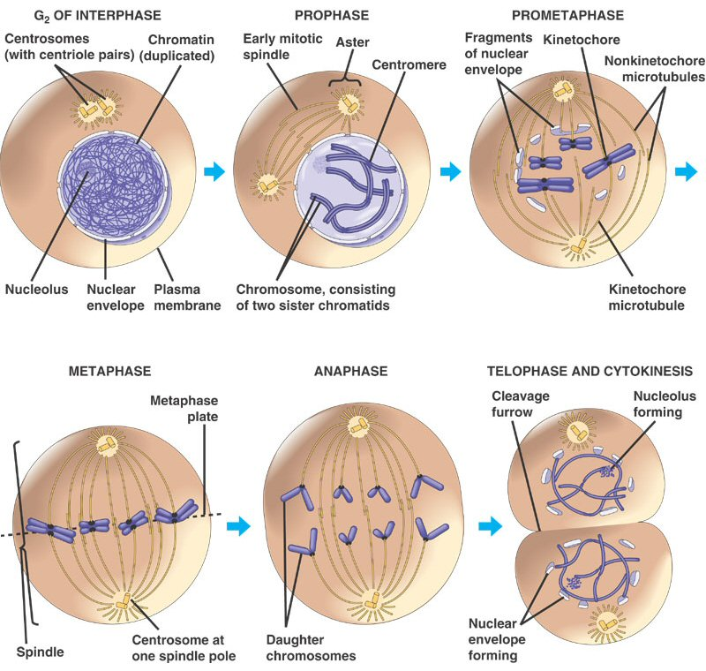
Mitosis is a continuous process of chromosome condensation, chromatid separation, and cytoplasmic division. This process is punctuated by particular events that are used to demarcate specific stages. This process was first described by Walther Flemming in 1878, we he developed new dyes and saw 'colored bodies' (chromo-somes) condensing and changing position in dividing cells. He also coined the term 'mitosis' - the greek word for thread - in honor of these thread-like structures.
1. Prophase: The transition from G2 to Prophase of Mitosis is marked by the condensation of chromosomes.
2. Prometaphase: The chromosomes continue to condense, and the nuclear membrane disassembles. The microfibers of the spindle apparatus attach to the kinetochores on the replicated chromsomes.
3. Metaphase: The spindle arranges the chromosomes in the middle of the cell.
4. Anaphase: The proteins gluing sister chromatids together are metabolized, and the sister chromatids are pulled by their spindle fibers to opposite poles of the cell. It is important to appreciate that these separated chromatids (now individual, unreplicated chromosomes) are idnetical to one another and identical to the orignial parental chromosome (aside from unrepaired mutations).
5. Telophase: The cell continues to elongate, with a concentrated set of chromosomes at each end. Nuclear membranes reform around each set of chromosomes, and the chromosomes begin to decondense.
6. Cytokinesis: Cytokinesis is sometimes considered a part of telophase. In this stage, the cytoplasm divides. In animal cells, the membrane constricts along the cell's equator, causing a depression or cleavage around the mid-line of the cell. This cleavage deepens until the cells are pinched apart. In plants, vesicles from the golgi coalesce in the middle of the cell, expanding to form a partition that divides the cell and acts as a template for the deposition of lignin and cellulose that will form the new cell wall between the cells.
As a consequence of this process, two cells are produced from one parental cell, each having a complete complement of genetic information - a copy of each original chromosome that was present in the parental cell. Each of these cells now begins the G1 phase of interphase.
C. Sexual Reproduction and Meiosis
1. Why sex?
a. Types of reproduction and sex

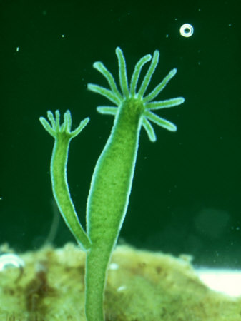
We have already considered the broader of issue of reproduction, itself. And we have examined one type of reproduction - mitosis. Although mitosis is the way that single eukaryotic cells divide, it is important to appreciate that, for single-celled eukaryotes (protists), like Paramecium and Ameoba, this is a mechanism of organismal reproduction, as well. In addition, many organisms that are multicellular use mitosis as a form of organismal reproduction. For example, many plants grow lateral 'runners' along the ground or under the soil. From the end of this runner, a new bud can develop that grows roots and shoots. This bud can grow into an individual plant that is capable of living on its own, even after the runner is cut. All the cells in this new independent plant were produced by mitotic divisions from the parent plant. Indeed, this new plant is genetically identical to the original plant - it is a 'clone'. Fragmentation is another example of clonal reproduction in plants, where a branch that is broken or cut from a plant takes root and becomes in independent organism. This is more common for aquatic plants, where the broken fragment can stay alive and not dry out while it grows its own roots. Clonal reproduction also occurs in many animals. Corals and Hydroids (like the Hydra pictured at right) will grow a new polyp by mitotic division, and this polyp can 'bud off' the parent and become a new independent organism. In these cases, an offspring has been produced by a parent through mitosis, alone. The offspring is genetically identical to the parent. This clonal form of reproduction is also called "asexual reproduction".
Sexual reproduction represents the formation of a new genotype. This occurs in a number of ways in nature. In bacteria, genes can be donated from one cell to another, or even absorbed from the environment. This changes the genotype of the bacterium the receives these new genes. A new genotype has formed, even though there is no organism produced. Many protists have multiple nuclei, and they exhibit a form of sex by exchanging micronuclei during conjugation. This also forms new genotypes without forming new organisms.
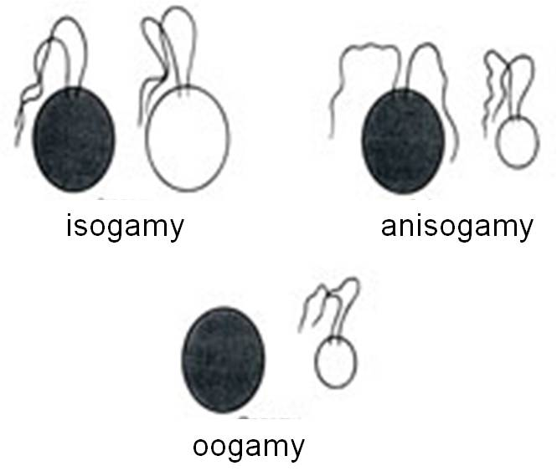
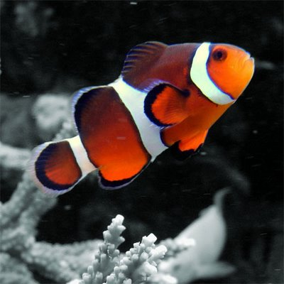
Typically, however, sexual reproduction occurs through the fusion of specialized reproductive cells called gametes. In some organisms (like fungi and some algae), the gametes are all about the same size and are usually motile (with flagella). These species are called isogamous (iso = equal). These species don't really have 'males' or 'females'. Anisogamous species have two distinctly different sized gametes that may still both have flagella. From this stage, oogamy evolved, in which the larger gamete became an unflagellated egg. In hermaphroditic or monoecious (one house) species (like many plants and invertebrate animals, and a few rare deep-sea fish), single individuals produce both sperm and egg in different organs. In dioecious (two 'houses') species, individuals are either male or female. Males are defined as the sex that produces sperm, while females are defined as the sex that produces the large egg. This is a more comprehensive way to define a sex, allowing us to define sexes in species where the sexes are morphologically indistinguishable. Many fish, for instance, lack genitalia and simply excrete their gametes - egg or sperm - into the water for fertilization. In some species, individuals change their sex as they develop and age. This is called sequential dioecy or sequential hermaphrodism. Organisms that are males first and then change to females are called protandrous, while individuals that are females first and then change to males are called progynous.
As you can see from this introduction, sex is a lot more complicated than you might have thought. It can involve the production of new organisms, or only new genotypes. It can involve multiple sexes, or just two sexes. It can involve organisms that are one sex, two sexes, or change sex, and organisms that mate with themselves. However, even given all this variation, the common element in every case of sexual reproduction is the production of a new genotype. In asexual reproduction, the daughter cells are nearly identical to the parent cell (except for rare mutations). Next, we will compare the adaptive benefits of each type of reproduction. And remember, adaptations are traits that increase the reproductive success of a genotype in a given environment.

b. The Costs and Benefits of Asexual and Sexual Reproduction
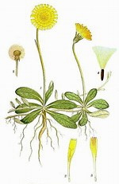
In Asexual Reproduction (cloning), the probability of mating is high - you don't need to find a mate! And, all else being equal, reproductive output and the transmission of genetic information to the next generation should be high. In fact, asexual reproduction maximizes the transfer of parental genes to the next generation: every offspring receives the entire genome of the parent. So, in terms of "differential reproductive success" (what's that? - you'd better know!!!), asexual reproduction has a quantitative edge in getting parental genes into the next generation. In a constant environment, the offspring should all do well (they have the parent's genome, and the parent survived and reproduced in this environment with that genome). So, when the environment is stable, the probability of offspring survival and reproduction should be high. So, in a constant environment, clonal/asexual organisms should reproduce easily and quickly, and their offspring should thrive and reproduce.
But, there are down-sides or “costs” to asexual reproduction. Mutations occur, and most are deleterious (have negative effect). From one generation to the next, these mutations will accumulate in a lineage because every parental gene is passed to the offspring. There is no way to "get rid" of bad genes or deleterious mutations.... this is called "Muller's Ratchet". Selection can weed out bad genes from a population, but over time all lineages will be burdened by the accumulation of deleterious genes. Mutations become the only source of beneficial, adaptive variation. Because mutation rates are low, reproduction must be very rapid (prodigious, like bacteria), to create enough variation through mutation, alone, to by chance produce something new and useful. Finally, few environments on Earth are stable over the long term. When an environment changes, survival of offspring will be an "all or none" affair. If that genome can't survive in the new environment, then all the offspring die and that lineage comes to an end. Over time, we might expect every lineage in a species to encounter an environment to which it is not suited, resulting in the extinction of the species.
Sexual reproduction has the opposite costs and benefits. For organisms that cannot mate with themselves, sexual reproduction can be an energetically expensive behavior. There are energetic costs to finding and acquiring a mate. In addition, only 1/2 a parent's genes are passed to each offspring; so it is not as effective at transmitting parental genes to the next generation as asexual reproduction. Many offspring will inherit combinations of genes poorly suited for the environment - or at least more poorly suited than the parental combination. In the luck of the draw, some offspring may receive most of the parents' 'bad' genes. But there are significant benefits. Since each offspring inherits only 1/2 the genes from each parent, deleterious genes can be purged from a lineage just be chance. In other words, just by chance, many of the offspring will have 'lucked-out' and will not inherit any of the new, deleterious mutations produced in the preceeding generations. This eliminates the effects of Muller's ratchet. And, most importantly, by combining genes from two parents, or by exchanging genes between organisms, new variation is produced MUCH more rapidly than by mutation, alone. Although many of these new genetic combinations may perform worse than the parents in a given environment, some may perform better. Better combinations will be able to harvest energy and convert it into offspring more effectively. In other words, "better" means better able to survive and reproduce in an environment. These organisms, and the combinations of traits they carry, will be “selected for” by the environment. When the environment changes (and it almost always will), it is more likely that, among the variable genomes produced by sexual reproduction, there will be a genome that can tolerate (if not excel) in this new environment. So, over the long term in changing environments, asexual lineages are likely to meet an environment they can't tolerate and go extinct, while sexual lineages are more likely to persist.
Many organisms reproduce asexually. Indeed, for many organisms like bacteria, asexual reproduction is the primary mode of reproduction. Asexual reproduction is adaptive when environmental conditions are stable; it is a highly effective way for a genotype or lineage to 'out reproduce' other genotypes or lineages in the environment, and acquire limiting resources. However, because sexually reproducing species produce more variation per unit time, sexually reproducing species will adapt more rapidly to environmental conditions. In a changing environment, this means that sexually reproducing species can continue to adapt with the changes in the environment, while asexual lineages go extinct as they meet up with environments that they can't tolerate. The exception proves the rule here. If we look at organisms that reproduce asexually most of the time, we can ask "under what conditions do they switch to a sexual mode of reproduction?" The answer is usually: "when the environment changes." It is precisely under changing conditions that sexual reproduction is adaptive.

2. Meiosis – Gamete Formation
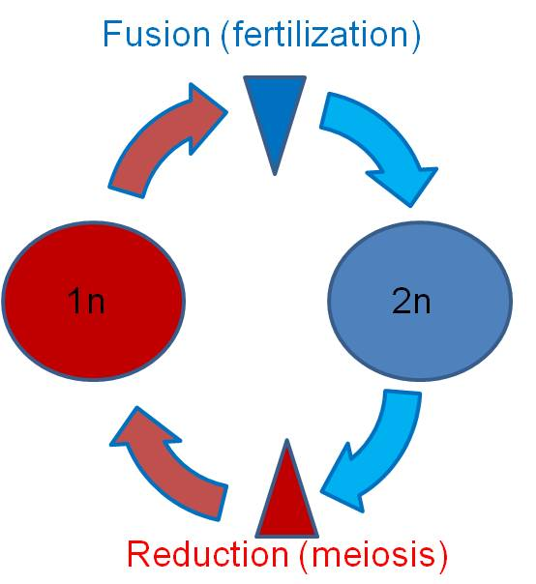
a. How? - Reduction and Fertilization
There is a big benefit to combining genes from different organisms - new variations are produced that may be adaptive. Some organisms donate genes between cells, others trade nuclei. But for most sexually reproducing organisms, this mixing of genomes occurs through the production of specialized cells called gametes that fuse to form a new genotype and a new organism.
There is a problem to fusing normal body cells to produce this variation. By fusing body cells, the number of chromosomes and the amount of genetic information doubles each generation. As we'll see, many of the chemical reactions and patterns of genetic regulation depend on a constant balance of enzymes and substrates, and a constant balance of particular proteins. Doubling the genetic information can disturb these quantitative relationships. In addition, fusing body cells does not escape the constraints of Muller's ratchet - all genes are passed to offspring and the offspring now acquire all the bad genes from BOTH parents.
The solution that life evolved is a new process of cell division - meiosis. In this process that produces specialized reproductive cells, the genetic information is halved. This halving is also called reduction. If the cells produced by this process are gametes (remembering that plants and fungi use meiosis to produce spores), then the fertilization of sperm and egg reconstitutes the appropriate set of genetic information for that species.
b. Overview of the Process:
Meiosis has two cycles of division, preceded by an interphase containing a G1, S, and G2 phase. So, the cell entering meiosis has replicated chromosomes. The first cycle is called Meiosis I, or the reduction cycle. A diploid cell containing two sets of replicated chromosomes divides and produces cells that are haploid, containing one set of replicated chromosomes. The second cycle is Meiosis II, also called the division cycle. In this cycle, the haploid cells divide in a manner much like mitosis. In other words, the sister chromatids of each replicated chromosome are separated, but there is no change in ploidy. The haploid cell with replicated chromosomes divides into haploid cells with unreplicated chromosomes.
3. Meiosis – The Process
Meiosis I (Reduction)
a. Prophase I:
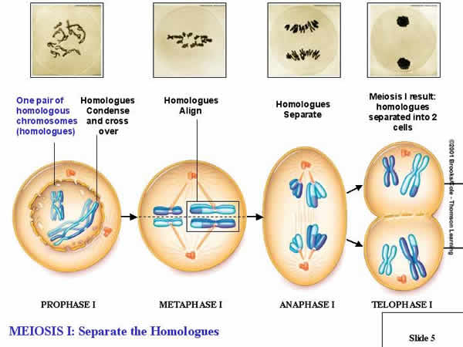
- The chromosomes condense as paired homologs.
DEFINITION: Homologous chromosomes govern the same suite of traits, but may affect those traits in different ways. So, if there is a chromosome with a gene for purple flower color at a particular spot (locus), then it's HOMOLOG will also have a gene for flower color at that same spot... but it might be a different ALLELE for flower color (white).
- As condensation occurs, replicated, homologous chromosomes pair up. Each replicated chromosome has two chromatids, so the pair of homolos for a structure with four chromatics - a 'tetrad'. Piece of chromosome can be exchanged between homologs. This is called 'crossing over' . This creates new combinations of genes on chromosomes. we will consider this in more detail in a couple days.
- As the spindles join to paired homologs, the spindle fibers from each pole can only attach to ONE homolog or the other.
b. Metaphase I:
- THIS IS THE MOST IMPORTANT STEP, AND THE THING THAT DISTINGUISHES MEIOSIS FROM MITOSIS... Homologous pairs line up on the metaphase plate (NOT in single file as in mitosis, but as PAIRS).
c. Anaphase I:
- Whole, replicated chromosomes are drawn to each pole by the spindle fibers. So, if the 'A' chromosome goes to one pole, the 'a' chromosome goes to the other.
d. Telophase I:
- The cytoplasm divides; each new cell has only ONE chromosome from each homologous pair. If the cell started with 4 chromosomes (2n = 4), NOW each daughter cell has only 2 chromosomes (1n = 2). This is REDUCTION, and it is the most important part of Meiosis. It occurs because homologs pair up in metaphase I, rather than lining up in single file as in mitosis.
An optional interphase:
The transition from meiosis I to meiosis II cay vary between species. In some species, the nuclear envelope reforms around the chromosomes in each nucleus. There may even be an interphase in which the chromosomes decondense, protein synthesis occurs, and the cells grow. However, no S phase occurs in this interphase - the chromosomes are already in their replicated state. If this interphase does occur, then Prophase II begins with the condensation of the chromosomes and the breakdown of the nuclear membrane.
In other species, the cells proceed directly from Telophase I to Prophase II; the chromosomes are already condensed and the nuclear membrane is already broken down. In this case, the only thing that happens is that a new spindle forms, attaching each chromosome to both poles of the cell.
Meiosis II: (Division):
a. Prophase II:
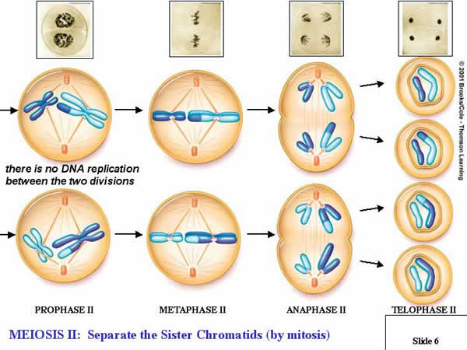
Depending on the transition, events proceed such that the new spindle apparatus attaches condensed chromosomes to both poles of each cell produced in the reduction cycle (Meiosis I).
b. Metaphase II:
Replicated chromosomes line up in single file on the metaphase plate, in the middle of each cell.
c. Anaphase II:
The chromatids in each replicated chromosome are drawn to opposite poles in each cell.
d. Telophase II:
The nuclear membranes reform while cytokinesis divides the cells.
video
5. Modifications in Anisogamous Species:
In isogamous species and in homosporous plants (that produce one type of spore by meiosis), the reproductive cells produced by meiosis are all the same size. In this case, the process works as described above, and one parental cell produces four equal-sized daughter cells.
In anisogamous species (and in heterosporous plants that produce different sized spores by meiosis), the reproductive cells produced by male and female organisms vary in size. Although the division of the genetic material occurs in the same way (creating daughter cells that a have exactly half of the genetic information of the parent cell), the division of the cytoplasm differs in these processes.
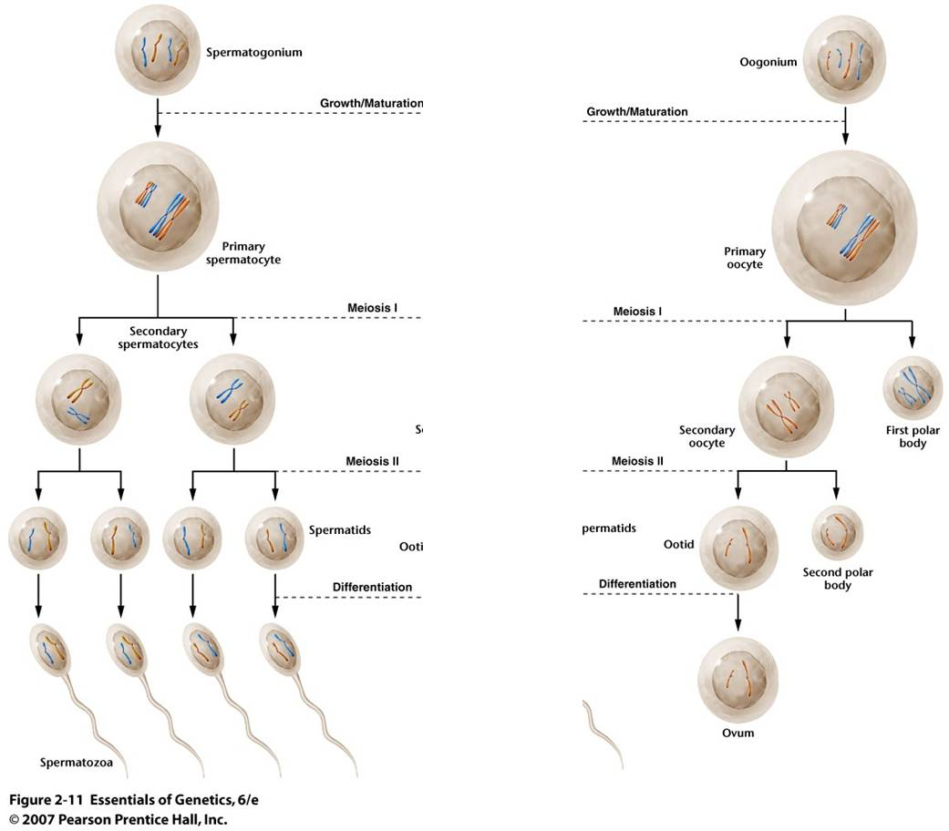
a. Spermatogenesis:
TIn sperm production, the division of the genetic information is EVEN, and the division of the cytoplasmic material is EVEN. So, Spermatogenesis produces four small functional sperm cells from one initial diploid cell.
b. Oogenesis:
Egg production is a little different. The division of the genetic information is EVEN, just as above. However, one of the cells produced in each divisional cycle receives almost ALL of the cytoplasm. So, after Meiosis I, there are two haploid cells, one is very small and the other is very large, having received almost all the cytoplasm. In fact, the small cell may be so small that it doesn't even have enough energy to divide again. The big cell DOES complete Meiosis II, but the cytoplasm is unequally divided again. So, another small cell is produced, and there is only one large functional egg cell produced. The small, non-functional cells are called "polar bodies." In many species, like humans, oogenesis stalls in prophase I. Girls are born with their full complement of egg-producing cells arrested in prophase I. With the onset of puberty, one cell each month completes the meiotic cycle and ovulation (eruption of the single egg from the ovary) occurs. This process of ovulating one egg per month continues throughout a woman's life until menopause. As such, many cells wait several decades before they complete meiosis. It is thought that this delay may increase the likelihood of divisional errors.... the longer a cell waits around, the more likely it is that when it divides it will not divide correctly. This would explain the increased frequency of genetic anomalies with increasing maternal age.

II. Heredity

A. Pre-Mendelian Ideas about Heredity:
It was common knowledge that offspring looked alot like their parents. This observation was especially obvious and important in the agrarian societies of the pre-industrial age, where people saw that certain traits in domesticated plants, domesticated animals, and humans 'ran in families'. In fact, this was not just an idle issue. Understanding how heredity worked was an important economic question to these farmers, who were trying to breed more valuable and productive crops and livestock.
1. Preformationist Ideas
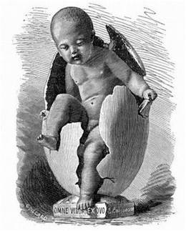
One school of thought - the "preformationist" school, thought that a miniature human lived within either the egg (the 'ovist' school), or the sperm ('the homunculan' school). This offspring laid in a state of suspended animation until the sperm stimulated the egg to grow (for the ovist school), or the sperm was placed in the fertile womb to grow ('homunculan' school). Of course, both of these ideas had serious flaws. If the offspring was really just a product of one sex, then why did the offspring have characteristics of both parents? Some theologians saw interesting implications, too. If all generations were preformed, then each generation must be nested within the egg or sperm of the preceeding generation - also already preformed. The generations of humans would be like a set of russian dolls, one nested with the other. At some point, it would seem that nature would reach the limit of how small a preformed person could be - and that would be the last generation (which would be followed by the apocalypse).
2. Epigenetic Ideas
The other major school of thought promoted the "epigenetic" idea. Here, the egg does not actually contain a small individual, but rather only the potential to grow and develop into an individual. This idea had much less support, because there were no ideas about how this could happen; the growth of a small human was alot easier to understand than the development of organs and organ systems from 'nothing' - or at least, from things that weren't organs or organ systems! However, the epigenetic idea had one major benefit - it could explain why offspring often expressed characteristics of both parents. If both parents contributed 'stuff' to this epigenetic mass of potential, then the developing offspring could inherit traits from both parents. Because semen is a fluid, it seemed likely that the genetic information was a fluid. The 'mixing' of the heredity fluids from two parents might explain, sort of, why the offspring expressed a mixture of traits from both parents.
There was an additional observation that was very problematic with this blending idea, however. Most people were well aware that some traits 'skipped a generation', or even many generations. The reappearance of an ancestral trait (" you have your great-grandmother's nose") was know as a 'sport'. If the hereditary information from two parents were fluids that mixed, like black and white paint, it seemed difficult to explain how, after mixing black and white into grey, you could get some pure white paint back out of the mixture in a later generation.

B. Mendel's Experiments
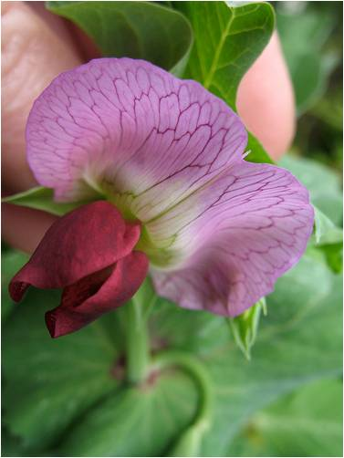
Mendel set out to test these alternate hypotheses by breeding organisms from different 'pure-breeding' stocks together. In other words, Mendel conducted hybridization experiments, forming hybrids by crossing strains that bred true for particular characteristics. He selected the common garden pea, Pisum sativum, as his study organism. He chose this plant because there were alot of pure-breeding varieties already available; farmers had selected for different characteristics, creating strains that produced round peas, wrinkled peas, yellow peas, green peas, tall plants, short plants, etc. Indeed, Mendel reports that he received 34 different strains from farmers. In addition, because peas were fast growing and fecund (produced lots of offspring - each pea is a separate offspring), he could generate a lot of data in a matter of months. (Some characters, however, like flower color or plant height, could only be determined in the following year, when the offspring grew up and exhibited the trait.) Being trained in mathematics and probability, he knew that a large sample would provide a 'truer' indication of a pattern than a small sample. Modern geneticists have chosen other study organisms - like fruit flies, mice, and bacteria - for the same reason.
1. Monohybrid Experiments (single traits)
Mendel reported the results of seven parallel experiments. In each experiment, he cross plants that had different expressions of a particular trait. So, in the third set of trials, he bred plants that 'bred true' for white flowers (when bred with themselves) with plants that produced purple flowers. For this experiment, he did 35 cross-fertilizations with ten plants.
a. Reciprocal parental crosses tested the ovist and homunculan schools:
A very important methodological aspect of the experiment was that he conducted reciprocal crosses between stocks. So, he placed pollen pure-breeding white flowers on the stigma of purple-flowers, and pollen from purple flowers on the stigmas of white flowers. So, by comparing the results of these reciprocal crosses, he could see if the inheritance of the trait (flower color) was associated with the sex of the parent. If the homunculan school was correct, then the offspring should bear the trait expressed in the stock that donated the pollen. If the ovist school was correct, then the offspring should bear flowers the color of the strain that received the pollen and donated the egg (in the ovule).
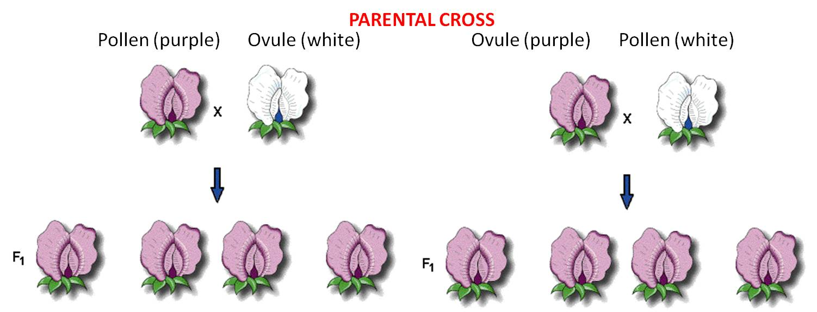
These 'pure-breeding' stocks were called the 'parental generation'.
pollen (male) from Purple flowers X ovule (female) from White flowers
AND
pollen (male) from White flowers X ovule (female) of Purple flowers
These crosses produced offspring (peas). The first generation of 'hybrids' produced from pure-breeding parental strains is called the F1 (for 'first 'filial') generation. He planted and grew the peas produced from both crosses and observed their flower color. In both reciprocal crosses, all the plants produced purple flowers. These results falsified both the homunculan and ovist schools; both hypotheses predicted that plants from one or the other cross would yield white flowers. Indeed, Mendel realized that these results suggested that both parents had to contribute hereditary factors for this trait; the purple offspring from the first reciprocal demonstrated that the male contributes, and the purple offspring in the other reciprocal demonstrated that the female contributes, too. But if both parents contributed hereditary information, what happened to the white information contributed by the other parent in each cross? Mendel hypothesized that the contribution was present in the offspring, but not expressed. He coined the term 'dominant' for the trait expressed in the F1, and 'recessive' for the trait he thought was there, but hidden. He became more confident in these hypotheses when all seven traits that he studied showed the same pattern.
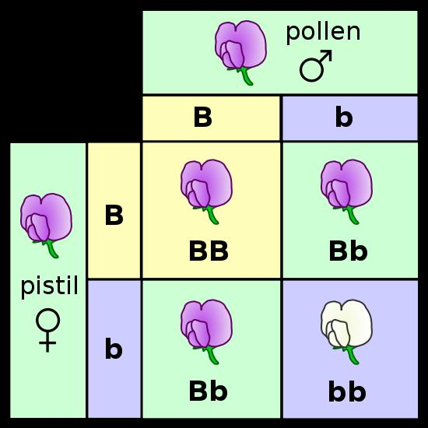
b. Crossing the F1 hybrids tested the blending hypothesis:
He allowed the F1 plants to fertilize themselves, essentially performing an F1 x F1 cross. He makes reference to the fact that, in many species and for many traits, the hybrids (F1's) exhibit a triat intermediate to the two parental types. This intermediate result might be expected of a blending pattern (white paint and black paint making grey), but one trait dominating the other could also be produced from a blending mechanism, too. One thing you would not expect from a blending of fluids, however, would be the re-expression of the recessive 'white' trait. Grey paint mixed with grey paint should not produce white paint.
The peas from these crosses were grown and the flowers were observed. Of the 929 plants that he grew from these seeds, 705 bore violet flowers and 224 had white flowers; a ratio of 3.15:1. In fact, all seven traits produced ratios near a 3:1 ratio in the F2 generation (offspring of F1 x F1 crosses). He recognized the importance of the 3:1 ratio when combining two things. It reminded him of a simple binomial expansion (a + b)² = 1aa + 2ab + 1bb. If an organism has 2 different types of hereditary units (a = purple and b = white) for a given trait and it mates with itself, then there are three combinations that are possible in the offspring (aa, ab, bb). And, they should occur in a 1/4:2/4:1/4 ratio. If, as a consequence of dominance, the progeny with different particles (ab) only express one - the 'a' (purple) - then they will look like the aa's and 'a' (purple) offspring will occur 3/4 of the time and 'b' (white) offspring will occur only 1/4 of the time.
c. Mendel proposed four postulates (hypotheses) to explain these data:
- genetic info is unitary or 'particulate' - it is not a fluid that blends
- each oganism has two unit factors (we call these 'genes' now) for each trait
- if an organism has different factors for a given trait, one is expressed (dominant) over the other (recessive)
- the two genes for a given trait separate and go into separate gametes during gamete formation. Subsequent fertilization (fusion of gametes) is random. This is called Mendel’s First Principle: Principle of Segregation
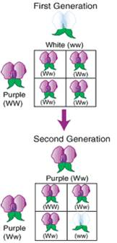
d. How his hypothesis explains his observations:
Parentals: WW (Purple) x ww (white) .... (and the reciprocal)
Gametes: W w
F1 offspring: Genotypic Ratio: 100% Ww (heterozygous)
Phenotypic Ratio: 100% Purple
F1 x F1 Cross: Ww x Ww
Gametes: W and w W and w
F2 offspring: Genotypic Ratio: 1/4 WW, 2/4 Ww, 1/4 ww
Phenotypic Ratio: 3/4 Purple, 1/4 White
Some Terms:
Genotype = the type of genes an organism has, like Ww.
Genotypic Ratio = is the fractional representation of different genotypes in a group, such as 1/4WW : 1/2Ww : 1/4 ww
Phenotype = the characteristic or trait that is expressed, such as 'Purple'. Usually, this is represented by the gene that causes the trait, such as 'W' in the example, above.
Phenotypic Ratio = the fractional representation of different phentypes in a group, such as 3/4W : 1/4 w.
2. Monohybrid Test Crosses
If the hypotheses are correct, Mendel reasoned, then the F1 has a gene for the recessive 'white' trait that is not expressed. How could he determine whether it was there or not? He realized that he could answer this question if he crossed it to the recessive white parent: (ww). The logic is this: the homozygous recessive parent can only pass recessive alleles to the offspring. Whatever the offspring receives from the OTHER parent will determine the expression of the trait. It the offspring receives a dominant allele for purple from the other parent, then the offspring (Ww) will express purple flowers. But, if the other parent is hiding a recessive allele and passes that to the offspring, then the offspring will have the homozygous recessive genotype (ww) and will produce white flowers.
Mendel predicted that, under this hypothesis, the phenotypic ratio in the offspring would be: 50% purple (W): 50% white (w). The results supported his hypothesis, and supported his postulates. Replication of this results across all seven traits gave strong confirmation that he had described a general pattern of heredity.
More Terms:
Homozygous: A zygote is a fertilized egg that has received genes from both parents. If the genes received from both parents for a given trait are the same, then this zygote (and the organism that develops from it) is homozygous for this trait. If the zygote has received dominant genes for the trait from both parents, it is homozygous dominant (WW); if it has received the recessive allele from both parents, it is homozygous recessive (ww).
Heterozygous: If the zygote receives different alleles from the parents for a given trait, then the zygote is heterozygous for that trait (Ww).
Alleles are different 'forms' of a gene, that affect a given trait - like flower color - in different ways ('W'and 'w' are alleles for flower color).
3. Dihybrid Experiments
Most animal and plant breeders had noticed that some traits seem to be inherited together. Indeed, in his own experiments, Mendel saw that flower color was always correlated with the color of the seed coat, such that seeds with white seed coats grew into plants with white flowers, and seed with brown seed coats grew into plants with purple flowers. Having demonstrated that his seven traits all exhibited the same pattern of inheritance, he now set out to determine whether these traits were inherited in a dependent or independent manner. This is a very insightful question. For example, he had already demonstrated that yellow pea color was dominant to green, that round pea shape was dominant to wrinkled, and that F1xF1 crosses for each trait produced a 3:1 ratio in the offspring. Well, maybe these traits are inherited in the same way because they are governed by the SAME heritable unit factor (gene)... and that's why they produce the same pattern. If yellow and round were caused by the same gene, then of course they would be inherited in the same way. Or, maybe they are governed by different unit factors that have a pattern of heredity that is related to one another... maybe they are governed by different factors that "travel" from parent to offspring together - yellow always traveling with round, for instance. This had important practical applications, too. A sheep farmer would profit from sheep that produce both good wool and good milk (for feta or roquefort cheese) from his sheep herd. But, maybe the trait of quality wool is inherited with the trait of poor milk production. In that case, they might not want to strongly select for great wool quality, as milk production would suffer. It might be best to maintain a variable population that produces good wool and adequate milk. Every organism expresses a combination of traits, so addressing how combinations of genes are inherited is a very important question.
a. Parental crosses of stocks breeding true for two traits
First, Mendel bred plants together and created stocks that bred true for two traits: seed color and seed shape. He created a stock of plants that produced yellow, round peas and a stock that produced green, wrinkled peas. He already knew the dominance patterns, and had already concluded that parents bore two 'unit factors' (genes) for each trait. So, he hypothesized that the genotypes of the plants in each pure-breeding stock would be RRYY (round, yellow) and rryy (wrinkled green). He placed pollen from the wrinkled, green stock on flowers of the yellow, round stock and observed the progeny.
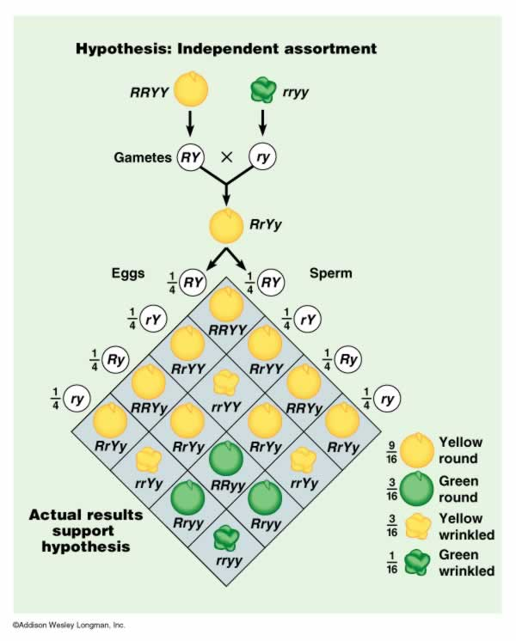
Round, Yellow (RRYY) x wrinkled, green (rryy)
He hypothesized that the parental types would produce RY gametes and ry gametes, respectively. The combining of the genes in the offspring would make only RrYy genotypes, that should all express the phenotypic traits of yellow, round peas. This hypothesis was confirmed. However, this did not yet address the issue of independence; this pattern would also have occurred if color and shape were governed by one gene, or if the genes were inherited in a dependent manner. In short, the Y had to be inherited with an R, because that's all the RRYY parent had to give.
b. Crossing the F1's:
He crossed the F1 individuals, and found the following results:
- 315 round, yellow peas (~ 9/16)
- 101 wrinkled yellow peas (~3/16)
- 108 round green peas (~3/16)
- 32 wrinkled green peas (~1/16)
TOTAL - 556 peas
c. His interpretation and hypothesis:
First, it was obvious that the two traits were not caused by the same gene; all yellow peas were not ALSO round - he had produced some yellow wrinkled peas. So, different genes governed see color and seed shape, and so the genes for these traits could occur in differnt combinations.
Mendel realized that the 3:1 ratios were still preserved for each trait, when considered separately. For example, taken together, the ratio of yellow:green peas was 416:140 (2.97:1) and the ratio of round:wrinkled peas was 423:133 (3.18:1).
And also, Mendel realized that the results of this experiment, and the results of subsequently self-crossing these hybrids, were consistent with the probability of occurrence of independent events. We know this as The Product Rule: "The probability that independent events will occur together is the product of their independent frequencies."
These ratios in which the traits occurred in combination equaled the products of the independent frequencies:
3/4 W X 3/4 Y = 9/16 WY (round yellow)
1/4 w X 3/4 Y = 3/16 wY (wrinkled yellow)
3/4 W x 1/4 y = 3/16 Wy (round green)
1/4 w x 1/4 y = 1/16 wy (wrinkled green)
Mendel's hypothesis can be stated like this:
During gamete formation, the way one pair of genes (governing one trait) segregates is not affected by (is independent of) the pattern of segregation of other genes; subsequent fertilization is random. This is called Mendel's Second Principle: Principle of Independent Assortment.
He tested this hypothesis is subsequent experiments using three traits (seed color, seed shape, and seed coat color), and showed that the combination of traits expressed in the offspring were consistent with predicitons from their independent frequencies. For example, In a "trihybrid" F1 cross (a self-cross of an individual that is heterozygous for all three traits - YyRrCc), the fraction of peas that are yellow, round, and have a brown seed coat (caused by the dominant allele, "C") should be 3/4 x 3/4 x 3/4 = 27/64. His results confirmed his hypothesis.
4. Dihybrid test cross:
We can test for independence a bit more directly, through a dihybrid test cross. The principle of independent assortment is really predicting what the frequencies of different gamete types will be. So, consider an organism that is a double heterozygote (RrYy). The principle of independent assortment predicts that the segregation of the R genes (R and r) during gamete formation will be unrelated to (independent of) the pattern of segregation of the Y genes (Y and y) going into the same gametes.
With respect to the "R" gene, it has the Rr genotype and should produce R and r gametes at a ratio of 1/2 R to 1/2 r.
Likewise, with respect to the "Y" gene, the organism should produce Y and y gametes at a ratio of 1/2 Y to 1/2 y.
Now, every gamete must carry one (and only one) gene for each trait. So first of all, there can't be Rr or Yy gametes. And, under the hypothesis of independent assortment, the types and frequencies of the gene combinations that occur in the gametes can be predicted as the product of their independent frequencies. So, we would predict that this organism would produce 1/4 RY gametes (1/2 R x 1/2 Y), 1/4 Ry gametes (1/2 R x 1/2 y), 1/4 rY gametes (1/2 r x 1/2 Y), and 1/4 ry gametes (1/2 r x 1/2 y). These gametes are in the first column in the figure, below.
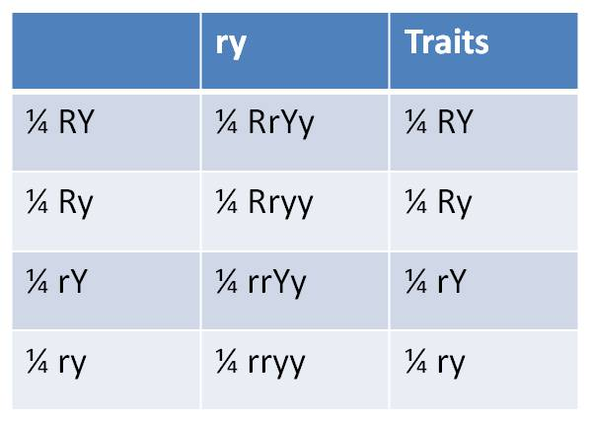
So, to test independent assortment, we really want to know whether this organism is producing gametes in these predicted frequencies. But we can't see the genes in the gametes too easily; through heredity, all we can observe are the traits in the phenotype of the offspring. And since these gametes carry recessive alleles, it seems likely that they would be hidden from our observations.
Unless we are clever.
If we mate this first organism to a second organism homozygous for the recessive traits (rryy), then the second parent will only donate recessive alleles (ry) to the offspring. (This gamete is in the header of the second column, at right). In this "test cross", the genes the offspring receives from the first parent will be expressed in the phenotype - we will be able to "see" the gene combinations, and their frequencies, produced in the gametes of the first individual. (The 'traits' expressed by the offspring - shown in the third column - are the same traits in the same frequencies as the gamete types produced by the first parent - shown in the first column.)

5. Summary
Mendel's quantitative approach and background in probability allowed him to conduct and interpret hybridization experiments in a new, more rigorous way. By examining and classifying the characteristics in offspring from particular parents, he was able to make insights into processes occuring at the cellular level. His two principles of heredity describe the allocation of genes to gametes - a process he never observed. However, 30 years later, cellular biologists confirmed that the hereditary units - called chromosomes - were allocated to gametes in a pattern consistent with Mendel's conclusions. It is worth reflecting on this for a second. All Mendel did was mate plants, collect and count seeds, and plant them. Yet, through his clever experimental design, he was able to test hypotheses and reach conclusions about phenomena that he could not observe directly. Human genius can be applied to any endeavor. In our modern technological society, we seem most impressed when genius is applied to making new technological innovations and devices. In science, however, genius can be expressed in the creativity of designing the correct experiment.

C. The Power of Independent Assortment:
1. If the genes assort independently, then you can calculate ‘single gene’ outcomes and multiply results together…
For Example: AaBb x Aabb:
- what is the probability of an Aabb offspring?
- What is the probability of an offspring expressing Ab?
- How many genotypes are possible in the offspring?
- how many phenotypes are possible in the offspring?
Do the single-gene Punnett squares:
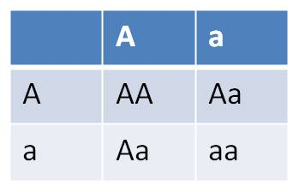and 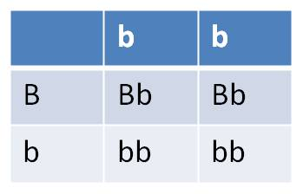
Answer each question for each gene, and then multiply the answers together:
- what is the probability of an Aabb offspring? 1/2 (Aa) x 1/2 (bb) = 1/4
- What is the probability of an offspring expressing Ab? 3/4 (A) x 1/2 (b) = 3/8
- How many genotypes are possible in the offspring? 3 x 2 = 6
- how many phenotypes are possible in the offspring? 2 x 2 = 4
2. You can easily address more difficult multigene problems:
For Example: (female) AaBbCcdd x AABbccDD (male)
- how many types of gametes can each parent produce?
- What is the probability of an offspring expressing ABCD?
- How many genotypes are possible in the offspring?
- how many phenotypes are possible in the offspring?
Answer the questions for each gene, then multiply the answers together:
- how many types of gametes can each parent produce?
FEMALES - types of gametes at each gene (locus) | MALES - types of gametes at each gene (locus)
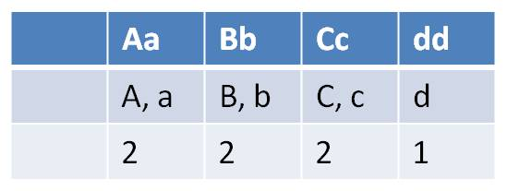 | 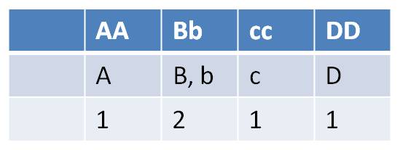
Females can make 2 x 2 x 2 x 1 = 8 gamete types | Males can make 1 x 2 x 1 x 1 = 2 gametes types
With respect to offspring, do the single-gene Punnett squares:
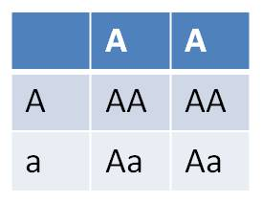 | 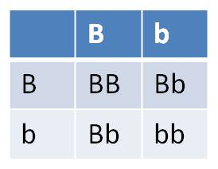 | 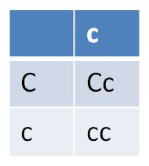 | 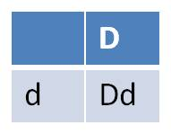
- What is the probability of an offspring expressing ABCD? = 1 (A) x 3/4 (B) x 1/2 (C) x 1 (D) = 3/8
- How many genotypes are possible in the offspring? = 3 x 3 x 2 x 1 = 18
- how many phenotypes are possible in the offspring? = 2 x 2 x 1 x 1 = 4
Note that for the C and D genes, we simplified the Punnett Squares. If a parent is homozygous for a gene, then it can only make one type of gamete with respect to that trait. So, to reduce redundancy, we just used one column for the 'cc' parent in the third Punnett Square, and only one row and one column for the parents in the last Punnett Square. The same could have been done for the AA parent in the first Punnett square - the information in the two columns is identical.

D. Allelic, Genic, and Environmental Interactions
While Mendel's contributions were seminal, his postulates and principles did not describe the full range of complexity that occurs in the patterns of heredity or the expression of genetic information in the phenotype. Although many genes exhibit simple patterns of complete dominance, even segregation, and independent assortment, many do not. In addition, the genes that are received by an organism are not the sole determinant of the phenotype - even of the characteristics that these genes affect. Now we will look at how Mendelian patterns are modified (or even violated).

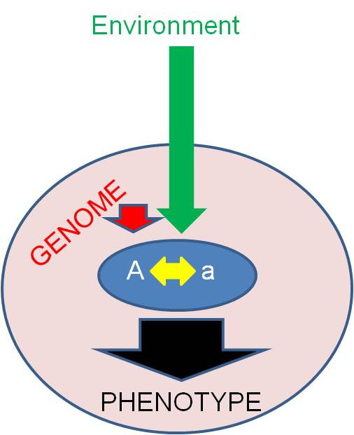
1. Overview
Consider a single allele. Now, what determines whether (and how) this allele is expressed in the phenotype? The manner in which an allele is expressed in the phenotype is affected by three broad categories of factors:
- other alleles at the same locus (intralocular interactions)
- other alleles at other loci in the genotype (Interlocular interactions),
- and environmental interactions. These environmental effects may be proteins in the cytoplasm that were not produced by this genome (maternal/cytoplasmic effects) or aspects of the extracellular environment.
In addition to considering whether (and how) an alelle is expressed, we will also consider the "value" of the allele to the organism (is it 'good' or 'bad'?) This may not be an intrinsic property of the allele. Rather, the value of an allele is also determined by these three classes of factors. Keep this in mind; it is the overriding message of transmission genetics. Unfortunately, our culture has not always appreciated these ideas.

2. Intralocular Interactions:
Diploid organisms have two alleles for each locus, or gene. Intralocular effects describe the way that these alleles interact to cause a phenotype. You are familiar with one type of intralocular interaction already, so we will start there.
a. Complete Dominance (Mendelian)
In this case, the heterozygote expresses a phenotype indistinguishable from the phenotype of the homozygous 'dominant' individual.
- AA = Aa > aa (Mendel's peas provide examples)
At a cellular level, why does this happen? Well, genes code for proteins. Apparently, one gene (A - the dominant gene) codes for the production of enough functional protein for complete cell function and phenotypic expression. Surplus has no effect. Maybe a reaction is limited by the amount of substrate, and not the concentration of enzyme (protein). So, one 'dose' of enzymes is enough to metabolize all of the substrate, and extra enzyme doesn't change this effect. Or the product of the dominant allele has a higher reactivity with the substrate and always reacts with it, it's way, even in the heterozygous condition.
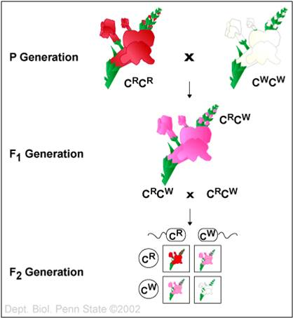
b. Incomplete Dominance/Intermediate Inheritance
In this case, the heterozygote expresses a phenotype that is intermediate between the phenotypes expressed by the homozygotes. This is quite common. A classic example is flower color in 4 o'clocks. Homozygotes for R ("RR") produce red flowers, homozygotes for "r" (rr) produce white flowers, and heterozygotes (Rr) produce pink flowers.
- AA > Aa > aa
At a cellular level, this is probably a function of a 'dosage effect'. Two 'on' genes produce more functional product than one, and this surplus influences cell function and phenotypic expression. Maybe the protein product of an active R gene is the pigment, itself, and r produces a nonfunctional protein (maybe it has a premature stop codon and no protein is even produced). So, the two functional genes in the RR homozygote produce more pigment and a deeper red color than the single functional gene in the pink heterozygote (Aa).
c. Codominance
In this case, the heterozygote expresses both traits completely; this does not produce something that is "in between" the homozygotes; rather, the heterozygote expresses both traits expressed in the homozygotes. The classic example is the A-B-O blood group in humans. These letters refer to alleles in the human population that encode a protein that is placed on the surface of blood cells. These proteins are called 'surface antigens', and they act as a chemical signal to white blood cells that these cells are "self". There are three alleles in the human population at this locus. Of course, each diploid person only has two of these three alleles. The genotypes that are possible, and the phenotypes they express, are as shown:
Genotype | Interaction between alleles | Phenotype
AA |  | A
AO | A dominant to O | A
BB |  | B
BO | B dominant to O | B
OO |  | O
AB | A and B codominant | AB
The A allele codes for the A surface antigen. The B allele codes for the B surface antigen. The O allele is non-functional; no surface antigens are produced. So, any genotype with an A allele makes A surface antigen; any genotype with a B makes B surface antigen. A genotype that is AB has different active genes, each producing their own surface antigen, and so BOTH A and B surface antigens are affixed to the outside of the cell. It is a phenotype that is BOTH A and B at the same time.
A more general cellular explanation is this. The allelic products are both functional and work on slightly different substrates. Having both gives the phenotype a qualitative diffence, not a quantitative difference. This is often confused with "incomplete dominance", but think about it this way: "pink" flowers are neither "red" nor "white" - they are something different that isn't red or white. But AB blood is BOTH A and B at the same time, not different from A and B, but a combination of both A and B.
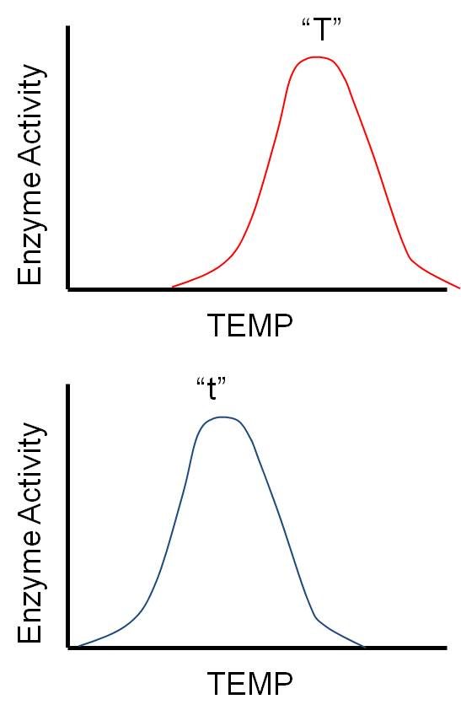
d. Overdominance (Heterosis)
In this seemingly unusual situation, the heterozygote expresses a phenotype "more extreme" than either homozygote. So, if AA = tall and aa = short, then the heterozygote Aa = Tallest.
This may seem unusual, but it is actually easy to explain. Suppose the two alleles work slightly differently, or under slightly different conditions. For instance, consider a gene that codes for an enzyme that influences growth. As you can imagine, there are LOTS of such genes! Almost any catalyst that affects metabolism, respiration or protein synthesis will influence growth. Maybe the two alleles for this enzyme work at different temperatures (H = warm and h = cold). If the organism lives in an environment that is warm most of the time, then the homozygote for HH will grow most of the time, and will be taller than the hh homozygotes that only grow during the rare colder periods. However, the heterozygote Hh grows ALL the time, when it is cold and warm, and so is taller than either homozygote. Variation at a locus can be as advantageous as variation in offspring; variation in the genotype (heterozygosity) may allow the organism to cope with a greater range of environmental conditions, or metabolize more substrates. Thus, there is often a 'heterozygote advantage' at certain loci.
e. Multiple Alleles
This doesn't describe an interaction, but merely a pattern. As the A, B, O blood group locus demonstrates, many genes have more than just two alleles in a population. And, as the previous example of heterosis shows, variation within a locus can be evolutionarily important. So, this variation that occurs because there are multiple alleles at a locus creates even more types of heterozygotes that are possible, and more genotypes, too. For example, consider the multiplicative increase in genotype diversity that occurs when each additional allele is added in the table, below:
1 allele (A) = 1 diploid genotype (AA)
2 alleles (A, a) = 3 diploid genotypes (AA, Aa, aa)
3 alleles = 6 diploid genotypes (as in the A,B,O example, above...)
4 alleles = 10 diploid genotypes
5 alleles = 15 ....etc.
So, when a new gene is produced by mutation, it does not just make ONE new genotype. It has the potential, through independent assortment, to be combined with all the other alleles already present in the population. So, in the example above, when a new FOURTH allele is added, you don't just get one new genotype (over the 6 that existed in the three-allele population), you get 4 more genotypes. There is a multiplicative effect on variation. And, since alleles may interact in interesting ways (incomplete dominance, codominance, and overdominance), these new genotypes may produce new phenotypes never produced before - new variation upon which selection can act.

3. Interlocular Interactions:
The effect of an allele can be influenced by other genes in the genome, at other loci. These are called "inter"-locular effects.

a. Quantitative "polygenic" effects
There are many proteins (and RNA's) that are valuable in high concentrations; higher concentrations than production from a single locus can produce. Selection has favored organisms in which these genes have been duplicated (through a process we will examine later). The organisms, with two or several different loci that produce the same protein (or RNA), can produce LOTS of that essential molecule. A good example is r-RNA. The production of all proteins in the cell depends on ribosomes, and they all carry r-RNA. So, selection has strongly favored organisms that have multiple copies of the genes that encode r-RNA; they can produce LOTS of r-RNA, and thus produce LOTS of ribosomes... and this increases the rate that they can produce all of their proteins. Now, for genes that encode proteins that influence a phenotypic characteristic, multiple genes means that more than one locus produces the protein product and influences that trait. So, the final phenotype is determined by the cumulative, "quantitative" sum of all the genes acting on this trait.
As a consequence of many loci acting on a trait, there are many more combinations that are possible - resulting in a wide variety of phenotypic expression that forms a nearly 'continuous' range of variation.
For example, consider human skin pigmentation. There are at least 16 loci that code for melanin (skin pigment) production. Although there is complete dominance at each locus, this multiplication of genes allows for an extraordinary and continuous amount of phenotypic variation, from all 16 genes 'on' (and very very dark skin), to 15 'on' and 1 'off' ( very dark skin), to 14 'on' and 2 'off' (a bit lighter), to , 13:3, etc. , all the way to 0 'on' and 16 'off' (no pigments produced at all).
Humans evolved on the plains of Africa. The loss of hair was adaptive (to decrease insulation in the subtropical heat), but this made the skin vulnerable to UV rays that cause mutation. Selection favored humans that could make lots of melanin, to protect the skin against these UV rays. Selection favored humans that duplicated their melanin genes, and could thus produce more pigment. Humans that continued to live in tropical areas continued to benefit from this dark skin. In cooler climes with less intense sun, selection favored humans that spent less energy on melanin production, selecting for the recessive alleles at each of these multiple loci. In addition, lighter skinned people benefitted at these latitudes by using the sun's energy to synthesize vitamin D in the skin.

b. Epistasis
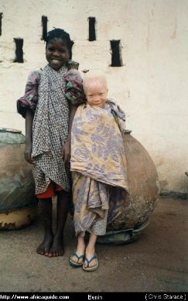
In epistasis, one locus has precedence over the expression at another locus and can override it. Albinism is the classic example. Albinism ooccurs in all populations of humans (and many other animals). It usually does NOT involve the melanin producing genes. (So, true albinism is NOT caused by the 0 'on', 16 'off' scenario described above). Rather, it involves another locus. An 'aa' individual at the albinism locus does not make the precursor for melanin. So, with no precursor from which melanin can be made, it doesn't matter WHAT the genotypes are at the 16 melanin loci - there won't be any melanin produced. This is why albinism occurs in all human populations (or 'races') regardless of of the skin color typical for that population - because it is influenced by a gene that is inherited independent of the melanin producing genes.
Multiple loci may influence genes in interactive ways, not just in quantitative, additive ways like skin color. For example, in sweet peas (not the garne peas of Mendel), there are two genes that influence flower color. Both exhibit complete dominance, and both proteins must be produced in order for purple flower color to be expressed. So:
aaBB (white) x AAbb (white)
|
100% AaBb (purple)
|
9/16 A_B_ (purple)
7/16 aaB_ or A_bb or aabb (white)
(In these examples, the underlined space means that it doesn't matter what the second allele is... if one allele at a locus is dominant, then in a completely dominant system, you will get the same phenotype regardless of whether the second allele is dominant or recessive. So, rather than writing all the separate genotypes out that yield the same phenotype, you just put the genes that determine the phenotype. Of course, to express the recessive phenotype, you have to be homozygous - so to represent genotypes that express the recessive phenotype, you need to write both alleles. aaB_ refers to aaBB and aaBb... they both yield the aB phenotype.)
In Summer Squash, fruit shape is influenced by interacting loci. Disc-shaped fruits form when both loci have at least one dominant allele present (A_B_). Long fruits are produced when dominant alleles are absent (aabb), and round fruits are produced when one locus is homozygous recessive but the other has at least one dominant allele. SO:
AABB (disk) x aabb (long)
|
100% AaBb (disk)
|
9/16 A_B_ (disk)
6/16 A_bb or aaB_ (ROUND)
1/16 aabb (long)
These effects are VERY important, because every organism has thousands of genes. So, at a given locus, it is quite likely that the way the genotype is expressed might be influenced by one of these other genes somehow. This means that two organisms with the SAME genotype at a given locus would have different phenotypes... because of the effects of the other genes in the genotype. Sometimes, these effects are collectively called the "genetic background". Like for squashes, above, consider two organisms that are both AA at the A locus. They could have different penotypes because of their genetic differences at other loci; the first could be AABb and have disk fruits, while the other is AAbb and have round fruits.

4. Environmental Interactions
The environment has many direct effects on the phenotype. A fox may change from white to brown because a bucket of white paint falls on it's head. That would be a direct environmental effect; it happened independently of anything going on with the genotype. Those are NOT the effects we are talking about here. Rather, we are talking here about an interactive effect between the environment and the genes at a locus, such that the environment changes how the genotype is expressed as the phenotype.
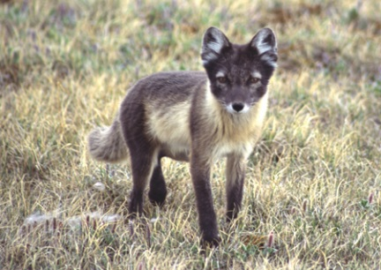
a. Temperature
In arctic fox, the brown summer fur turns to white as temperatures drop. This is NOT a direct effect of temperature change on pigment in the hair shaft. Rather, the change in temperature changes how the genes and their protein products work. As temperatures drop, melanin genes are turned off, or the enzymes that catalyze the production of melanin change shape and no longer function. The result is that no melanin is produced, and thus the fur turns white.
b. Toxins
Susceptibility to certain mutagens will vary with the genotype. So, two people who are homozygous for a type of lung cancer (and 'should' genetically express that cancer) might have very different phenotypes. One, who smokes and exposes their lungs to mutagenic compounds might trigger those cancer genes. The other person, however, with the same genotype, might not have cancer because they never smoked and thus never exposed themselves to the environmental "trigger". Likewise, someone homozygous for an alternative allele might smoke without developing lung cancer.
These effects may be "probabilistic". For instance, some genes associated with cancers are only expressed (cause cancer) in a fraction of the individuals with that genotype. This could be due to different environmental exposure, but it could also be caused by different genes at other loci that interact with this cancer gene and augment or supress its effects through interlocular interactions.
5. The 'Value' of an Allele
a. Lethal Alleles: Some alleles are ALWAYS bad.
Usually, these have rather profound effects on basic cellular metabolism, affecting a vital enzyme or structural protein. Typically, lethal alleles that are DOMINANT get weeded out of the population very quickly by selection (anyone that gets one allele dies...). So, most lethal alleles that are maintained in natural populations are recessive, and thus are "hidden" in heterozygotes and are be passed down through generations. However, some lethal alleles ARE dominant. Can you think of another way that an allele could 'escape detection' by selection (which is "differential REPRODUCTIVE success"?). Huntington's Chorea is a dominant lethal neurodegenerative condition. Actually the Homozygote dies in utero. However the heterozygotes survive and are phenotypically normal into their 50's. THEN, only AFTER they might have reproduced and passed the gene on, do the effects of this dominant gene start to come forward. So, they are "invisible" to selection because they are expressed POST-REPRODUCTIVELY.
b. Environmental Effects: The value of an allele often depends on the environment
In Sickle Cell Anemia, red blood cells 'sickle' when the concentration of oxygen in the bloodstream drops. This occurs when the person is active and the oxygen demand by muscle increases, drawing oxygen out of the bloodstream and depressing oxygen concentration in the cells in the bloodstream. The sickle-shaped cells do not pass through capillary beds as easily as normal red blood cells; they clog capillaries, resulting in oxygen deprivation and tissue damage downstream from the clot. This is usually most pronounced in the liver, kidneys, and brain, and eventually often results in premature death.
Sickle cell anemia is caused by an altered beta globin allele, which causes a single amino acid change in the beta-globin proteins in hemoglobin. The trait exhibits incomplete dominance - one "s" allele will result in some "sickling" of red blood cells at low oxygen concentration, but the condition is not nearly as severe as it is in the homozygous condition.
Now, you might think that even one sickle-cell allele would 'always be bad' - after all, I just said that heterozygotes do suffer some debilitating effects. But in this case, the "value" of a sickle cell allele - whether it is 'good' or 'bad' - depends on the environment. In particular, it depends on the presence of the Plasmodium parasite that causes malaria.
In the tropics, a primary source of human mortality is malaria. In 2006, nearly 900,000 people died of malaria; over 91% of these deaths were children in Africa. There were an estimated 250 million cases reported globally. Malaria is caused by several species of protists in the genus Plasmodium. This single-celled parasite is transmitted by female mosquitos. When they bite a human to take a blood meal (only female mosquitos drink blood - they use the protein to nourish their developing eggs), the parasites enter the human host's bloodstream and infects red blood cells. They divide mitotically, producing hundreds of offspring and eventually rupturing the cell. Thus, infection causes extreme loss of RBC's - "anemia" (don't get this confused with sickle cell anemia; we are just talking about malaria right now!!). Curiously, the Plasmodium parasite can not reproduce in cells with the altered form of "sickle-cell" hemoglobin - even in the heterozygous condition. So, the heterozygote suffers some sickling on occasion, but is protected from malaria. In Africa, SS homozygotes have lower survivorship than the Ssheterozygotes because the SS individuals are exposed to malaria. The ss homozygotes have lower survivorship than the Ss heterozygotes because of the more pronounced debilitating effects of the sickle cell disease.
So, is an 's' allele "good" or "bad"? Well, that depends on other alleles at that locus (if it's with another 's' allele it is always bad), but it also depends on the environment. If the 's' is with an 'S' in the temperate zone, it is bad (relative to the reproductive succes of the normal SS homozygote).... but if the 's' allele is paired with an 'S' allele in the tropics, then it is "good" - better than having two dominant alleles (SS).
TEMPERATE ZONE: survivorship: SS > Ss > ss
TROPICS: survivorship: SS < Ss > ss
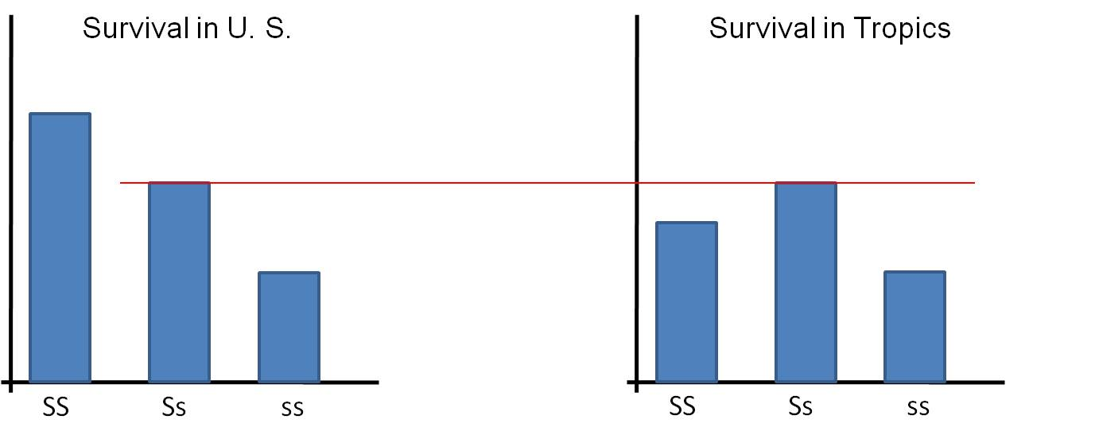
You should relate this to the corollary of Darwin's Theory of Natural Selection. Populations in different environments will diverge from one another genetically, as the environment selects for different traits (genotypes).
Summary:
An organism is more than just the sum of their parts, even at a genetic level. How the genotype works is not just the additive sum of all the genes acting independently. Rather, the way some genes work depends on the other genes in the genotype. The phenotype - what a complex organism IS - is the result of these complex interactions between genes, with the additional layer of environmental interactions and direct environmental effects. Indeed, given the potential complexities involved in how 1000's of genes and a complex environment can interact, it is rather surprizing that many genetic effects are simple enough to model as independent entities with a Punnet Square - without considering the other genes or the environment. So, Mendelian Genetics are actually the easiest, simplest patterns in heredity to recognize: and that is probably why they were recognized first.

Study Questions:
1. Draw the cell cycle, labeling each stage and highlighting the main event in each stage.
2. Draw a chromosome before and after replication; use the terms chromosome and chromatid.
3. Draw a cell, 2n = 6, and show each of the stages of mitosis. Write a brief description of the events of each stage.
4. What are three reasons why it is adaptive for cells to divide?
5. Sex always involves the production of a new genotype, but not always the production of a new individual. Explain.
6. What are the costs an benefits of asexual and sexual reproduction?
7. Diagram a cell, 2n=4, as it goes through Meiosis.
8. What are homologous chromosomes? How is their movement of meiosis important?
9. Explain how recombination creates an extraordinary amount of variation.
10. Determine the genotypic and phenotypic ratios from the following crosses. Assume dominance of capital letter:
a. AA x AA
b. AA x Aa
c. Aa x Aa
d. Aa x aa
e. aa x aa
11. Why did Mendel conduct reciprocal crosses? What hypotheses did this test?
12. Why did Mendel conduct an F1 x F1 cross (the second generation of crosses)? What hypothesis did this test?
13. How did the results from the reciprocal crosses suggest that both parents must contribute genetic information?
14. What question was Mendel addressing with his dihybrid cross?
15. How did the results lead him to hypothesize that the traits must be inherited independently? Use the product rule in your answer.
16. State Mendel's second principle, without using the word 'independent' in your definition.
17. Consider this cross: (male) AaBbCcDD x (female) AaBBccDD
- Assume independent assortment and dominance (capital is dominant to lower case) at each gene.
- How many types of gametes can each parent make with respect to these traits?
- How many genotypes and phenotypes are possible in the progeny?
- What fraction of offspring would you expect to express the ABCD phenotype?
18. Explain how a continuously variable trait could be governed by genes.
19. What is an epistatic interaction? Give an example.
20. Describe how the position of a gene can affect its effect.
21. How can the environment influence the expression of a trait?
22. How can the environment influence the VALUE of a trait? Relate this to Darwin's idea of the diverge of populations in different environments.
23. Why are most lethal alleles recessive? Answer with respect to the effects of selection on a dominant, deleterious gene.
24. As such, how can a dominant lethal allele be maintained in a population?
25. Consider this cross:
AaBbCc x AaBbCC
- assume independent assortment of the three genes
- There is incomplete dominance at the A locus (meaning A is incompletely dominant to a).
- There is complete dominance at the B locus.
- There is overdominance at the C locus.
How many genotypes are possible in the offspring?
How many phenotypes are possible in the offspring?
10. Provide cellular explanations for incomplete dominance and overdominance.

