Lecture 3: Energy Harvest
All living things are very complex, “non-random” assemblages of matter. And all living things do some pretty complicated stuff, even at the cellular level. Some, like muscle, make contractile proteins that can change the shape of the cell. Others, like secretory cells in the stomach, make digestive enzymes that break down food. Others, like neurons in your brain, transmit electric signals and communicate in networks. But all of these things requires ENERGY to do. How do cells harvest energy from the environment, so they can do these things that are critical for life to continue? That’s what we will examine in this lecture.
I. Cellular Respiration

A. Overview:
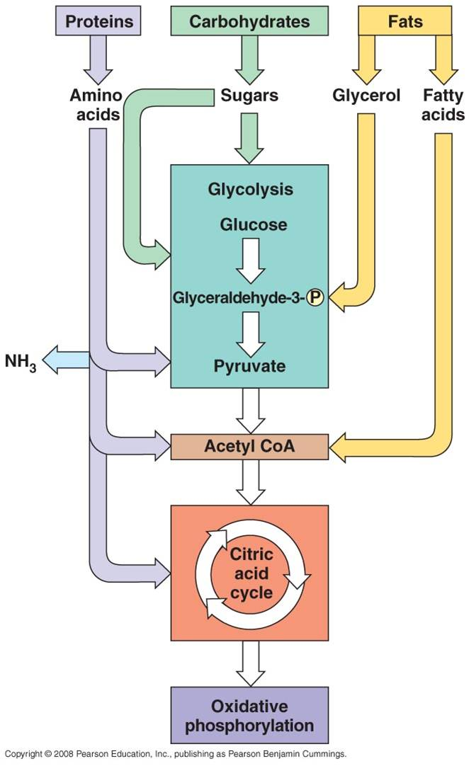
We have already briefly described one way that some organisms harvest energy from the environment: they transform radiant energy into chemical energy in bonds. Of course, only photosynthetic organisms perform those reactions. We know that modern photosynthesis (that releases oxygen as a waste product) evolved about 2.3 billion years ago, at least. But life is much older, as you know: the oldest fossils are 3.5-3.8 by old. So, what came before photosynthesis as a way to harvest energy?
Now, we will examine the energy harvesting reactions that ALL living cells perform: Cellular Respiration. All living cells - eubacteria, archaea, protists, fungi, plants, and animals - can harvest the energy contained in the chemical bonds of complex organic molecules. By breaking the covalent bonds between carbon atoms in these molecules, energy is released. The energy released by these catabolic reactions is used to bind ADP + P --> ATP in coupled, anabolic reactions. As such, some of the energy in the covalent bonds of the initial organic molecules is transformed into chemical energy in bonds of ATP. Energy in this form is now available to all of the enzymes in the cell, for catalyzing their own reactions (chemical energy) or doing work like muscular contraction (mechanical energy) or pumping ions across a membrane against their concentration gradient (active transport).
All four classes of biological molecules (carbo's, fats, proteins, and nucleic acids) are broken down for energy harvest. The process of carbohydrate metabolism, however, is the central process. Fats, proteins, and nucleic acids are broken into their monomers, these are modified, and then these products can be shunted into the carbohydrate digestion process. So, although we will focus on carbohydrate metabolism - and glucose metabolism in particular - you should appreciate that all other polymers can be broken down for energy harvest. And respiration not only harvests energy - respiration also provides the monomers needed by the cell to build its own biomolecules. So, when you digest protein, energy is harvested and the separated amino acids can be used by your cells to make your DNA-specified proteins. This is why a balanced diet is important - digestion of varied complex organic molecules provides the different monomers and other essential vitamins and minerals (often used as cofactors in reactions) that your cells require.
The metabolism of glucose can occur in the presence of absence of oxygen. The first step is glycolysis, in which the six-carbon sugar is split into 2 C₃ molecules of pyruvate. The breaking of this bond releases a small amount of energy. In the absence of oxygen, fermentation occurs. The primary function of this "anaerobic" respiration is to recycle some chemicals needed to keep glycolysis going. So, anaerobic respiration, including glycolysis and fermentation, breaks only a couple bonds and produces only a small amount of energy. In the presence of oxygen, the pyruvates can be completely oxidized. The C₃ molecules are completely broken down into 3 one-carbon molecules of carbon dioxide. The complete breakdown of the the pyruvates releases much more energy. This is probably why aerobic organisms have come to dominate the planet - they harvest more energy from the food they consume, and can use this energy to survive and reproduce more effectively.
B. Glycolysis
a. the process:
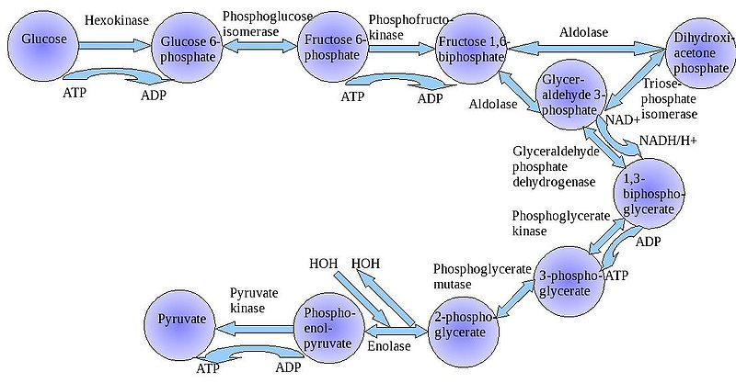
The "splitting of glucose" (glyco-lysis) is probably an ancient metabolic reaction; it is performed in the cytoplasm of ALL living cells from prokaryotes to eukaryotes, and cells can perform this reaction in the presence OR absence of oxygen gas. So, it seems likely that this was an important energy harvesting reaction for ancient cells that lived before ~2 bya - before oxygen became abundant in the oceans and atmosphere. As you can see in the flowchart, glycolysis is not ONE reaction - it is a series of reactions catalyzed by a variety of enzymes. For our purposes here, we will consider the primary "inputs" and "outputs" of the entire reaction, rather than concerning ourselves with each step.
Through this series of reactions, the six-carbon glucose is modified and split into 2 C₃ molecules of pyruvate. Glycolysis requires an input of energy to "get the reaction going". This activation energy is provided by 2 ATP. A phosphate is transferred from each ATP to the terminal carbons on the glucose. These phosphates destabilize the glucose, and also give it a charge - it will not diffuse back across the lipid bilayer. The splitting of the molecule releases energy and high energy electrons. Some of the energy is used to phosphorylate 4 ADP--> 4 ATP. Thus, although 2 ATP were used to start the reaction, there is a net gain of 2 ATP. The high energy electrons are accepted by an important molecule called NAD (nicotinamide adenine dinucleotide). With the acceptance of an electron, each NAD becomes negative charged (NAD-) and reacts with a H+ ion in solution - making NADH. So, NAD is a low energy form of the molecule, and NADH is a high energy form of the molecule.
So, for our purposes here, we can summarize glycolysis as:
glucose (C₆) + 2 ATP + 2NAD ----> 2 pyruvate (C₃) + 4 ATP + 2NADH
video
b. Requirements:
In order for glycolysis to occur (and all subsequent glucose metabolism!!!) the cell must have all three reactants - Glucose, ATP, and NAD. Obviously, if glucose is absent then the cell starves. That's moot. And, As glycolysis proceeds, there is always a net surplus of ATP produced by previous glycolysis reactions. But what about NAD? As glycolysis proceeds, extra ATP is produced that can be used in subsequent reactions to keep metabolism going. However, NAD is used up and converted to NADH. If NAD is not present, glycolysis stops (very BAD).
c. Solutions:
So, NADH must give up its electrons (and H+) to something else, so that the NAD can be recycled and used in glycolysis. This happens two ways, depending on whether oxygen is present (aerobic respiration) or absent (anearobic respiration). In the absence of oxygen, the NADH passed the electron back to pyruvate, and either lactate or ethanol is formed. No new energy is released from these reactions, so the energy produced by anaerobic respiration is just what is produced in glycolysis - fermentation is just a mechanism for the cell to recycle the NAD to keep glycolysis going. In the presence of oxygen, the pyruvates can be metabolized more completely - splitting all the carbon-carbon bonds and releaseing much more energy. Indeed, this is the primary benefit of aerobic respiration; but the recycling of NAD also happens during the process.
C. Anaerobic Respiration
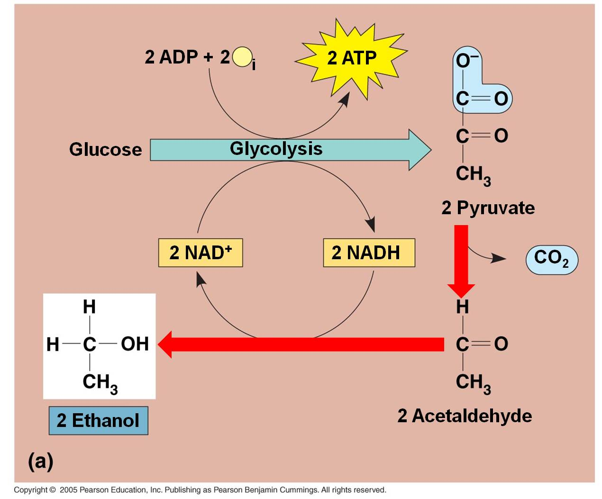
These pathways take place in the absence of oxygen. For aerobic organisms that need oxygen to survive (eukaryotes and most prokaryotes) these are temporary, facultative reactions meant to "weather the storm" while oxygen concentrations are low. If oxygen concentrations remain low, eukaryotic cells will not be able to survive on these reactions, alone, and they will die. Because they are smaller and have lower energy demands, some facultatively anaerbic bacteria can sustain themselves on these reactions. Some organisms are obligate anaerobes (some eubacteria and most archaea) that use these pathways all the time and are poisoned by oxygen. Indeed, some bacteria perform both these types of fermentation reactions at once, with one pyruvate converted to lactic acid while the other is metabolized to alcohol.
a. In plants, fungi, and bacteria:
In the absence of oxygen, the C₃ pyruvates are broken into a C₂ molecule and CO₂. The NADH releases its electron and hydrogen to the C₂ molecule, forming ETHANOL (alcohol). The NAD can be recycled and glycolysis can continue, even in the absence of oxygen. This is alcohol fermentation. Of course, the only energy produced by the "glycolysis and fermentation" pathway is a net of 2 ATP per glucose. That is not alot of energy. In a confined environment (like a beer keg or a wine cask), the alcohol concentration may rise to levels that are toxic to the fermenting yeasts. Different yeasts have different tolerances, but even the most tolerant die at about 20% alcohol concentrations. Humans increase the alcohol concentration of fluids by 'distilling' the products of fermentation.
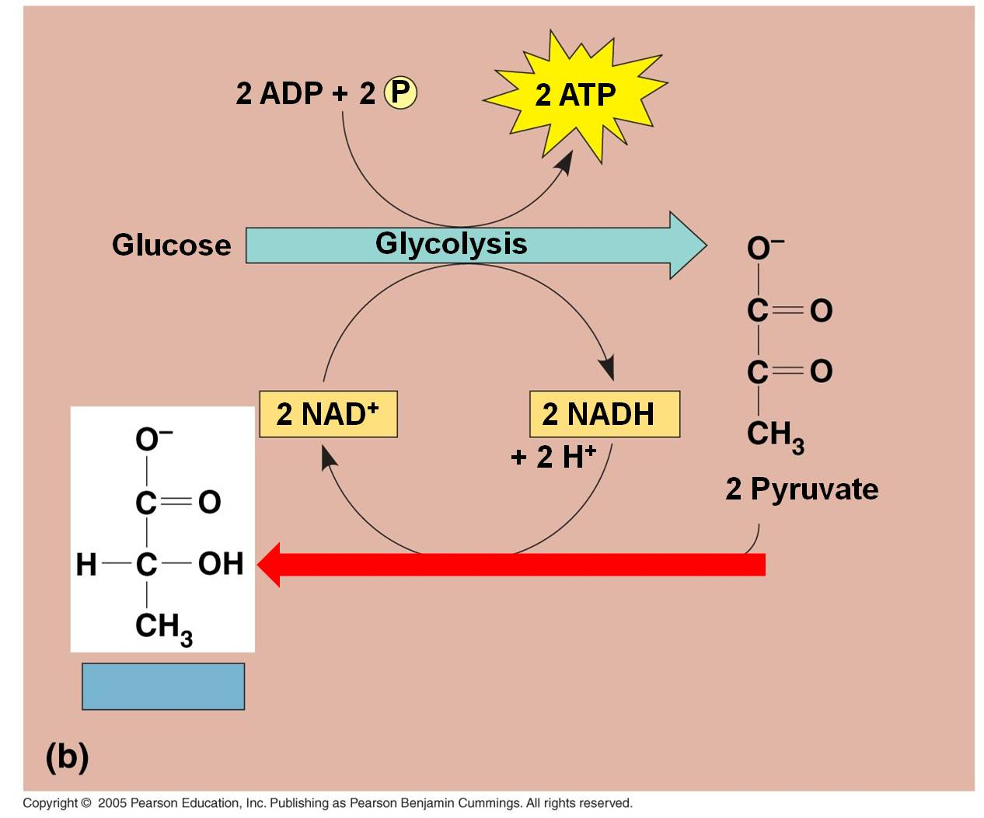
b. In bacteria, fungi, and some animal cells:
In lactic acid fermentation, the electron and H+ on NADH is transferred directly to the C₃ pyruvates. This converts them into lactate. Typically, this type of respiration in animals can only occur for short periods because the energetic demands for ATP will eventually exceed the rate of production from glycolysis, alone. At this point, oxygen concentrations must rise again so that the lactate can be converted back to pyruvate and metabolized by aerobic respiration. In animal muscle cells, this is known as the 'oxygen debt', and it is why animals keep breathing hard even after they have stopped exerting themselves. Short, intensive bursts of activity, usually for up to two minutes, will burn up available oxygen and cells will rapidly switch to anaerobic pathways. And of course, the reason these intense activities can't be sustained for more than 2 minutes at a time is that anaerobic pathways don't produce enough energy to sustain it! So, you will only be able to run at maximum speed for a short while... then you stop. Curiously, even though you have stopped and are not exerting yourself any more, you still breathe heavily for a while. You are pumping oxygen concentrations back up to normal levels, and processing the lactate that has built up in your muscle cells. In the presence of oxygen, the lactate can be convereted back into pyruvate, and then processed in the reactions described below.

D. Aerobic Respiration
Anaerobic respiration and lactate fermentation break only a single carbon-carbon bond in the glucose molecule. As such, only a small amount of the energy present in a glucose molecule is released. In aerobic respiration, the glucose is completely oxidized - all six carbon atoms are broken apart, and much more energy is released (and harvested).
Oxygen is a very reactive gas - it oxidizes things - stripping electrons from other molecules and breaking bonds. Combustion is an oxidative process, and it can occur spontaneously, without an ignition source. So, if combustible material heats up above its ignition temperature, and if a strong oxidative agent like oxygen is present, it will ignite. Gasoline is a long hydrocarbon polymer. When raised above it's ignition point, it will combust. The gasoline will be oxidized to CO₂ and H₂O - and the breaking of the carbon-carbon bonds that occurs during this process will release energy. A gallon of gasoline contains ALOT of bonds and ALOT of energy; and if it is released all at once, the energy is difficult to control or use - you get an uncontrolled explosion. In a car's internal combustion engine, very small amounts of gasoline are ignited in sequence, by spark plugs, causing a little explosion in each cylinder that pushes the piston that turns the crankshaft that turns the wheels of the car. In a diesel engine, there are no spark plugs and no spark; the fuel ignites when the temperature exceeds its ignition point when placed under high pressure when the piston rises. By controling the reaction, by oxidizing just a little at a time, the energy released can be used to do work.
All organic molecules - sugars, nucleic acids, proteins, and fats - can be oxidized in the presence of a strong oxidative agent like oxygen gas. In fact, after oxygenic photosynthesis evolved and after iron precipitated out of suspension, when oxygen began to accumulate in the oceans and atmosphere, it was probably toxic to life. As described above, most of the most ancient forms of life - like archaeans - are obligate anaerobes and are still poisoned by oxygen to this day. Some life forms evolved specific enzymes and 'anti-oxidants' to protect themselves from the oxidative effects of oxygen gas, and they tolerated this new environment. Some of their descendants evolved a mechanism to use the oxidative effects of oxygen gas in a productive way - in a way that released the energy in organic molecules in controlled reactions where the energy could be harvested effectively and used to do chemical work. These aerobic organisms came to dominate the planet, probably in part because they could harvest more energy from the food they consumed; energy they could use to grow, survive, and reproduce. Aerobic respiration probably evolved about 2.0 billion years ago, in response to the increase in oxygen concentrations. Shortly thereafter, aerobically respiring bacteria were engulfed by other cells but not consumed; rather, the host cells used the ATP produced by these energetically efficient 'bacteria'. These host cells were the first eukaryotes, that evolved about 900 million years ago. Their energetic endosymbionts evolved into the mitochondria present in living eukaryotic cells. Like chloroplasts, mitochondria have their own bacteria-like chromosome and a bacteria-like double membrane system. In eukaryotes, the process of aerobic respiration occurs within these organelles. From these ancestral eukaryotes, some absorbed photosynthetic endosymbionts, too; these because the photosynthetic algae and their descendants, the plants. SO - PLEASE KNOW THIS: all eukaryotes (except a couple weird protists like Giardia), HAVE MITOCHONDRIA - that includes protists, fungi, animals, and PLANTS. Photosynthetic eukaryotoes, the algae and plants, ALSO HAVE chloroplasts.
a. Overall Process:
- Pyruvates are broken down into carbon dioxide.
- Energy that is released from the complete breadown of the C-C bonds is used to make bonds in ATP (38).
- When bonds are broken, electrons are released. They have to be accepted by another molecule. They are initally accepted by NAD and FAD, which then take their "high energy" forms of NADH and FADH₂. Ultimately, they transfer this energy to ATP, give up their electrons and H+, and are recylced as NAD and FAD. (That's important, remember? We need to recycle that NAD so glycolysis - the first step in this whole process - can continue.)
- Ultimately, the electrons are passed to Oxygen O--, which then binds two hydrogen ions to balance charge (forming water).
- Aerobic respiration is a more complete breakdown of glucose, so it yields more ATP than glycolysis, alone
- In eukaryotes, this occurs in a three step process in the mitochondria of cells.
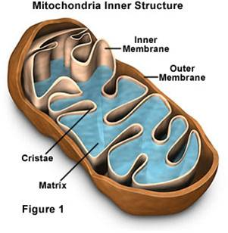
b. Mitochondrial Structure:
- Mitochondria have a double membrane system like bacteria and chloroplasts, with an intermembrane space and matrix within inner membrane.
- They have their own DNA, and they replicate themselves by fission - they aren't 'made' by the cell.
- Given these observations, Lynn Margulis hypothesized that these similarities were due to common ancestry, rather than common environment. She raised this hypothesis as the endosymbiotic hypothesis of eukaryote evolution, hypothesizing that eukaryotes acquired their organelles by engulfing free-living bacteria and, rather than digesting them, simply engulfed them and consumed their products (in this case the ATP that the bacteria produce. The relationship is called symbiotic, because Margulis hypothesized that the bacteria would also benefit by being in a stable environment where the concentration of glucose was high (inside the cell).
- The most direct test of a hypothesis of relatedness is DNA similarity. DNA only comes from parents, so similarities imply a common source. When these tests were performed in the 1970's, her hypothesis was confirmed. Additional tests with choloplasts and basal bodies (other organielles in eukaryotes) also showed strong patterns of relatedness with free-living bacteria. As such, we now refer to this tested model as the Endosymbiotic Theory. We will describe this theory in more detail later in the term...
c. The Details:
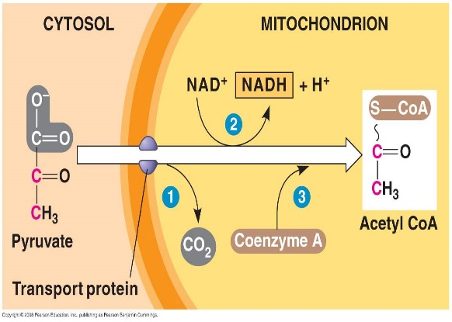
1. 'Gateway' Step:
- Pyruvates cross both membranes into the mitochondria and enter the 'matrix' - the cytoplasm of the organelle.
- Each pyruvate reacts with a Coenzyme A molecule, and is split into a C₂-CoA molecule and CO₂. (One C broken off).
- The electrons and energy released are accepted by NAD, forming 1 NADH for each pyruvate used.

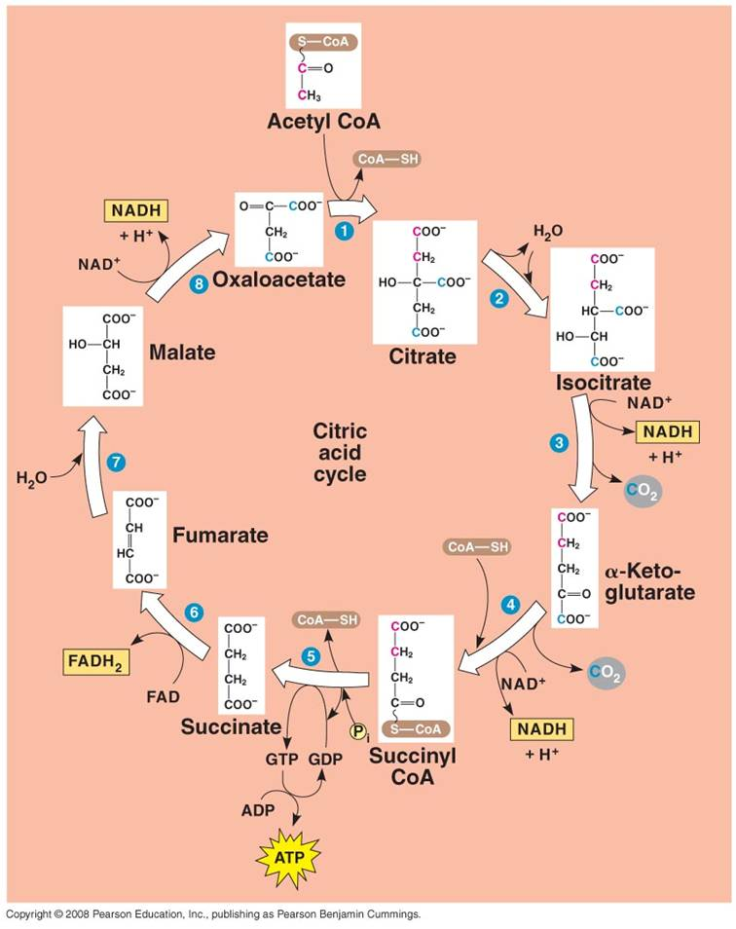
2. Krebs Cycle:
- Each C₂-CoA reacts with a C₄ molecule (oxaloacetate).
- The C₂ acetate is transferred to the C₄ molecule, forming a C₆ molecule of citrate. (CoA is released and recycled).
- Through a series of reactions, the 2 'extra' C's are broken off as CO₂ molecules and the C₄ molecule is regenerated (Cycle).
- Some of the energy released by the breaking of the C-bonds is used to make 1 ATP, 3 NADH, and 1 FADH₂.
3. Electron Transport Chain:
- Proteins nested in the inner membrane of the mitochondria accept the electrons from NADH and FADH₂
- The electrons are passed from molecule to molecule, and some of the energy released is used to pump H+ ions across the inner membrane from the matrix to the intermembrane compartment
- Asteep concentration gradient of H+ ions is formed... this represents chemical potential energy.
- When the ions flow through protein channels associated with ATP-synthesizing enzymes in the membrane, this potential energy is transformed into chemical energy in bonds between ADP and P, making ATP.
- When the electrons reach a low energy state, they are accepted by oxygen in the matrix and H+ ions react with the O-- to form water. This is the ONLY use of oxygen in the process - as an electron acceptor.
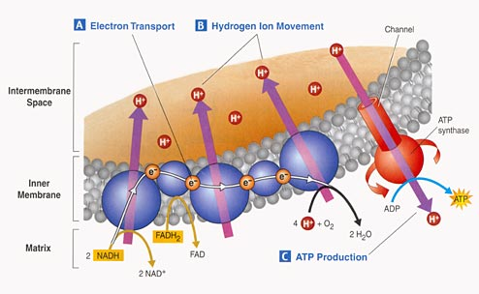
- 34 to 36 ATP are made from the energy tranferred from NADH and FADH₂ molecules produced in the Krebs Cycle.

E. Summary of Glucose Metabolism
Glycolysis - net yield is:
Glycolysis: 2 ATP (net), NADH
Gateway: 2 NADH
Krebs: 2 ATP, 6 NADH, 2 FADH₂
ETC: 34 ATP
Total: 38 ATP

F. Metabolizing other Biomolecules
All Biomolecules represent stores of energy that can be harvested when the molecules are digested.
a. Fats:
- Glycerol broken from fatty acids; glycerol (3C) fed into glycolysis and are modified into pyruvates (C₃). - the Fatty Acids are broken down into C₂ groups that are modified to react with CoA - they are shunted to the Krebs Cycle - these reacts are reversible, so if there is a surplus of C₂-CoA, it can react to form fatty acids ---> energy consumed in carbo's can be stored as bonds in fat.
b. Proteins:
- Broken into Amino Acids which, depending on their structure, can be shunted into glycolysis, modified into pyruvate, or broken into acetate (C₂). - In all cases, the amine groups are cleaved, producing ammonia (NH₃) as a toxic waste. In mammals, this is converted into urea which must be diluted in water for removal from the body (urine). Reptiles and birds convert it to uric acid, which is expelled as a paste that does not require as much water for dilution.
c. Nucleic Acids: - ribose can be metabolized after coversion to glucose.
II. Evolution of Metabolic Pathways
Metabolic pathways are often complex; a useless substrate is modified and changed into something else by an enzyme (enzyme 1). This intermediate is modified by another enzyme (enzyme 2), and is converted into another intermediate. Finally, this intermediate is modified by a third enzyme (enzyme 3), and a useful functional product is made.
Substrate A ---> intermediate B ---> intermediate C ---> useful product D
| | |
enzyme 1 used enzyme 2 used enzyme 3 used
- It seems like all three enzymes have to be present at once for the useful product to be made. It couldn't occur by a stepwise process, because a system with just the first step (substrate A to intermediate B) isn't functional - there is no useful product and it dies! So, it seems that all the steps have to be present at once. Again, this is the argument of intelligent design. Do you recognize it? A stepwise process is impossible; this is too complex; everything has to be present together for it to work - be it the eye, a new species, a new gene, or now, metabolic pathways. It is all Paley's old argument, wrapped in new clothes. Well, as with the evolution of the eye, there IS another possibility.
Suppose useful product D is present in the primordial environment. All the protocells are gobbling it up and using it. Well, we might expect the concentration of D to drop. If the useful product "D" is now in short supply, then selection will favor protocells that can make it out of something else - making it on their own and not relying on environmental supply. Maybe they can absorb something similar, like substance C, and "tweak" it chemically into D. So, selection will favor the evolution of the pathway: C--> D, even if C can't be used for anything else.
So, if this pathway is adaptive, then cells with this pathway increase in frequency. Generations later, only protocells with this pathway exist, and all the cells are competing for substrates D (which they can still use when they find it) AND substrate C, which all cells convert to useful product D.
Now, as substrate C decreases in supply (because cells are using it to make D), selection will favor protocells that can convert B into C, and thus into D: B--> C --> D.
Thus, useless intermediate substrates are added to the process in a sequence that is the "reverse" of the direction of the pathway, itself; and a complex pathway of A--> B --> C --> D evolves by a stepwise process.
- Many pathways are fundamentally quite similar - electron transport chains, etc. As is often the case in biological systems, once a functioning system evolves it is often "co-opted" for other functions - like electron transport systems are used in photosynthesis and respiration.

III. Photosynthesis

A. Overview:
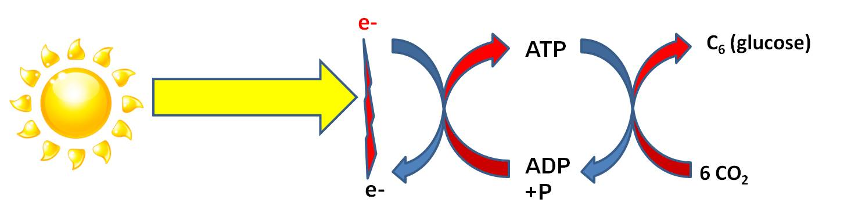
Photosynthesis is a process of energy transformation. Again, although energy can neither be created nor destroyed, it can be transformed. In the "Light Dependent Reaction" radiant energy ('carried' by photons in light) is transformed into chemical energy ('carried' by electrons). It requires an electron DONOR to provide electrons that will 'carry' this energy. The energy 'carried' by this electron is used to form a bond between ADP and P, creating ATP. Through this transfer, the electron loses this energy. As we have discussed before, the phosphate bonds in ATP are easily made and easily broken - that's why energy in this form of chemical bond can be 'used' by all enzymes in the cell. However, ATP is readily hydrolyzed in water...so it is difficult for a cell to build up a large amount of ATP before it 'dissolves' to ADP and P again. To store large amounts of energy for a longer time, the energy in ATP can be converted to a more stable molecule. In most photosynthetic organisms, the catabolism of ATP is coupled to anabolic reactions that bind carbon dioxide molecules together into stable molecules of glucose, for longer term E storage. This also provides the cell with organic carbon that it can use to make the other biologically important molecules. These are the "Light Independent Reactions" of photosynthesis.
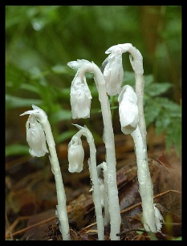
When we think of photosynthesis, most of us think "plants". This is generally correct, but very incomplete. First, there are some plants like Indian Pipe (Monotropa uniflora) that do not photosynthesize. Although they evolved from photosynthetic ancestors, they have adopted a parasitic lifestyle and no longer harvest their own energy from sunlight. In addition, there are photosynthetic protists (algae and Euglenozoans), and photosynthetic archaeans and eubacteria. In fact, there are several animals that harbor photosynthetic symbionts, too. Many corals (corals are animals) ingest algal cells and distribute them to their tentacles. The algae photosynthesize, and excess sugars are passed to the coral animal. These symbiotic algae give corals their spectacular colors. When stressed by water polution or high water temperatures, the corals release their symbionts and lose their color ("a phenomenon called "coral bleaching"). Long periods without their symbionts results in coral death.
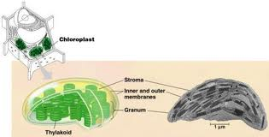
Photosynthesis in prokaryotes occurs on the double-membrane system of these organisms. In eukaryotes, photosynthesis occurs in organelles called chloroplasts. Chloroplasts have a bacteria-like double membrane, and they have their own DNA. This DNA is more similar in most respects to the DNA in free-living bacteria than to the DNA in the nucleus of the eukaryotic cells they 'inhabit'. For these reasons, most scientists accept the 'endosymbiotic theory' of chloroplast origins. This theory states that chloroplasts in the cells of photosynthetic eukaryotes are descendants of free-living photosynthetic bacteria. At some point in the early evolution of protists, these photosynthetic bacteria were engulfed by not digested. Rather, the host cells fed on the excess sugars produced by the internalized bacteria. Eventually, as the result of gene exchange between the host and proto-chloroplasts, the eukaryotic host and the prokaryotic symbiont became dependent on one another. But chloroplasts can still live outside of cells for several days. Plants, evolving from green algae ancestors, inherited these bacteria-like chloroplasts, too.
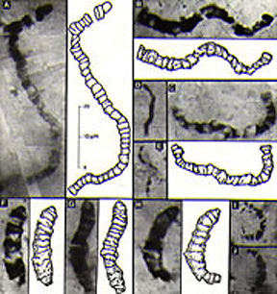
Photosynthesis is a critically important process in the evolution and diversity of life. Prior to the evolution of photosynthesis, life was dependent on absorbing spontaneously generated organic molecules, or preying on other cells. Neither of these sources of energy was probably all that common and easy to find. Evolving the ability to use sunlight as an energy source, which IS abundant and IS easy to find, meant that life could grow, prosper, and radiate dramatically - almost anywhere there was a light source. Indeed, it looks like photosynthesis evolved very early in the history of life; the earliest fossils (stromatolites and filamentous microfossils dating to ~3.5 by) look very similar to photosynthetic bacteria that are alive today. When photosynthetic organisms became abundant, they provided a food supply for a wider variety of heterotrophic cells. Heterotrophs could then live anywhere phototrophs lived; they were not limited to those rare places where biological molecules were forming spontaneously. So, complex bacterial food webs evolved. These early photosynthetic organisms used a primitive form of photosynthesis that did not produce oxygen as a waste product. So, even though they flourished for a billion years, no oxygen was added to the atmosphere. About 2.0 billion years ago, a 'modern' type of photosynthesis evolved that used water as the electron donor and produced oxygen gas as a waste product. The production of oxygen gas transformed the oceans (precipitating iron), and eventually changed the atmosphere, as well. Although oxygen was probably a highly toxic gas at first (because it is so reactive), life eventually evolved to tolerate it and then to USE it in oxidative respiration. The evolution of aerobic respiration allowed for more energy to be harvested from the catabolism of complex organic molecules, and may have allowed for the evolution of more energy-demanding eukaryotes and multicellular organisms. As you know, almost all food webs are ultimately dependent on the photosynthetic organisms at the base of the "food chain" (hydrothermal vent communities are a possible exception). We use this energy to stick amino acids together to make our proteins, etc. Even the gas and oil that powers our industrial societies was initally stored as glucose produced by photosynthesis. Coal, gas, and oil are just fossilized plants - and we "burn" that energy millions of years after it was converted from sunlight. We are powering our societies with sunlight that hit the Earth millions of years ago. But not only are you (and every other heterotroph) energetically dependant on photosynthetic organisms for food, you are also indebted to them for changing the planet and stimulating the evolution of eukaryotic and multicellular life. In short, there are few processes more important to the history and current function of living systems (and our petroleum-based economy) than photosynthesis.

B. Step 1: The Light Dependent Reaction
AGAIN, the purpose of the light-dependent reaction is to convert radiant energy to chemical energy. Obviously, light must be present; so this reaction "depends" on sunlight. There is one group of Archaeans that performs photosynthesis (Halobacteria), but their process of harvesting light energy seems quite different from the process in eubacteria and chloroplasts in eukarya and probably evolved independently. Within the eubacteria, there are also a wide variety of photosynthetic processes. We will focus on a couple major types and make reference to others as we go.
1. PRIMITIVE SYSTEMS:
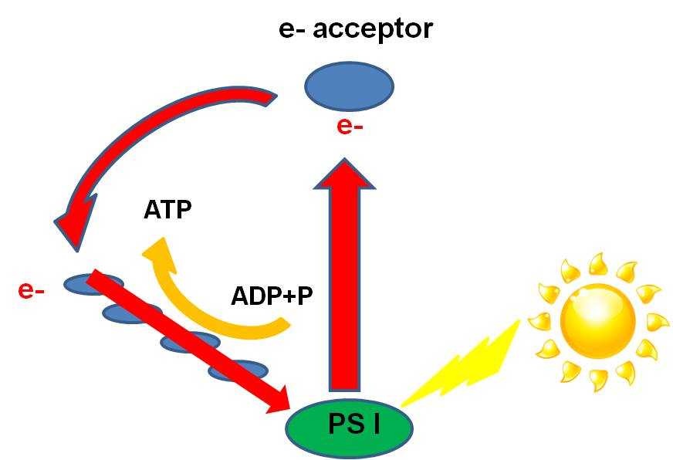
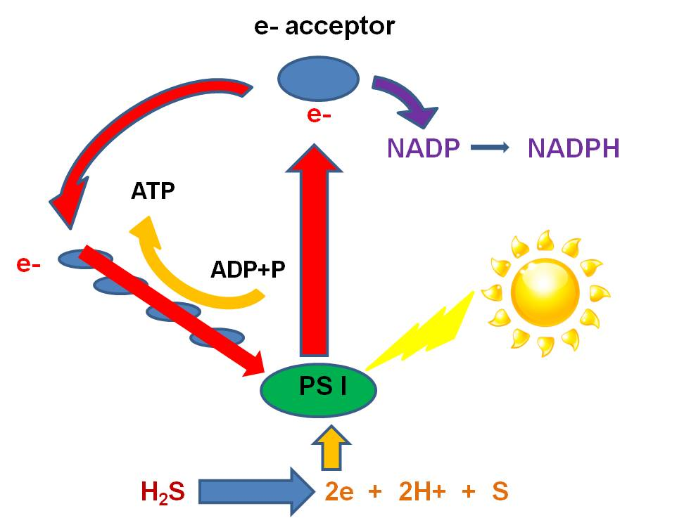
a. cyclic phosphorylation in "purple non-sulphur" and "green non-sulpher" bacteria:Like all bacteria, they have a double membrane (two bilayers). Proteins nested within the inner membrane form "reaction centers (also called "photosystems") and "electron transport chains" (ETC's) used in photosynthesis. This inner membrane is often highly convoluted, increasing the surface area and the number of reaction centers and ETC's that can be imbedded. Each reaction center contains proteins arrayed around molecules of bacteriochlorophyll, which contain atoms of Magnesium. In the presence of light, the photons transfer energy to these electrons. The electrons are raised to a higher energy state, lost from the atom, and transferred to an 'electron acceptor molecule' in the inner membrane of the bacterium, which transfers the electron the the electron transport chain. When a high-energy electron is transferred down the chain, protons (H+) follow ('electrostatically') and are pumped across the inner membrane into the intramembrane space. This build-up of H+ ions in the intermembrane space creates an electrostatic charge differential across the membrane. There are closed protein channels that, when opened, allow the H+ to flood through in response to the charge gradient. This electric discharge energy is used by the enzyme ATP-synthetase to add a phosphate group to ADP, making ATP. This is called 'chemiosmotic synthesis' or 'chemiosmosis'. So, what has happened is that the passage of an electron -excited by light energy - has been used to 'pump protons' into the intermembrane space, establishing an H+ ion charge gradient. The flow of H+ ions through protein channels transforms this electric energy to chemical bond energy in the form of a bond between ADP and P--> ATP. The high-energy electron is then passed down the electron transport chain. and ATP is produced. The electron, having lost its energy, can be recycled back to the Mg atom. This cyclic production of ATP, powered by sunlight, is called cyclic phosphorylation. As discussed below, these odd bacteria do not perform the light independent pathways. In other words, they do not use the energy in ATP to make glucose. This has two interesting consequences. First, it means they can't rely on photosynthesis, alone, for energy harvest, because ATP isn't stable enough to last over the course of an evening. So, they must also 'eat' - they are heterotrophs, and can harvest energy from the food they ingest. The other consequence is discussed below.
b. "green sulphur" and "purple sulphur" bacteria that use sulphides as the electron donors:
When the excited electron is recieved by the 'electron acceptor',something else can happen. Instead of the Electron Acceptor giving the electron to the ETC, it can give the electron to NADP... another 'energy transport molecule' like ADP. When this happens, the NADP gains energy and a negative charge and is NADP-. It reacts with free H+ ions that are always present in aqueous solutions (you should know why...), to make the high energy transport molecule, NADPH. In this case, the electron isn't returned to the Magnesium.... photosynthesis would stop, unless the photosystem can strip electrons from other molecules in solution. There are several groups of primitive eubacteria ("green sulphur bacteria" and "purple sulphur bacteria") that use sulfides (like hydrogen sulfide - H₂S) as the electron donor.
Sulphur bacteria have photosystems that strip electrons from Hydrogen Sulphide (H₂S). This releases 2H+ ions and S as a waste product. So, sulphur bacteria that are still present today photosynthesize in sulphur springs and do not produce oxygen as a waste product. This explains an interesting geological pattern: The oldest fossil life on record are photosynthetic bacteria that date to 3.8 billion years old. However, the first evidence of oxygen in the Earth's atmosphere occurs at about 2 billion years ago. So, how can you now explain how there were photosynthetic bacteria present for 1.8 billion years, without any oxygen being produced? Sulphur bacteria. And they have another interesting characteristic - they are anaerobic organisms poisoned by oxygen gas. So, not only don't they produce oxygen, but they can only survive in its absence. All these factors suggest that they may be similar to the first photosynthetic life forms that thrive in the anaerobic environment of the early earth. There is a problem for them, however. These bacteria can only survive in places where H₂S is abundant - like sulphur springs. These places are rare. If something evolved a system that could strip electrons from a more abundant source, like water (H₂O), then these new organisms could exploit almost the whole planet - as 75% of the planet is covered by H₂O.

2. ADVANCED SYSTEM: most other photosynthetic bacteria (cyanobacteria), and photosynthetic eukaryotes.
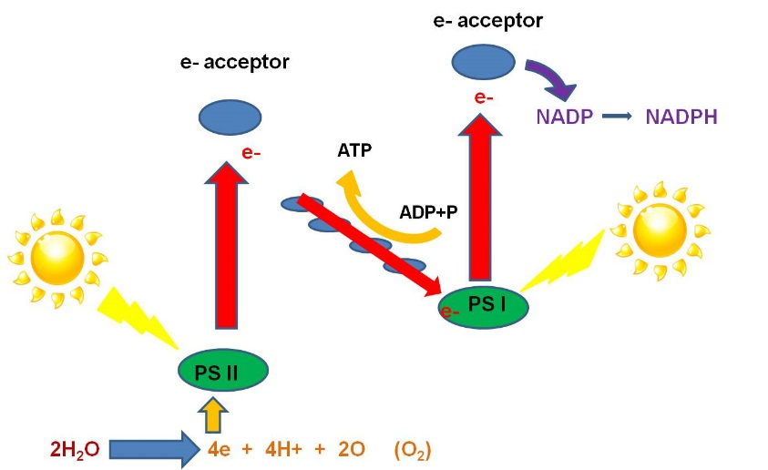
- In photosynthetic Eukaryotes(photosynthetic protists and plants), these reactions occur on the inner membrane of the Chloroplast - a specific membrane-bound organelle very much like a bacterium within the larger eukaryotic cell. Indeed, as described above, eukaryotic chloroplasts are probably the deescendants of free-living cyanobacteria - with whom they share basic membrane structure and DNA similarity.
- In cyanobacteria and chloroplasts, there are two types of reaction centers called "photosystems". The second photosystem (PSII) has a lower electronegativity than the first, so it can exert a 'stronger' pull and can strip electrons from WATER (which holds the electrons more strongly than H₂S does.) The splitting of water releases oxygen gas as a waste product, so this type of photosynthesis is also called "oxygenic photosynthesis".
- Here's how it works: Light strikes the phosystems nested in the inner membrane (called the 'thylakoid' membrane in chloroplasts). An electron in each photosystem is excited and lost from the Mg in the chlorophyll molecule. The electrons are accepted by partcular electron acceptor molecules. The electron lost from PS I is ultimately passed to NADP, which accepts a H+ to balance the charge, making the high energy molecule, NADPH. The electron lost from PSII is passed to an electron acceptor, and then to molecules in the electron transport chain. As the electron is passed down the chain, ATP is produced by chemiosmosis (as described above). When this electron has lost it's energy, it replaces the electron lost from PS I. So, PS I is all set, and need not strip electrons from an electron donor. However, PS II has lost an electron, and must replace this electron for photosynthesis to continue. PSII strips electrons from H₂O. Water is split into oxygen, 2 H+, and 2 electrons. The electrons are passed to the cholorophyll in PS II, excited by light, and energized. The oxygen reacts with another oxygen atom to produce oxygen gas, which is released as a waste product. The propose of photosynthesis is not "to produce oxygen". The purpose of the light reaction of photosynthesis is to transform radiant energy into chemcial energy, and produce ATP and NADPH. The two molecules, ATP and NADPH, are the useful products. Again, oxygen gas is produced as a waste product when electrons are stripped from water. The presence of oxygen in the oceans 2.5-2 billion years ago, indicated by the presence of sedimentary deposits with oxidized iron (banded iron formations), indicates the evolution of this more advanced type of photosynthesis that evolved in ancient photosynthetic bacteria.
3. SUMMARY OF LIGHT REACTIONS:
- Radiant energy excites electrons, which are passed down an electron transport chain and ATP is made.
- The first organisms to evolve this process probably used H₂S as the donor of these electrons. These sulphur bacteria do not produce oxygen as a waste product; they produce sulphur.
- The evolution of PSII was very important, because photosynthetic organisms could use H₂O as the electron donor and were no loner limited to living in places where H₂S was abundant. These organisms that use water as the electron donor produce oxygen as a waste product, and the geologic record suggests that this process evolved about 2.3-2.0 bya.
- Ultimately, the electrons are passed to NADP, making NADPH.
- Water + ADP + NADP --> in the presence of light --> ATP + NADPH + O₂ (waste)

C. Step 2: The Light Independent Reactions:
The purpose of the "Light Independent Reactions" is to convert the chemical energy in fragile ATP and NADPH molecules into a more stable energy form by building covalent bonds between carbon atoms to make glucose. In prokaryotes, these reactions occur in the cytoplasm of the cell; in eukaryotes, these reactions occur in the stroma - or cytoplasm - of the chloroplasts. It is important to appreciate that organisms using both primitive and advanced light reactions perform the light independent reactions.
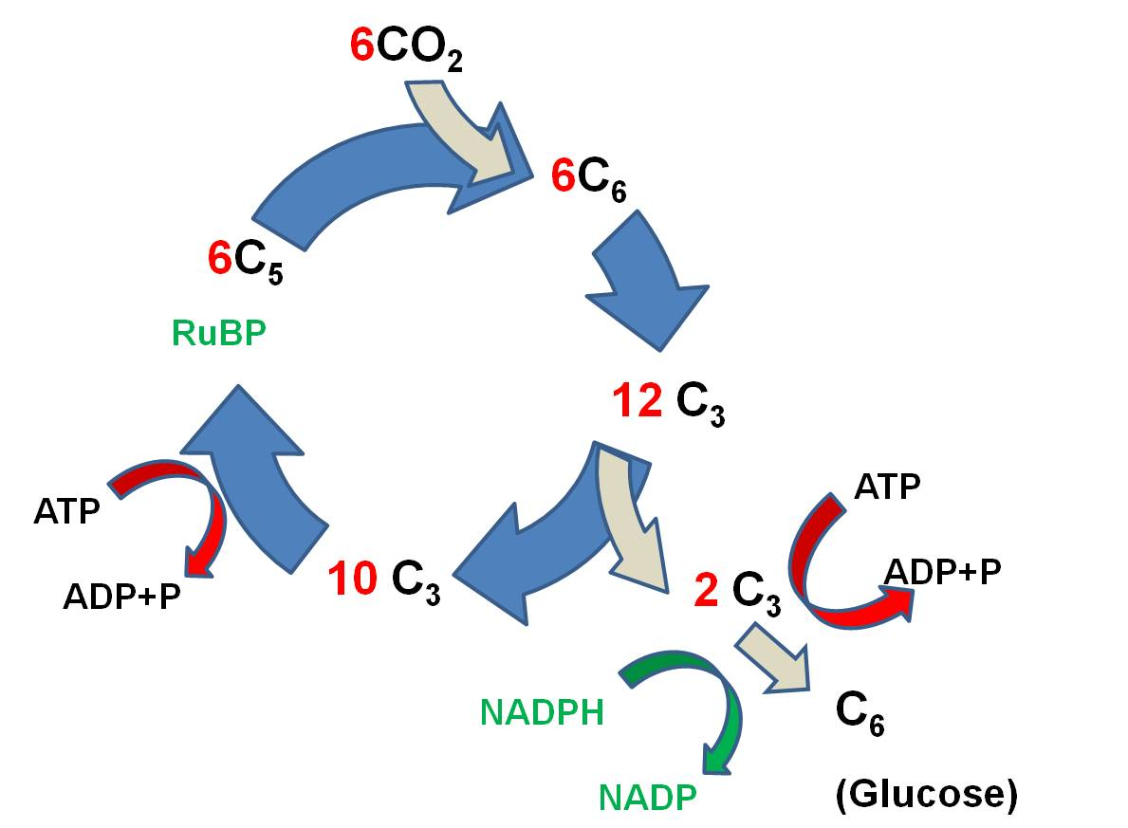
The primary reaction is called the Calvin-Benson Cycle, and it works like this:
- 6 CO₂ molecules bind to 6 C₅ molecules of Ribulose Biphosphate (RuBP), making 6 C₆ molecules. (ATP is broken and the energy that is released is used to link CO₂ to RUBP).
- These energized C₆ molecules are unstable; the split into 12 C₃ molecules. So, since the first stable product is a C3 molecule, this type of reaction is called the C3 pathway.
- 2 C₃ molecules are used to form 1 glucose (C₆) molecule. More ATP is used, and NADPH is used, too, and H is transferred to put the 'hydrogen' in 'carbohydrate'.
- the 10 remaining C₃ molecules (30 C total) are rearranged, using ATP and NADPH, and 6 C₅ molecules are generated (30 C total).
The reaction can be summarized like this: Six CO₂ molecules are used to make one molecule of glucose. Six RuBP molecules are involved, and are recycled through the process. The ATP and NADPH formed in the light reaction are used to power this reaction; the energy in these molecules is used top make bonds between the CO₂, and the H from NADPH is used to reduce the CO₂ to form glucose (C₆H₁₂O₆). As such, the radiant energy initially trapped in chemical bonds in ATP and NADPH is transferred to form bonds between carbon atoms in glucose. The energy intially trapped in fragile molecules has been stored in a more stable form.
When cells build glucose from CO2, they have not only stored energy in a stable form - they have also harvested carbon from the environment and transformed it into a usable organic molecule. Since all biologically important molecules (except water) are carbon-based organic molecules, all life forms needs a source of carbon to build amino acids, nucleotides, sugars, and lipids. "Heterotrophs" get organic carbon in the 'food' they eat. "Autotrophs" get their carbon through the light independent reaction, which also stores energy.
The first group of bacteria discussed above - the green non-sulphur bacteria and purple non-sulphur bacteria - perform the Light Dependent Reaction and make ATP using sunlight, but they do not perform the light indepedent reactions. So, they do not absorb CO2 to make their organic molecules. Instead, they must consume organic molecules to acquire their carbon. These organisms are "photoheterotrophs". They may represent the first step in the evolution of photosynthesis: the evolution of light-trapping reactions by heterotrophic cells. They use cyclic phosphorylation to make ATP in the presence of light, but they use organic molecules as electron donors.
D. Photorespiration - Problem and Solutions:
1. PROBLEM:
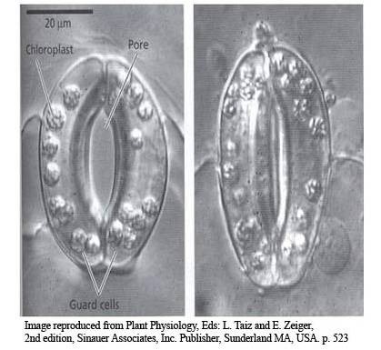
RuBP will bind to BOTH CO₂ and O₂. And when RuBP binds to O₂, it is split and transformed to the amino acid serine, with the production of CO₂ as waste. Essentially, it is digested. These reactions use the ATP and NADPH produced in the light reaction, too. So, when RuBP binds O₂, it does the exact opposite of photosynthesis - it IS RESPIRED - the energy of the light reaction is used to BREAK DOWN a carbohydrate (RuBP) and RELEASE CO₂. This happens when the relative concentrations of O₂ and CO₂ cross a critical threshold, If O₂ is super-abundant and CO₂ is scarce, then photorespiration will ocur. Oxygen levels can rise to these levels on HOT, DRY days, when there is a lot of sun for photosynthesis to proceed (so O₂ concentrations rise in the leaf and CO₂ concentrations fall), and it is DRY so the stomates are closed and gases can't be exchanged with the environment (so O₂ builds up in the leaf). It may seem curious that such a critical molecule has such a debilitating characteristic. However, because
the light independent reaction probably evolved long before oxygenic light reactions, it was already incorporated into the process before the accumulation of oxygen in the oceans and atmosphere revealed its weakness.
2. SOLUTIONS:
a. C4 metabolism:
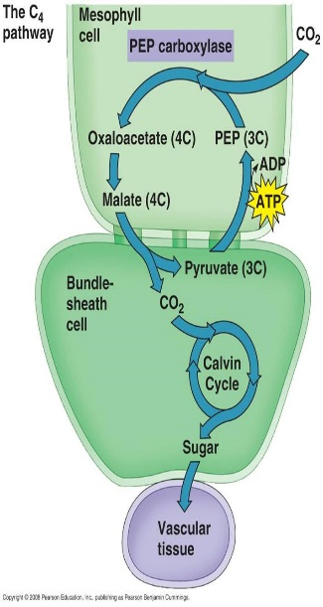
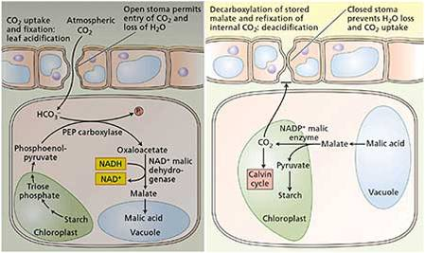
"C3 plants" (as described above - called C3 because the first STABLE product of carbon fixation is a C3 molecule) have chloroplasts in their mesophyll and not their bundle shealth. They suffer from photorespiration on hot dry days. "C4 plants" have chloroplasts in both cells; the bundle shealth has RuBP, but the mesophyll has a different binding molecule (PEP) with a higher affinity for CO₂. So, PEP (a C₃ molecule) can bind CO₂ at low concentrations, and then the product (a C₄ product) is passed to the bundle shealth. In the bundle shealth the CO₂ is dissociated from PEP, and PEP is returned to the mesophyll. This keeps the concentration of CO₂ in the bundle shealth high enough for RuBP to keep fixing CO₂, even though the leaf may be closed. So, PEP "pumps" CO₂ into the bundle shealth, keeping the concentration of CO₂ high enough that photosynthesis (and not photorespiration) will occur. This allows C4 plants to maintain glucose production even on hot dry days when their stomates are closed. Grasses are classic C4 plants, and they have adapted physiologically (and morphologically) to their environment.
b. Crassulacean Acid Metabolism (CAM)
"CAM plants" (for crassulacean acid metabolism) fix CO₂ at night and bind it to a C# molecule to form malate (C₄). Then, in the day when stomates are closed but light is available, they harvest energy and split the malate to release the CO₂ to RUBP, allowing both reactions to proceed.

Study Questions:
1. How can biological systems get bigger and more complex without violating the first and second law of thermodynamics?
2. Describe glycolysis.
3. What is the purpose of fermentation, and under what environmental condition does it occur? Why is this probably the first type of energy harvest that evolved?
4. What happens in the gateway step?
5. What happens in the krebs cycle?
6. What happens in the electron transport chain? Explain chemiosmosis.
7. How is oxygen involved in the process of aerobic respiration?
8. How does the food we eat get to the cells in our body?
9. Draw what happens in the primitive light reaction of sulphur bacteria, and explain the events that occur.
10. What is the electron donor for sulphur bacteria? What type of limitation does this impose on where these organisms can live?
11. Draw and explain what happens in the more advanced light dependent reaction. Why can we call this an 'adaptation'? (Why is this an improvement over the the more primitive system, considering the habitats available on Earth?)
12. Describe the correlations between these observations:
- the oldest fossils are 3.8 billion years old and look like photosynthetic organisms
- eukaryotic photosynthetic organisms about 2 billion years ago
- 'red beds', the oldest sedimentary deposits that include oxidized minerals, date to about 2 billion years
- previous to these red beds, minerals in sedimentary deposits are in their reduced state, suggesting that they were not exposed to an oxidizing atmosphere during their erosion and deposition, suggesting that the atmosphere contained no oxygen gas.
13. Draw the Light Independent reaction and describe the events that occur.
14. Explain photorespiration and describe two different adaptations of plants that live in hot, dry, environments.
15. When, where, and why is oxygen produced by photosynthesis? What is the primary function of photosynthesis?
16. What is “reverse evolution” and how might this explain the evolution of complex metabolic pathways?

