**Adaptations to the Physical Environment**

**I. Water**

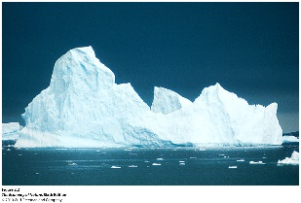**A. Properties and Adaptations**

**1. High Specific Heat**

**- It takes a large change in energy content to change the temperature of water**

**- it takes a MUCH larger change in energy content to change its state**

**- So, over most earthly temperatures, water is a liquid and stays a liquid – and is a thermally stable liquid.**

**- So, water is an excellent internal and external environment for life, because it is thermally stable, and it is a liquid in which other things can dissolve and interact.**

**- Also, the evaporation of water from a surface transfers latent heat energy from surface (earth or organism) to the atmosphere, cooling that surface. Evaporative cooling is a great way to lose heat, but you lose water, too.**

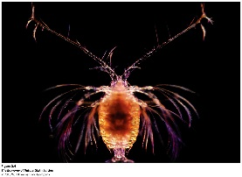**2. Density and Viscosity**

**- water is dense and viscous, providing bouyancy but also drag.**

**- salt water is more dense than cellular fluid, so many marine organism float**

**- those with dense tissues (cellulose, cartilage) have flotation devices (oil droplets, gas bladders, or filamentous appendages that increase SA/V and drag to prevent sinking, and they swim).**

**- Hydrodynamic shapes are selected for to reduce drag… sphere has lowest sa/v ratio for a given volume.**

**3. Universal Solvent**

**- polar molecules, gases, and ions dissolve in water, up to their maximum solubility (saturation value).**

**- Plants absorb inorganic nutrients dissolved in soil water (NH4+, NO3-,PO43-)**

**- H2O + CO2 🡪 H2CO3 (carbonic acid) 🡪 H+ + HCO3- (bicarbonate) 🡪 2H+ + CO32- (carbonate)**

**SO: CO2 dissolves in water, forming an acid. 50% of all the anthropogenic CO2 has dissolved in water, actually lowering the pH of the OCEANS by 0.1 pH (remember, pH is a log scale!!).**

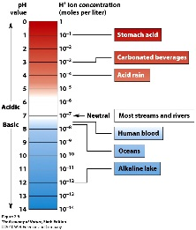**Carbonate ions react with Ca2+, forming calcium carbonate (CaCO3) which is not very soluble in water (the oceans are already saturated with it) so it precipitates out as limestone deposits. Thus, the lithosphere, via the hydrosphere, is a major carbon sink; making the composition of the Earth’s atmosphere much different than that of Mars or Venus.**

**4. Water Dissociates**

**- Water dissociates, releasing H+ that are very reactive. Also, CO2 dissolves in water, making carbonic acid which dissociates (above), releasing H+ ions. H+ ions can displace other cations from minerals, in a process called “cation displacement”, freeing soluble Na+, Ca+, K+ nutrients for biological uptake. However, it also frees heavy metals like Fe+, Al+, As+, Cd+, Hg+ that can be toxic.**

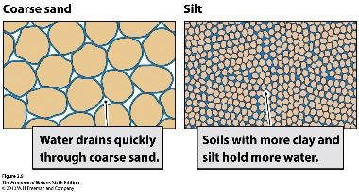**5. Water is Adhesive and Cohesive**

**- Water sticks to charged surfaces, like soil particles of clays (smallest), silts (medium), and sand (large). A given volume of clay particles has more total surface area, and so will bind more water, than the same volume of sand (with lots of spaces between). The amount of water held by the soil, after gravity has drained excess water out of the interstices, is called the field capacity (50% by volume for clay, 10% soil volume for sand).**

**6. Water Potential (Ψ)**

**- Water moves from areas of high water potential to low water potential.**

**- Pure water at sea level is standardized as having a water potential = 0.**

**- Water Potential is a function of:**

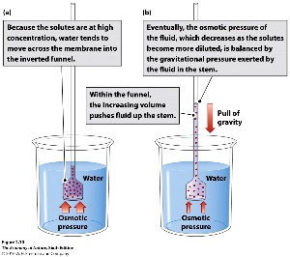 **- mechanical pressure: water, pushing out against a cell wall of a plant, can make the cell wall more rigid (TURGOR ) and equalize the force of gravity. When pressure drops, leaves and stems wilt and fall.**

**- solute pressure: has a negative effect on water potential. So, as solute concentration increases, water pressure declines. So, water will move from a more dilute solution (with higher water potential) to a more saline solution (lower water potential).**

**- gravimetric pressure: the force of gravity acting on the mass of the water**

**- potential due to humidity (to explain flow from liquid water to the atmosphere; drier air is more negative)**

**- matrix effects (surface tension and cohesion, as in a soil – also negative).**

**- Because soil ABSORBS/ATTRACTS/SUCKS UP pure water (capillary action), soil has a negative water potential. The more negative the water potential, the more water the soil will hold against the pressure of gravity (-0.01 MegaPascals). A saturated clay soil may be 50% water by volume; a saturated sandy soil may be only 10% water by volume. A very dry, salty soil will have a very negative water potential, even as low as -10 MPa. Water will be absorbed by the soil until water potential of the soil rises to -0.01MPa, at which point it will begin to drain from the soil (by gravity) to the water table.**

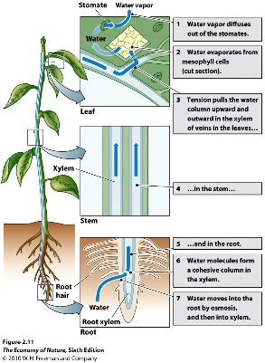**7. Water Absorption, Transport, and Regulation in Plants**

**- Plants must lower the water potential in their roots below that in soil to absorb water**

**- They lower water potential by increasing the concentration of dissolved solutes (amino acids, sugars, ions).**

**- large molecules stay in the cell, but ions leak out and their concentration gradient must be maintained by active transport, which can be energetically expensive in dry salty soils.**

**- Transport occurs in xylem – dead, hollow cells which, end to end, form long hollow tubes.**

**- The osmotic pressure of water (“root pressure”) entering the roots pushes water up the xylem (6m max)**

**- in the stem, water clings and crawls up xylem walls by adhesion and cohesion (“capillary action”), with dreiction encouraged by root pressure and, more significantly, by evapotranspirational loss of water from leaves…pulling water up tree.**

**- In leaves, water evaporating out of leaves to air (-133 MPa!!!) lowers the water potential in the leaves. Difference of -2 to -5 between roots and leaves causes the continuous column of water flows up the tree as long as the pressure offsets the gravitational pull on this long column of water in the xylem (cohesion-tension theory).**

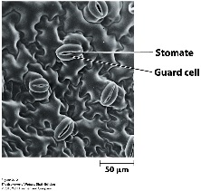 **- When soil reaches wilting point (lower potential than roots), water doesn’t enter root or flow up**

**- Leaves dry, and stomates close, stopping water loss due to evapotranspiration, water movement, and energy expended on active transport of salts into roots. But closing stomates also stops gas exchange and eventually stops photosynthesis and energy harvest.**

**- In salty environments, plants pump salts out, but maintain a low water potential by maintaining high concentrations of amino acids and sugars in roots.**

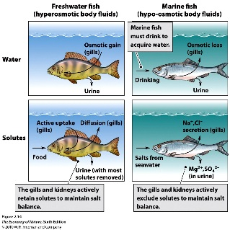**8. Osmoregulation in Animals**

**- Freshwater organisms have saltier tissue than the environment and absorb excess water. This is excreted in a dilute urine, and salts are retained by the kidney and actively transported into animal across gills.**

**- Marine organisms either passively react (and increase salt concentrations to match ocean), or retain other molecules in tissues to lower water potential to that of sea water (-1.2MPa). Marine sharks and rays retain urea; copepods synthesize amino acids when the environment gets salty.**

**- Osmoregulation is tied to excretion of nitrogenous waste. Freshwater animals excrete NH3 in dilute urine. Mammals convert ammonium to urea, which still requires water to dilute and excrete the waste. Birds and reptiles convert it to uric acid which crystallizes out of solution into a paste.**

**- Metabolism to urea and uric acid costs animal organic carbon.**

**II. Light**

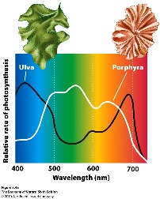**A. Properties and Adaptations**

**1. Pigment Absorbances**

**- Chlorophylls absorb in blue and red; carotenoids in blue and green.**

**- Algae at depth absorb in green, because red is absorbed by water quickly, and blue is scattered at surface… so the majority of light energy at depth is in green range.**

**2. C3 Photosynthesis**

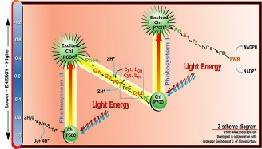**a. Light Dependent Reaction**

**- Photosystems irradiated; electrons excited and passed to electron transport chains**

**- transfer produces ATP and NADPH**

**- water is split to replace the electrons; oxygen is released as a waste product.**

**b. Light Independent Reaction**

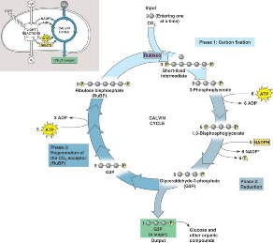 **- Energy is ATP and NADPH used to reduce and bind CO2 into glucose**

**- 6 CO2 bound to 6 RUBP molecules (C5), making 6 C6 molecules that are unstable and split (12 C3 molecules). Two are modified (reduced) and bound to form a C6 molecule of glucose. The other 10 C3 molecules are rearranged to recycle the 6 RUBP molecules. (This is a cycle… the Calvin Cycle).**

**- The enzyme that links RUBP to CO2 is RUBP carboxylase-oxidase (rubisco). It is inefficient at low CO2 concentrations, so plants overcome this shortcoming by having LOTS of it (30% dry weight of leaves!!)**

**c. Photorespiration**

**- when it is dry, plants close stomata.**

**- continued photosynthesis causes CO2 concentrations to drop and O2 concentrations to increase.**

**- Rubisco binds O2, not CO2, and reverses the reaction… at least shutting it off so no more glucose accumulates – BAD. Plants that experience dry conditions often have adapted new pathways.**

**3. C4 Photosynthesis**

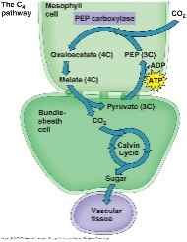 **- bundle sheath cells surround xylem/phloem. Surrounded by mesophyll.**

**- mesophyll perform a new reaction, linking CO2 to PEP (C3) to form malate (C4). PEP can fix CO2 even at low CO2 concentrations.**

**- The malate diffuses into the bundle sheath cells and is dissociated into PEP and CO2, keeping the CO2 concentrations high enough for rubisco to perform the Calvin Cycle correctly and photorespiration does not occur for a while. Carbon fixation and glucose production are separated spatially.**

**- So, these plants (many grasses) can close their stomata, save water, and still photosynthesize for a while. However, some energy is used in these extra steps, so C3 plants have an advantage in moist environments.**

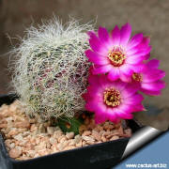**4. ‘CAM’ Plants**

**- Succulents (like cacti) that have adapted to desert environments where drought stress is most svere and stomata need to remain closed almost all day. So, these plants separate carbon fixation and glucose synthesis temporally; with fixation at night (when stomates can be open) and the Calvin Cycle in the day (when ATP and NADPH are available from the light reaction).**

**- AT NIGHT: stomates are open, CO2 is fixed by PEP into malate (as in C4 plants) stored in vacuoles in mesophyll cells.**

**- IN DAY: Stomates close, malate converted to CO2 and PEP, and CO2 used in Calvin Cycle.**

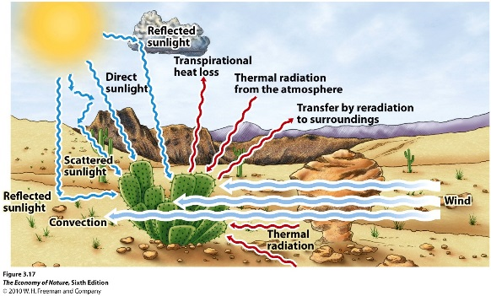**III. Heat Exchange**

**A. Pathways of Exchange**

**1. Radiation - emission of energy by a warm surface, which may be absorbed by a cooler surface. Sources are the sun, (direct solar) sky (indirect solar), earth (reflected solar and reradiated), other organisms (biogenic, reflected solar, reradiated). Rate of exchange depends on surface area and energy differential.**

**2. Conduction – transfer of kinetic energy between substances in contact. The denser the substance (more molecules/volume), the more rapid and efficient the energy transfer. Vacuum has no substance, so no energy transfer by conduction (thermos, vacuum windows). Water is denser than air, so transfer from a warm body to cool water is more rapid than to cool air. SA and temperature gradient affect rate, as well.**

**3. Convection – transfer of heat by moving liquids/gases that disrupt and remove a heated boundary layer, increasing the energy gradient between the environment and the organisms surface. “Wind chill”.**

**4. Evaporation – a phase change from solid to liquid to gas absorbs latent (“hidden”) energy from outside the system, cooling that system. When a droplet of water evaporates from your arm to the air, they absorb energy (needed to overcome the h-bond force linking them as a liquid) from your arm, cooling your arm.**

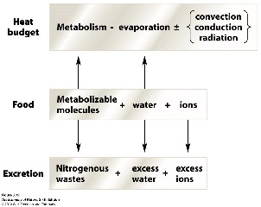**B. Effects on Organisms**

**1. Organismal Heat Budget**

**- Represents gains and losses of heat due to factors above AND heat production by metabolism.**

**- Because heat budget is affected by evaporation and food metabolism, the heat budget is connected to water, food, and salt budgets.**

**In Cold: Energy loss by radiation, conduction, convection are high. Metabolic demand for food increases. “Comfort foods” – especially those with high energy content (fats) and liquid (soups, stew).**

**In Heat: water loss by evap is high, heat load is high. Want to keep metabolic production of heat down (siesta), eat less, drink more, and replace salts lost by evap/urination.**

**2. Effects of Body Size**

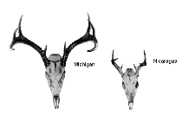 **- Energy exchange occurs across the body surface, but metabolic heat is generated by the volume of the tissue in the body. As organisms get larger, the SA/V ratio decreases. So, internal heat generation and storage increase (good in cold environments), but heat dissipation declines (bad in hot environments). Bergman’s Rule: Body size in a taxon increases towards the poles.**

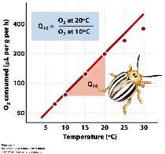**3. Effects of Temperature**

**- increasing temperature increases metabolic rate, increase growth rate, shorten generation time, increase reproductive rate; increase biological activity (uptake, decomposition) and biological productivity. Increase process rate 2x-4x for every 10oC temp change. So warmer body temp is usually better**

**- Constant body temperature (HOMEOTHERMY) is good, too, as it allows for enzymatic adaptation (selection over generations) and acclimation (adjustment of a single organism to the environment) to maximize efficiency at that temperature.**

**- A constant high body temp is usually adaptive… Large or well-insulated animals can generate enough heat internally to keep body temperatures high and constant = endothermic homeotherms.**

**- Small organisms (insects) or those that are poorly insulated (lizards) maintain high body temperatures behaviorally by moving to warm or cool areas to keep body temps stable = ectothermic homeotherms.**

**- Many organisms (plants, amphibians) cannot or do not regulate their temperature and are the temp of the environment = poikilotherms.**

**C. Adaptations**

**- Concept of “flux” is a unifying idea here. The rate of exchange of E or matter is dependent on: SA/V ratio, the concentration gradient, and the characteristics of the surface**

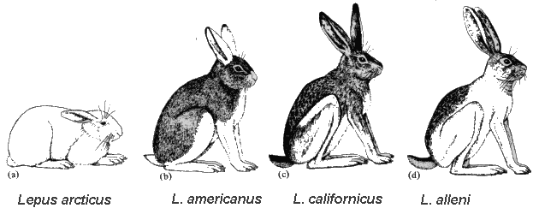**1. Structural**

**a. Size and SA/V Ratio**

**- Increase SA/V ratio to dissipate excess heat; danger is losing too much water.**

**- Decrease SA/V ratio to retain water, and retain metabolic heat.**

**- Bergman’s Rule: within a taxon, size increases with increasing latitude.**

**b. Hairs, Spines, Feathers**

**- these create a boundary layer that insulates against heat/water loss**

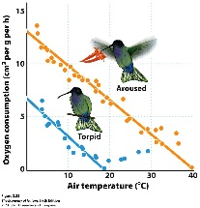**2. Physiological**

**- Change blood flow to dissipate or conserve heat loss.**

**- Maintain solute (glycerol and glycoprotein) concentrations in blood to reduce freezing point of cellular water.**

**- Reduce body temp/activity when food is unavailable: torpor, hibernation, aestivation**

**- counter-current heat exchange**

**3. Behavioral**

**- Bask or move to shade to regulate temperature**

**- Migrate**

**IV. Life History Evolution**

**A. Trade-Offs**

**1. Components of Fitness: *fitness = number of reproducing offspring***

**- probability of survival**

**- number of offspring**

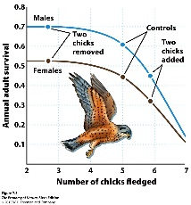 **- probability of offspring survival**

**2. Relationships with a Finite Energy Budget**

**- All organisms have a finite amount of energy to spend on basal metabolism, growth, and reproduction (specific tissues, mate acquisition, parental care).**

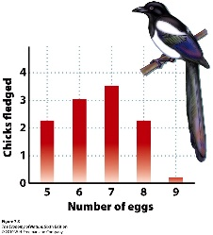 **- Investing in one component means decreasing allocations to another.**

**3. Trade-offs between Survival and reproduction**

**- Investing in Metabolism (homeothermy?) and growth increase survival (and lifespan).**

**- Investing in reproduction decreases size and survival.**

**- Investing in reproduction decreases energy stores and increases mortality**

**4. Trade-offs between #offspring and offspring survival**

**- if probability of survival is low, need to maximize number**

**B. Timing**

**1. Age of first reproduction**

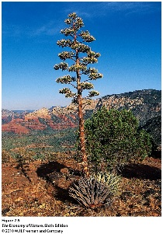 **- Big selective advantage to reproducing early if all else is equal**

**- If you delay reproduction (to invest in growth), may payoff if you can reproduce MORE later**

**- experiments show that the timing of metamorphosis is not just dependent on time or size, but both (see text, figs 7.15-16).**

**2. Parity: How Often**

**- Semelparous: reproduce once, then typically die. Adaptive if cost of reproduction are very high, or if breeding is rare and synchronous... Not the same as “annual” as annuals can breed several times in their year of life.**

**- Iteroparous (“iterative”) – more than one reproductive bout.**

**3. Senescence**

**- Why age?**

**- Accumulation of mutations**

**- Cost of DNA repair late in life vs. expending that energy in reproduction earlier in life.**

**- Why do humans have a long post-reproductive period? The selective value of grandmothers.**

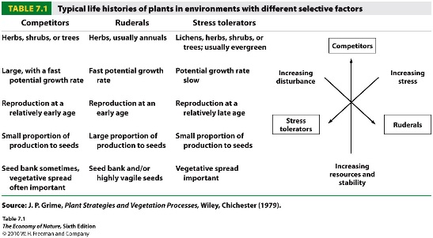**C. Life History Strategies**

**- these relationships between survivorship, fecundity, and fecundity schedules crate suits of traits that are often seen together as a “life history strategy”**

**- Ruderals (r-strategists): exploit open, disturbed habitats with lots of available resources and little competition. They exploit a “get in, get out” strategy of investing in early reproduction, typically of lots of small, vagile seeds. Investment on reproduction early results in a short life-span; often an annual life cycle.**

**- Competitors (K strategists): exploit closed, stable habitats where competition is often intense. Acquisition of resources is critical, selecting for growth and survival early, with some delay in reproduction. Can produce lots of little seeds or a few large ones.**

**- Tolerators: Exploit very stressful environments where energy acquisition limits both growth and reproduction. Usually grow slow, reproduce very late and a little.**

**STUDY QUESTIONS**

**1) How does water’s high specific heat affect it as an internal and external environment?**

**2) Water is dense and viscous, providing buoyancy and drag. What physical adaptations maximize buoyancy? Minimize drag?**

**3) Liquid water has changed the Earth’s atmospheric composition in a very important way, dramatically reducing the CO2. How? What two sinks now store the Earth’s carbon, and how did it get there?**

**4) Water dissociates into what? What affect do the products of dissociation have on weathering rock and mobilizing soil nutrients? What negative effect of “cation displacement” can occur?**

**5) Water is adhesive, binding to charged surfaces like soil particles. Explain why clay holds more water per unit soil volume than sand.**

**6) List the five components of water potential.**

**7) Water moves from areas of high water potential to low water potential. What is the primary method that roots use to lower their water potential and “entice” water to move into them?**

**8) As water moves into roots, it is pushed up by the force of the water moving in behind it… this is root pressure and it is eventually balanced by gravity far below the height of most tall trees. So, what other force (or “negative force”) helps explain how water moves up trees?**

**9) Where does the nitrogen in animal’s nitrogenous waste come from? What does it turn into in the aqueous solution of the blood? How do freshwater organisms get rid of it? How do saltwater organisms and terrestrial organisms get rid of it? How do saltwater organisms retain water in their tissues against the tendency of water to be lost from their tissues to the saltier environment?**

**10) How does the spectrum of available light energy change with water depth, and how have rooted algae responded?**

**11) Make a diagram of the ligh dependent reaction of photosynthesis. Why is water needed? Why os oxygen produced? What are the two useful products, and what are they used for in the light Independent reaction?**

**12) Diagram the light independent reaction of C3 plants.**

**13) What is photorespiration and why does it occur? Why is it “bad”?**

**14) How does C4 photosynthesis work, and under what conditions is it adaptive? When is it NOT adaptive?**

**15)How does CAM photosynthesis work, what plants do this, and why is it adaptive?**

**16) List the four mechanisms of heat exchange.**

**17) Why do you lose more heat to water than air of the same temp?**

**18) What affect does body size and the SA/V ratio have on heat production and the rate of heat loss?**

**19) Why are high, constant body temperatures usually adaptive?**

**20) Distinguish between endothermy, poikilothermy, homeothermy, and ectothermy.**

**21) Describe Bergmann’s and Allen’s rules, and relate them to an animals heat budget.**

**22) Describe two effects that hairs/spines have on an organisms heat budget, using two different mechanisms of exchange.**

**23) Salt water freezes at ~-2oC. Marine vertebrates have less salty tissues and so (based on salt concentrations, alone), should freeze at higher temps (like, -1oC). Why don’t they?**

**24) Explain how a counter-current exchange system in a duck’s foot conserves heat energy and minimizes heat loss to cold water.**

**25) An organism is confronted by many environmental variables simultaneously. Adaptations are rarely perfect solutions; rather, they are efficient compromises that weigh the relative importance of particular stresses. Consider the contradictory pressures on a plant of maximizing irradiation for photosynthesis, while maximizing water retention (and minimizing water lost by evaporation as leaf temperature increases). Considering this trade-off, explain why plants in rainforests and grasslands have different sized leaves.**

**26) How does a limited energy budget impose constraints on the components of fitness?**

**27) What two trade-offs arsie as a consequence? Provide an example for each.**

**28) How can these allocation patterns change under different environments? Provide an example.**

**29) Why is the first age of reproduction so important? If an organism delays reproduction, how can it “catch up” in tems of fitness against others that have reproduced earlier?**

**30) When might semelparity be adaptive? (Three reasons).**

**31) Provide a hypothesis why humans have a long post-reproductive senescent period.**

**32) Contrast r and K life histories life histories.**