Primary Sources for Revolution Lesson

Stamp Act Text
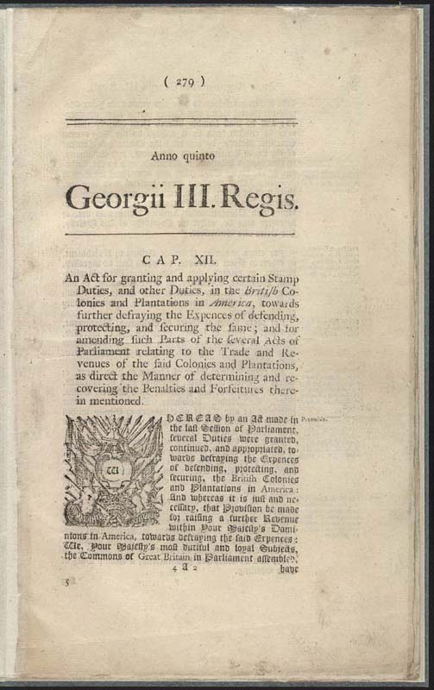

Stamp Act Picture
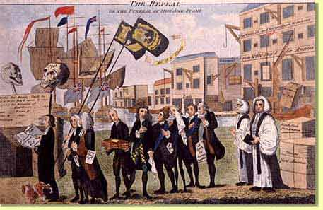

Pennsylvania Newspaper Response
