Lesson Plan

Textile Technology in South Carolina during the Industrial Revolution

Katherine Patrick

Objectives
Students will gain knowledge about the importance of technology in the cotton mills and why it was developed. They should also be able to discuss how the technology affected children and families in South Carolina.

Essential Question

How did technology in the cotton mills develop or advance during the late nineteenth and twentieth century? How did that affect the children and families of South Carolina?

SC Curriculum Standards
SC-SS-05.3.5.1 Summarize developments in industry and technology in South Carolina in the late nineteenth century and the twentieth century, including the rise of the textile industry, the expansion of the railroad, and the growth of the towns. (H, G, E)

Background Information

Background
Upstate History Museum:
The Textile Capital
Working the Mill Floor
Books:
Textile Town edited by Betsy Wakefield Teter
Greenville County South Carolina: From Cotton Fields to Textile Center of the World by Ray Belcher
Greenville: The History of the City and County in the South Carolina Piedmont by Archie Vernon Huff, Jr.
South Carolina: The History of an American State (8th grade textbook)
South Carolina textiles: Southern workers, northern bosses a study of industrial concentration and locale of ownership by the Textile Workers Union of America
At Home in South Carolina by Suzanne H. McDaniel, Sandra G. Thomas, and Thomas R. McDaniel
Cotton: Origin, History, Technology, and Production by C. Wayne Smith, Joe Tom Cothren (found online)
Inventing the Cotton Gin: Machine and Myth in Antebellum America by Angela Lakwete (found online)
The Rise of Cotton Mills in the South by Broadus Mitchell
Interview:
Betty is a Greenville native who has seen the development of this city over a lifetime. She experienced the mills and the life surrounding them through her husband and her father who both worked in mills in Greenville. Her knowledge of her father and husbands occupation is a first had account of what went on in the mills in terms of the process and forms of technology. Also she can shed some light on how the textile industry has made the Upstate of South Carolina what it is today from her perspective.
Websites:
www.answers.com
How the Industry Developed
http://americanhistory.si.edu/index.cfm
Engines of Change: The American Industrial Revolution, 1790–1860
www.wikipedia.org
Cotton mill
Textile manufacturing
www.youtube.com
Carding and Spinning
U.S. Child Labor, Dorsey Dixon, Babies In The Mill, Newport (song)
Cotton Mill

A cotton mill is a building that houses the machinery need to spin and weave cotton into fabric. There is a different room for each operation carding, spinning, and weaving. As new technology was developed that made textile production faster the more money could be made from it. In the South, after the Revolutionary War plantations and farms were destroyed. The agricultural economy could not longer be supported. Investors from the North saw that there was an opportunity for cheap labor. As the Industrial Revolution began, people needing work moved closer to the mills. This was the being of mill towns. In other words, cotton textile technology advances had a huge impact on society and the economy.

Brief History of Cotton Textile Production in the South

When cloth was first produced in the United States it was all made at home. Typically the women of the family would card, spin, and weave the cotton into cloth. After the Revolutionary War cotton mills sprang up in the Carolinas. Here the owners could take advantage of the cheap labor and the local water power produced by the hills of the Piedmont. Because cotton was grown in this area, the mill owners could save on transportation cost. As newer and faster technology came about the cotton mills in the South became more and more efficient and successful.
Carding and Spinning
After the cotton is picked and the seeds are removed, the fibers of cotton need to be cleaned and straightened. The cotton carder is used to brush out the fibers into a long mat of cotton. Once the fibers were straight they are twisted together to make yarn or thread. The spinning wheel is believed to have been used as early as 1000AD. This is the human powered wheel turns the spinner twists the fibers in their hand to produce a single spool of yarn or thread.
Cotton Gin
In 1792, Eli Whitney developed a mechanical way to separate the seeds from cotton fibers. Because removing the pulling the seeds from fibers are very labor intensive and take a good amount of time this was a tedious process. The cotton gin was so successful because it the job easy and works ten times faster than removing the seeds from the cotton by hand. The cotton gin made it possible to provide large amounts of cotton fiber to the rapidly growing textile industry.
Spinning Jenny
The Spinning Jenny is a multi-spooled spinning wheel invented by James Hargreaves around 1764. This tool allows for one spinner to produce eight spools of yarn at a time. Obviously, this wheel speeds up yarn production and reduces the amount of work that a spinner had to do to make yarn.
Carding Machine
Carding cotton is meant to prepare the fibers for spinning. Doing it by hand took time. The carding machine was developed to speed up the process allowing more cotton to be carded at one time and quicker. The machine carder is called a drum carder.
Spinning Machine
Spinning machines or industrial spinning are a combination of several inventions one of them including the spinning jenny. Spinning was originally done by hand power then it moved from water to steam power and now is done by electricity. Each power source developed speed up thread and yarn production.
Hand Loom and Power Loom
A loom is device that allows for the weaving of thread into cloth. Handlooms are the earliest forms of these weaving machines. They required that a weaver take two groups of thread and intersecting them to make cloth. When power looms were developed production was maximized. They are completely automatic and reduce the amount of work a weaver must do. Today there are looms that are computer automated.
Water Power
Water power is using the energy produced by moving water to power machinery. This took the place of muscle power. Mill owners look advantage water power produced by the hills of the Piedmont. As a result the Piedmont became the hotspot for textile mills.
Steam Power
Steam Power was used in cotton mills in the form of steam engines to power machinery such as the spinning machine, carding machine, and the power loom. Steam Power made it possible for textile mills to move away from the Piedmont. They were no longer dependent on flowing water sources for power.
Cotton production today: http://www.ars.usda.gov/IS/timeline/cotton.htm

Primary Activity

Materials
Cotton carder (artifact)
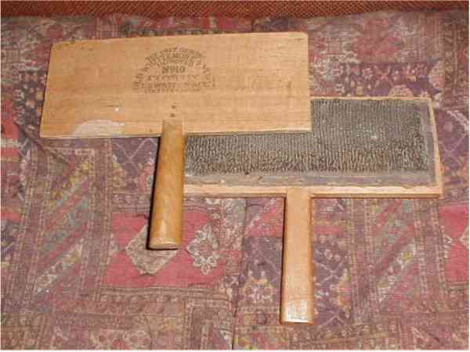
Textile Technology Powerpoint
Cotton -with seeds (for simulation)
Photographs or pictures of people working with technology in the mills (from where?)
Paper to do writing/drawing activity

Instruction
Hook:
Begin the lesson by playing the video clip called U.S. Child Labor, Dorsey Dixon, Babies In The Mill, Newport (song). This clip is about the many thousands of children who were forced to work in the mills. After showing this clip explain to the students that after the Revolutionary War South Carolina went through some changes. South Carolina could not longer be an agriculturally driven society. Thousands of families that farmed were now out of a job and were not able to support their families. Many business men from the North saw this as an opportunity for cheep labor. Because their pay was so terrible, in many cases entire families had to go to work in the mills. Children as young as 8 and 9 were documented working in the mills in South Carolina....in Greenville and Spartanburg . Explain to the students that they were boys and girls just their age. They didn't get a lot of time to play, many of them didn't get to go to school, and children had to work long hours on machinery that dangerous and complicated. Ask the students do they think they could have been able to do it.
Simulation:
We are going to pretend that we are children who are going to work in a cotton textile mill. Today all of the machinery in our mill is broken so we are going to have to do everything by hand. Make sure to explain to your students that textile is piece of material or fabric made up of thread or yarn that has been woven together . Give them an example like the t-shirt you are wearing, the towel you take to the beach, the cloth that covers your sofa at home. We have to get the cotton ready to be spun into yarn to be woven into a piece of fabric. To do that, we need to take all of the seeds out. Then we need to straighten out all of the fibers our so that they can be spun.
Give each student a piece of cotton that still has the seeds. Once everyone has a piece of cotton tell them they have three minutes to try get the seeds out and straighten the fibers before the next load of cotton comes in.
Walk around an observe students. Some of them might become frustrated because this is not an easy task. It is almost impossible to get the seeds out and then straighten out the incredibly tangled fibers. After they have given it a good try, ask they students if they would like some help. What if there was a tool that could help you do this in half the time? Would you use it?
Now, pull out the cotton carder (artifact). Explain that many families use to make their own clothes in their own homes. This cotton carder was used here in the Upstate of South Carolina. Ask the students who do they think used this cotton carder? Talk with them about how women and children mainly used these in the home but sometimes they had these in the mills as well. The people who would have used this type of a tool would be making their own clothes to wear. They would being by picking their cotton or have someone pick their cotton. Then they would seed the cotton just like you tried and then try to straighten out the fibers. This cotton carder is would they would have used to straighten out these fibers. There would be two of these tools. These metal bristles would brush out the cotton into a mat that could them be stretched out and spun into yarn that would then be put on a loom to be woven into cloth. (Optional video clip of woman carding and spinning).
Powerpoint:
In the mills, they were asked to make large amounts of cloth to be shipped all over the United States and all over the world. Ask the students: Do you think that using spinning and carding could produce enough thread or yarn to make cloth fast enough? No! So what did they do? They came up with new technology to help produce more cotton yarn and thread at an even faster rate. Let's find out how.....
In the Powerpoint there is a progression that you can show students how technology progressed to make textiles production more efficient:
Carding and Spinning
Cotton Gin
Spinning Jenny
Carding Machine
Spinning Machine
Hand Loom
Power Loom
Water Power
Steam Power
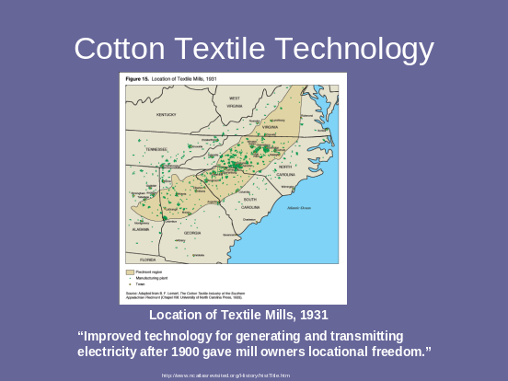
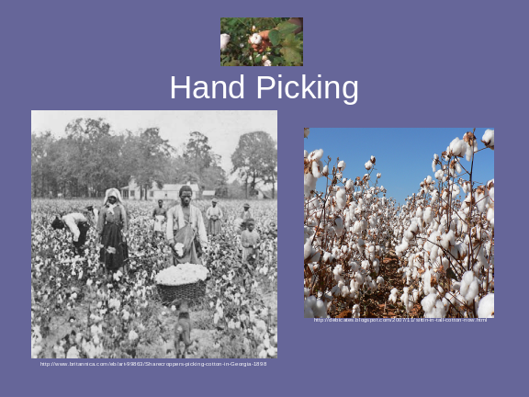
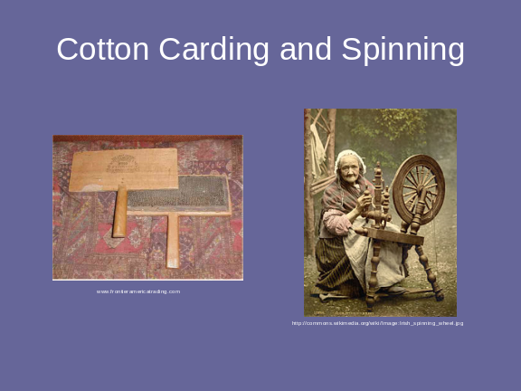
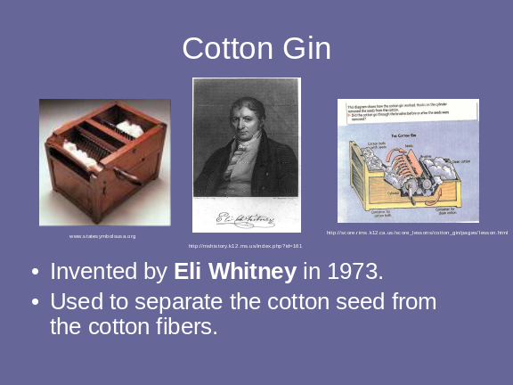
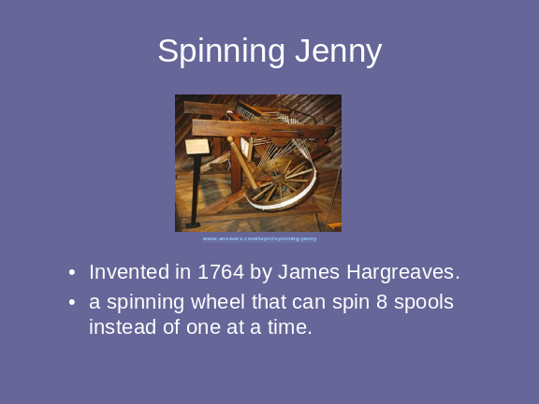
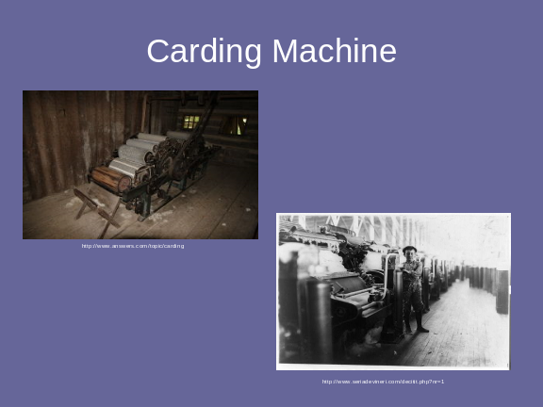
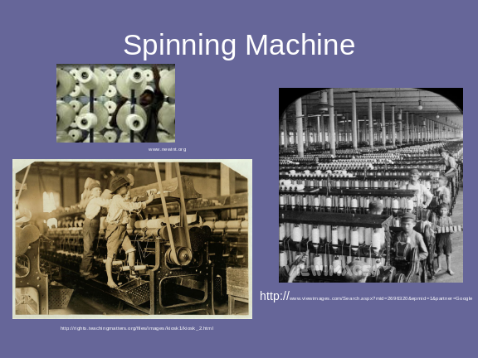
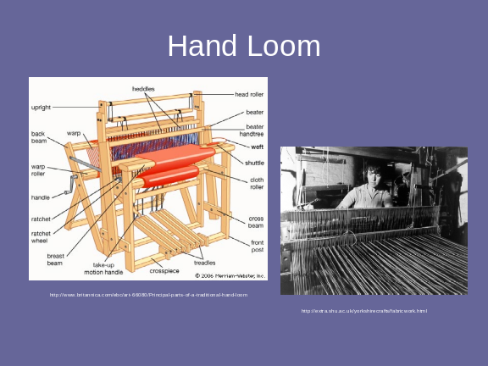
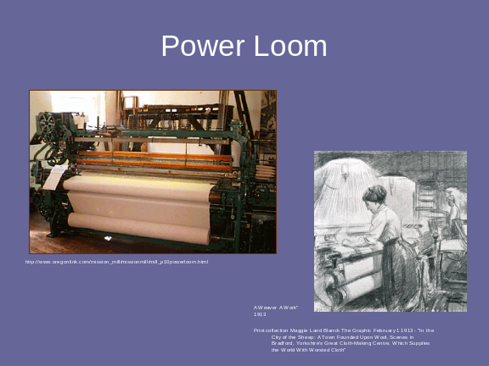
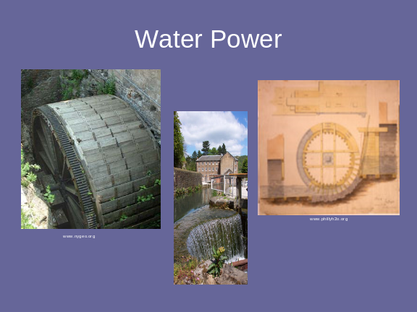
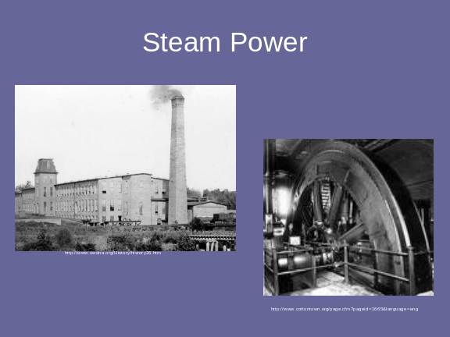
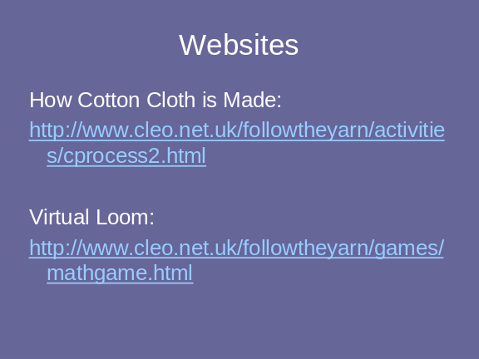
Activity:
Now break students up into groups of threes. Here are the instructions:
You have learned about the technology that was used in the mills and why that technology was developed. I am going to give each group a picture of a person who worked in the mills, it could be a child, a mom, a dad, a grandparent. I want you and your groups to be detectives. From the clues in the picture look at this person and make a guess what kind of technology in the mill this person is working with. Then I want you to tell me the pros and cons of using this technology. Why was that technology developed? You can explain the pros and cons through writing or through drawing. Feel free to use other resources such as books, dictionaries, even the Internet. After you and your groups have finished researching I want you to share what you have found with the class. Finally we are going to put the technology in order of their use and line the pictures up chronologically.
Spinning Machine
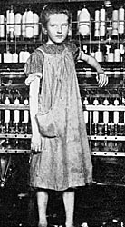
http://newdeal.feri.org/survey/37a01.htm

Hand Cotton Carding
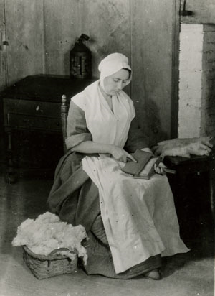
http://www.maggieblanck.com/Land/WE.html

Cotton Carding Machine
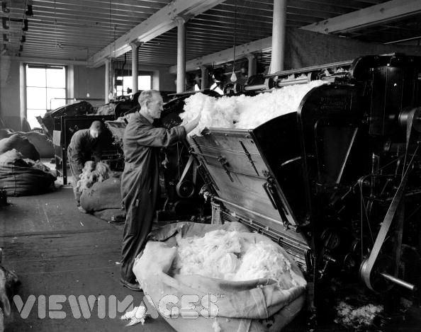
http://www.viewimages.com/Search.aspx?mid=3418624&epmid=1&partner=Google

Spinning Machine
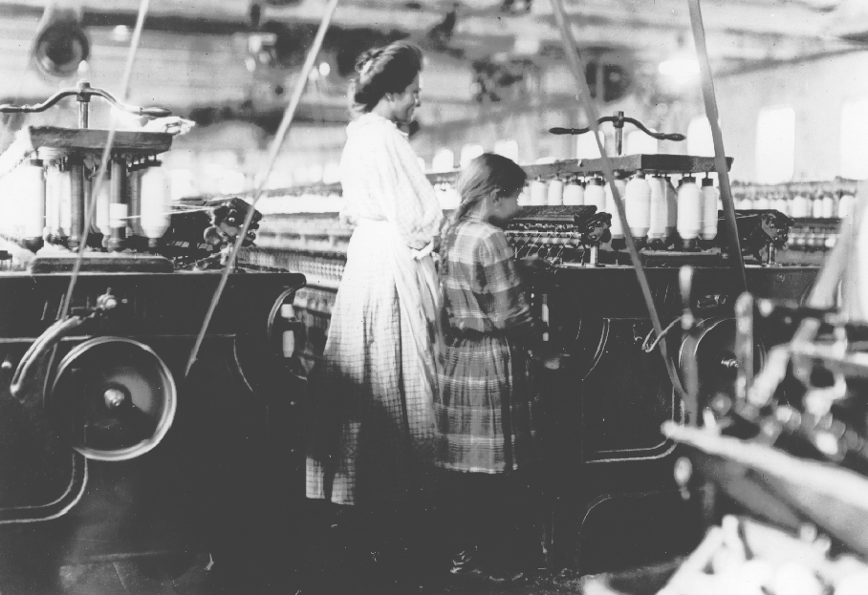
Learning to spin, ca. 1910. Photograph by Lewis Hine. For a larger high resolution version of this image (276K), Courtesy of the Walter P. Reuther Library, Wayne State University.
http://ibiblio.org/sohp/laf/factoryimages.html

Power Loom
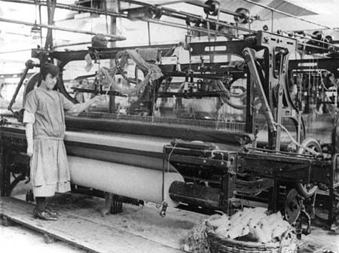
http://witneyblanketstory.org.uk/WBP.asp?navigationPage=Industrial%20Revolution

Steam Power

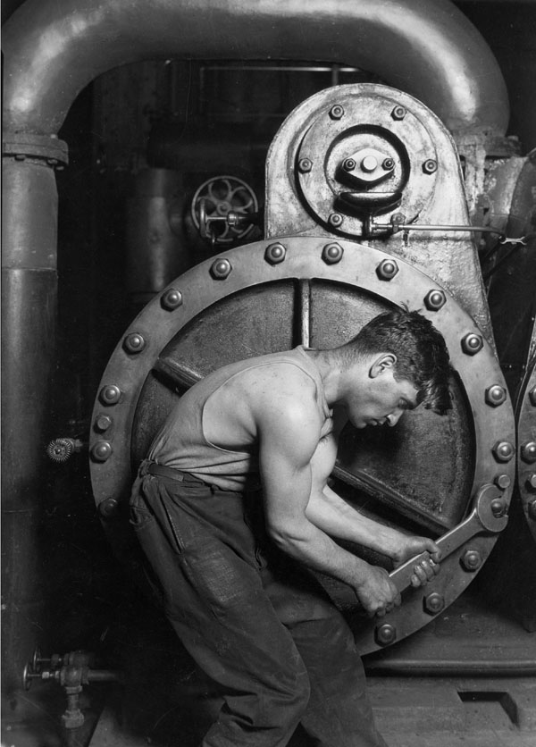

"Power house mechanic working on steam pump"
By Lewis Hine, 1920
National Archives and Records Administration, Records of the Work Projects Administration
(69-RH-4L-2) [VENDOR # 36]
http://www.archives.gov/exhibits/picturing_the_century/portfolios/port_hine.html

Power Loom
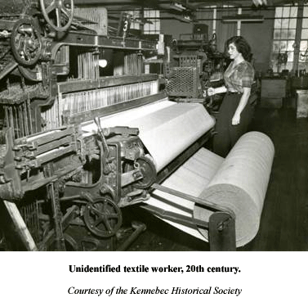
http://dll.umaine.edu/historytrail/site38.html

Spinning Wheel
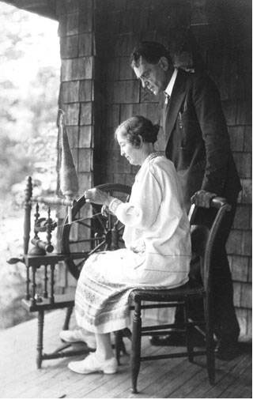
http://www.learnnc.org/lp/multimedia/6529

Hand Loom
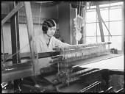
http://www.prints-online.com/page.php?page=search%20media&keyid=11134&keyword=textile
Attachments Cotton_Textile_Technology.ppt

Assessment Plan

Assessment - Informal
As the lesson is taking place observe students for participation and understanding of knowledge through discussions with teacher and peers. Also during the group research portion of the project, walk around the classroom and observe for participation in group and for relevant input into the activity.

Assessment – Formal

Use optional attached rubric to assess research and writing activity on technology and workers in the cotton mills.

Group Planning -- Research Project : Mill Technology Picture Activity

Teacher Name:
Student Name: ________________________________________

CATEGORY | Exceeds Expectations | Meets Expectations | Below Expectations | Unacceptable
Delegation of Responsibility | Each student in the group can clearly explain information on technology and its impact on workers in the picture that is being researched by the group. They find what information s/he is responsible for locating, and when the information is needed. | Each student in the group can clearly explain information on mill technology and its effect on workers that s/he is responsible for locating. | Each student in the group can, with minimal prompting from peers, clearly explain what information on mill technology and the workers that s/he is responsible for locating. | One or more students in the group cannot clearly explain what information they are responsible for locating.
Ideas/Research Questions | Researchers independently identify at least 4 reasonable, insightful, creative ideas/questions to pursue when doing the research on technology in the mills and effect it has on workers. | Researchers independently identify at least 4 reasonable ideas/questions to pursue when doing the research on technology in the mills and effects it has on workers. | Researchers identify, with some adult help, at least 4 reasonable ideas/questions to pursue when doing the research on mill technology. | Researchers identify, with considerable adult help, 4 reasonable ideas/questions to pursue when doing the research.
Writing and Art Quality | Students are able to organize their thoughts and information found through research and clearly express them through writing and art work. | Students are able to organize their thoughts and information found through research and express them through writing and art work. | With a lot of teacher help students are able to organize their thoughts and information found on technology research through their writing and art work. | Students are unable to organize their thoughts and information found through research and clearly express them through writing and art work.

Cross-Curricular Activities

Cross-Curricular
Research
Writing or Art
Technology
In this lesson, students will be asked to not only apply what they are learning about social studies but also research, writing, and art. In the final activity done by the class, they students are asked to look at a picture of a person working in the mills. They are to hypothesize about what this person's job is in the mill and then research to find out more about the technology they are using and about how this technology effects this person. The students will be asked to write up their responses and/or draw a picture. When they have completed their research, writing, and art work they will be asked to teach the class about what they have learned.

