Textile Baseball
by Brad Cake
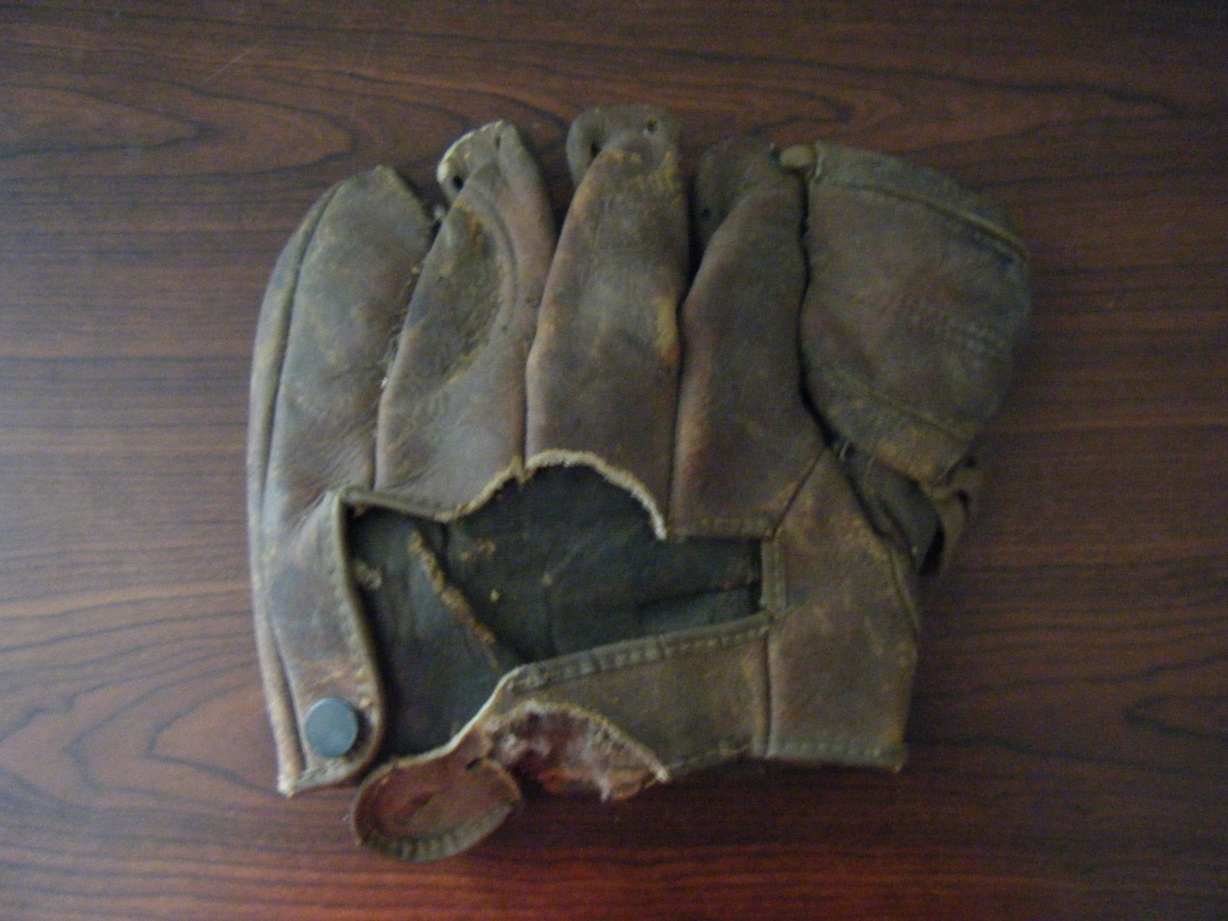

Grade Level: 3rd
Objectives: For students to understand the connection between the textile industry and baseball in Upstate South Carolina.
Essential Question: How did the textile industry contribute to the rise of textile baseball leagues in the Upstate?

Standards:
3-5.1
Summarize the developments in industry and technology in South Carolina in the late nineteenth century and the twentieth century, including the rise of the textile industry, the expansion of the railroad, and the growth of the towns.

3-5.3
Summarize the changes in South Carolina’s economy in the twentieth century, including the rise and fall of the cotton/textile markets and the development of tourism and other industries.

Background Information:
A main summary of background information can be found in the attached handout. Most of the facts from the handout came from these sources:

Textile League Baseball, South Carolina’s Mill Teams 1880-1955 by Thomas K. Perry – A book detailing the history of baseball in the textile leagues from the area.

http://www.greenvillesouth.com/joe1.html -A Greenville website about Shoeless Joe Jackson and baseball in Greenville. There are good pictures relating to Shoeless Joe and his life in the area.

http://www.scstatehouse.net/sess117_2007-2008/bills/4005.htm -A Resolution passed by the House of Representatives of the South Carolina General Assembly recognizing the importance of the textile league baseball teams in South Carolina.

http://www.teleproductiongroup.com/thread.html -Short quotations from interviews with former textile baseball players who described the essence of playing textile baseball.

http://walk-onlegislator.blogspot.com/2007/05/textile-league-baseball.html - Short description of South Carolina textile baseball and an interesting piece of trivia written by a legislator who lived near an old mill baseball player.

http://www.greenvilledrive.com/clubhouse/history/ - A history of textile baseball from the Greenville Drive website that describes players, how the leagues ended, and about salaries of players.

http://scmillhills.com/ - a page dedicated to the history of local mills with pictures of the mills.
Primary Activity:
Materials:
-Baseball glove artifact and modern baseball glove
-Handout (at end of document)
-Markers
-Crayons
-Poster board
-Wiffle bat
-Wiffle ball
-Bases (anything will suffice)

Instruction:
1. Begin the lesson by showing the students the old baseball glove (the picture is attached). Ask them to guess how old it is/when it was used. Juxtapose the old glove with a modern day baseball glove to show the students the difference between baseball then and baseball now.
2. Jump right in to an introduction to textile mill baseball in Greenville to get students excited about the topic. Read the attached handout and list of sources in order to introduce the topic.
3. Pass out the handout to each student and have students read it in groups of 3 or 4. Then have each student in their groups answer the questions at the end of the reading. They can work together on the answers, they just have to write down their answers on their own paper.
2. After they have completed the handout/have been given ample time to complete it, break the class in half to represent two different local mills. One side of the class can be the Monaghan Mill (near Monaview Elementary School) and the other can be the Brandon Mill (where Shoeless Joe Jackson worked and played). See last source for other mill information.
4. Have both groups/teams come up with a nickname/mascot and then have the two teams break into smaller groups of 3 or 4. Have these smaller groups make posters with the team’s name, the nickname/mascot, and a drawn picture or logo on them. Once each smaller group is done with their poster, have them get back together in the larger two groups/teams and then have the groups decide which poster best represents their team.
5. At recess, have the two teams play against each other in a friendly game of baseball (wiffle-ball), still pretending to be the two teams for which they made posters. Participation in this activity can be optional if a student does not feel comfortable playing. Before going outside for recess, create a parallel for the students: relate their school to working in the mills and compare recess baseball to the baseball games the mill workers played in during their free time.
6. After recess is over and the class is back in the room, close out the lesson by having a discussion about the last question on the handout. Ask students how they would feel if they were mill workers and whether they would want to play mill baseball during their free time instead of resting after hard days of work. Encourage students to share their opinions and teach them how to discuss opinions in a respectful way and be good listeners.

Assessment Plan:
-Assess the handout on a point system. For example, have it be out of twelve points, two points per question, or whatever will work with the teacher’s point system. An answer key is attached in order to assess the students’ answers.
-Passively assess the poster part of the lesson by walking around the room and observing how the students are working. Assess them on how they work with other students, how much they add to the group work, how their attitude is, and how focused they are on the poster.

Cross-curricular Activities:
Social Studies-
-History- Teaching the students about the history of the area, about textile mills, and baseball gives them a great starting point to learn about Greenville. To do more history, you could do a class investigation about a certain mill/baseball team.
-Economics-Informing the students about how the textile mills helped the South recover from the Civil War provides some early economics lessons about our country, specifically the south. The teacher could give a mini-lesson more on how this was accomplished, thus further informing the students about textile mills in the area.

Writing- By having students write answers to the questions at the end of the handout, they can practice writing, spelling, and forming sentences. If you wanted to further their writing abilities, you could have the students write a story about a mill worker and baseball player and his life back then.

Research and Language Arts- By reading the handout, students can practice honing their reading skills and can expand their vocabulary. To encourage research and more reading practice, have students research more about local baseball teams on the internet (have websites available for students to utilize).

Physical Education- Incorporating a baseball game into the lesson, students can get excited about playing baseball and pretending to be mill players. This will especially benefit those kinesthetic learners.

Art- Drawing posters helps develop students’ artistic and creative abilities.

Textile Baseball in Greenville

After the Civil War ended, the South, including Greenville, needed some economic help. The industrial cotton mills brought money back into the south, and they were the reason for south's recovery from the Civil War. Modeling the northern states, textile mills started to be built throughout the south, especially in Greenville. These cotton mills were built in the center of a mill town, with houses surrounding the mill. The workers in the mills would live in these houses and the mill towns became very close communities.

Working in a textile mill was really hard work. The workers labored in the mills for long hours, sometimes under harsh working conditions. They treasured any free time that they had, and residents of the small villages turned to baseball as a diversion from the hard work of the mills. Whenever they were not working in the mills, they were at the ballpark playing baseball. Each mill would form its own mill team, and the team became the pride and joy of each mill village. Competition between mill teams back then is similar to how high school teams play sports against each other today.

Mill owners knew that the game prepared players for working at the mill. Baseball taught respect for authority, self-control, discipline and increased employee morale. At the same time, owners knew how much baseball meant to the communities, so they scaled back the workweek in order to give the players more practice time.

Children as young as seven started working in the mills, and started playing baseball as well. One of these youngsters, “Shoeless” Joe Jackson started his baseball career after working in the Brandon Mill for a few years. At thirteen he started playing baseball for the Brandon Mill baseball team. Eventually he went on to play Major League Baseball and was one of the best hitters of all time, and a statue of him stands in downtown Greenville.
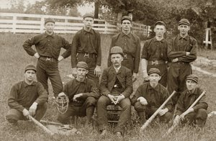

Questions
1. Why were textile mills so important to the South?

2. What did working conditions seem like in these mills?

3. Why did workers start playing baseball?

4. What worked-related skills did baseball teach the workers?

5. How old were children when they started to work in the mills?

6. Would you have liked to work in a mill and play for the mill’s baseball team?

Answer Key
1. Why were textile mills so important to the South?

After the Civil War, the south was in economic trouble and needed to rebuild. The textile mills helped the South recover from the Civil War and allowed for economic opportunities for the inhabitants of the area. The mills also fostered an inviting social atmosphere and brought southern communities together.

2. What did working conditions seem like in these mills?

Working in these textile mills was very hard work, and workers labored long hours each day. The mills were often dusty and had poor ventilation, leading to respiratory problems among the workers.

3. Why did workers start playing baseball?

The harsh working conditions in the mills lead the workers to get outside and enjoy playing baseball any chance they had. They enjoyed playing the game, being outside, and being in their communities with each other.

4. What worked-related skills did baseball teach the workers?

Baseball taught respect for authority, self-control, discipline and increased employee morale. Also, mill workers had to work in a mill in order to be on the baseball team, so baseball encouraged people to obtain a job at the mills.

5. How old were children when they started to work in the mills?

Children as young as seven started working in the mills, and started playing baseball as well. Shoeless Joe Jackson worked in the Brandon Mill for a few years before he started playing on the mill baseball team at thirteen.

6. Would you have liked to work in a mill and play for the mill’s baseball team?

This question does not have a right or wrong answer, but assess this on completeness, quality, and relevance to the question.



