The Life of a World War II Soldier (5th Grade)
Annah Reese

Objectives:
- Students will be able to identify several military bases in and around South Carolina, which trained soldiers for World War II.
- Students will be able to discuss the daily lives of World War II soldiers in training and at war.
- Students will be able to describe the reactions of soldiers to war.
- Students will have the opportunity to read firsthand accounts of soldiers' experiences in WWII and examine actual photographs from the war.
- Students will have the opportunity to use imaginative entry to place themselves in the WWII soldiers' shoes as they role-play and write letters from a soldier's point of view.
Essential Question:
What was life like for soldiers as they trained for World War II, and then as they actually served in the war?
SC Curriculum Standards:
SC-2007.ELA.5.1.7 | Create responses to literary texts through a variety of methods such as writing, creative dramatics, and the visual and performing arts.
SC-2007.ELA.5.5.3 | Create written descriptions using precise language and vivid details.
SC-SS-05.5.4.5 | Summarize the political and social impact of World War II, including changes in women’s roles, in attitudes toward Japanese Americans, and in nation-state boundaries and governments. (P, E, H)
Background Information:
America in World War II
After losing so many young men in World War I, the American people were hesitant to become involved in another distant war. However, when World War II broke out in 1939, President Roosevelt was eager to get the U.S. involved. Although he could not directly enter the war because of the Neutrality Act, he proclaimed a limited emergency and authorized increases in the size of the Regular Army. Because of this declaration, many young American men entered military training camps across the country. However, all of the U.S. infantry divisions were under-strength and ill-equipped. On December 7, 1941, Japan attacked Pearl Harbor and the United States officially entered World War II. Although many young men were trained and ready for war, a military draft was needed to fill the army quotas and prepare U.S. troops for war. The soldiers who fought in World War II had many different reasons for fighting: some believed it was their duty to their country; others saw it as an opportunity for adventure; still others were forced to go, due to the institution of the military draft. Overall, approximately 16 million Americans served in the U.S. military during World War II. By the end of the war, more than 295,000 Americans had been killed.
Life on the Military Training Bases
South Carolina, as well as most states throughout the country, sent many of their young men into military training to prepare for the war. The closest Army bases to South Carolina were Fort Jackson, located in Columbia, SC, Camp Croft Replacement Training Center, located in Delmar, SC, and Fort Benning, located in Georgia. World War II especially transformed Fort Benning into a beehive of activity, as it became a major staging area for sending troops overseas. The base also opened up a new parachute school to prepare soldiers for the war. In all, more than 600,000 World War II soldiers trained at Fort Benning. Although soldiers from South Carolina trained at various military bases across the country, they all had similar experiences as they went through the rigorous training. The men were initially sent to Reception, where they were given uniforms and supplies, tested with the AGCT, interviewed, and recommended for a training assignment. Most of the recruits were civilians with no military experience, so life on the bases came as a shock. The drill instructors at the bases were brutal. As one soldier recalls, they “stared at [the trainees] as though they were some low and disgusting form of animal life” (Dowling, 100). Corporal punishment was the norm, and recruits were routinely beaten for disciplinary reasons. Daily life on military bases was monotonous, and the soldiers entertained themselves in their spare time with movies, gambling, reading, and writing letters back home. Soldiers were desperate for leaves that would allow them to go home, yet travel by train was difficult and expensive. Surprisingly, many soldiers praised both the quality and quantity of Army meals. Their training included learning about different types of artillery, chemicals, attacks, and communication in the field. Over time, those unfit for combat were weeded out, and the rest learned all about following orders and enduring physical hardship.

Life on the Battlefield

While enduring the monotony of everyday existence, the soldiers also lived in anticipation of the day they would be shipped into battle. Few soldiers wanted to go into battle, but all were prepared to fight if necessary. However, many felt guilty about not being overseas to help. Many times, selectees had little choice of what unit they desired to join, and after graduation they were sent to supplement infantry units already in the field. The soldiers experienced many emotions as they fought in the war. One soldier said he “had never been more scared, more mad, and more tired” in his life (Adler, 5). Countless times, the soldiers would come across one of their own men on the battlefield who had been mutilated and butchered. Daily, they faced shellfire and bombs and booby traps, and many men spiraled into depression as they lost officers and friends to enemy attacks. Often times, the soldiers lived in jungles and forests, with no tents and no change of clothes. They ate twice a day, usually canned salmon and rice. They wished for gum and chocolate, and they hoarded toilet paper like it was gold. They built foxholes and dugouts for protection. It was difficult to sleep, and water shortages made bathing nearly impossible. Sickness and disease spread quickly. Homesickness overcame many of the soldiers fighting a war in a strange land. There were many ups and downs for the soldiers as the developments of the war changed from day to day. One soldier described war as "terrible at its best" (Adler 147). Writing letters and postcards to friends and family back home sustained many of the soldiers and provided them with hope and a boost of morale.

More information on the procedures on military training bases (in particular, Fort Benning) and the experiences of WWII soldeirs in the field can be found in the following:

Adler, Bill (Ed.) (2002). World war II letters. New York: St. Martin's Press.
Aquila, Richard (1999). Home front soldier. Albany, NY: State University of New York Press.
Dowling, Timothy C. (Ed.) (2005) Personal perspectives: World war II. Santa Barbara, CA: ABC-CLIO, inc.
Finke, Blythe Foote (2004). No mission too difficult. Wheaton, IL: Cantigny First Division Foundation
Place in history. Retrieved May 1, 2008, from http://www.nps.gov/history/seoc/benning-book/ch22.htm.

Materials:
- 1940 postcard from Fort Benning military base [see attachment]
- Copy of a letter from a WWII soldier (from the book World War II Letters by Bill Adler)
- 4 photographs of World War II soldiers in the Army from the link www.historylink101.com/ww2_color/index.html [see attachment]
- 4 pieces of cardstock cut to size/shape of a postcard
- Markers/colored pencils
- 4 cards containing scenarios for the role playing activity
- Lists of "Army Lingo" definitions including: pogey bait (candy), head (latrines), scuttlebut (rumors), boondocks (swamps), deck (floor), hatch (doorway) [from Dowling, 101]
- Paper
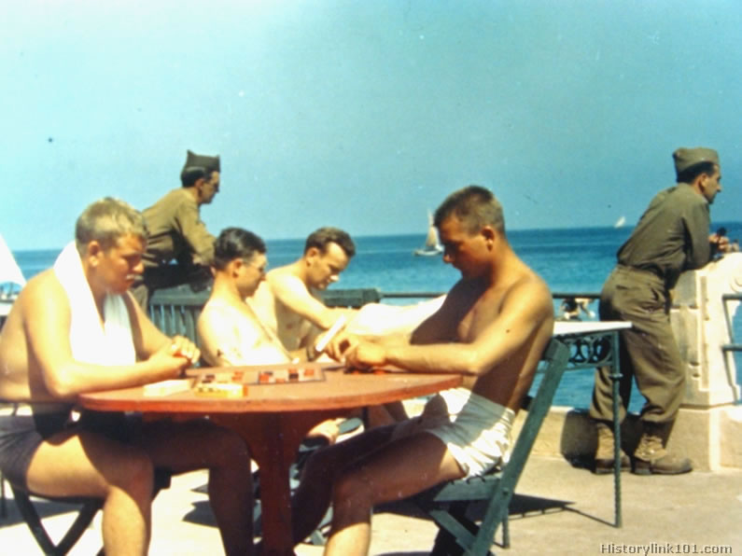
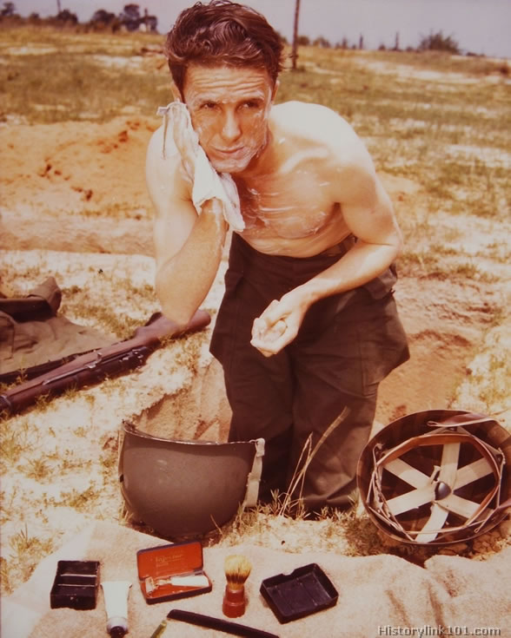
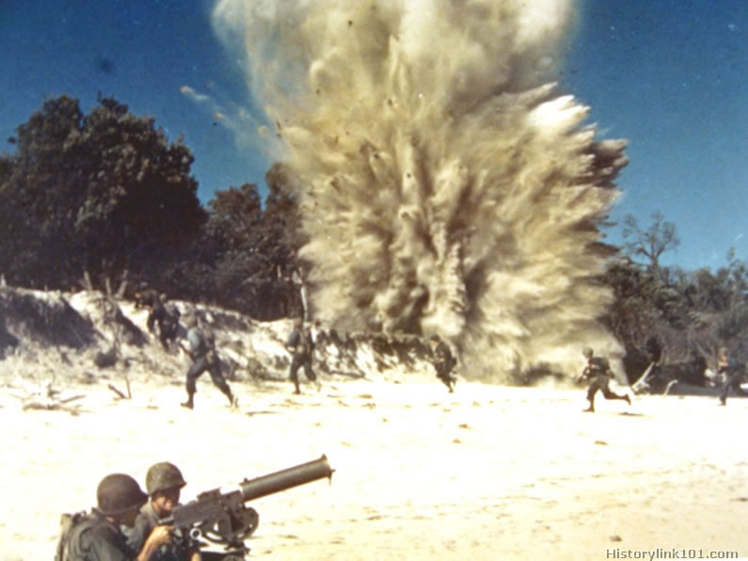
- Pens/pencils
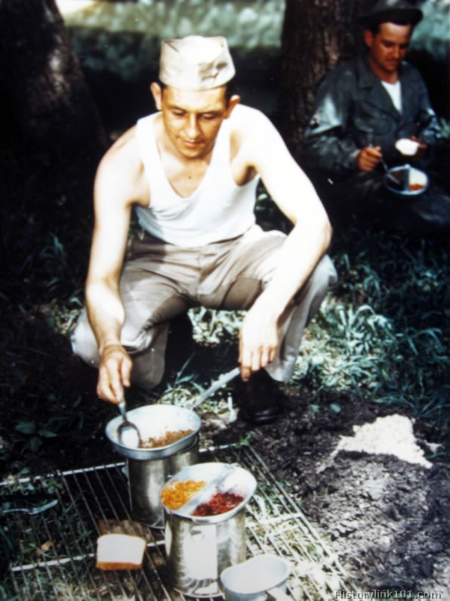
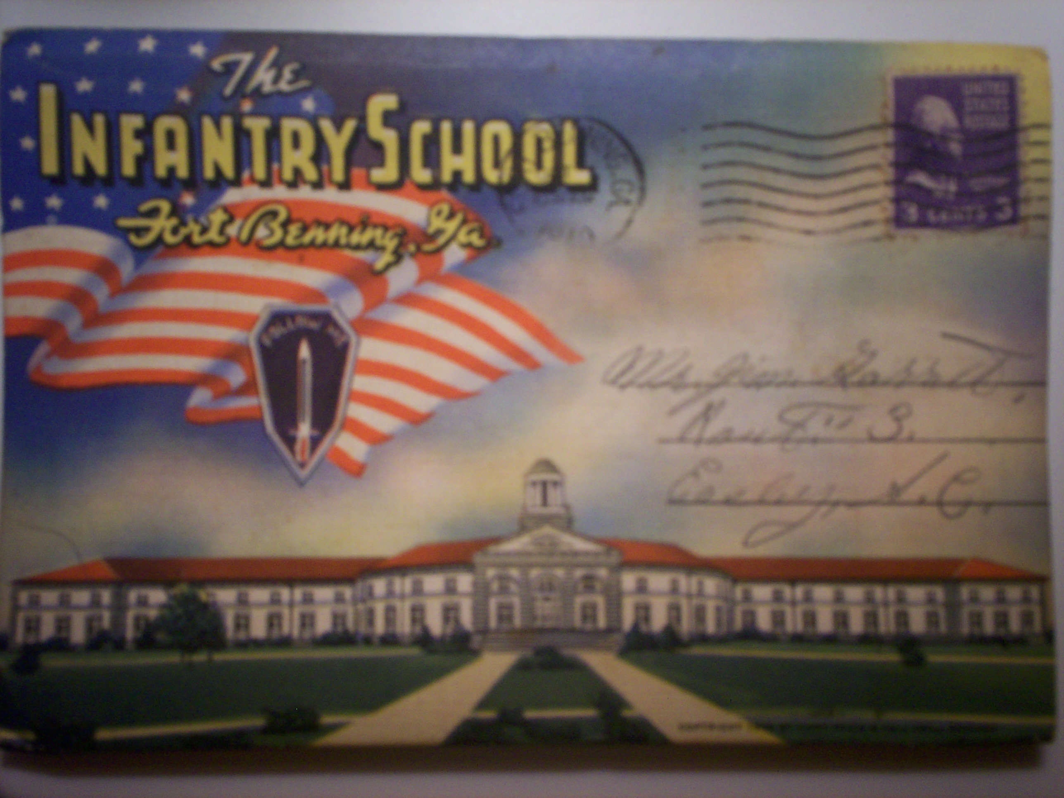

Instruction:

1. Prior to this lesson, students should be taught about the United States' entry into World War II.
2. Introduce the lesson by asking students, "Do you think there were soldiers from South Carolina who fought in World War II?"
3. Show students the postcard from Fort Benning, and point out the address listed as Easley, SC. Allow students to have a discussion as to who may have been sending this postcard. Also, point out the postmarked date and ask students, "What was going on in the war in 1940? Had the U.S. entered the war at this point?"
4. Explain to students that, although this soldier was from Easley, SC, he was training for the military in Fort Benning, GA. You could talk to students about Fort Jackson, the military base located in South Carolina. However, you can tell students that the experiences of soldiers in training were very similar at all military bases across the country.
5. Open up the brochure inside the postcard and show students the pictures from the training base at Fort Benning. Use these pictures as a prompt to talk to students about the soldiers' experiences as they trained for World War II, including their housing, training, equipment, forms of entertainment, new vocabulary (give each student an "Army Lingo" list), and feelings about war.
6. Once students have a grasp on the daily life of a soldier in training at a military base, divide the students into 4 small groups (4-5 students per group).
7. Have one student from each group come to the front of the classroom to blindly draw a "scenario" from out of a hat. Explain to students that each group will be role-playing a different scene of a soldier in training for World War II. Encourage students to use their new knowledge of military bases and Army training in their skits. Also, encourage them to use their "Army lingo" in their skits, if possible. Tell students they need to have a written script which includes all members of their group. The scenario cards should read as follows: A. You are to play a young man and his family as he receives his letter drafting him to military training. B. You are to play a young man at Reception as he is examined, tested, and interviewed to determine his training placement. C. You are to play a group of recruits and their drill instructor going through daily physical training. D. You are to play a group of recruits during free time on the military base.
8. After all groups have had a chance to perform their skit for the rest of the class, have a brief class discussion about how students think it would have felt to be a soldier training for WWII, and the emotions they probably would have felt. Then, transition into how soldiers got their assignments to leave the bases and go to war overseas. Talk about types of artillery, battle strategies, food rations, living conditions, homesickness, etc.
9. Read to students a soldier's letter written home from the battlefield out of the book World War II Letters. Have a class discussion about that particular soldier's experiences and emotions. Explain how many soldiers got homesick and wrote letters to family and friends to give themselves hope and encouragement.
10. Have students get in their 4 groups again. Give each group markers/colored pencils and a piece of cardstock cut in the shape of a postcard. Also, give each group a different photograph of soldiers in the battlefield during WWII. The photos should include: A. A soldier bathing in a foxhole. B. Soldiers playing a game of checkers during leisure time. C. A soldier cooking his food ration. D. Soldiers fighting on the beach and bombing the enemy. Explain to each group that they will be creating a postcard from the point of view of a WWII soldier writing a letter home. Tell each group that they should use their photograph as inspiration for what aspect of soldier life to focus their letter on.
11. Encourage students to decorate the front of their postcard with a colorful picture of life on the battlefield. Remind students to be conscious of voice, organization, and vivid language as they write their letters. Have each group stand in front of the class, display their photograph, and then read their postcard.
Assessment- Informal:
The students will be informally assessed based upon their participation in discussions of soldier training and experiences. Students will also be assessed on their ability to work cooperatively in a group, as well as on their background knowledge of World War II from preceding lessons.
Assessment- Formal:
Military Training Skits | 4 (4 pts) | 3 (3 pts) | 2 (2 pts) | 1 (1 pt)
Role (1, 25%)  SC-2007.ELA.5.1.7 SC-2007.ELA.5.5.3 | Point-of-view consistently maintained, lots of detail included | Point-of-view often maintained, sufficient detail included | Point-of-view sometimes maintained, some detail included | Point-of-view rarely maintained, hardly any detail included
Historical Accuracy (1, 25%)  SC-SS-05.5.4.5 | All historical information appeared to be accurate. | Almost all historical information appeared to be accurate | Most of the historical information was accurate | Very little of the historical information was accurate
Knowledge Gained (1, 25%)  SC-SS-05.5.4.5 | Includes many details about World War II military training camps | Includes sufficient details about World War II military training camps | Includes some details about World War II military training camps | Includes no details about World War II military training camps.
Presentation Skills (1, 25%) | Everyone has a role. Speaks clearly and loudly. Uses lots of expression | Almost everyone has a role. Mostly speaks clearly and loudly. Uses sufficient expression | Only a couple group members have roles. Speaks clearly and loudly some of the time. Uses some expression. | Only one person has a major role. Does not speak clearly or loudly. Does not use any expression.

WWII Postcard Rubric
 | 4 (4 pts) | 3 (3 pts) | 2 (2 pts) | 1 (1 pt)
Ideas (1, 25%) | Ideas were expressed in a clear and organized fashion. It was easy to figure out what the letter was about. | Ideas were expressed in a pretty clear manner, but the organization could have been better | Ideas were somewhat organized, but were not very clear. It took more than one reading to figure out what the letter was about. | The letter seemed to be a collection of unrelated sentences. It was very difficult to figure out what the letter was about
Sentences & Paragraphs (1, 25%)  SC-2007.ELA.5.5.3 | Sentences and paragraphs are complete, well-constructed and of varied structure | All sentences are complete and well constructed (no fragments, no run-ons). Paragraphing is generally done well. | Most sentences are complete and well constructed. Paragraphing needs some work | Many sentence fragments or run-on sentences OR paragraphing needs lots of work
Capitalization & Punctuation (1, 25%)  SC-2007.ELA.5.5.3 | Writer makes no errors in capitalization and punctuation | Writer makes 1-2 errors in capitalization and punctuation | Writer makes 3-4 errors in capitalization and punctuation | Writer makes more than 4 errors in capitalization and punctuation
Content Accuracy (1, 25%)  SC-SS-05.5.4.5 | The letter contains at least 5 accurate facts about life on the battlefield | The letter contains 3-4 accurate facts about life on the battlefield | The letter contains 1-2 accurate facts about life on the battlefield | The letter contains no accurate facts about life on the battlefield

Cross-Curricular:
- Geography- Students will be learning about the location of military bases in and around South Carolina. The lesson could be extended to have students create maps of these military bases, or to propose a new geographical site which they believe would be ideal to set up a military base in South Carolina.
- ELA- Students will be doing creative writing as they make their postcards and write their scripts for their skits. This activity is especially good for helping students to write with an awareness of their audience, voice, and use of detail and organization. Students also work on their reading skills as they share their postcards with the class.
- Visual/Performing Arts- Students will use role-play to creatively present new information they have attained through acting. This will help students work on their fluency and expression. Students are also getting exposure to Visual Arts as they examine photographs from WWII and analyze them to gain additional information about the war.

